Code:
#include <stdio.h>
#include <stdlib.h>

int main() {
int n;
scanf("%d", &n);

int grades[n];

for (int i = 0; i < n; i++) {
scanf("%d", &grades[i]);
}

for (int i = 0; i < n; i++) {

if (grades[i] < 38) {
printf("%d\n", grades[i]);
}
else if (grades[i] % 5 >= 3) {
grades[i] = grades[i] + (5 - grades[i] % 5);
printf("%d\n", grades[i]);
}
else {
printf("%d\n", grades[i]);
}
}

return 0;
}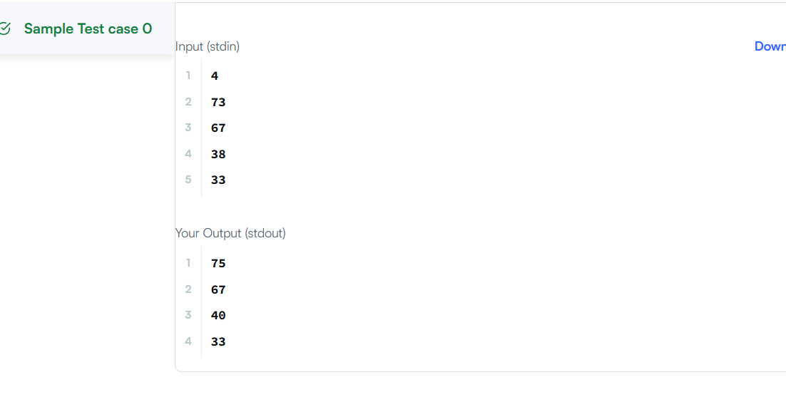

Link to code:
Grading Students | HackerRank

