Code:

#include <assert.h>
#include <ctype.h>
#include <limits.h>
#include <math.h>
#include <stdbool.h>
#include <stddef.h>
#include <stdint.h>
#include <stdio.h>
#include <stdlib.h>
#include <string.h>

char* readline();
char* ltrim(char*);
char* rtrim(char*);
char** split_string(char*);

int parse_int(char*);

char* kangaroo(int x1, int v1, int x2, int v2) {

if (v1 > v2 && (x2 - x1) % (v1 - v2) == 0) {
return "YES";
}
else {
return "NO";
}
}

int main()
{
FILE* fptr = fopen(getenv("OUTPUT_PATH"), "w");

char** first_multiple_input = split_string(rtrim(readline()));

int x1 = parse_int(*(first_multiple_input + 0));

int v1 = parse_int(*(first_multiple_input + 1));

int x2 = parse_int(*(first_multiple_input + 2));

int v2 = parse_int(*(first_multiple_input + 3));

char* result = kangaroo(x1, v1, x2, v2);

fprintf(fptr, "%s\n", result);

fclose(fptr);

return 0;
}

char* readline() {
size_t alloc_length = 1024;
size_t data_length = 0;

char* data = malloc(alloc_length);

while (true) {
char* cursor = data + data_length;
char* line = fgets(cursor, alloc_length - data_length, stdin);

if (!line) {
break;
}

data_length += strlen(cursor);

if (data_length < alloc_length - 1 || data[data_length - 1] == '\n') {
break;
}

alloc_length <<= 1;

data = realloc(data, alloc_length);

if (!data) {
data = '\0';
break;
}
}

if (data[data_length - 1] == '\n') {
data[data_length - 1] = '\0';
data = realloc(data, data_length);

if (!data) {
data = '\0';
}
} else {
data = realloc(data, data_length + 1);

if (!data) {
data = '\0';
} else {
data[data_length] = '\0';
}
}

return data;
}

char* ltrim(char* str) {
if (!str) {
return '\0';
}

if (!*str) {
return str;
}

while (*str != '\0' && isspace(*str)) {
str++;
}

return str;
}

char* rtrim(char* str) {
if (!str) {
return '\0';
}

if (!*str) {
return str;
}

char* end = str + strlen(str) - 1;

while (end >= str && isspace(*end)) {
end--;
}

*(end + 1) = '\0';

return str;
}

char** split_string(char* str) {
char** splits = NULL;
char* token = strtok(str, " ");

int spaces = 0;

while (token) {
splits = realloc(splits, sizeof(char*) * ++spaces);

if (!splits) {
return splits;
}

splits[spaces - 1] = token;

token = strtok(NULL, " ");
}

return splits;
}

int parse_int(char* str) {
char* endptr;
int value = strtol(str, &endptr, 10);

if (endptr == str || *endptr != '\0') {
exit(EXIT_FAILURE);
}

return value;
}
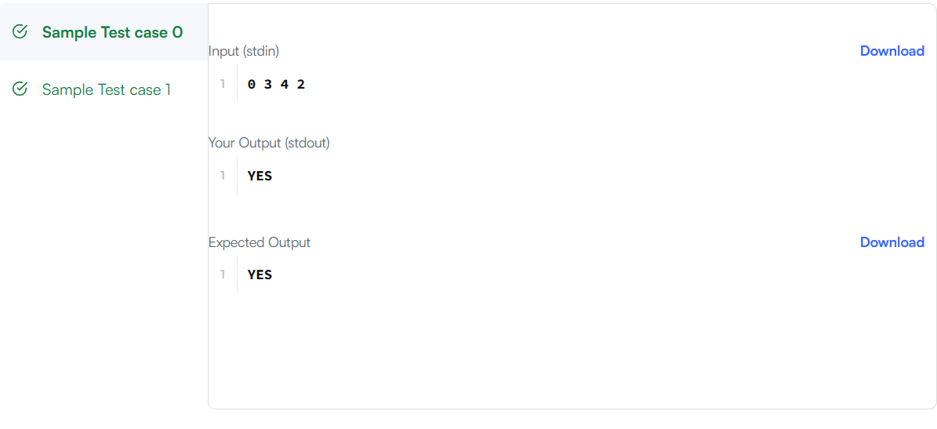

Link to code:
Number Line Jumps | HackerRank

