Code:
#include <stdio.h>
#include <string.h>
#include <math.h>
#include <stdlib.h>

int main()
{
int n;
scanf("%d", &n);

int size = 2 * n - 1;

for(int i = 0; i < size; i++) {
for(int j = 0; j < size; j++) {

int min = i;

if(j < min)
min = j;

if(size - 1 - i < min)
min = size - 1 - i;

if(size - 1 - j < min)
min = size - 1 - j;

printf("%d ", n - min);
}

printf("\n");
}

return 0;
}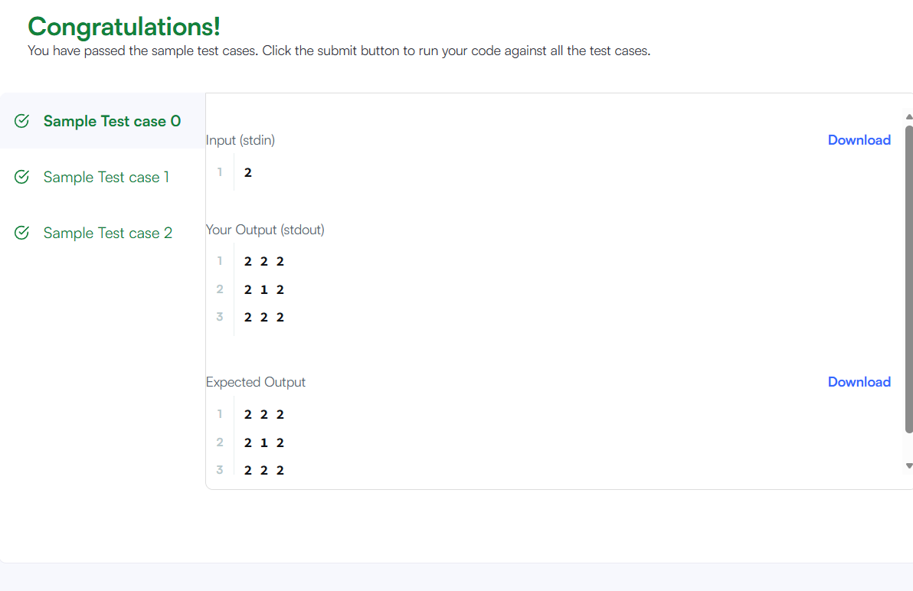

Link to the code:
Printing Pattern Using Loops | HackerRank

