Code:
#include <stdio.h>
#include <string.h>
#include <math.h>
#include <stdlib.h>

int solveMeFirst(int a, int b) {
return a + b;
}

int main() {
int num1,num2;
scanf("%d %d",&num1,&num2);
int sum;
sum = solveMeFirst(num1,num2);
printf("%d",sum);
return 0;
}
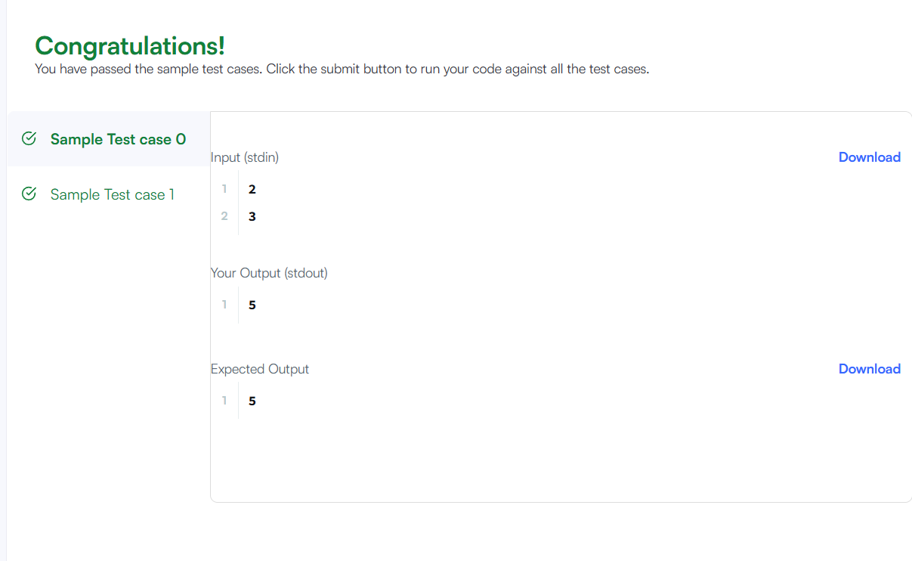

Link to code:
https://www.hackerrank.com/challenges/solve-me-first/problem

