Code:

int subtractProductAndSum(int n) {
int digit, sum = 0, product = 1;

while(n > 0) {
digit = n % 10;

sum = sum + digit;
product = product * digit;

n = n / 10;
}

return product - sum;
}
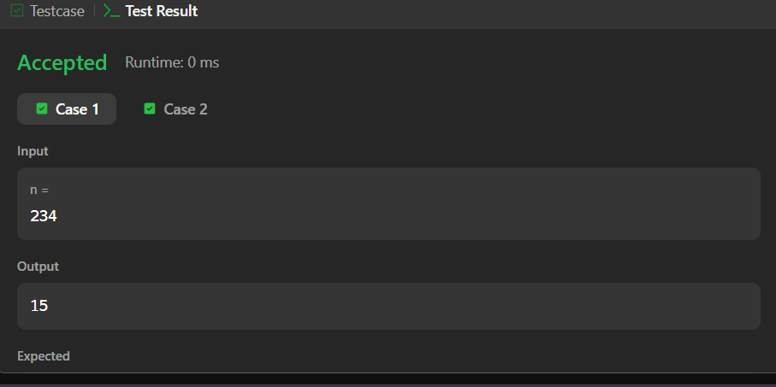

Link to code:
Subtract the Product and Sum of Digits of an Integer - LeetCode

