Code:
int numberOfSteps(int num) {
int steps = 0;
while(num != 0) {
if(num % 2 == 0) {
num = num/2;
}

else {
num = num - 1;
}
steps++;
}
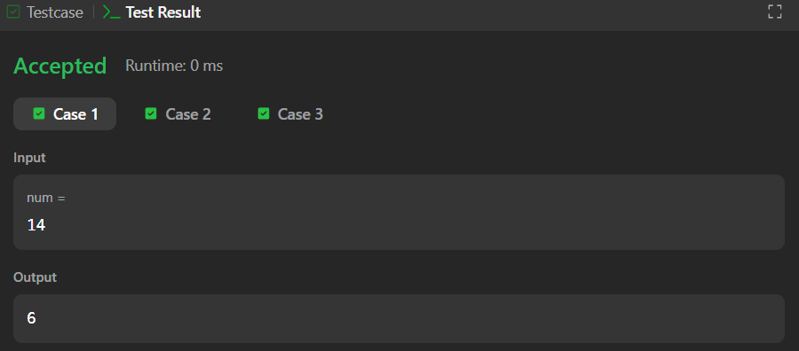

Link to code:
Number of Steps to Reduce a Number to Zero - LeetCode

