Code:
int countOdds(int low, int high) {
return (high + 1) / 2 - low / 2;
}
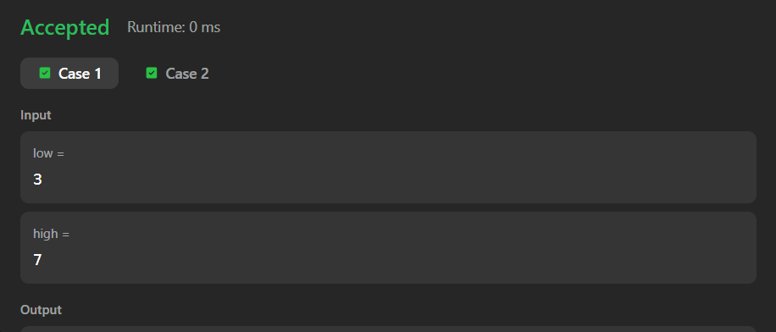

Link to code:
Count Odd Numbers in an Interval Range - LeetCode

