Code:
int sum(int num1, int num2) {
return num1 + num2;
}
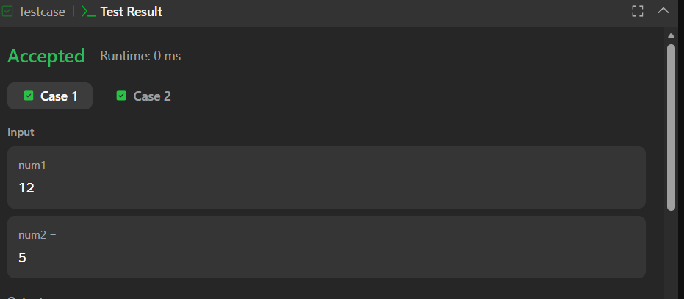

Link to code:
Add Two Integers - LeetCode

