Code:

bool isPowerOfTwo(int n) {
if(n <= 0) {
return false;
}

return (n & (n - 1)) == 0;
}
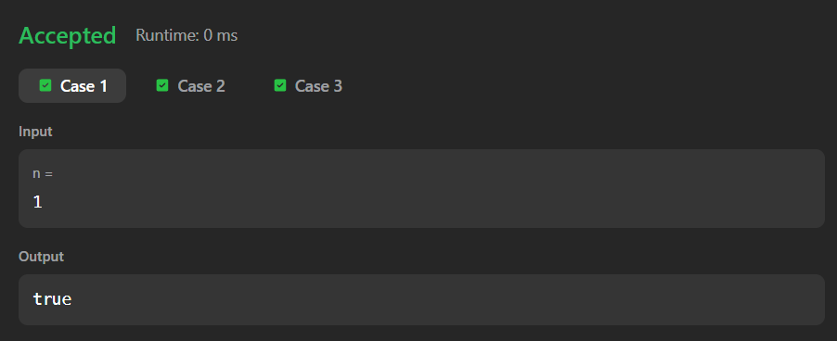
Link to code:
Power of Two - LeetCode

