Code:
int smallestEvenMultiple(int n) {

if(n%2 == 0) {
return n;
}
else {
return n * 2;
}
}

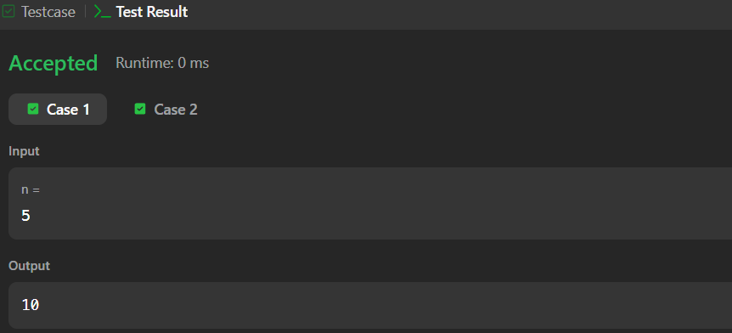
Link to code:
Smallest Even Multiple - LeetCode

