Code:

int countDigits(int num) {
int digit, count = 0;
int first = num;

while(first > 0) {
digit = first % 10;

if(num % digit == 0) {
count++;
}

first = first / 10;
}

return count;
}
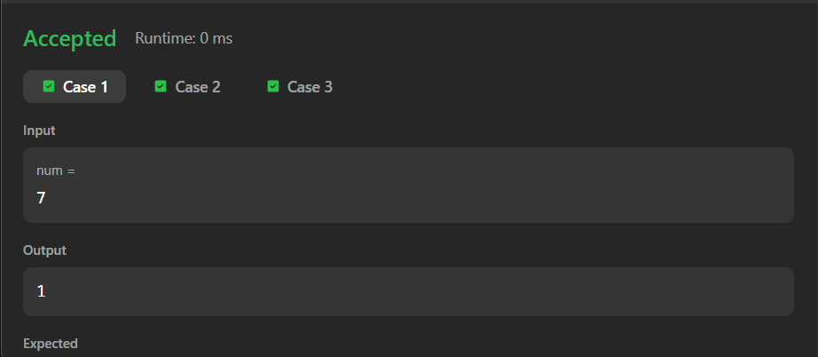

Link to code:
Count the Digits That Divide a Number - LeetCode

