Code:
int distanceTraveled(int mainTank, int additionalTank) {
int distance = 0;

while (mainTank >= 5) {
distance += 50;
mainTank -= 5;

if (additionalTank >= 1) {
mainTank += 1;
additionalTank -= 1;
}
}

distance += mainTank * 10;

return distance;
}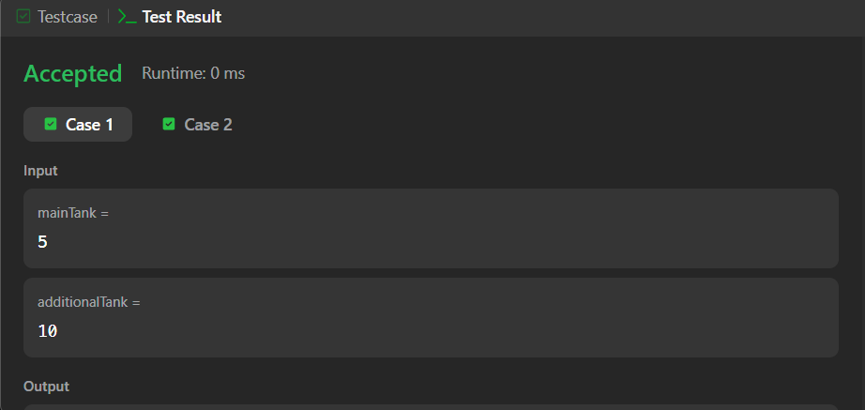
Link to code:
Total Distance Traveled - LeetCode

