Code:

bool isPowerOfThree(int n) {
if(n <= 0) {
return false;
}

while(n % 3 == 0) {
n = n / 3;
}

return n == 1;
}
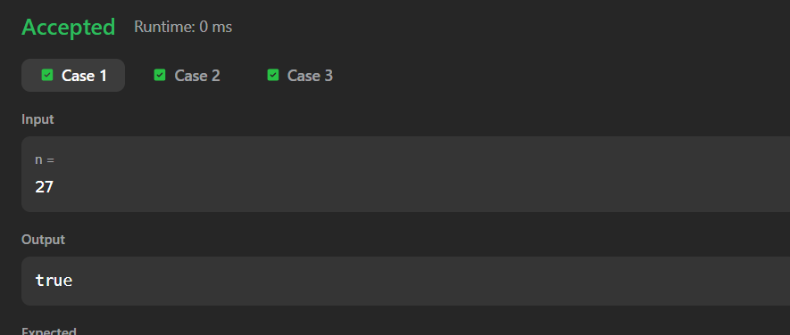
Link to code:
Power of Three - LeetCode

