Code:

bool checkPerfectNumber(int num) {
int sum = 0;

for(int i = 1; i <= num / 2; i++) {
if(num % i == 0) {
sum = sum + i;
}
}

if(sum == num) {
return true;
}
else {
return false;
}
}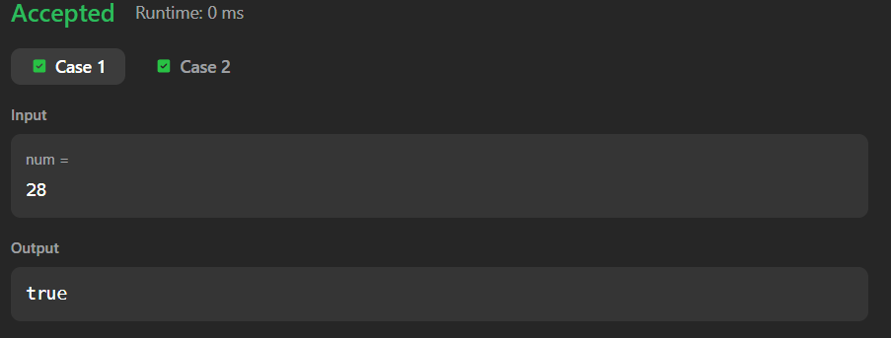

Perfect Number - LeetCode

