Code:

int reverse(int x) {
int digit, rev = 0;

while(x != 0) {
digit = x % 10;

if(rev > 214748364 || (rev == 214748364 && digit > 7)) {
return 0;
}

if(rev < -214748364 || (rev == -214748364 && digit < -8)) {
return 0;
}

rev = rev * 10 + digit;

x = x / 10;
}

return rev;
}
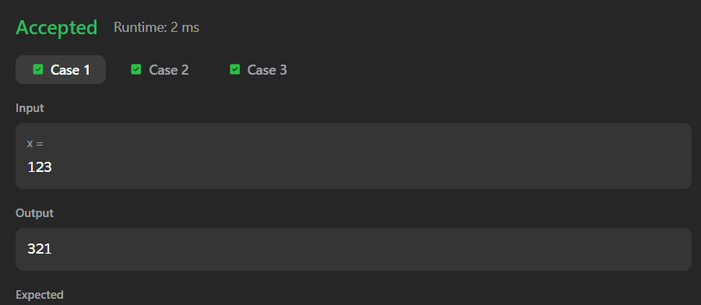

Link to code:
Reverse Integer - LeetCode

