Code:

bool isPalindrome(int x) {
int original = x;
int reverse = 0;
int digit;

if(x < 0) {
return false;
}

while(x > 0) {
digit = x % 10;

reverse = reverse * 10 + digit;

x = x / 10;
}

if(original == reverse) {
return true;
}
else {
return false;
}
}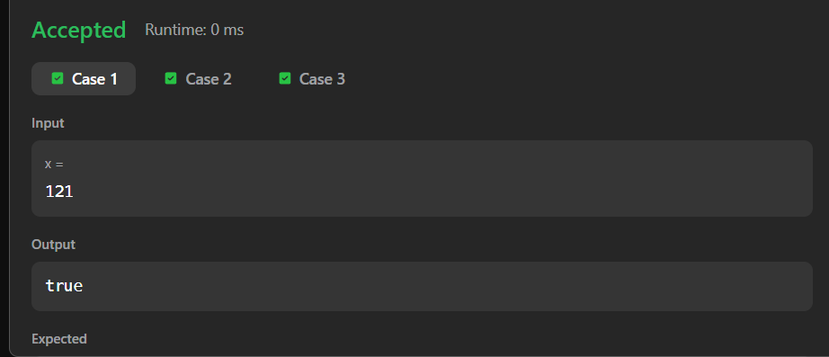
Link to code:
Palindrome Number - LeetCode

