Reg.No: 23BCE1745
Name: Kanishk Kumar S
Software Week-3
UML Diagram

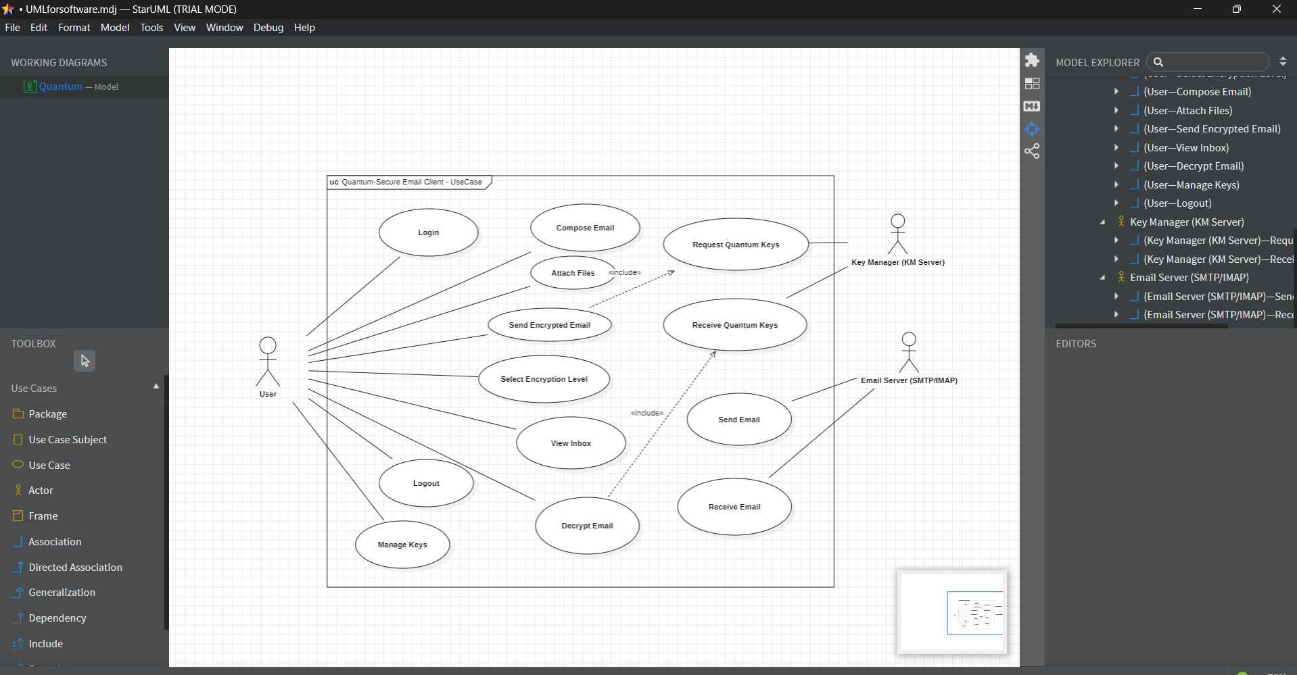
Use Case Diagram:

Class Diagram:
