LAB 2 - AGILE MODEL
Quantum Secure Email Client
23BCE1745
Kanishk Kumar S

Overview of the Agile Approach
The Agile model is an iterative and incremental development methodology that emphasizes continuous improvement, frequent feedback, and flexibility.
In this Quantum Secure Email Client project, Agile is used to progressively refine application features, encryption implementations, and security mechanisms through multiple sprints rather than building the entire system in one step.

Agile Sprint Cycle
The project is divided into five iterative sprints, each focusing on a specific phase of the development pipeline.
Sprint 1 – User Authentication & GUI Design
- Develop secure login interface with username and password validation
- Design user registration module with session management
- Create UI mockups for Compose Email, View Inbox, and Security Level Selection modules
- Implement password hashing and secure storage mechanisms
- Establish Windows GUI framework (PyQt5/PyQt6 or WinForms)
Outcome: Functional authentication system and intuitive GUI framework ready for integration.
Sprint 2 – Key Manager Integration & API Communication
- Design REST API communication with Quantum Key Manager server
- Implement secure HTTPS/TLS connection to KM
- Develop key request and retrieval functionality
- Implement ETSI-style key format parsing and validation
- Create secure local key storage with encryption
- Handle key rotation and updates
Outcome: Reliable KM integration with secure key distribution pipeline.
Sprint 3 – Email Encryption Implementation (Levels 1-4)
- Implement Level 1: Quantum One-Time Pad (XOR with quantum keys)
- Implement Level 2: Quantum-Aided AES-256 encryption
- Implement Level 3: Post-Quantum Cryptography (PQC) or custom encryption
- Implement Level 4: Standard email without quantum security
- Encrypt email content at application layer before transmission
- Create encryption level selection UI with descriptions and recommendations
Outcome: Multi-level encryption system with user-selectable security options.
Sprint 4 – Email Transmission & Reception
- Integrate SMTP protocol for sending encrypted emails
- Integrate IMAP/POP3 protocols for receiving emails
- Connect with existing email services (Gmail, Yahoo, Outlook)
- Implement email composition with recipient, subject, and body content
- Develop inbox retrieval and email list display
- Implement draft saving functionality
- Preserve encrypted payload format across transmission
Outcome: Full email transmission and reception capabilities with encrypted payload preservation.
Sprint 5 – Email Decryption, Testing & Optimization
- Implement decryption engine for all encryption levels (1-4)
- Display decrypted email content in viewer
- Conduct unit testing for encryption/decryption modules
- Perform integration testing with Key Manager API
- Execute GUI testing for user workflows
- Run security testing for vulnerability assessment
- Optimize performance for encryption/decryption operations
- Compatibility testing across Windows versions and email providers
Outcome: Complete, tested, and optimized Quantum Secure Email Client ready for deployment.

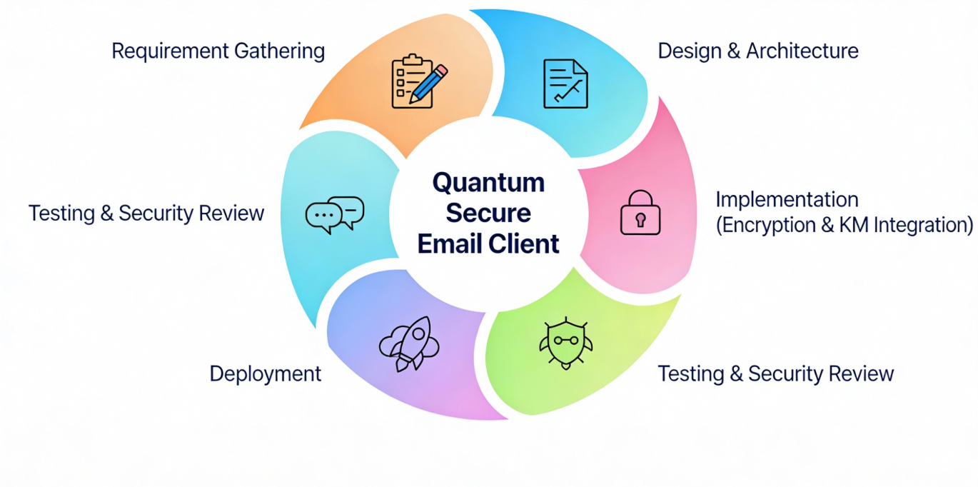

Agile Ceremonies
The Agile workflow includes standard ceremonies to maintain efficiency:
- Sprint Planning: Select user stories and tasks from the product backlog for each sprint
- Daily Stand-up: Monitor progress, discuss challenges, and resolve blockers
- Sprint Review: Evaluate sprint outcomes, test implemented features, and gather feedback
- Sprint Retrospective: Identify improvements, discuss lessons learned, and plan optimizations for the next sprint

Continuous Feedback Loop
After every Sprint Review, feedback from stakeholders, security audits, and performance testing is incorporated back into the Product Backlog.
This allows:
- Refinement of encryption implementations
- Enhancement of user interface based on usability feedback
- Adjustment of security strategies based on threat analysis
- Optimization of API communication and key retrieval
- Improvement of error handling and edge cases
This feedback loop ensures continuous learning, enhanced security, and better user experience.

Advantages of Using Agile for This Security-Focused Project
- Supports iterative security improvements through multiple review cycles
- Adapts easily to emerging security threats and changing requirements
- Enables rapid prototyping of encryption modules and KM integration
- Enhances collaboration between developers, security experts, and stakeholders
- Produces reliable and secure email communication system through continuous testing
- Reduces risk through incremental development and frequent validation
- Allows flexibility in technology choices (Python vs C#, PyQt vs WinForms)

