Reg.No: 23BCE1745
Name: Kanishk Kumar S
Software Week-4
UML Diagram

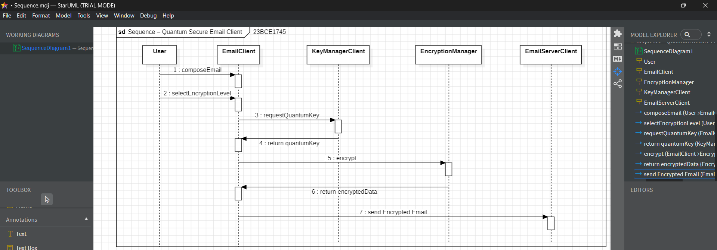
Sequence Diagram:

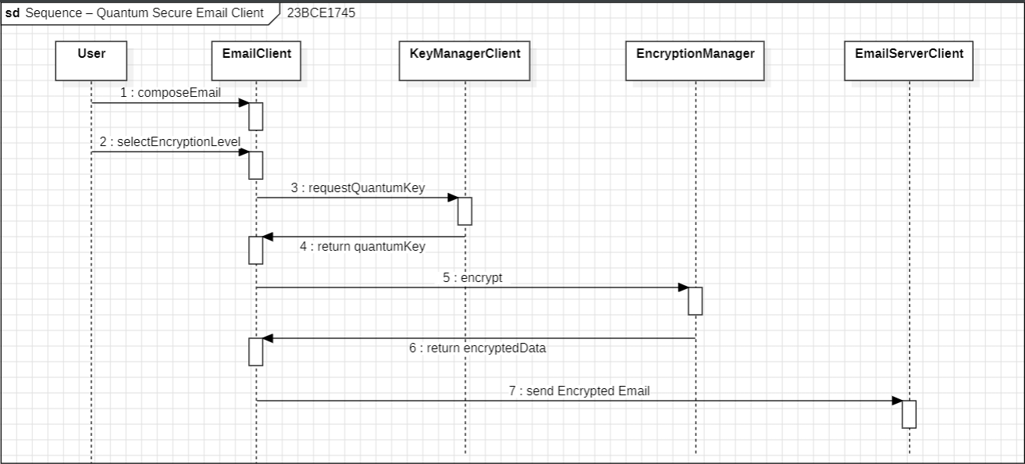

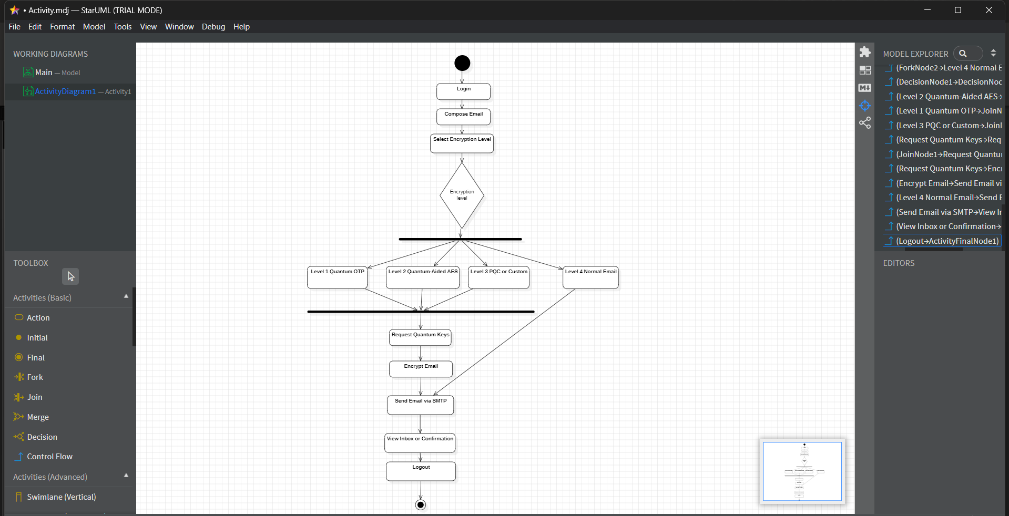
Activity Diagram:

