LAB-1
Architecture and Requirements
23BCE1745
Kanishk Kumar S
Architecture:
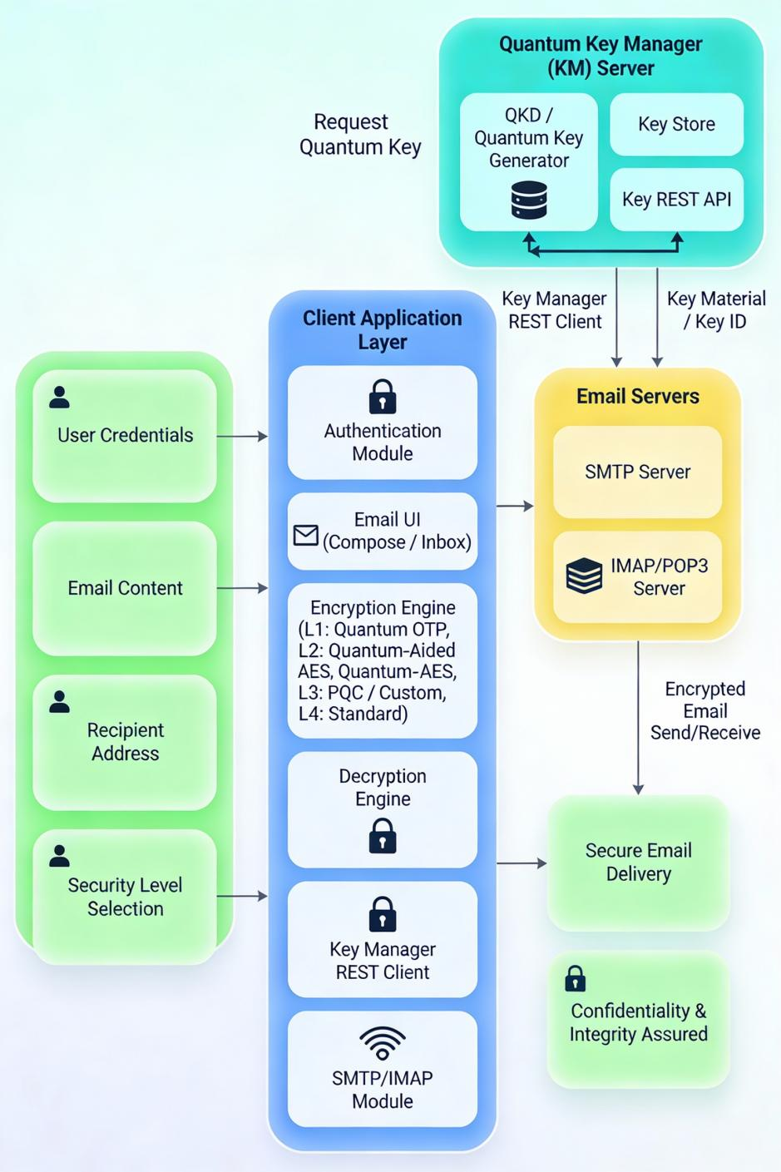
Requirements:
1. Functional Requirements
FR1: User Authentication
- The system shall provide a secure login interface with username and password validation.
- The system shall support user registration and session management.
- The system shall implement secure password storage using hashing techniques.
FR2: GUI Implementation
- The system shall provide an intuitive graphical user interface (GUI) for Windows-based operations.
- The system shall include separate modules for: Login/Registration, Compose Email, View Inbox, Email Viewing, Security Level Selection.
- The system shall display user-friendly error messages and notifications.
FR3: Integration with Key Manager (KM)
- The system shall communicate with a Key Manager server via REST API.
- The system shall request quantum keys from the KM server.
- The system shall support ETSI-style key format for key storage and handling.
- The system shall validate and store retrieved quantum keys securely.
FR4: Email Composition
- The system shall allow users to compose emails with recipient address, subject, and body content.
- The system shall enable users to select encryption levels before sending.
- The system shall support draft saving functionality.
FR5: Email Encryption
- The system shall implement Level 1: Quantum One-Time Pad encryption.
- The system shall implement Level 2: Quantum-Aided AES encryption.
- The system shall implement Level 3: Optional Post-Quantum Cryptography (PQC) or custom encryption.
- The system shall implement Level 4: Standard email without quantum security.
- The system shall encrypt email content at the application layer before transmission.
FR6: Email Transmission
- The system shall integrate with existing email services (Gmail, Yahoo, etc.).
- The system shall send encrypted emails through standard email protocols (SMTP).
- The system shall preserve encrypted payload format across email transmission.
FR7: Inbox Management
- The system shall retrieve emails from the user's inbox.
- The system shall display email list with sender, subject, and timestamp.
- The system shall enable viewing of individual emails.
FR8: Email Decryption
- The system shall decrypt emails received with quantum encryption.
- The system shall display original content after decryption.
- The system shall handle decryption for all encryption levels (1-4).
FR9: Security Level Management
- The system shall allow users to select encryption level (1-4) for each email.
- The system shall display security level descriptions and recommendations.
- The system shall log encryption level usage statistics.
2. Non-Functional Requirements
These describe how well the system should perform.
NFR1: Performance
- The system shall respond to user actions within 2 seconds.
- Email encryption/decryption shall be completed within acceptable time limits.
- Key retrieval from KM shall not exceed 3 seconds.
NFR2: Security
- The system shall prevent unauthorized access to user credentials.
- The system shall securely store quantum keys with encryption.
- The system shall use secure channels (HTTPS/TLS) for communication with Key Manager.
- The system shall prevent man-in-the-middle attacks on key distribution.
NFR3: Scalability
- The system shall support multiple concurrent users.
- The system shall handle large email attachments efficiently.
- The system shall support key rotation and updates from KM.
NFR4: Usability
- The system shall be intuitive for non-technical users.
- The system shall provide clear guidance on encryption level selection.
- The system shall include help documentation and tooltips.
NFR5: Reliability
- The system shall maintain 99% uptime during normal operation.
- The system shall handle network failures gracefully with error recovery.
- The system shall validate all cryptographic operations and report failures.
NFR6: Maintainability
- The system shall be modular with clear separation of concerns.
- The system code shall follow standard design patterns.
- The system shall include comprehensive logging for debugging.
NFR7: Compatibility
- The system shall run on Windows 7 and above.
- The system shall be compatible with major email providers (Gmail, Yahoo, Outlook).
3. Hardware Requirements
Component | Requirement
Processor | Intel i5 or above
RAM | Minimum 4 GB
Storage | 5 GB free space
GPU | Optional (for quantum key generation simulation)
Network | Internet connectivity required

4. Software Requirements
Software | Requirement
Operating System | Windows 7 / 10 / 11
Programming Language | Python 3.8+ or C# .NET
GUI Framework | PyQt5/PyQt6 or WinForms/.NET
Cryptography Library | PyCryptodome, Qiskit (for quantum simulation)
Email Protocol | SMTP/IMAP
API Communication | Requests library / HttpClient
Database | SQLite / SQL Server (for local storage)
Version Control | Git

5. Key Manager (KM) Requirements
- REST API endpoint for quantum key distribution.
- Support for ETSI quantum key format.
- Key management and rotation capabilities.
- Authentication mechanism for secure communication.
- Response time optimization for key requests.
6. Encryption Requirements
- Quantum key length: Minimum 256 bits.
- One-Time Pad implementation: XOR operation with quantum keys.
- AES encryption: 256-bit key size for Level 2.
- Key storage: Encrypted local storage with master password.
7. Constraints
- Key distribution limited by KM server availability.
- Email size limitations based on email service provider.
- Quantum key generation simulation (not hardware QKD).
- Compatibility with standard email protocols may limit encryption method choices.
- Legacy email systems may not support large encrypted payloads.
8. Testing Requirements
- Unit testing for encryption/decryption modules.
- Integration testing with Key Manager API.
- GUI testing for user interactions and workflows.
- Security testing for vulnerability assessment.
- Performance testing for encryption operations.
- Compatibility testing across supported Windows versions and email providers.

