LAB 5 – Project 50% Submission
Quantum Secure Email Client
23BCE1745
Kanishk Kumar S

Problem Statement:
Traditional email systems rely entirely on classical encryption mechanisms such as TLS and AES. With the rapid advancement of quantum computing, these classical cryptographic systems are at risk of becoming vulnerable in the near future.
The challenge is to demonstrate how Quantum Key Distribution (QKD) can be integrated into existing email infrastructure (Gmail/Yahoo) without modifying email servers, while allowing users to choose different levels of security.
The goal is to design a Windows-based email client that fetches quantum-generated keys from a Key Manager (KM) and applies encryption at the application layer before sending emails through standard SMTP services.

Objectives

Primary Objectives
- Develop a Windows-based GUI email client.
- Provide multi-level encryption options (Quantum → Classical).
- Integrate (UI-ready) support for ETSI-style QKD key requests.
- Ensure compatibility with existing email providers (Gmail/Yahoo).
- Offer an intuitive, modern, space-inspired UI.

Security Objectives
- Enable:
  - Level 1: Quantum One-Time Pad
  - Level 2: Quantum-Aided AES
  - Level 3: Hybrid PQC
  - Level 4: Standard Email (No Quantum Security)
- Show hybrid encryption strength (e.g., 192-bit security visualization).

Methodology / Approach
Since this submission represents 50% completion (Frontend Implemented), the approach focused on UI architecture, encryption workflow design, and modular integration readiness.

Encryption Workflow (Frontend Designed)
- User selects security level.
- UI displays:
  - Encryption strength
  - Security badge
- On "Send Secure":
  - Frontend will (future stage) request key from KM via REST API.
  - Apply selected encryption module.
  - Send encrypted content via SMTP.
(Currently UI flow is fully designed and interaction-ready.)

Basic Backend (Partially Implemented)

Gmail Integration for Fetching Emails
- IMAP-based email retrieval from Gmail
- Inbox listing functionality connected to UI
- Email subject, sender, and timestamp display
- Connection authentication working via App Password
- Backend service structured using Flask

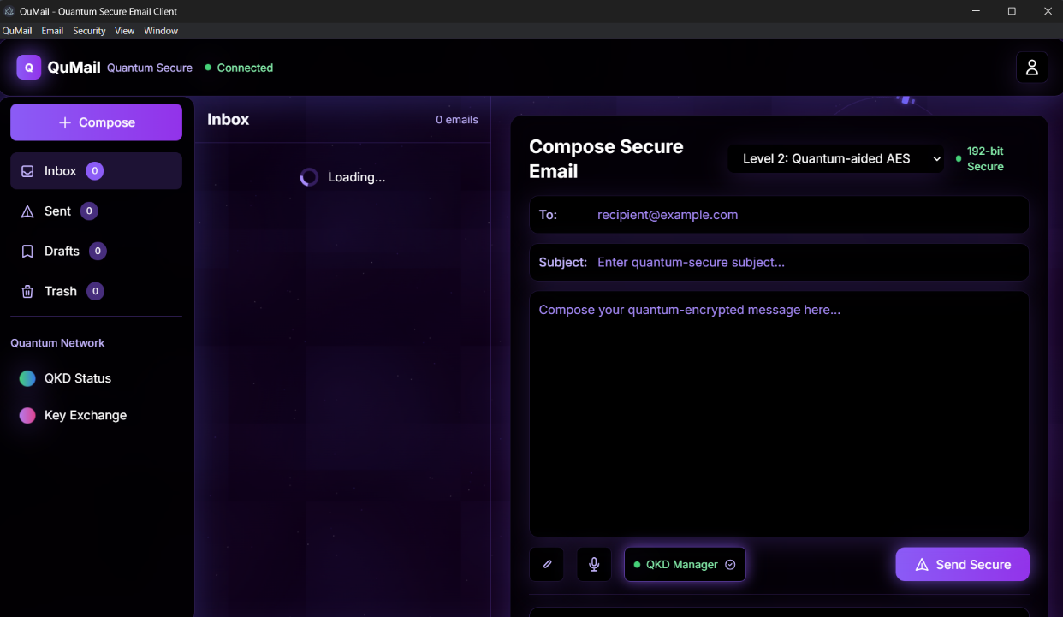

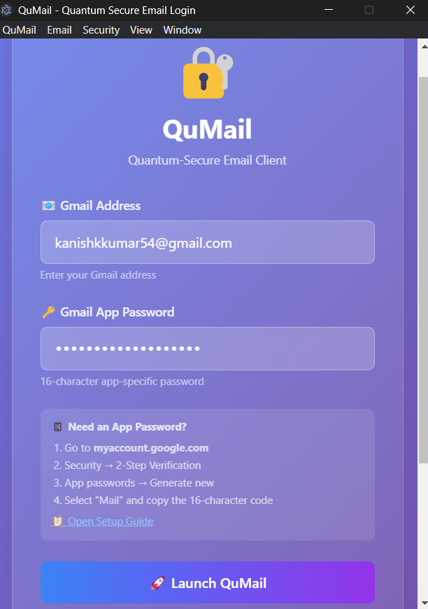

Video Link: https://drive.google.com/file/d/1Bk5aVfvhZkuJBiCHXGpp-USK3ZwDbbCG/view?usp=sharing

