Quantum Secure Email Client Application

Name : Kanishk Kumar S
Reg.No: 23BCE1745

Github Link: https://github.com/kanishkkumar23/D2_23BCE1745_Kanishkkumar/tree/main/QSEM_Proj

Video Link: https://drive.google.com/file/d/1atgWXfwbjLKF9gp0loy6JWSvJ2H7l8lP/view?usp=drive_link

Abstract
The rapid advancement of quantum computing poses a significant threat to classical cryptographic protocols currently securing digital communications. This project presents the design and implementation of a Quantum Secure Email Client, a Windows-based desktop application that enhances standard email security by integrating Quantum Key Distribution (QKD) concepts and Post-Quantum Cryptography (PQC). Operating entirely at the application layer, the system provides end-to-end encryption without requiring modifications to existing email server infrastructure (e.g., Gmail). By leveraging standard SMTP and IMAP protocols alongside a novel hybrid cryptographic framework, the application allows users to dynamically select from four distinct security levels, ranging from standard transmission to a simulated Quantum One-Time Pad. This report details the system architecture, underlying protocols, and experimental implementation of the secure client.

Background
Traditional email infrastructure relies heavily on protocols like SMTP (Simple Mail Transfer Protocol) and IMAP (Internet Message Access Protocol), which are typically secured in transit using Transport Layer Security (TLS). TLS, in turn, depends on classical asymmetric cryptographic algorithms such as RSA and Elliptic Curve Cryptography (ECC).
The advent of large-scale quantum computers will render these classical algorithms obsolete, as algorithms like Shor’s can solve the underlying mathematical problems (integer factorization and discrete logarithms) in polynomial time. To future-proof sensitive communications, there is an urgent need to transition to quantum-resistant security measures. While deploying physical QKD networks globally remains a logistical challenge, integrating simulated QKD and standardized PQC at the application layer provides an immediate, deployable bridge to quantum-safe communication.

Proposed System
The proposed system is an independent, secure email client that layers quantum-safe encryption over existing email services.

System Workflow
- Authentication: The user logs into the client using their standard Gmail credentials and an application-specific password.
- Retrieval: The client connects to the email server via IMAP, fetching and rendering the user's inbox, sent items, drafts, and trash.
- Composition & Configuration: The user drafts an email (recipient, subject, body) and selects a desired encryption tier (Levels 1 through 4) using the application interface.
- Key Generation & Exchange: Based on the selected level, the system either generates a new key pair or retrieves existing symmetric keys via the QKD Manager.
- Encryption: The message payload is encrypted locally at the application layer.
- Transmission: The encrypted cipher text is transmitted over standard SMTP.
- Decryption: Upon receipt, the recipient's client identifies the security level and applies the corresponding decryption algorithm to reveal the plaintext message.

Originality and Contributions
- Application-Layer Security: By applying cryptographic transformations before the message hits the transport layer, the system ensures zero reliance on the email provider for data confidentiality.
- Hybrid Cryptographic Model: The system pioneers a blended approach, merging classical cryptography, NIST-standardized Post-Quantum Cryptography, and Quantum Key Distribution.
- Granular User Control: Users are empowered to balance computational overhead with security needs by choosing specific encryption levels.
- Modern Interface: The integration of a glassmorphism-based UI and Three.js key exchange visualizations bridges the gap between complex cryptographic processes and user accessibility.

Comparison with Traditional Email Systems
Unlike standard clients (e.g., MS Outlook, Apple Mail) that rely entirely on the provider’s TLS for transit security and offer PGP as a cumbersome add-on, this system natively embeds quantum-safe protocols. Traditional systems leave plaintext data on the provider's servers; the proposed system ensures the provider only ever stores and forwards indistinguishable ciphertext.

System Architecture
The architecture is divided into three primary components: the Frontend UI, the Backend Engine, and the Cryptographic Layer.

Frontend Module
Built using Electron, the frontend serves as a standalone desktop executable.
- User Interface: Styled with Tailwind CSS, featuring a modern glassmorphism aesthetic. It handles user interactions, inbox navigation, and email composition.
- Visualizations: Utilizes Three.js to provide real-time, 3D visual feedback of the quantum key exchange process and QKD status.
- Accessibility: Incorporates the Web Speech API for enhanced user interaction.

Backend Module
Powered by a Flask server, the backend bridges the UI with external networks and the cryptographic engine.
- Email Interfacing: Uses Python’s smtplib and imaplib (or equivalent libraries) to handle the transmission and retrieval of emails.
- Database/State Management: Integrates Firebase to manage user states, public key directories for PQC, and routing metadata, supported by the requests library for external API calls.

Cryptographic Layer
This engine dictates the security parameters based on user selection:
- Level 1 (Quantum One-Time Pad): Offers information-theoretic security using keys generated via the QKD simulation.
- Level 2 (Quantum-aided AES): Utilizes AES-256 for symmetric encryption, where the symmetric keys are derived and distributed via the QKD protocols.
- Level 3 (Hybrid Post-Quantum): Deploys ML-KEM-768 for secure key encapsulation and ML-DSA for digital signatures, alongside classical ECDH/X25519 and EdDSA fallbacks.
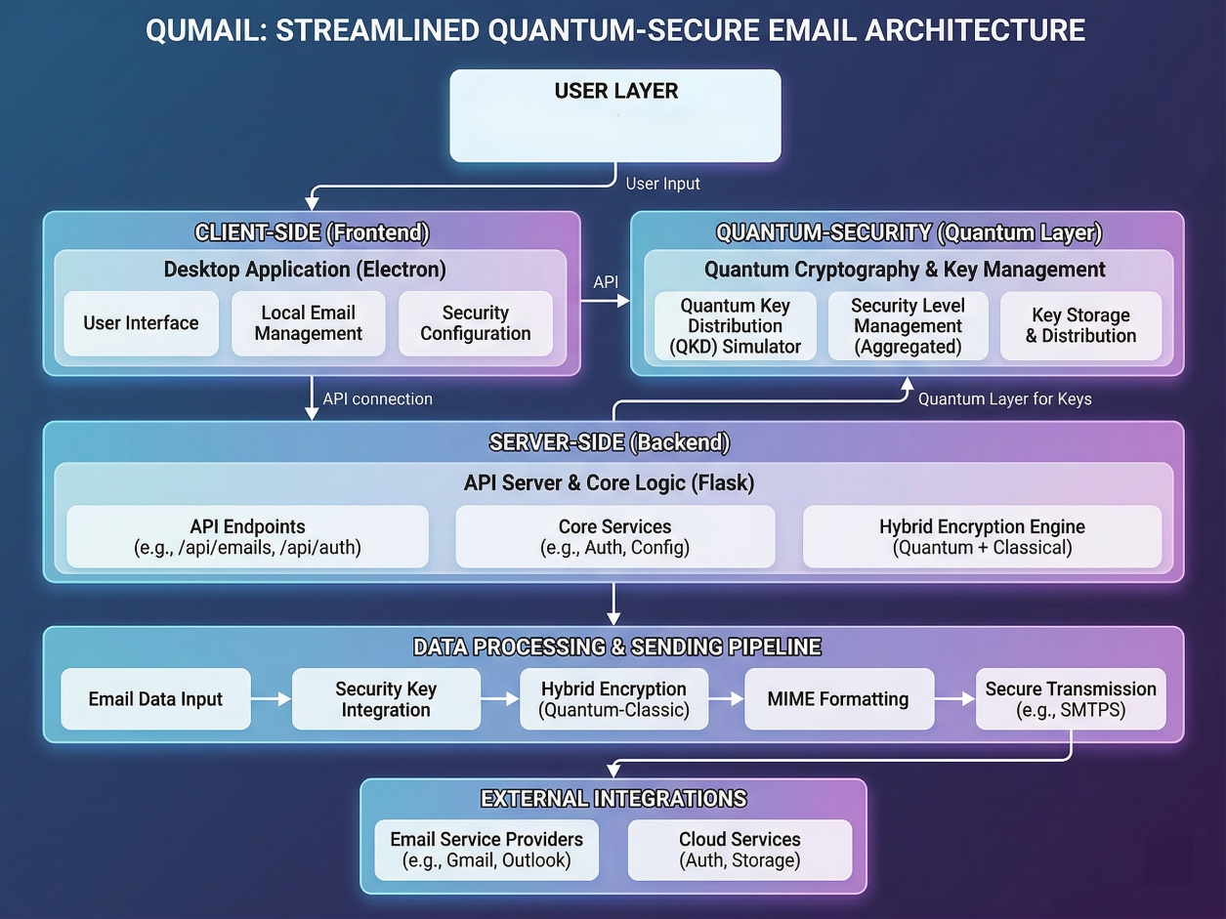
- Level 4 (Standard): Transmits standard SMTP/TLS emails without additional application-layer encryption.

Protocol Stack
The system implements a customized protocol stack to facilitate secure communication:
- Application Interface Layer:
  - Electron UI, User Input, Web Speech API.
- Cryptographic Processing Layer (The Core Innovation):
  - Quantum Sub-layer: Qiskit (BB84 Protocol Simulation, ETSI-style QKD key handling).
  - Post-Quantum Sub-layer: liboqs-python (ML-KEM, ML-DSA).
  - Classical Sub-layer: Python cryptography (AES-256, ECDH, EdDSA).
- Application Transport Layer:
  - SMTP (Port 465/587) for outbound transmission.
  - IMAP (Port 993) for inbound synchronization.
- Network/Physical Layer:
  - Standard TCP/IP over existing internet infrastructure.

Testbed / Experimental Setup
The project was developed and tested in a controlled environment to ensure the seamless interaction of quantum simulations with classical web protocols.
- Operating System: Windows (Desktop Application Environment).
- Frontend Technologies: Node.js, Electron framework, HTML5, Tailwind CSS, Three.js.
- Backend Technologies: Python 3.x, Flask microframework.
- Cryptographic Tooling: * IBM Qiskit (for simulating the BB84 quantum key distribution protocol).
  - liboqs-python (Open Quantum Safe library for ML-KEM and ML-DSA).
  - Python cryptography package.
- Third-Party Integrations: Gmail SMTP/IMAP servers, Firebase (BaaS).

Results and Observations
The implementation successfully demonstrated the viability of integrating quantum-resistant algorithms into standard email workflows.
- Integration Success: The application seamlessly authenticated with Gmail using App Passwords, successfully fetching and sending emails without triggering provider-side rejections.
- Cryptographic Efficacy: * Level 3 (PQC) encryption demonstrated acceptable latency for real-world application, successfully wrapping and unwrapping AES keys using ML-KEM-768.
  - The BB84 simulation via Qiskit effectively modeled the generation of a secure key, validating the logic required for future integration with physical QKD hardware.
- User Experience: The Three.js visualizations successfully abstracted the complexity of key exchange, providing users with intuitive verification of their selected security tier.

Conclusion and Future Scope

Conclusion
The Quantum Secure Email Client effectively bridges the gap between current communication infrastructures and the impending quantum era. By utilizing a hybrid cryptographic framework at the application layer, the project proves that high-level, quantum-resistant security can be achieved without requiring global overhauls of existing SMTP/IMAP servers. The multi-tiered security approach ensures flexibility, making it a robust prototype for future secure communication tools.

Future Scope
- Hardware QKD Integration: Transitioning the Qiskit simulation to interface with physical QKD network nodes via standardized ETSI APIs.
- Cross-Platform Support: Expanding the Electron build to support macOS and Linux distributions, and developing companion mobile applications.
- Performance Optimization: Further profiling and optimizing the liboqs implementation to reduce latency and payload sizes for Post-Quantum signatures and ciphertexts over low-bandwidth connections.

