**CONVOLUTIONAL NEURAL NETWORK TO DETECT DISTINCT TYPE OF PNEUMONIA**

Kanishk Sharma [1]

Indranil Sarkar[2]

Uddashay Kumar Gupta[3]

School of Information Technology and Engineering

Vellore Institute of Technology

Vellore – 632014, Tamil Nadu, India

[kanishk.sharma2022@vitstudent.ac.in](mailto:kanishk.sharma2022@vitstudent.ac.in)

[indranl.sarkar2022@vitstudent.ac.in](mailto:indranl.sarkar2022@vitstudent.ac.in)

uddashaykumar.gupta2022@vitstudent.ac.in

PROF. JAGADEESAN S.*[4]

Associate Professor Senior Grade 2

School of Information Technology and Engineering

Vellore Institute of Technology

Vellore – 632014, Tamil Nadu, India

E-mail: s.jagadeesan@vit.ac.in

**Abstract:** Pneumonia is an infectious disease which affects one or both lungs. Pneumonia can be caused by bacteria as well as virus. The common practice to detect using CT scan or x-ray scans of chest. But it needs an expert eye to distinguish between different types of pneumonia. The disease spreads so rapidly, it needs to be detected earlier in remote areas. A recent boom in the development of Deep Convolutional Neural Network and its performance in classifying Medical Imaging suggests the task needs to be automated. In this research ResNet-50 has been employed as feature-extractor for the experiment and proposed a novel Deep Convolutional Neural Network as classifier to detect if the patient has pneumonia and further classify if it is caused by bacteria or virus. The dataset is divided into three directories, on the basis of the cause of the disease- Normal, Bacteria, Virus. The performance metrics for the evaluation of the proposed model consists of Specificity and Sensitivity.

**Keywords:** Pneumonia, Bacterial infection, virus infection, transfer learning

**Introduction**

Pneumonia is one of the leading diseases that affects millions of people around the world every year. It mostly affects children and elderly people with low immunity. It causes inflammation in the alveoli, which fills up with fluid that results in difficulty in breathing. It also causes various symptoms like fever, coughing, chest pain, etc. It has significant impact around the world as it is one of the leading causes of death of children below five years which accounts around 15% for under five years old. Pneumonia also has economic impact on individuals, families and communities. Pneumonia can also affect in productivity as the effected people will have to miss school and office days. It is treatable and preventable disease, but it requires effective response as it includes access to vaccines and antibiotics.

Pneumonia is a type of infection that is caused by bacteria fungus or viruses. The severity of the symptoms can vary according to various factors like the age and health of the affected person. When the symptoms become serious it can lead to complications like sepsis, respiratory failure, or lung abscess. Treatment fop pneumonia includes antibiotics and antiviral medications. Therapies such as Oxygen treatment might also be needed for ease of breathing. Vaccines can be also used for prevention of pneumonia.

There are several types of pneumonia like community acquired, Hospital acquired, ventilator associated pneumonia, etc. Pneumonia can largely be classified into three types: bacterial, viral, fungal. The most common types are viral and bacterial of which we have taken the dataset of.

Viral pneumonia is a type of pneumonia caused by viruses such as influenza, respiratory syncytial virus or COVID-19. Viral pneumonia is typically less harmful than bacterial pneumonia yet it can still be dangerous for people with low immunity. Symptoms are similar to that of other types pneumonia. Treatment depends on the type virus that includes antiviral medications. Bacterial pneumonia occurs when bacteria affect the lungs and causes inflammation in the alveoli’s, leading to accumulation of fluids and pus. In case of severe symptoms hospitalization might be required. Treatment of such disease can be achieved through antibiotic medications which kills the bacteria causing the infections.

In this paper we have used an image data set that includes lung x-rays of people affected with viral and bacterial pneumonia to train our deep learning model that includes Visual Geometry Group (VGG-16) and Convolutional Neural Networks (CNN). The model classifies the dataset of images into two categories that helps in determining whether the image of Xray has pneumonia or not.

CNN is a type of artificial neural network that is commonly used in image and video recognition tasks. It processes data with a grid-like topology by applying filters that detect features int the input data. CNN comprises of multiple layers that include convolutional layers, pooling layer and fully connected layers. It has achieved state of art performance on variety of tasks where they have outperformed human accuracy in image recognition. It is very effective in image datasets but it also depends on the complexity of the task and architecture of the networks.

This paper has been divided into five parts. The first part is introduction and the problem statement. Section 2 describes significant related works. Section 3 begins by laying out the detailed proposed model, followed by fourth section, which presents the experimental outcomes of the research and its analysis. Finally, the closing provides a concise review and analysis of the results as well as the future outlook.

**Literature Survey**

Recent research has indicated that ensemble learning has a positive impact on the performance of the image recognition model. The CNN model numerous hyper-parameters including kernel size, dropout layers, numerous other parameters; depending upon the model intending to be employed for addressing a particular problem. The selection of hyper-parameters is generally accomplished manually and involves expensive trial and error. As a result, CNN training typically takes a long time since different hyper-parameter combinations are evaluated in different rounds and numerous iterations of training occurs for the determination of the precision of the neural network with the respective combination of hyper-parameters. On the other hand, effective hyper-parameter tuning can improve the CNN model's overall performance.

An effective deep neural network model, consisting of VGG-16 as base model and a custom CNN architecture as output layers, is then developed utilizing the optimized hyper-parameters. This study [4] identify several advantages of VGG-16 in image diagnosis. One of them is the capability to give high accuracy even when trained on smaller dataset. However, the main weakness of the study is the usage of limited dataset to training and testing the convolutional neural network. The study might have been more interesting if the author had used larger dataset.

[5] In this study, the author shows an automated method for detecting viral or bacterial pneumonia in chest radiographs using deep learning models and handcrafted characteristics. The segmentation is done using two datasets, JSRT and MC (Japanese Society Datasets). To categorize the target lung areas, a deep convolutional neural network (DCNN) model is employed. Features of the target lung areas are automatically retrieved using the DCNN model, and their performance is compared to that of manual features. They input the outcome into a binary SVM classifier using support vector machines. The results indicated that DCNN with transfer learning had (0.8048±0.0202) accuracy and (0.7755±0.0296) sensitivity in extracting features.

[6] CNN was employed for classification of different human actions. The methodology they adopted is consists of weight initialization for the CNN using grey wolf optimizer. By identifying the local minima during fitness computation, the CNN was trained. The activity recognition dataset utilized in this research paper namely HMDB51, UCF50, Olympic Sports and Virat Release 2.0. An interesting finding has been found in this research, i.e., the CNN without GWO has more accuracy than CNN with GWO (88.3% and 76.5% respectively). But training with gradient descent increased the accuracy to 99.98%

[7] Here Srikanth Tammina demonstrated that basic CNN network yields high training accuracy i.e., 98.20% but lower validation accuracy i.e., 72.40%. The cause could be over-fitting of the model. But fine tuning of the model with image augmentation fetches more accuracy over validation dataset i.e., 79.20%. In conclusion, the author developed a basic ensemble learning model which comprises of VGG-16 as base model and a simple CNN layer as output layer on top of the base model, for binary classification of cat and dogs which achieved the validation accuracy of 95.40%.

[8] In order to provide healthcare practitioners with accurate tools for screening the COVID-19 and diagnosing confirmed patients, this researcher studies deep learning algorithms for automatically analysing query chest X-ray pictures. Since they all topped 84% of average accuracy on pneumonia detection cases for the pneumonia reorganised dataset, tailored models have demonstrated promising performances. On the COVID-19 blind test set, the InceptionResNetV2 model has specifically detected the lowest percentage of false negatives for pneumonia (0.7%).

[9] In order to streamline the detection process while improving accuracy, the author of this study suggests a unique deep learning approach for the automatic identification of pneumonia. ImageNet dataset used for models, including ResNet50, InceptionV3, and InceptionResNetV2. Additionally, two optimizers, Adam and Stochastic Gradient Descent (SGD), are employed to extract the useful features and boost the accuracy of pre-trained models, and their performances are examined with batch sizes of 16 and 32. ResNet50 model work reportedly obtained 93.06% accuracy, 88.97% precision rate, 96.78% recall rate, and 92.71% F1-score rate, which is greater than the models they compare, including DenseNet-169+SVM, VGG16, RetinaNet + Mask RCNN, VGG16, and Xception.

[10] For the categorization of COVID-19, non-COVID-19 viral pneumonia, bacterial pneumonia, and normal chest X-rays images (CXR), the author of this research advocated the use of a deep learning strategy based on a trained AlexNet model. The accuracy, sensitivity, and specificity of the non-covid model were 94.43%, 98.19%, and 95.78%, respectively. The model's accuracy, sensitivity, and specificity for healthy and datasets with bacterial pneumonia were 91.43%, 91.94%, and 100%, respectively. The model's performance for COVID-19 pneumonia and healthy CXR pictures was 99.16% accurate, 97.44% sensitive, and 100% specific. The model's COVID-19 pneumonia classification accuracy, sensitivity, and specificity were 99.62%, 90.63%, and 99.89%, respectively.

[11] In this research paper, different types of optimization algorithms have been utilized to select the relevant hyper-parameters of the CNN so as to optimize the CNN architecture by improving its performance in addressing the skin cancer multi class classification problem. The optimization techniques used were namely, GWO, GA and PSO. The ISIC skin lesion multiclass data set has been employed for the purpose of this research. The image preprocessing comprises of gray scale image conversion and gaussian filtering, has been performed, which helped by saving time during the generation of feature map. While all the optimization techniques yield same training loss of 18%, testing/validation loss is where CNN optimized using GWO outperformed other algorithms with the minimum loss of 0.58% while the training loss of PSO and GA was 0.60 and 0.75 respectively

[12] In this research, the researchers reviewed past papers on medical image analysis, with a sample space of 308 papers. The year of publication of the papers, ranges from 2012-2017 which a heavy skewness towards the year 2016. In the prior papers, transfer learning has been extensively utilized on the contrary custom models has been used in the recent papers (2016-2017). CNN is the primary neural network model for the medical image processing, with a large and proper research in this field. Though, hyper-parameter optimization and classification optimization has not been discussed in the paper, which could have provided more insight in the matter

[13] In the paper titled “Early Tumor Diagnosis in Brain MR Images via Deep Convolutional Neural Network Model” published in February 2021. researchers used Deep-CNN model to detect tumor using clinical presentations and magnetic resonance imagining (MRI). In the conclusion, the authors have mentioned to reduce the no. Of hyper-parameters to improve the accuracy of proposed model

[14] A faster-CNN based pixel classifier to detect prostate and breast cancer was cnstructed. In contrast to the prior papers, which perform patch-by-patch classification, here the researchers used fully convolutional networks to obtain per-pixel cancer likelihood maps and segmentations in whole-slide images. Also, they are the first to report slidelevel accuracies for cancer detection. Some false positives were found during the validation of cancer detection model. The purposed model identified broken tissues as prostate cancer, which violates the idea of usage of fully automated cancer identification system. Adding to this, the authors admitted that another limitation is that the dataset used during this research is from one single organization

[15] In this survey paper, Ricardo Ribani and Mauricio Marengon reviewed the literature on Transfer learning for Convolutional Neural Networks. The researchers mentioned the need of transfer learning for CNN as manual training over millions of images is time-consuming besides being cost-inefficient. The paper also discussed about the various use of VGG models in the image classification and segmentation, such as vanilla model, just as a feature extractor, VGG Model with fine tuning. During the conduction of this research VGG model has been used as feature extractor and, fine tuning and hyper-parameter optimization is implemented on the output layers of CNN.

[16] In the paper published in 2016, the researchers presented a network of neurons with extremely small kernels for visual segmentation and detection of a class of brain tumor called ‘Gliomas’. Small kernels results prevented overfitting and gave fewer weights in the network, hence, made the CNN model lighter. The authors implemented intensity normalization prior to the training of the model during the preprocessing stage, which is not a common practice as the past papers on image segmentation has shown. The accuracy of the model is further improved by performing data augmentation on MRI images.

[17] The manual segmentation of MRI Images during brain tumor detection is time-consuming, as discussed in this paper [10]. Hence, a number of physicians uses rough measures for the evaluation, this demands into the semi-automation or full automation of image segmentation of Magnetic resonance imaging (MRI) Scans.

[18] Research proposed vanilla CNN from scratch to detect the tumor. The dataset used for the purpose of this research comprises of 3064 Fig-share dataset images. The proposed methodology achieved an accuracy of 96%. This research lacks comparative analysis of the given and other approaches.

[19] The author of this research suggests a revolutionary two-stage deep learning architecture to identify pneumonia and categorise it in chest radiographs. One network in the architecture categorises images as normal or pneumonic, while a second deep learning network categorises the type as bacterial or viral. They used the dataset, which included 5856 photos (1583 normal images and 4273 pneumonic images). 2780 individuals are classified as bacteria in the dataset, whereas the remaining patients fall into the virus group. On a collection of 624 photos, they test their suggested algorithm(s), and they are able to detect pneumonia with an area under the receiver operating characteristic curve of 0.996. They also classify pneumonic chest radiographs with an accuracy of 97.8%. The classification of photos of pneumonia as caused by a virus or bacteria was found to have an overfitting problem when transfer learning methods employing well-established deep learning networks were used. But they were able to solve this issue because to a straightforward CNN architecture designed specifically for this application.

**Methodology**

The proposed framework for the research comprises of three main stages. Image preprocessing is implemented on the dataset. Then it is followed by the hyper-parameter tuning which then followed by CNN training using manually chosen hyperparameters. The flow diagram of the Methodology is constructed as:

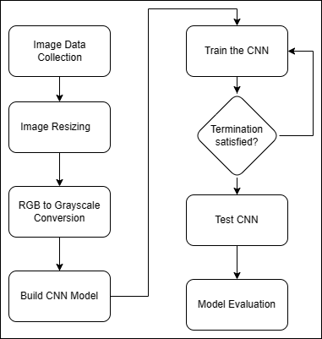

*Step 1: Data Collection*

Dataset was collected from Kaggle. The employed dataset included three kinds of x-ray scans. One of those patients who are normal and others of those who have pneumonia caused by bacteria and virus respectively. There are 5,863 X-Ray images (JPEG) and 2 categories (Pneumonia/Normal).

Chest X-ray images (anterior-posterior) were selected from retrospective cohorts of pediatric patients of one to five years old from Guangzhou Women and Children’s Medical Center, Guangzhou. All chest X-ray imaging was performed as part of patients’ routine clinical care. Figure below reveals two samples of the scans.

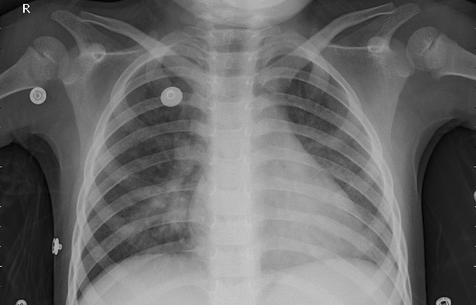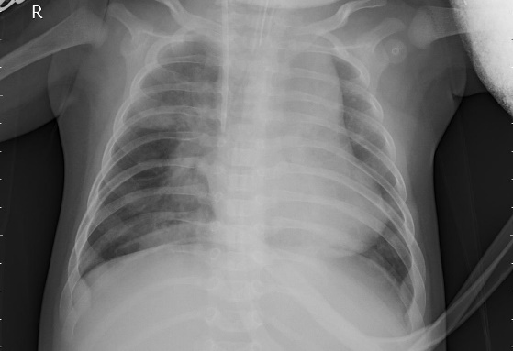

***Figure.2*** *Chest x-ray*Images Dataset Sample (**left**) =normal, (**right**) = patient with pneumonia

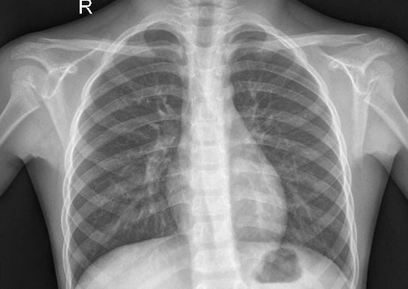

***Figure.3*** *Chest x-ray*Images with pneumonia caused by (**left**) = bacteria, (**right**) = virus

*Step 2: Image Resizing*

The size of the dataset images varies and needed to be normalized according to the VGG-16 standard. The abnormality in the distribution of size of the inputs needs to be removed. The standard input size of VGG-16 is 224x224. Hence, the x-ray images were resized to 224x224 using opencv2 library in python.

*Step 3: RGB to gray conversion*

RGB images are consists of red, green and blue color and consists of a 3D matrix. While grayscale images consist of only 2D matrix only. This reduces the computational time required by the neural network to recognize a pattern in the image. So, the x-ray images then converted to grayscale images using opencv2 library of python.

*Step 4: Build CNN Model*

The layers of CNN model are used to filter the features in the image and generate a feature map. Transfer learning approach has been used to develop the CNN model. The model can be breakdown into two models- base model and top model. VGG-16 is used as base model as it shows high accuracy with minimal hyper-parameters. Lesser number of hyper-parameters leaves more room for the list of candidate’s parametric value for each one of those. The top layers or output layer of the VGG-16 is being replaced with a custom CNN which acts as a top model or output model, The top model comprises of one AveragePooling2D, one flattens, one dropout and two dense layers. Here transfer learning serves as the backbone for this architectural design of the convolutional neural network.

*Step 5: Hyper-parameter tuning*

Manual hyper-parameter tunning takes place. Random set of collection of hyper-parameters were created and the performance for each set has been recorded. And the most optimized hyper-parameter set has been chosen for the training purpose.

*Step 6: Train the CNN*

The CNN model is trained over training dataset with the hyper-parameters selected during hyper-parameter tuning. The dataset is divided into training and testing dataset, while training dataset consists of 80% and testing data consists of rest 20% of the total x-ray scans.

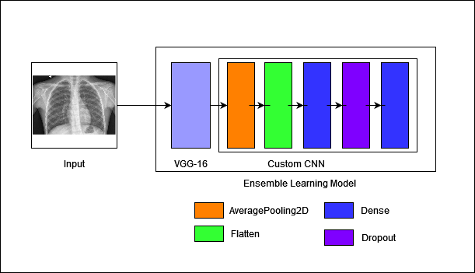

***Figure.3*** CNN Architecture

*Step 7: Test the CNN*

Test the model over testing dataset and store the model as .h5 with the help of pickle library in python.

*Step 8: Model Evaluation*

Evaluation of the purposed model takes place using accuracy and precision.

**Experimental result analysis**

**Model performance criteria**

The final model is evaluated on a set of classification metrices such as Accuracy and Precision.

*Accuracy* = $\frac{Tp+ Tn}{Tp+Tn+Fp+Fn}$

*Precision* = $\frac{Tp}{Tp + Fp}$

where $Tp$ = True Positive, $Fp$ = False Positive,

$Tn$ = True Negative, $Fn$ = False Negative

**Result analysis**

Machine used during the research comprises of 4GB RAM wit graphic card NVidia 740M and i7 4th generation chipset. ­­­The approximate time took to train the CNN is 20 minutes. The optimized CNN model gives the accuracy of 92% and precision of 86% and 89% for Bacterial and Viral scans respectively on the testing dataset. The result indicates that model can identify normal and bacterial scans more precisely as compared to the viral ones.

The set of hyper-parameters used during this research have been chosen manually for the employed CNN. The loss and precision of the optimized model are very low and high respectively. Hence, performance of the constructed model is efficient for detection of Pneumonia using chest x-ray and further classifying the cause as viral or bacterial.



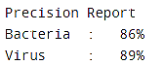

The proposed model identifies pneumonia in the chest x-ray scan on training dataset with better accuracy and precision as compare to testing dataset. The model has been trained over 5,863 images, whereas only 253 images were used in past paper [20].

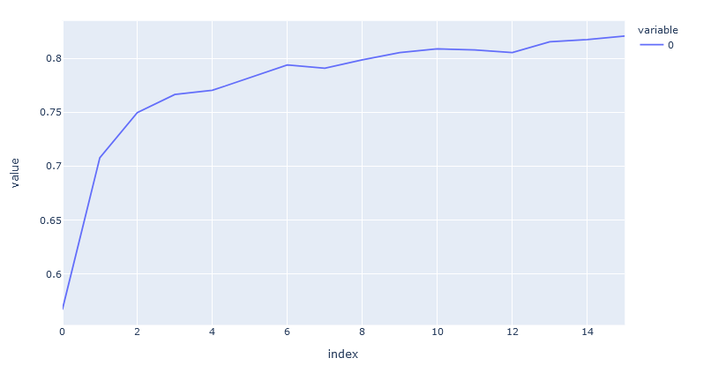

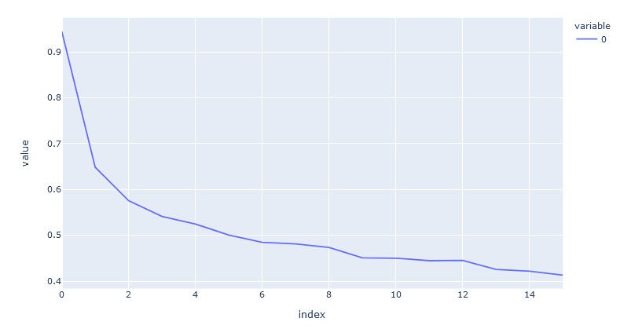

**Conclusion**

Recent development in the Image processing and machine learning has paved a path for automating the task of pneumonia detection and classification of the infectious agent. In this research, a cost-effective CNN has been built and transfer learning has been adopted to reduce the computational time. Proper image preprocessing has been implemented which includes the conversion of the images to grayscale and resized the image according to the input size of the transfer learning model used as the base model in this research i.e., VGG-16. The proposed model achieved accuracy of 92%.

In future, the research can be further expanded by including a greater number of hyper-parameters like training size, testing size, etc. Hyper-parameters tuning can be automated using any meta-heuristic function.

The data augmentation can also be improved by introducing a greater number of filters and choosing the best hyper-parameters to generate the augmented data. Various other optimization techniques and a comparative analysis of their performance is also a vast topic for the research. Further, new transfer learning models like VGG-19, MobileNet, etc. can be used as the based for the comparative analysis of their performance.

**References**

1. Kaur, Prabhpreet, Gurvinder Singh, and Parminder Kaur. "A review of denoising medical images using machine learning approaches." *Current medical imaging* 14.5 (2018): 675-685.
2. Rasmiranjan Mohakud, Rajashree Dash, Designing a grey wolf optimization based hyper-parameter optimized convolutional neural network classifier for skin cancer detection, Journal of King Saud University - Computer and Information Sciences, Volume 34, Issue 8, Part B, 2022, Pages 6280-6291, ISSN 1319-1578, https://doi.org/10.1016/j.jksuci.2021.05.012.(https://www.sciencedirect.com/science/article/pii/S1319157821001270)
3. Kumaran, Natarajan & Ayyasamy, Vadivel & Kumar, S.. (2018). Recognition of human actions using CNN-GWO: a novel modeling of CNN for enhancement of classification performance. Multimedia Tools and Applications. 77. 10.1007/s11042-017-5591-z.
4. Albashish, Dheeb, et al. "Deep CNN model based on VGG16 for breast cancer classification." *2021 International Conference on Information Technology (ICIT)*. IEEE, 2021.
5. Classification of Bacterial and Viral Childhood Pneumonia Using Deep Learning in Chest Radiography [ Xianghong Gu1 , Liyan Pan2 , Huiying Liang2 , Ran Yang]
6. N. Kumaran, A. Vadivel, and S. Saravana Kumar. 2018. Recognition of human actions using CNN-GWO: a novel modeling of CNN for enhancement of classification performance. Multimedia Tools Appl. 77, 18 (September 2018), 23115–23147. https://doi.org/10.1007/s11042-017-5591-z
7. Tammina, Srikanth. "Transfer learning using vgg-16 with deep convolutional neural network for classifying images." *International Journal of Scientific and Research Publications (IJSRP)* 9.10 (2019): 143-150.
8. Deep Learning on Chest X-ray Images to Detect and Evaluate Pneumonia Cases at the Era of COVID-19 [Karim Hammoudi1,2 · Halim Benhabiles3 · Mahmoud Melkemi1,2 · Fadi Dornaika4,5 · Ignacio Arganda-Carreras4,5,6 · Dominique Collard7,8 · Arnaud Scherpereel9]
9. Automated pneumonia detection on chest X-ray images: A deep learning approach with different optimizers and transfer learning architectures[ Adhiyaman Manickam a , Jianmin Jiang a , Yu Zhou a , Abhinav Sagar b , Rajkumar Soundrapandiyan c,* , R. Dinesh Jackson Samuel e]
10. Viral and Bacterial Pneumonia Detection using Artificial Intelligence in the Era of COVID-19 [Mehmet Ozsoz Near East University, Abdullahi Umar Ibrahim Near East University, Sertan Serte Near East University, Fadi Al-Turjman Near East University Polycarp Shizawaliyi Yakoi Cyprus International University]
11. Rasmiranjan Mohakud, Rajashree Dash, Designing a grey wolf optimization based hyper-parameter optimized convolutional neural network classifier for skin cancer detection, Journal of King Saud University - Computer and Information Sciences, Volume 34, Issue 8, Part B, 2022, Pages 6280-6291, ISSN 1319-1578, <https://doi.org/10.1016/j.jksuci.2021.05.012.(https://www.sciencedirect.com/science/article/pii/S1319157821001270)>
12. Litjens, G., Kooi, T., Bejnordi, B. E., Setio, A. A. A., Ciompi, F., Ghafoorian, M., van der Laak, J. A. W. M., van Ginneken, B., & Sánchez, C. I. (2017). A survey on deep learning in medical image analysis. *Medical image analysis*, *42*, 60–88. <https://doi.org/10.1016/j.media.2017.07.005>
13. T. Kumar Das, P. Kumar Roy, M. Uddin, K. Srinivasan, C. Chang *et al.*, "Early tumor diagnosis in brain mr images via deep convolutional neural network model," *Computers, Materials & Continua*, vol. 68, no.2, pp. 2413–2429, 2021.
14. Litjens, G., Sánchez, C. I., Timofeeva, N., Hermsen, M., Nagtegaal, I., Kovacs, I., Hulsbergen-van de Kaa, C., Bult, P., van Ginneken, B., & van der Laak, J. (2016). Deep learning as a tool for increased accuracy and efficiency of histopathological diagnosis. *Scientific reports*, *6*, 26286. https://doi.org/10.1038/srep26286
15. Ribani, Ricardo, and Mauricio Marengoni. "A survey of transfer learning for convolutional neural networks." *2019 32nd SIBGRAPI conference on graphics, patterns and images tutorials (SIBGRAPI-T)*. IEEE, 2019.
16. Pereira, Sérgio, et al. "Brain tumor segmentation using convolutional neural networks in MRI images." *IEEE transactions on medical imaging* 35.5 (2016): 1240-1251.
17. Bauer, Stefan, et al. "A survey of MRI-based medical image analysis for brain tumor studies." *Physics in Medicine & Biology* 58.13 (2013): R97.
18. Siar, Masoumeh, and Mohammad Teshnehlab. "Brain tumor detection using deep neural network and machine learning algorithm." *2019 9th international conference on computer and knowledge engineering (ICCKE)*. IEEE, 2019.
19. Two-stage deep learning architecture for pneumonia detection and its diagnosis in chest radiographs[ Barath Narayanan University of Dayton Venkata Salini Priyamvada Davuluru University of Dayton Russell C. Hardie University of Dayton]
20. Younis A, Qiang L, Nyatega CO, Adamu MJ, Kawuwa HB. Brain Tumor Analysis Using Deep Learning and VGG-16 Ensembling Learning Approaches. *Applied Sciences*. 2022; 12(14):7282. <https://doi.org/10.3390/app12147282>