

**SET5001 - SCIENCE, ENGINEERING AND TECHNOLOGY PROJECT - II**

***TITLE***

**CONVOLUTIONAL NEURAL NETWORK TO DETECT DISTINCT TYPE OF PNEUMONIA**

***Done by,***

22MCA0137- KANISHK SHARMA

22MCA0174 - UDDASHAY KUMAR GUPTA

22MCA0343 - INDRANIL SARKAR

***Under The Guidance Of***

PROF. JAGDEESAN S.

**Abstract:** Pneumonia is an infectious disease which affects one or both lungs. Pneumonia can be caused by bacteria as well as virus. The common practice to detect using CT scan or x-ray scans of chest. But it needs an expert eye to distinguish between different types of pneumonia. The disease spreads so rapidly, it needs to be detected earlier in remote areas. A recent boom in the development of Deep Convolutional Neural Network and its performance in classifying Medical Imaging suggests the task needs to be automated. In this research ResNet-50 has been employed as feature-extractor for the experiment and proposed a novel Deep Convolutional Neural Network as classifier to detect if the patient has pneumonia and further classify if it is caused by bacteria or virus. The dataset is divided into three directories, on the basis of the cause of the disease- Normal, Bacteria, Virus. The performance metrics for the evaluation of the proposed model consists of Specificity and Sensitivity.

**Keywords:** Pneumonia, Bacterial infection, virus infection, transfer learning

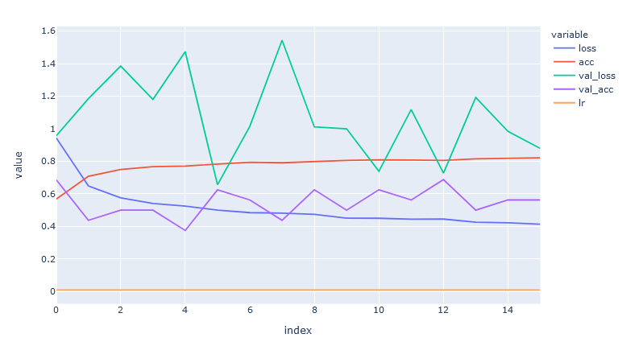

px.line(history.history['acc'])

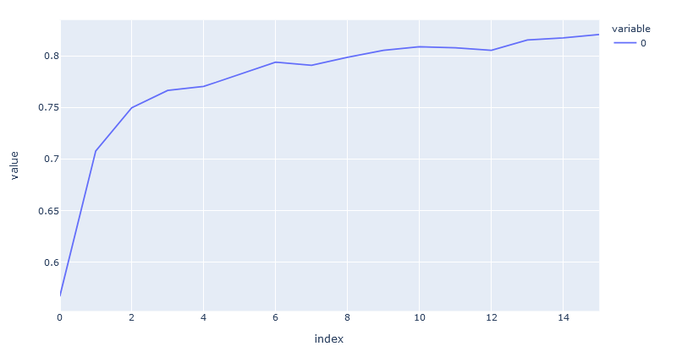

px.line(history.history['loss'])

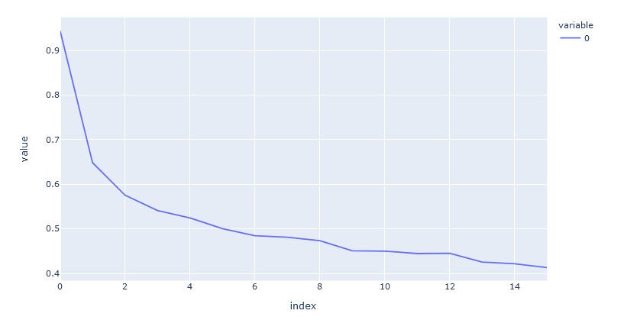

px.line(history.history['val_acc'])

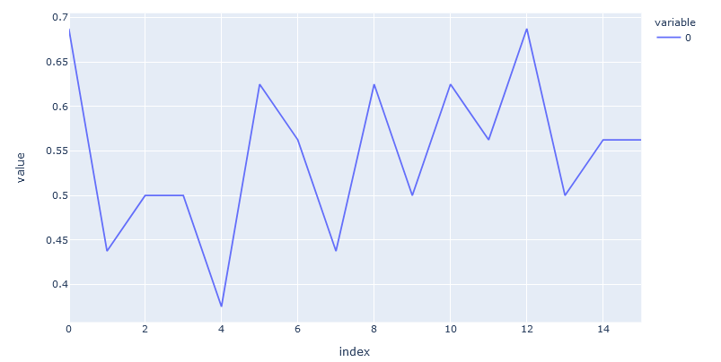

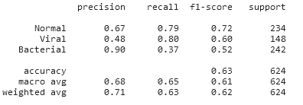

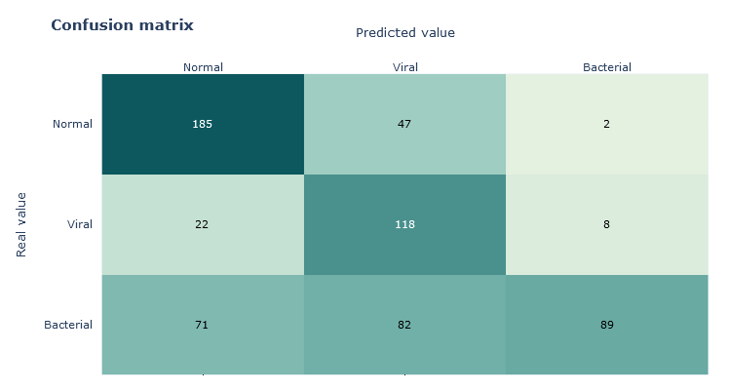

# Work Plan

|  |  |  |  |
| --- | --- | --- | --- |
| **TASK** | **DESC** | **START DATE** | **END DATE** |
| Module 1 | Abstract | 12-03-2023 | 17-03-2023 |
| Module 2 | Study on ResNet-50 & literature survey | 18-03-2023 | 28-03-2023 |
| Module 3 | Implementation of basic CNN architecture | 29-03-2023 | 10-04-2023 |
| Module 5 | Optimization (fine-tuning) and performance analysis | 10-05-2023 | 18-05-2023 |
| Module 8 | Conclusion and future enhancement | 19-05-2023 | 25-05-2023 |
| Module 9 | Uploading Final Draft of the Research Paper | 25-05-2023 | 26-05-2023 |