**Experiment Number: 03**

**TITLE**

SQL- DML (Insert, Update, Delete) and SELECT statement with WHERE clause and SQL operators.

**Aim:** Write suitable DML and select command to manipulate and retrieve requested data from tables.

**Objective:** To study

* DML (Insert, Update, Delete) commands,
* SQL Select- Logical, IN, Negation, NULL, Comparison Operators.
* Where Clause, Between AND, Exists, ALL, LIKE

**Problem Statement:**

Write the SQL commands to create a COMPANY database schema for the following relational schema:

* **EMP Table Fields**

**Column name Data type Description**

EMPNO Number Employee number

ENAME Varchar Employee name

JOB Char Designation

MGR Number Manager’s Emp. number

HIREDATE Date Date of joining

SAL Number Basic Salary

COMM Number Commission

DEPTNO Number Department Number

* **DEPT Table Fields**

**Column name Data type Description**

DEPTNO Number Department number

DNAME Varchar Department name

LOC Varchar Location of department

**Data for EMP Table**

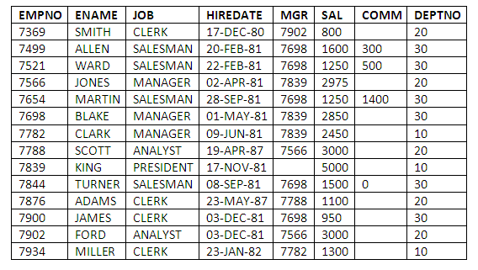

**Data for DEPT Table**

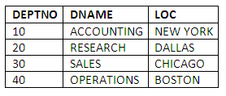

**Create above tables with appropriate constraints like primary key, foreign key and write following queries.**

1. List the employee names and his annual salary dept wise.
2. Find out at least 5 earners of the company.
3. List the records from emp whose deptno is not in dept
4. List those employees whose sal is odd value.
5. List the employees whose sal contain 3 digits.
6. List the employees who joined in the month of ‘DEC’
7. List the employees whose names contains ‘A’
8. List the maximum, minimum and average salary in the company.
9. Write a query to return the day of the week for any date(or HIRE_DATE) entered in format ‘DD-MM-YY’
10. Count the no of characters in employee name without considering spaces for each name.
11. List the employees who are drawing less than 1000. Sort the output by salary.
12. Write a query in SQL to display the unique designations for the employees.
13. Delete Employees who joined in Year 1980.
14. Increase the salary of Managers by 20% of their current salary.
15. List employees not belonging to department 30, 40, or 10.
16. List the different designations in the company.
17. List the names of employees who are not eligible for commission.
18. List employees whose names either start or end with “S”.
19. List employees whose names have letter “A” as second letter” in their names.
20. List the number of employees working with the company.

**Theory:**

* Explain SQL DML Commands.
* Explain SELECT query.
* Explain SQL Operators.

**Input:** Database

**Output:** Data as per request

**Platform:**

**Conclusion:** Thus, we have learned SQL DML commands, SELECT Command with SQL operators thoroughly.

**FAQs:**

1. What is the difference between Truncate table and Drop table command?
2. How is the pattern matching done in the SQL?
3. Write a DELETE command to delete all the records from CUSTOMERS table.