SIMATS ENGINEERING
ASSESSMENT TOOL 1
COURSE CODE: CSA04
COURSE NAME: Operating Systems

COURSE OUTCOME COVERED
CO1: Apply the concepts of Operating System types, structures, and system calls to demonstrate their functions in various computing environments.

QUESTIONS: 5 Total Marks:100
Annexure A
SHORT ANSWER TEST

Code of Conduct:
I Kanishk C / 192511278 (Name / Reg No) certify that this submission is my original work and that I have adhered to the guidelines specified for this assessment.
I understand that any violation of academic integrity rules will result in disciplinary action.
Signature of the student:

Short Answer Test

Question 1 (5 Marks)
Suppose a modern Operating System supports multiple users and processes with shared resources like CPU, memory, and I/O devices.

(a) Types of Operating Systems for this scenario
Operating Systems can be grouped by the way they handle jobs and users. The main types are listed below, along with how well each one fits a system where many users share the CPU, memory and I/O devices.
Type of OS | How it works | Suitable here?
Batch OS | Similar jobs are collected and run one after another with no user interaction. | No. Users cannot interact, and the CPU sits idle during I/O.
Multiprogramming OS | Keeps several jobs in memory. When one job waits for I/O, the CPU switches to another. | Yes. It keeps the CPU busy.
Time-sharing (multitasking) OS | The CPU time is cut into small slices and given to each user or process in turn. | Yes. Best match, every user feels the system is theirs.
Multi-user OS | Many users log in at the same time, each with their own account, files and permissions. | Yes. This is the core need of the scenario.
Multiprocessor OS | Uses more than one CPU to run processes in parallel. | Helpful, gives more speed.
Real-time OS | Guarantees a response within a fixed deadline. | Not needed, it is meant for control systems.
Distributed OS | Many computers work together and look like one system. | Not needed for a single machine.
Mobile / Embedded OS | Designed for phones and small devices with limited resources. | No. Not meant for multi-user sharing.

Choice and justification
For this scenario, the best choice is a multi-user, time-sharing OS with multiprogramming and multitasking support (examples: Linux, UNIX, Windows Server). My reasons are:
- Fair use of the CPU. The scheduler gives each process a small time slice (a quantum) using round robin or a similar method, so no single user can hog the processor.
- Better CPU utilisation. With many jobs in memory, the CPU always has some process to run while others wait for I/O.
- Quick response. Each user gets a reply within a short time, which is important for interactive work such as editing or compiling.
- Protection between users. User accounts, file permissions and separate address spaces stop one user from damaging another user’s data.
- Sharing of devices. Printers, disks and other devices are shared in a controlled way using queues and spooling.

(b) Structure of the Operating System and resource management
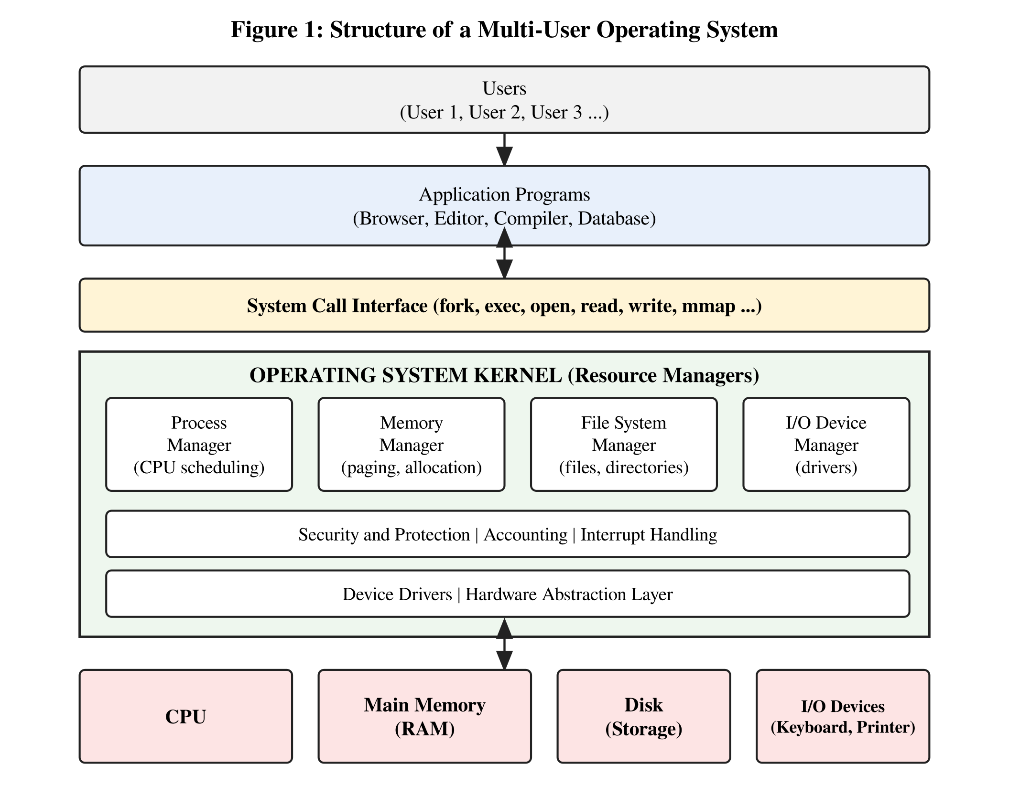
The figure shows the OS sitting between the users and the hardware. Users work through application programs. Whenever a program needs something from the system, it makes a system call. The call goes into the kernel, where four main managers handle the shared resources:
- Process manager: creates and ends processes, decides which one gets the CPU next, and handles switching between them.
- Memory manager: gives every process its own area of memory, keeps track of what is free or used, and uses paging and virtual memory when RAM is not enough.
- File system manager: stores files and directories on the disk and checks the access permissions.
- I/O device manager: talks to the hardware through device drivers and handles buffering, queues and interrupts.
Security, accounting and interrupt handling support all four managers. The device drivers and the hardware abstraction layer sit at the bottom, so the upper layers do not need to know the details of the hardware.

Question 2 (5 Marks)
Consider an Operating System managing multiple files and devices for concurrent users.

(a) Categories of system calls for file and device management
System calls are the doorway through which a program asks the OS for a service. For files and devices, they can be grouped as follows.
File management system calls
System call | Purpose
create() / open() | Create a new file or open an existing one. Returns a file descriptor.
read() | Read data from an open file into a buffer.
write() | Write data from a buffer into an open file.
lseek() | Move the read/write position inside a file (reposition).
close() | Close the file and free the descriptor.
unlink() / delete | Remove a file from the directory.
stat() / chmod() | Get or change file attributes such as size, owner and permissions.

Device management system calls
System call | Purpose
request device / open() | Ask the OS for a device (for example a printer or a USB port) before using it.
read() | Read data from the device.
write() | Send data to the device.
ioctl() | Get or set device settings such as baud rate or volume.
release device / close() | Give the device back so another process can use it.
attach / detach | Logically attach or detach devices.

In UNIX and Linux, devices are treated like files (for example /dev/sda or /dev/tty), so the same calls open, read, write and close work for both. The other categories of system calls are process control, information maintenance and communication, but they are not the focus here.

(b) Handling file operations with a layered structure
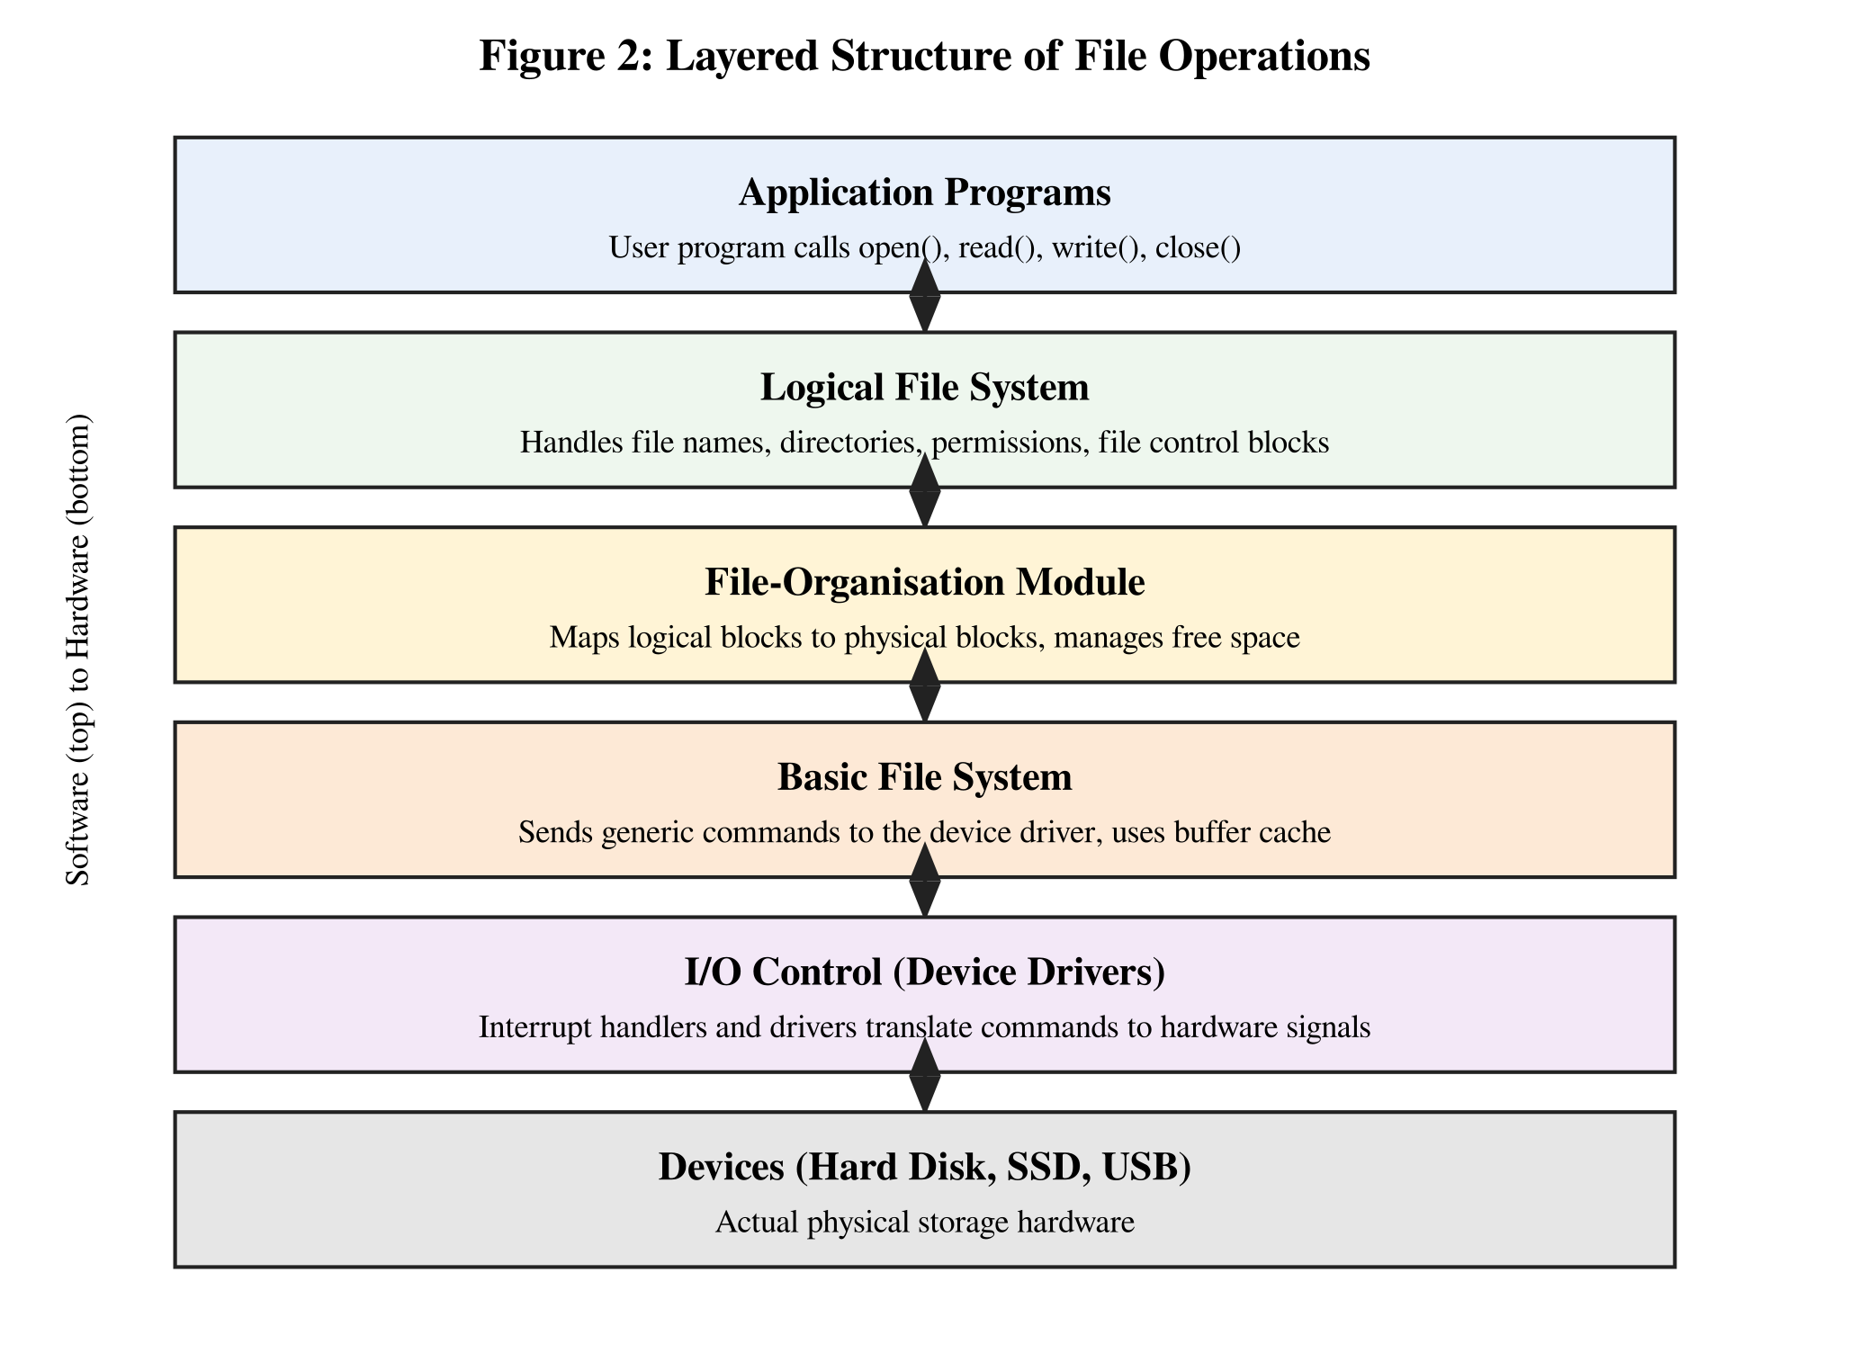
The OS divides file handling into layers. Each layer uses the services of the layer below it and gives services to the layer above it. This makes the design easier to understand, test and change.
- Application programs start the work by calling open(), read(), write() or close().
- Logical file system works with file names and directories. It finds the file control block (inode), checks the permissions and keeps the file information.
- File-organisation module knows about logical blocks and physical blocks. It converts "block 5 of this file" into an actual disk block number and manages free space.
- Basic file system issues generic read and write commands to the right device driver and uses the buffer cache to avoid repeated disk access.
- I/O control layer contains the device drivers and interrupt handlers. They turn the commands into the exact signals the hardware understands.
- Devices are the real hard disk, SSD or USB drive.
For example, when a user program calls read(), the request moves down through all layers to the disk, and the data comes back up the same way to the user’s buffer.

Question 3 (5 Marks)
Assume a real-time Operating System used in an embedded system controlling industrial machinery.

(a) Type of OS and why it suits real-time applications
The OS needed here is a Real-Time Operating System (RTOS), and for machinery that can cause injury or damage it should be a hard real-time OS. Examples are VxWorks, QNX, FreeRTOS and RTLinux. In a hard real-time system, missing a deadline is counted as a system failure. In a soft real-time system (like video streaming) a missed deadline only reduces quality.
It is suitable for real-time work because:
- Predictable timing. Tasks finish within a known and guaranteed time. This is called determinism.
- Priority-based pre-emptive scheduling. A high-priority task, such as an emergency stop, can interrupt a low-priority task at once.
- Very low interrupt latency. The system reacts to a sensor signal in microseconds.
- Small size. The kernel is tiny and fits in the limited memory of an embedded controller.
- High reliability. It has no heavy features like a big GUI that could cause delays or crashes, and it can run for years without a restart.
- Good inter-task tools. Semaphores, message queues and timers are built in to keep the tasks in order.

(b) Interaction between hardware, kernel and user processes
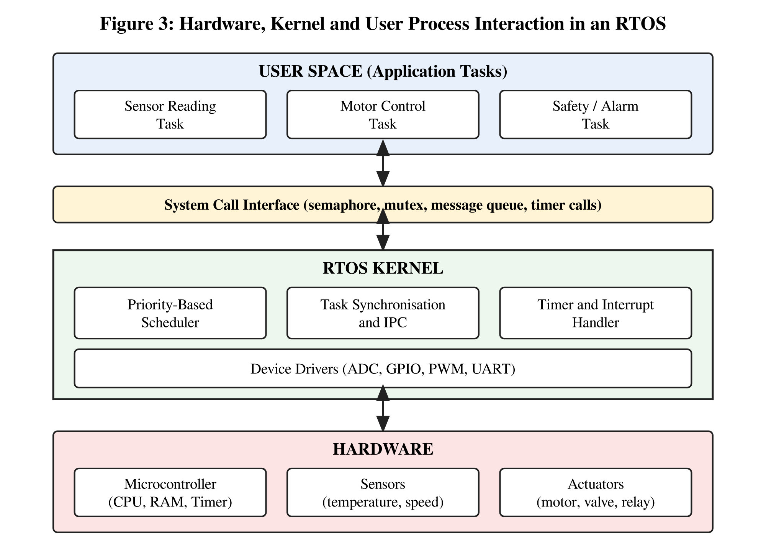
At the top are the user tasks such as sensor reading, motor control and the safety alarm. They do not touch the hardware directly. Instead they call the RTOS through the system call interface. The kernel scheduler picks the highest-priority ready task, the synchronisation module keeps the tasks from clashing, and the timer and interrupt handler deal with events from outside. The device drivers pass the commands to the hardware. Sensors send readings up through the same path, and actuators such as motors and valves receive the control commands coming down. The whole loop is repeated at fixed time intervals.

(c) System calls for process synchronisation
When several tasks use the same data or machine part (for example, a shared counter of finished parts), they must be synchronised so that only one task is in the critical section at a time. The common calls are given below. (On a real RTOS, the names differ a little, for example semTake and semGive in VxWorks or xSemaphoreTake and xSemaphoreGive in FreeRTOS, but the idea is the same.)
Call | Explanation
sem_init() | Creates a semaphore and gives it a starting value. A value of 1 makes a binary semaphore that works like a lock.
sem_wait() | The "wait" or P operation. It decreases the value. If the value is already 0, the task blocks until another task releases it.
sem_post() | The "signal" or V operation. It increases the value and wakes up one waiting task.
sem_destroy() | Deletes the semaphore when it is no longer needed.
pthread_mutex_lock() / unlock() | A mutex allows only the owner to unlock it. Many RTOS mutexes also support priority inheritance to avoid priority inversion.
pthread_cond_wait() / signal() | A task waits for a condition (like "sensor data ready") and another task signals it.
mq_send() / mq_receive() | Message queues let a task pass data to another task and wait for it in an orderly way.

Question 4 (5 Marks)
A distributed computing system consists of multiple interconnected computers sharing resources over a network.

(a) Type of OS and comparison with a centralized OS
The OS used in this system is a Distributed Operating System. It controls a group of independent computers (called nodes) and makes them look like one single computer to the user. The user does not need to know on which node a file is stored or on which node a program is running. This is called transparency. (A network OS is different, because there the user knows about the separate machines and logs in to each one.)
Point | Centralized OS | Distributed OS
Number of computers | One single computer controls everything. | Many computers connected by a network.
Control | One central kernel makes all decisions. | Control is shared among the nodes.
Resources | CPU, memory and disk are in one place. | Resources are spread over many nodes and shared.
Communication | Through local memory, very fast. | Through messages over the network, slower.
Failure | If the machine fails, the whole system stops. | If one node fails, the others keep working (fault tolerance).
Scalability | Hard to grow, need to buy a bigger machine. | Easy to grow by adding more nodes.
Speed | Limited by one CPU. | Tasks run in parallel on many CPUs.
Complexity and cost | Simple and cheap to manage. | More complex, needs network security and synchronisation.
Examples | Early UNIX, MS-DOS, single-server Linux. | Amoeba, LOCUS, Plan 9, cluster systems.

(b) Architecture of a distributed OS
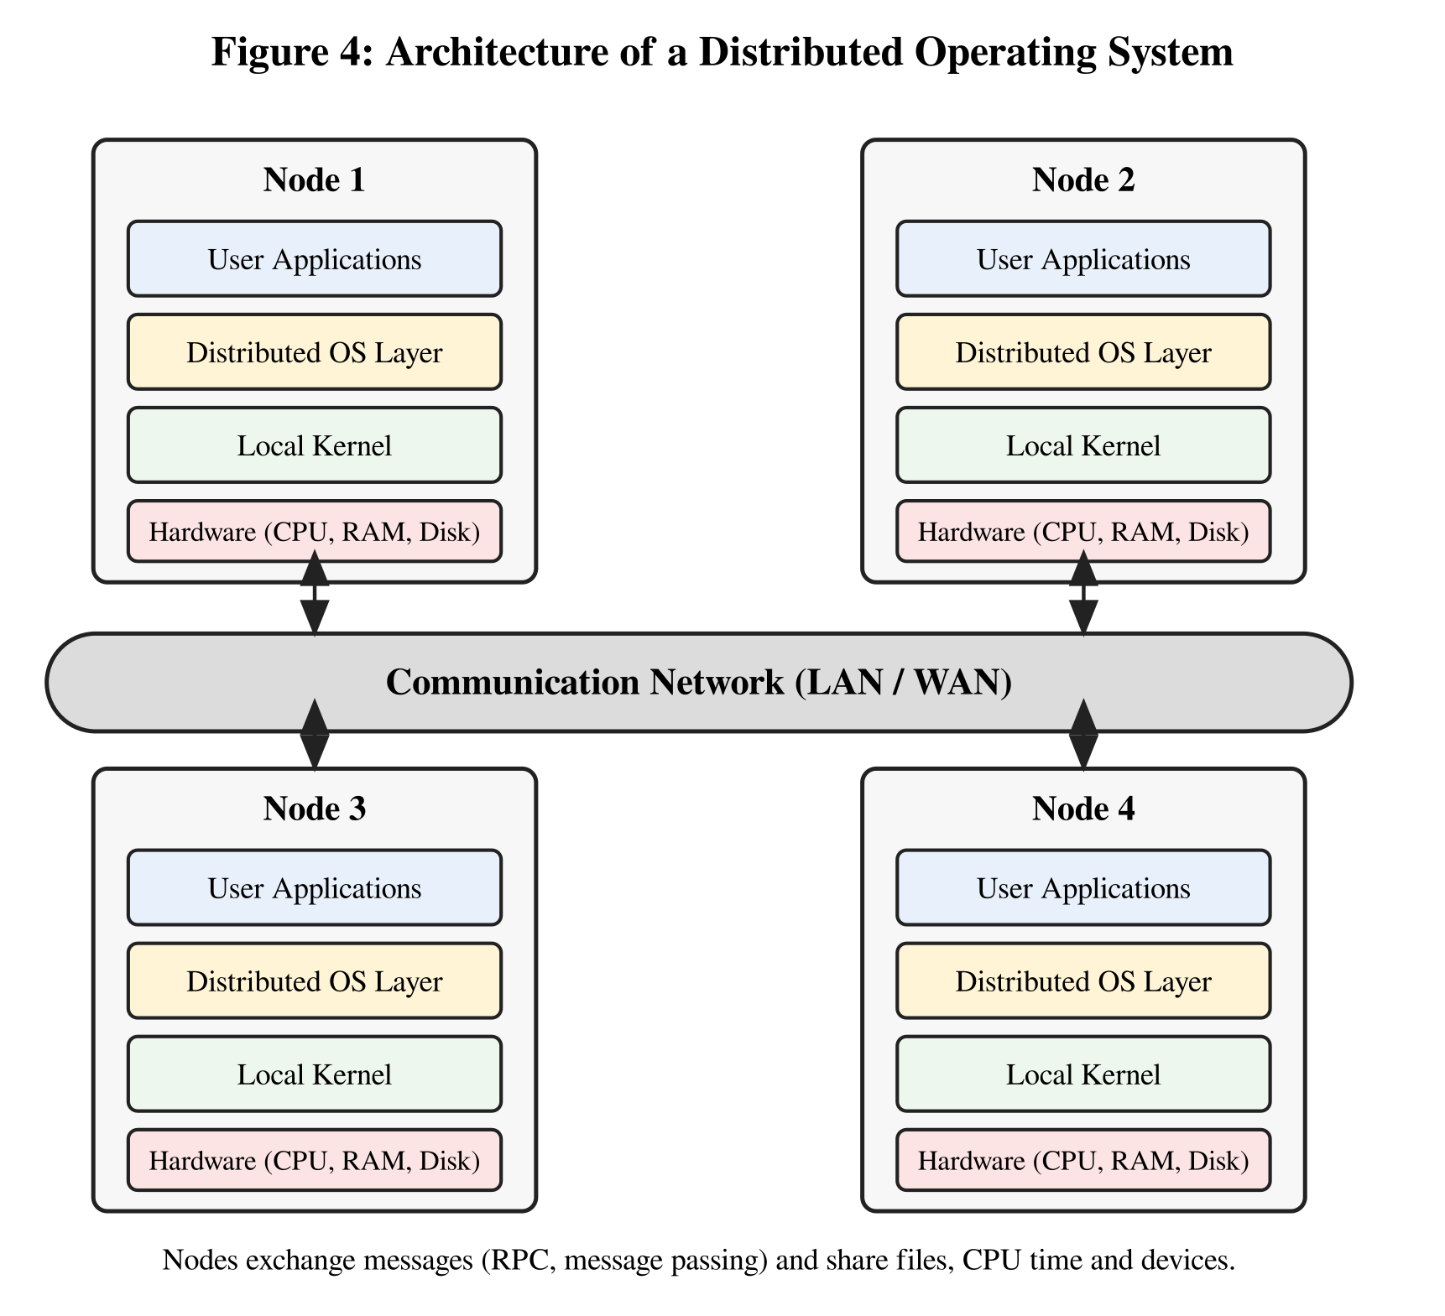
In this architecture, every node has its own hardware and its own local kernel. On top of the kernel, a distributed OS layer (middleware) is placed. This layer takes care of process migration, distributed file access, naming, clock synchronisation and message passing. All nodes are linked by a communication network. When an application on Node 1 needs a file stored on Node 3, the distributed OS layer sends a request message through the network, Node 3 replies with the data, and the application never notices that the file was remote.

(c) System calls involved in inter-process communication (IPC)
IPC lets processes exchange data. On a single machine we can use pipes, shared memory or message queues. Between different nodes of a distributed system, sockets or remote procedure calls (RPC) are used. The sequences are given below.

Question 5 (5 Marks)
Consider a scenario where an Operating System must manage process scheduling, memory allocation, and device communication efficiently.

(a) Major functions of an OS in handling these tasks
Process scheduling (process management)
- Creates and terminates processes and keeps track of their states (new, ready, running, waiting, terminated) using the Process Control Block.
- Uses a scheduling algorithm such as FCFS, SJF, Round Robin or Priority scheduling to decide which process runs next, so that the CPU stays busy and the waiting time is low.
- Performs context switching, and provides synchronisation and communication between processes. It also detects and handles deadlocks.
Memory allocation (memory management)
- Keeps track of which parts of memory are used and which are free.
- Allocates memory when a process starts and takes it back when the process ends, using methods like paging, segmentation or contiguous allocation (first fit, best fit, worst fit).
- Uses virtual memory and swapping, so programs larger than the RAM can still run, and protects each process from accessing another’s memory.
Device communication (I/O management)
- Hides the hardware details with device drivers, so programs use simple read and write calls.
- Uses buffering, caching and spooling to match the speed of fast CPU and slow devices, and keeps request queues for devices like the disk and printer.
- Handles interrupts, which are signals from devices to say that an operation is complete, and gives devices to the processes in a safe order.
Along with these, the OS also takes care of file management and of security and protection, which help the main tasks work smoothly.

(b) Block diagram of OS components and their interactions
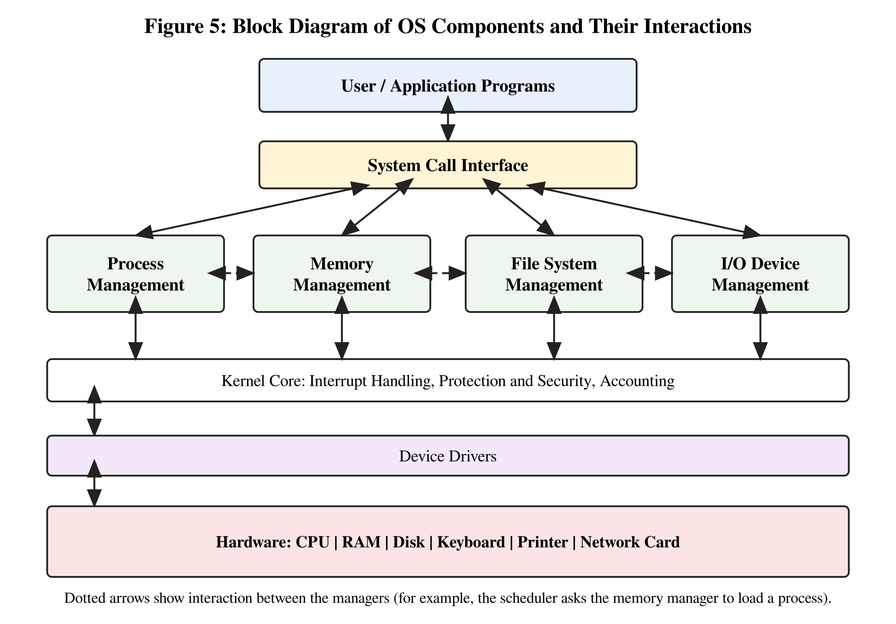
User programs request services through the system call interface. The request is passed to the right manager. The process manager asks the memory manager for space when it loads a process. The memory manager may ask the file system manager to bring a page from the disk (virtual memory). The file system and the memory manager both need the I/O device manager to reach the disk. At the base, the kernel core handles interrupts and protection, and the device drivers pass commands to the hardware.

Rubrics for Calculation
Criteria | Weightage (Marks) | Level 4 – Exemplary (Full Marks) | Level 3 – Proficient | Level 2 – Developing | Level 1 – Beginning
Conceptual Understanding | 35 | Demonstrates clear, complete, and in-depth understanding of OS concepts (types, structure, system calls) | Good understanding with minor gaps | Basic understanding with some misconceptions | Poor or incorrect understanding
Accuracy of Answers | 25 | All answers are correct, precise, and relevant | Mostly correct with minor errors | Partially correct with noticeable errors | Mostly incorrect or irrelevant
Application of Knowledge | 15 | Effectively applies concepts to scenarios / questions | Applies with minor mistakes | Limited or partial application | No meaningful application
Completeness of Response | 15 | All parts of each question are fully answered | Most parts covered with small omissions | Some parts missing | Incomplete answers
Clarity & Presentation | 10 | Clear, well-structured, and neatly presented answers | Understandable with minor issues | Somewhat unclear or poorly structured | Difficult to understand

