SIMATS ENGINEERING
ASSESSMENT TOOL 1
COURSE NAME: OBJECT ORIENTED ANALYSIS AND DESIGN
COURSE CODE: CSA1102
COURSE OUTCOME COVERED
CO2: Design UML diagrams to represent system requirements and architecture. (BL3)
Assessment Tool Weightage: 40%
QUESTIONS: Any 4 Total Marks: 40
Annexure A
ANALYTICAL PROBLEM SOLVING
Code of Conduct:
I Kanishk C (Reg. No. 192511278) certify that this submission is my original work and that I have adhered to the guidelines specified for this assessment.
I understand that any violation of academic integrity rules will result in disciplinary action.
Signature of the student: Kanishk C

Question 1: Use Case Diagram Problem
A Hospital Management System allows patients to book appointments, doctors to update medical records, and administrators to manage hospital resources. The requirements are not clearly documented.
a) Identify all actors involved in the system
- Patient – the person who wants to book an appointment, make payments and check his/her own medical records.
- Doctor – the medical staff member who checks patients, updates medical records and views appointment details.
- Administrator – the staff member who manages hospital resources such as rooms, staff duty and billing reports.
- Hospital User (abstract actor) – a general actor that represents the common behaviour shared by Patient and Doctor, such as logging in to the system. Both Patient and Doctor are specialised forms of this actor, so a generalisation relationship is used between them.
b) List the primary use cases
- Login / Authenticate
- Book Appointment
- Cancel Appointment
- Make Payment (with two specialised forms – Online Payment and Cash Payment)
- View Medical Records
- Update Medical Records
- Manage Hospital Resources
- Generate Reports
c) Define relationships (include, extend, generalization)
- Include: "Book Appointment" includes "Login/Authenticate", because a patient must always be logged in before an appointment can be booked. In the same way, "Update Medical Records" includes "Login/Authenticate" and "Make Payment" includes "Book Appointment" since payment only happens after an appointment is created.
- Extend: "Cancel Appointment" extends "Book Appointment" because cancelling is an optional step that only happens sometimes, not every time an appointment is booked. In the same way, "Generate Reports" extends "Manage Hospital Resources" as an optional additional action for the administrator.
- Generalization: "Online Payment" and "Cash Payment" are specialised versions of "Make Payment". Also, "Patient" and "Doctor" both generalise from the abstract actor "Hospital User" since they share the login behaviour.
d) Construct a complete Use Case Diagram representing system functionality
The diagram below shows the Hospital Management System boundary with the three main actors on the outside, all identified use cases inside the boundary, and the include, extend and generalisation relationships explained above.
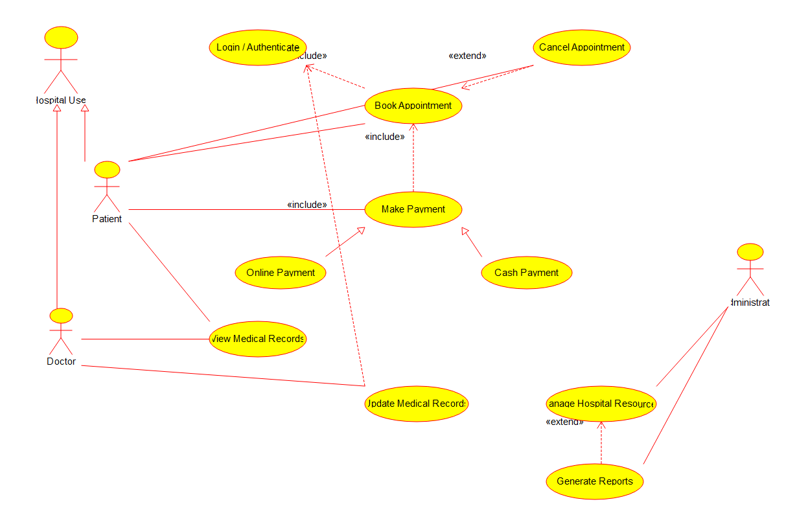
Figure 1: Use Case Diagram – Hospital Management System

Question 2: Class Diagram Problem
A Library Management System contains entities such as Book, Member, Librarian, and IssueRecord. The relationships among entities are not properly defined.
a) Identify classes with attributes and methods
- Person (abstract superclass): name, address, contactNumber; method: getDetails().
- Member (inherits Person): memberId, email, membershipType; methods: register(), searchBook(), viewHistory().
- Librarian (inherits Person): staffId, designation; methods: issueBook(), returnBook(), addBook().
- Library: libraryName, location; methods: addBook(), removeBook().
- Book: bookId, title, author, isbn, status; methods: checkAvailability(), updateStatus().
- IssueRecord: recordId, issueDate, dueDate, returnDate, fineAmount; methods: calculateFine(), closeRecord().
b) Define relationships (association, aggregation, inheritance)
- Inheritance (Generalization): Member and Librarian both inherit common attributes and behaviour from the abstract class Person, since both are people who use the library in different roles.
- Aggregation: Library aggregates Book. A library "has" many books, but a Book object can conceptually exist in a catalogue even without being tied permanently to one physical library instance, so this is a weaker "whole-part" relationship shown with a hollow diamond at the Library end.
- Association: Member is associated with IssueRecord (a member creates issue records when borrowing books), Book is associated with IssueRecord (each record refers to one book), and Librarian is associated with IssueRecord (a librarian processes each issue/return transaction).
c) Specify multiplicity between classes
- Library (1) — Book (0..*): one library holds zero or many books.
- Member (1) — IssueRecord (0..*): one member can have zero or many issue records over time.
- Book (1) — IssueRecord (0..*): one book can appear in zero or many issue records across different time periods.
- Librarian (1) — IssueRecord (0..*): one librarian can process zero or many issue records.
d) Design a detailed Class Diagram for the system
The class diagram below shows all six classes with their three compartments (name, attributes, methods), the inheritance arrows from Person, the aggregation between Library and Book, and the three associations connecting Member, Book and Librarian to IssueRecord, each labelled with correct multiplicity.
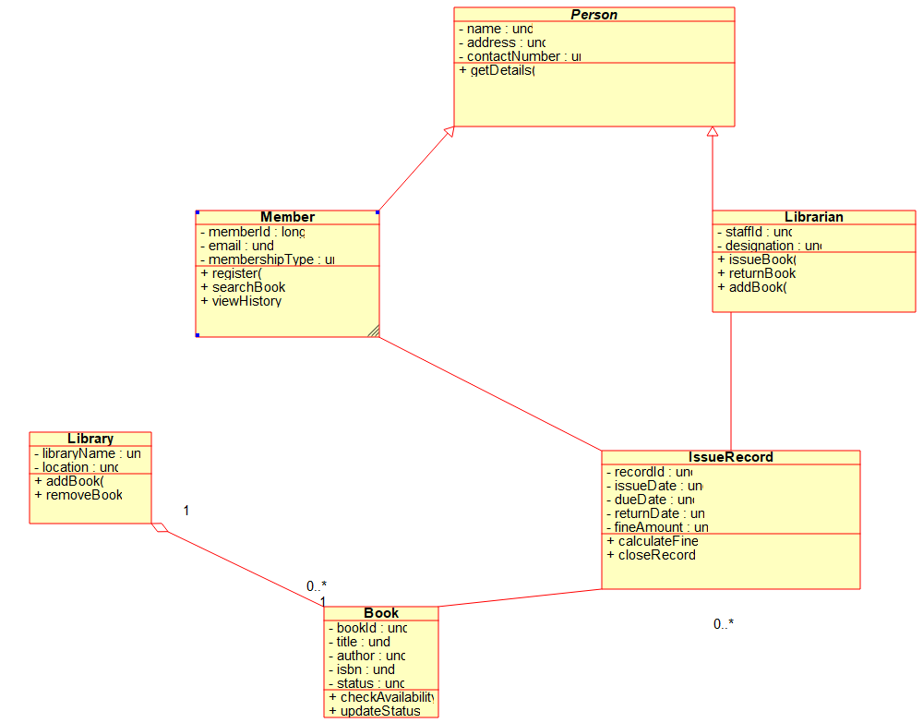
Figure 2: Class Diagram – Library Management System

Question 3: Sequence Diagram Problem
In an Online Food Ordering System, a customer selects food items, places an order, makes payment, and receives order confirmation. The interaction flow is unclear.
a) Identify objects involved in the process
- Customer (actor) – the person using the mobile/web application.
- :FoodApp UI – the front-end screen the customer interacts with.
- :OrderManager – the back-end object that creates and validates the order.
- :PaymentGateway – the object that handles payment collection and confirmation.
- :Restaurant – the object representing the restaurant/kitchen system that prepares the food.
b) Define message flow between objects
The customer first browses the menu through the FoodApp UI, which asks the OrderManager to create an order once items are selected. The OrderManager validates the order and requests payment from the PaymentGateway. After the customer submits payment details and the PaymentGateway confirms the payment, the OrderManager forwards the order to the Restaurant object, which acknowledges it. Finally, a confirmation message travels back through the OrderManager and the UI to the customer.
c) Represent activation and lifelines
Each object has a vertical dashed lifeline running down the diagram, and a rectangular activation bar is drawn on the lifeline for the duration that the object is actively processing a message (for example, the FoodApp UI stays active for the whole conversation, while PaymentGateway is active only while it is validating and confirming the payment).
d) Construct a Sequence Diagram showing complete interaction flow
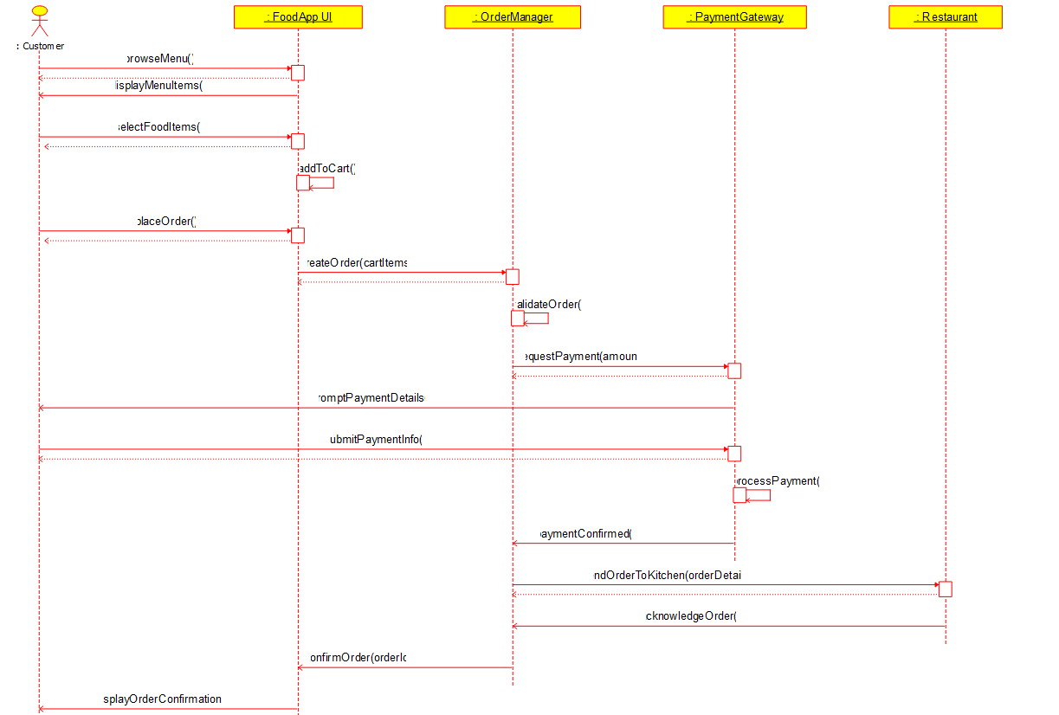
Figure 3: Sequence Diagram – Online Food Ordering System

Question 4: Activity Diagram Problem
A Student Admission System includes application submission, document verification, fee payment, and enrollment confirmation. The workflow lacks proper decision-making steps.
a) Identify all activities in the workflow
- Submit Application Form, Upload Required Documents, Verify Documents, Application Shortlisted, Pay Application Fee, Attend Entrance/Interview, Approve Admission, Pay Course Fee, Confirm Enrollment, and Issue Admission Letter/ID Card.
b) Add decision nodes for approval/rejection
Two decision (diamond) nodes are used. The first one checks "Documents Valid?" right after document verification — if the answer is No, the application is rejected immediately; if Yes, the process continues. The second decision node checks "Fee Paid and Interview Cleared?" after the parallel fee-payment and interview steps are finished — again, a No leads to rejection, while a Yes lets the student move forward to final admission approval.
c) Include parallel processing where applicable
After the application is shortlisted, the workflow forks into two activities that can happen at the same time: paying the application fee and attending the entrance test/interview. These two branches run independently of one another, and a join bar brings them back together before the system checks whether both conditions are satisfied.
d) Design an optimised Activity Diagram
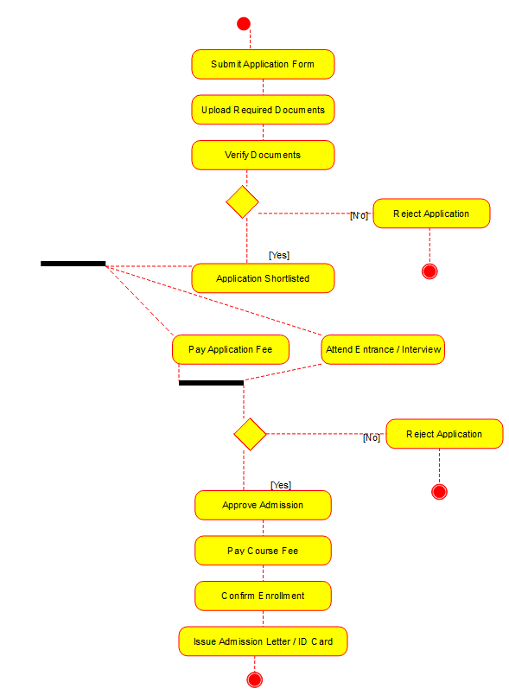
Figure 4: Activity Diagram – Student Admission System

Question 5: State Diagram Problem
A Vending Machine System operates through states such as Idle, Product Selected, Payment Received, Product Dispensed, and Transaction Completed.
a) Identify all possible states
- Idle, Product Selected, Payment Received, Product Dispensed, Transaction Completed, and Powered Off (the final state reached only when the machine is shut down by an administrator).
b) Define events triggering transitions
- selectProduct(code) moves the machine from Idle to Product Selected.
- insertCoin() moves it from Product Selected to Payment Received, and can repeat as a self-transition on Payment Received while the amount inserted is still less than the price.
- Once the amount inserted is greater than or equal to the price, the system automatically calls dispenseProduct() and moves to Product Dispensed.
- If the customer cancels or a timeout occurs while in Payment Received, refund() is triggered and the machine returns to Idle.
- collectProduct() moves the machine from Product Dispensed to Transaction Completed, after which an automatic reset() event brings it back to Idle for the next customer.
c) Include initial and final states
A filled black circle marks the initial pseudostate, which leads straight into the Idle state when the machine first starts up. A final state (shown as a circle with a ring around it) is included to represent the machine being powered off by an administrator through the adminShutdown() event, which can only happen from the Idle state.
d) Construct a State Transition Diagram representing system behaviour
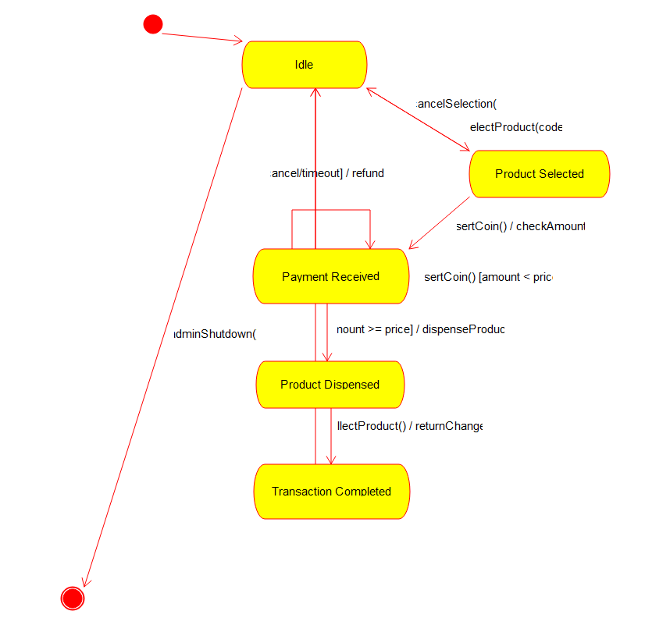
Figure 5: State Transition Diagram – Vending Machine System

Question 6: Component Diagram Problem
An Online Learning Platform consists of modules such as User Management, Course Management, Assessment Module, Content Delivery Module, and Notification Service.
a) Identify major system components
- User Management, Course Management, Assessment Module, Content Delivery Module, and Notification Service.
b) Define interfaces between components
- IUserAuth – provided by User Management, used by Course Management and Assessment Module to verify who is logged in.
- ICourseData – provided by Course Management, used by Assessment Module and Content Delivery Module to fetch course and syllabus information.
- IContentStream – provided by Content Delivery Module, used by Assessment Module to load learning material during a test.
- INotify – provided by Notification Service, used by User Management, Course Management and Assessment Module to send alerts and reminders.
c) Show dependencies among modules
Course Management and Assessment Module depend on User Management for authentication. Assessment Module and Content Delivery Module depend on Course Management for course data. Assessment Module also depends on Content Delivery Module to stream content, and three of the modules depend on Notification Service to send out alerts, as shown by the dashed dependency arrows in the diagram.
d) Construct a Component Diagram representing system architecture
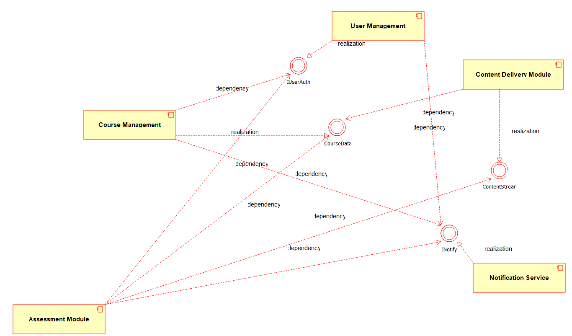
Figure 6: Component Diagram – Online Learning Platform

Question 7: Deployment Diagram Problem
A Smart Traffic Monitoring System uses roadside sensors to collect vehicle data. The data is transmitted to a central cloud server where traffic authorities monitor congestion through a web dashboard. Alerts are generated during traffic violations and accidents.
a) Identify all hardware nodes involved in the system
- Roadside Sensor Unit (a device that includes the physical sensors and camera placed on the road).
- Central Cloud Server (the main processing node in the cloud).
- Database Server (stores all traffic data collected over time).
- Traffic Authority Workstation (a device used by staff at the monitoring office).
b) Specify software components deployed on each node
- Roadside Sensor Unit runs the SensorDataCollector.exe program and the GPS/Camera Module that capture vehicle movement.
- Central Cloud Server runs TrafficAnalytics.exe, which processes incoming data, and AlertGenerator.exe, which raises alerts for violations or accidents.
- Database Server hosts the TrafficDB (SQL) database that stores all historical and live traffic records.
- Traffic Authority Workstation runs the WebDashboardClient, a browser-based dashboard used by traffic officials.
c) Define communication links between nodes
- The Roadside Sensor Unit connects to the Central Cloud Server using a wireless 4G/5G link to upload data continuously.
- The Central Cloud Server connects to the Database Server through a TCP/IP link to store and retrieve traffic records.
- The Central Cloud Server connects to the Traffic Authority Workstation through an HTTPS link, so the dashboard can be viewed securely over the internet.
d) Construct a complete Deployment Diagram representing the system architecture
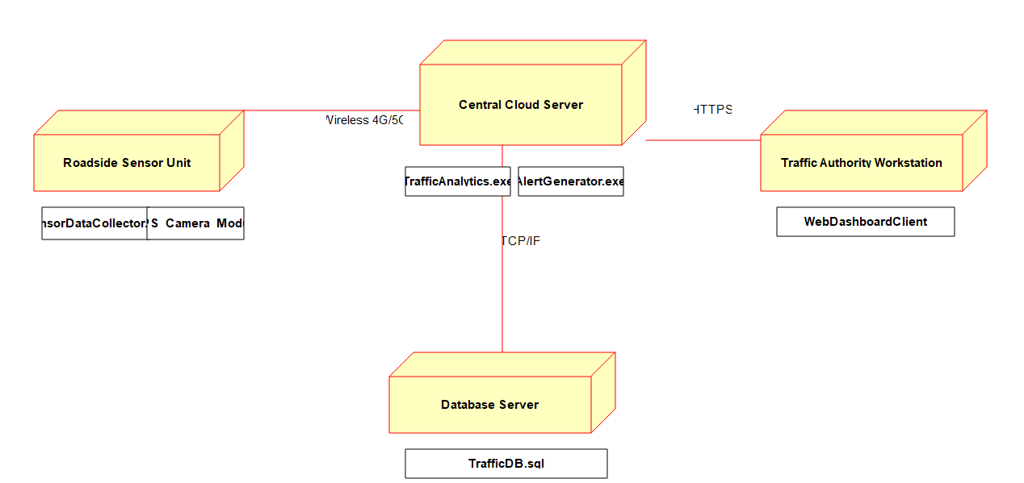
Figure 7: Deployment Diagram – Smart Traffic Monitoring System

