SIMATS ENGINEERING
ASSESSMENT TOOL 2
COURSE NAME: OBJECT ORIENTED ANALYSIS AND DESIGN
COURSE CODE: CSA1102

COURSE OUTCOME COVERED
CO2: Design UML diagrams to represent system requirements and architecture.
(BL3)
Assessment Tool Weightage: 60%

QUESTIONS: 6 | Total Marks: 60

Annexure A
Application Based Questions

Code of Conduct:
I Kanishk C / 192511278 (Name / Reg No) certify that this submission is my original work
and that I have adhered to the guidelines specified for this assessment.
I understand that any violation of academic integrity rules will result in disciplinary action.
Signature of the student: Kanishk C

Annexure A
Application Based Questions
1. Use Case Diagram Analysis
A Smart Hotel Reservation System allows guests to search rooms, make reservations, cancel bookings, and process payments. Managers handle room allocation and reports, while payment services process transactions. Analyze the system requirements, identify missing actors and use cases, and design an optimized Use Case Diagram showing proper relationships (include, extend, generalization) for better system clarity. (10 Marks)
The problem statement only mentions a guest, a manager and the payment service, but when we look closely at the flow, a few more roles come into the picture. A normal guest can search rooms and book them, but many hotels also deal with corporate guests who get special discounted rates and different billing rules. So it makes sense to add a "Corporate Guest" actor that generalizes from the "Guest" actor, since a corporate guest is still a guest but with some extra behaviour.
Apart from actors, the use cases given in the question also needed some extension. Along with Search Rooms, Make Reservation, Cancel Booking and Process Payment, I added Send Confirmation and Process Refund. This is because when a guest makes a reservation, the system should confirm it through an email or SMS, and when a guest cancels a booking, a refund process usually kicks in. On the manager side, Allocate Room and Generate Reports are kept as it is since the question already names these two responsibilities.
For the relationships, Make Reservation includes Process Payment and Send Confirmation, because these two steps always happen whenever a reservation is completed - they are not optional, so include is the right relationship here. Cancel Booking extends to Process Refund, because a refund only happens sometimes (for example, if the guest cancels within the allowed time window), which is exactly what the extend relationship is meant for.
The diagram below shows Guest and Corporate Guest on one side with a generalization arrow between them, Manager handling room allocation and reporting, and Payment Gateway connected to payment and refund related use cases. This layout keeps each actor responsible only for the use cases that logically belong to them, which was missing in the original vague description given in the question.
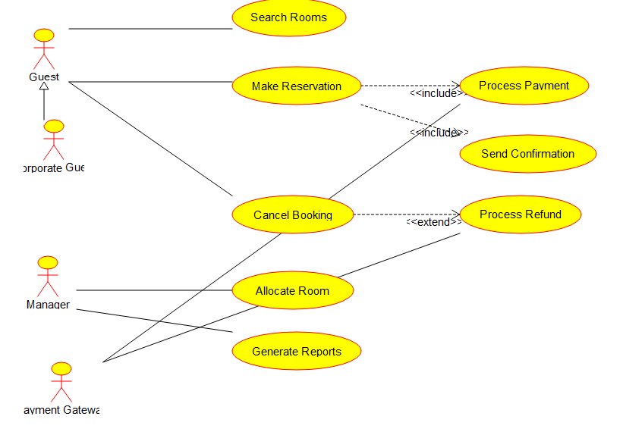
Figure 1: Use Case Diagram for the Smart Hotel Reservation System
2. Class Diagram Design
A University Management System includes entities such as Student, Faculty, Course, Department, and Examination. The existing design lacks proper attributes, operations, and relationships among classes. Analyze the system, identify relevant classes with attributes and methods, define relationships (association, aggregation, inheritance), and construct a well-structured Class Diagram. (10 Marks)
The five classes mentioned in the question - Student, Faculty, Course, Department and Examination - form the base of the design, but each one needed proper attributes and operations to actually mean something. For Student, I used studentId, name, dateOfBirth and email as attributes, along with methods like register() and viewResults(). Faculty carries facultyId, name, designation and email with methods such as assignCourse() and submitMarks(). Course holds courseCode, title and credits with addStudent() and scheduleExam(), Department holds deptId, name and headOfDept with addFaculty() and addCourse(), and Examination holds examId, examDate and duration with conductExam() and publishResults().
Since the question also expects inheritance to be shown, I split Student into two more specific classes - UndergraduateStudent and PostgraduateStudent - which inherit from Student through generalization. UndergraduateStudent adds a programName attribute, and PostgraduateStudent adds a thesisTitle attribute, since postgraduate students usually work on a thesis while undergraduates follow a fixed programme.
For the relationships, a Department aggregates many Faculty members and many Courses, because faculty and courses belong to a department but can technically exist as separate records even if the department is restructured, which is why aggregation (the hollow diamond) fits better than a strict composition here. A Faculty member is associated with the Course they teach, and a Student is associated with the Course they enroll in, both shown as plain associations since these links can change every semester. Examination is composed inside Course (a filled diamond), because an exam record only makes sense as part of a specific course and does not exist independently.
This structure fixes the main problem in the question, which was that the original design had classes without any real attributes, operations or defined relationships between them, making it impossible to tell how the classes actually interact.
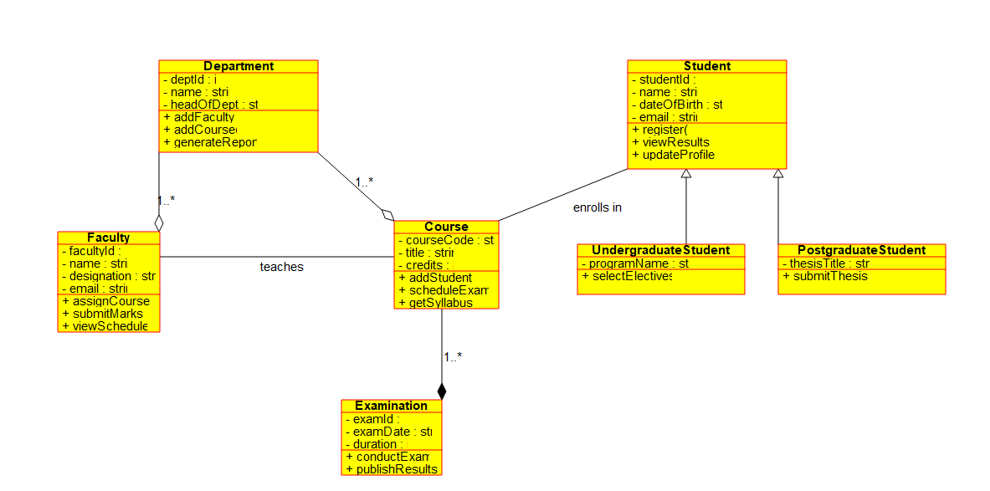
Figure 2: Class Diagram for the University Management System
3. Sequence Diagram Evaluation
In a Vehicle Rental System, a customer searches for a vehicle, books it, makes payment, and receives a rental confirmation. The interaction among system components is incomplete and poorly documented. (10 Marks)
The question only gives a rough outline - search, book, pay, receive confirmation - so the first step was to break this down into the actual objects that would exist in a real system and figure out what each one talks to. I identified six participants: Customer, RentalInterface (the front-end the customer interacts with), VehicleCatalog (which holds the list of available vehicles), BookingManager (which creates and tracks bookings), PaymentGateway (which handles the transaction) and ConfirmationService (which sends out the final confirmation).
The missing objects in the original description were mainly VehicleCatalog, BookingManager and ConfirmationService - the question mentions the customer searching, booking and paying, but never says which internal component actually stores the vehicle data or generates the confirmation, so I added these to make the flow complete.
The message flow starts with the customer calling searchVehicle() on the RentalInterface, which then calls getAvailableVehicles() on the VehicleCatalog and gets a list back. The interface displays this to the customer, who then selects a vehicle. This selection triggers createBooking() on the BookingManager, which in turn calls processPayment() on the PaymentGateway. Once payment succeeds, the BookingManager calls generateConfirmation() on the ConfirmationService, which finally sends the confirmation back to the customer. This gives a total of ten messages, which properly shows the round trip between all the components instead of just naming the four broad steps mentioned in the question.
Keeping the messages numbered in this way (1 to 10) also makes the sequence easy to trace top to bottom, which was one of the main things missing from the "incomplete and poorly documented" version referred to in the question.
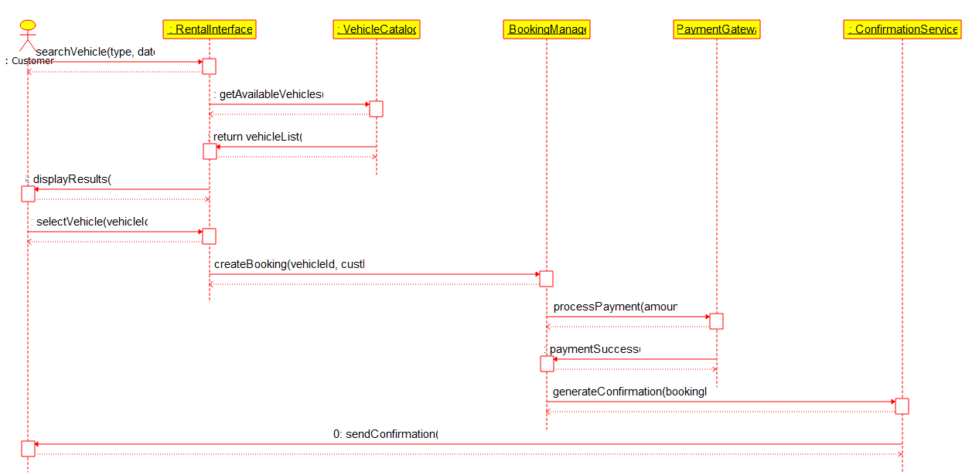
Figure 3: Sequence Diagram for the Vehicle Rental System
4. State Diagram Construction
A Traffic Signal Control System operates through states such as Red Signal, Green Signal, Yellow Signal, Emergency Mode, and Maintenance Mode. The transitions between states are not clearly defined. (10 Marks)
The five states given in the question are all valid, but the question does not say how the system moves between them, so this was the main gap to fill. I started with an initial pseudostate that leads into Red Signal, since a traffic light always begins in a safe stopped condition when the system is switched on.
From Red Signal, the system moves to Green Signal once the timer expires, then from Green Signal to Yellow Signal on another timer expiry, and finally from Yellow Signal back to Red Signal, completing the normal cycle. This three-way loop is the everyday working of the signal and needed to be shown clearly since the question only listed the states without connecting them.
Emergency Mode and Maintenance Mode are special states that can interrupt the normal cycle. I added a transition from both Red Signal and Green Signal into Emergency Mode, triggered by the event "emergency vehicle detected" - this reflects real traffic systems where an approaching ambulance or fire truck can override the timer. Once the emergency clears, the system goes back to Red Signal to restart the safe cycle. Similarly, Maintenance Mode is reached from Red Signal when maintenance is scheduled, and once maintenance is completed, the system returns to Red Signal again.
Bringing every path back to Red Signal was a deliberate choice, since a traffic light should always resume from the stop state rather than jumping into green or yellow directly after an interruption, which keeps the intersection safe. This addresses the core issue in the question, which was that the transitions and the conditions that trigger them were left undefined.
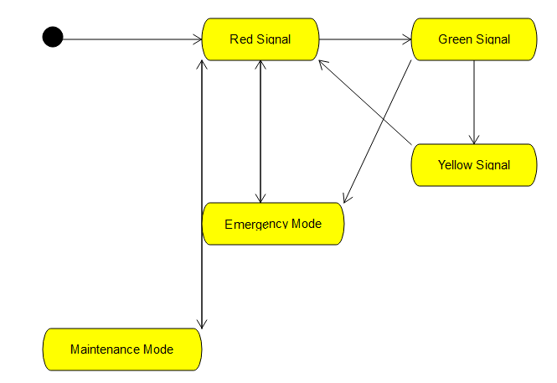
Figure 4: State Diagram for the Traffic Signal Control System
5. Component Diagram Design
A Smart Healthcare Portal consists of modules such as Patient Management, Appointment Scheduling, Medical Records, Billing, and Notification Services. The current architecture does not clearly define component interactions and dependencies. (10 Marks)
All five modules named in the question - Patient Management, Appointment Scheduling, Medical Records, Billing and Notification Services - are kept as separate components, since each one clearly handles a distinct responsibility in a hospital portal. The part that was missing was how these components actually talk to each other, which is exactly what the question points out.
Patient Management sits at the centre of the design because almost every other module needs basic patient details at some point. I exposed this through an interface called IPatientData, drawn as a lollipop on the Patient Management component. Appointment Scheduling, Medical Records and Billing all depend on this interface, since scheduling an appointment, updating a medical record, or generating a bill all require the patient's basic information first.
Notification Services depends on both Appointment Scheduling and Billing, because it is responsible for sending appointment reminders and payment or billing alerts to patients. It does not need to depend on Patient Management directly, since it only cares about the events raised by scheduling and billing, not the raw patient data itself.
This dependency structure answers the exact gap mentioned in the question - instead of five modules just sitting next to each other with no defined connections, the diagram now shows which component provides functionality, which components consume it through a proper interface, and how a notification eventually reaches the patient after an appointment or billing event.
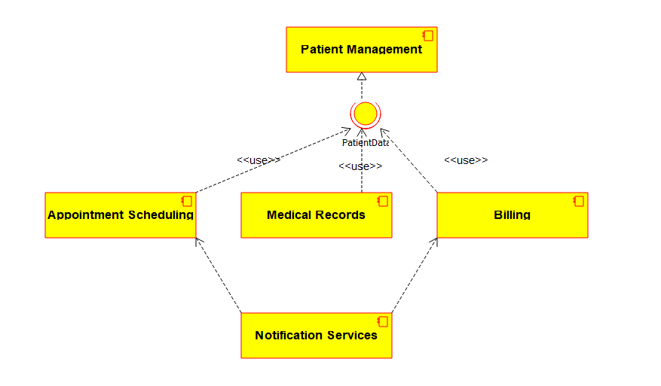
Figure 5: Component Diagram for the Smart Healthcare Portal
6. Deployment Diagram Design
A Smart City Waste Management System is deployed across IoT waste-bin sensors, edge devices, cloud servers, and monitoring dashboards. The current design lacks clarity regarding physical architecture and communication links. (10 Marks)
The four physical nodes mentioned in the question - IoT waste-bin sensors, edge devices, cloud servers and monitoring dashboards - are modelled as separate deployment nodes, since each one represents a different physical machine or device in the real deployment. The missing piece, as the question points out, was what software runs on each node and how the nodes are connected.
The IoT Waste-Bin Sensor node runs a small piece of firmware, SensorFirmware.bin, which reads the fill-level of the bin and sends the reading out. This connects over a short-range wireless protocol such as Zigbee or LoRaWAN to the Edge Gateway Device, which runs EdgeProcessingService.jar. The edge device's job is to collect readings from many nearby bins, do some basic filtering, and forward only the meaningful data onward, instead of sending every single raw reading to the cloud.
The Edge Gateway Device then connects over the internet using HTTPS (with an MQTT bridge for the sensor data) to the Cloud Server, which hosts two artifacts - WasteManagementAPI.war, the main application that processes and stores the waste data, and WasteDataDB, the database that keeps historical records. Finally, the Cloud Server exposes a REST API over HTTPS to the Monitoring Dashboard Client, which runs DashboardApp.exe and is what the city staff actually look at to plan collection routes.
Labelling each communication link with its protocol (Zigbee/LoRaWAN, HTTPS/MQTT, HTTPS/REST API) was important here, because the question specifically complained about the lack of clarity on communication links, and simply drawing plain lines between boxes would have left the same ambiguity as before.
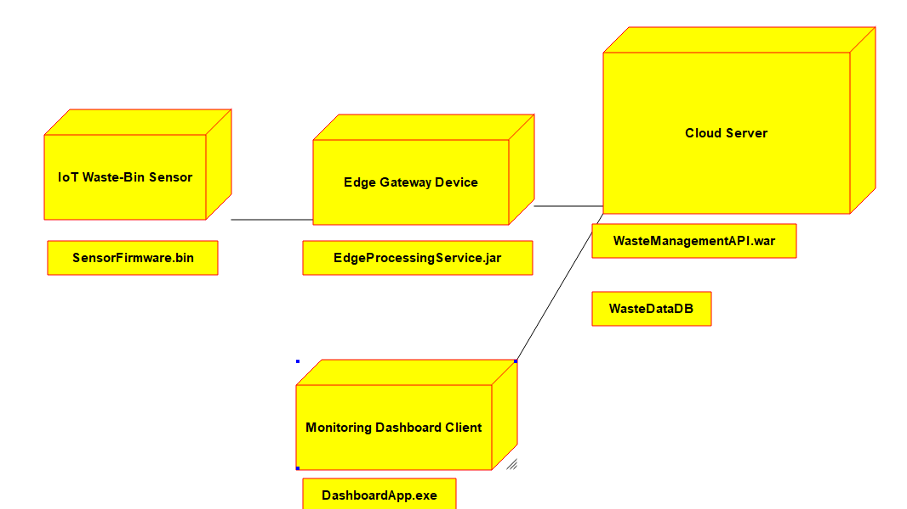
Figure 6: Deployment Diagram for the Smart City Waste Management System

