SIMATS ENGINEERING
ASSESSMENT TOOL 1

COURSE NAME: OBJECT ORIENTED ANALYSIS AND DESIGN
COURSE CODE: CSA1102

COURSE OUTCOME COVERED
CO5: Analyze object-oriented software using quality assurance and usability testing
Techniques (BL4, BL5)

Assessment Tool Weightage: 35%
QUESTIONS: 5 Total Marks: 35

Annexure A
Constraint-Based Problem Solving

Code of Conduct:
I Kanishk C (Name / Reg No) 192511278 certify that this submission is my original work
and that I have adhered to the guidelines specified for this assessment.
I understand that any violation of academic integrity rules will result in disciplinary action.
Signature of the student: Kanishk C

ANNEXURE A – ANSWERS
This document presents detailed answers to the five constraint-based problem-solving questions given in Assessment Tool 1 for the course Object Oriented Analysis and Design (CSA1102), covering Course Outcome 5 – analysing object-oriented software using quality assurance and usability testing techniques.
Question 1 – Online Banking System (Quality Assurance under Constraints)
System Components: Account Management, Fund Transfer, Bill Payment, Transaction History.
Given Constraints: Transaction completion time under 2 seconds, multi-factor authentication required, and the system must support 5000 or more concurrent users.
Understanding the Problem
This banking system has to be fast, secure and available to a huge number of users at the same time. If any one of these three things fails — speed, security or scalability — the bank can lose customer trust and even face legal trouble. So the quality assurance (QA) process here has to be built around these three constraints specifically, not just general functional testing.
Potential Defects
- Security defects: weak session handling after multi-factor authentication (MFA), OTP not expiring on time, or the system allowing login with only one factor when the second factor fails silently.
- Performance defects: fund transfer taking more than 2 seconds during peak hours, database queries not optimized, or the server timing out when many users transact together.
- Reliability defects: transaction getting deducted from the sender's account but not credited to the receiver (a very common banking bug), duplicate transactions on double-click, or the system crashing under high load and losing transaction records.
- Concurrency defects: two users accessing the same account at the same time causing incorrect balance updates (race condition).
Testing Strategies Proposed
- Security Testing: Penetration testing and vulnerability scanning to check the MFA flow, session tokens, and SQL injection points in login and transfer forms.
- Performance Testing: Load testing and stress testing using tools such as JMeter, simulating 5000+ concurrent users to measure whether the 2-second transaction limit is met under peak load.
- Reliability Testing: Recovery testing — deliberately crashing the server mid-transaction to check if the system rolls back correctly and does not lose or duplicate money.
- Regression Testing: Every time a new feature (like bill payment) is added, old modules such as fund transfer must be re-tested to make sure nothing broke.
- Concurrency Testing: Running parallel transactions on the same account to verify locking mechanisms work and balances stay accurate.
Justification
Each strategy is matched directly to a constraint. Load and stress testing justify the 5000+ user requirement because they mimic real peak traffic instead of just testing with 10-20 dummy users. Security testing is essential because MFA is a hard requirement — if it's not tested properly, the whole system's trust breaks down. Recovery and concurrency testing target reliability because banking cannot afford even one wrong transaction. Together, these strategies make sure the system is not only functionally correct but also fast, safe and dependable, which is exactly what quality assurance for a banking system should achieve.
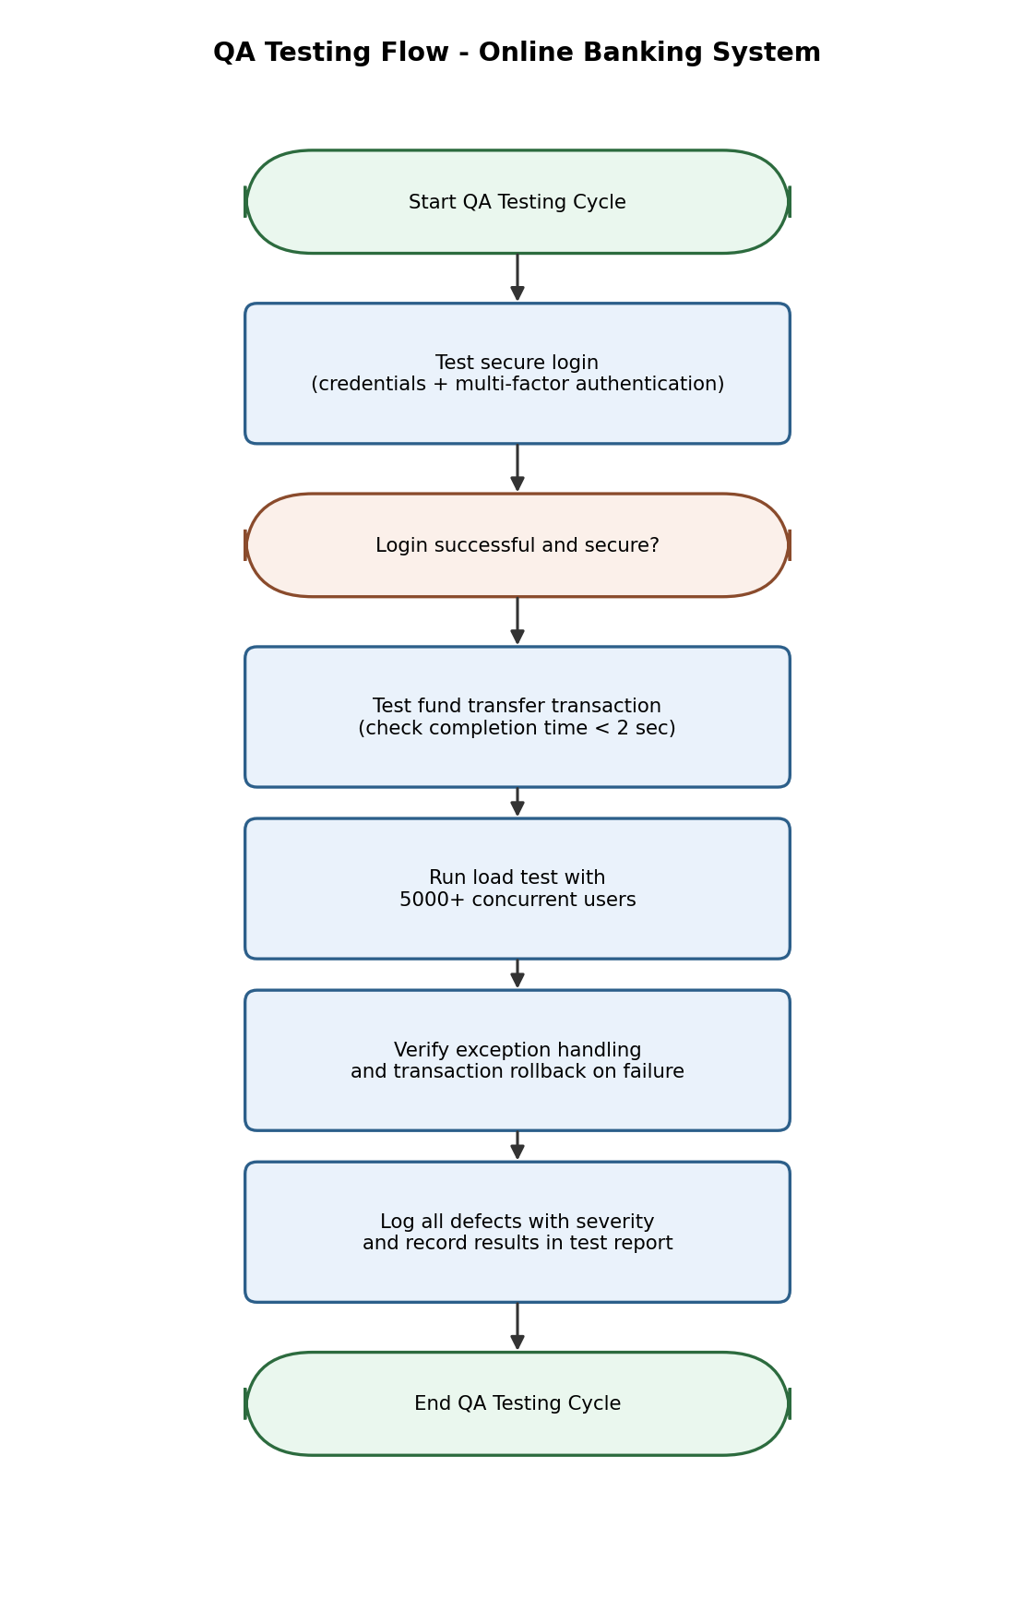
Figure 1: QA Testing Flow followed for the Online Banking System
Question 2 – E-Commerce Shopping Application (Usability Testing under Constraints)
System Features: Product Search, Shopping Cart, Checkout, Payment Gateway.
Usability Constraints: Checkout process within 3 steps, easy product navigation, and a responsive design that works on both mobile and desktop devices.
Applying Usability Testing
Usability testing here means putting real or representative users in front of the application and watching how easily they can find a product, add it to the cart, and complete the payment. The goal is not to check if the code works (that is functional testing) but to check if a normal customer, without any training, can use the app smoothly and quickly.
Usability Challenges Identified
- Checkout taking more than 3 steps because address entry, coupon application and payment are shown on separate pages instead of being combined.
- Product search returning too many irrelevant results, or filters (price, brand, rating) being hidden or hard to find.
- Navigation menu collapsing badly on smaller mobile screens, buttons becoming too small to tap accurately, and text overflowing outside the screen.
- Users abandoning the cart because the 'Buy Now' button is not visible without scrolling on mobile.
Recommended Design Improvements
- Combine address, delivery option and payment confirmation into a single-page or 3-step checkout with a clear progress indicator (Step 1 of 3, etc.).
- Add auto-suggestions and smart filters to the search bar so users reach the right product in fewer clicks.
- Use a responsive grid layout (CSS media queries / mobile-first design) so the same interface adjusts cleanly between mobile and desktop.
- Keep the primary action button (Add to Cart / Buy Now) fixed and visible at all times on mobile view.
How These Changes Improve Customer Satisfaction and Efficiency
When checkout is short and predictable, customers are less likely to abandon their cart, which directly increases sales conversion. Better search and filters reduce the time customers spend looking for products, making the shopping experience feel faster and less frustrating. A properly responsive layout means the business doesn't lose mobile customers, who today make up the majority of online shoppers. Overall, these usability improvements reduce customer effort, which is one of the strongest predictors of repeat purchases and customer loyalty.
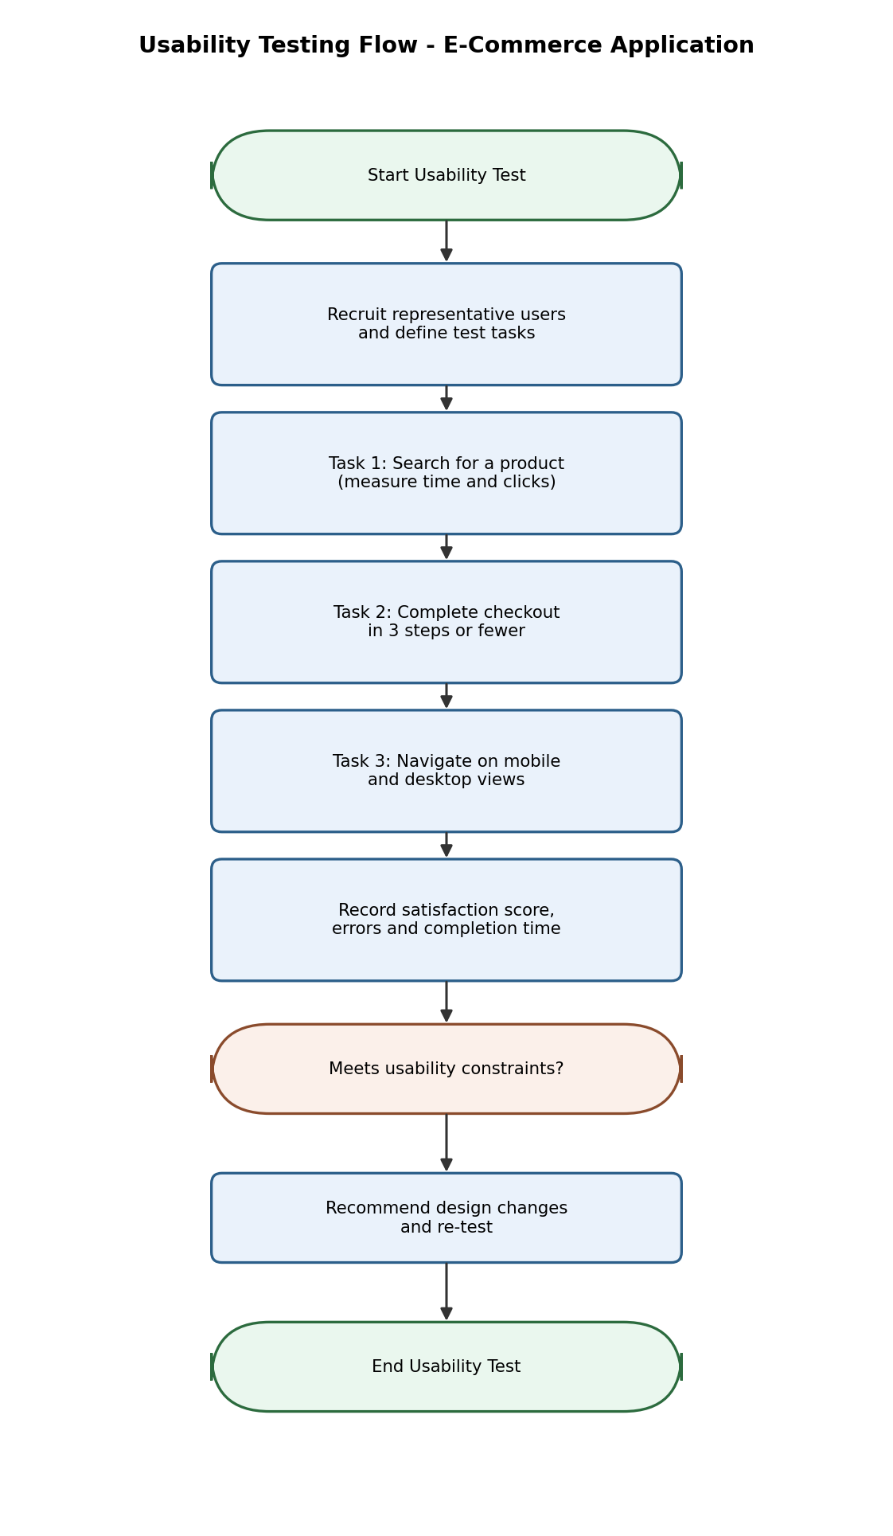
Figure 2: Usability Testing Flow followed for the E-Commerce Application
Question 3 – Hospital Management System (Quality Assurance Analysis)
Modules: Patient Registration, Appointment Scheduling, Medical Records, Billing.
QA Constraints: Patient data accuracy must be maintained, the system must have 24/7 availability, and multiple departments must be able to access it simultaneously.
Why This System Needs Careful QA
A hospital system is different from most other software because a mistake here doesn't just cause inconvenience — it can put a patient's health at risk. Wrong medical records, a missed appointment, or the system going down at midnight when a doctor needs a patient's history can have serious real consequences. So QA for this system has to prioritise data accuracy and availability above almost everything else.
Critical Test Cases
- Verify that patient details entered during registration (name, age, blood group, allergies) are stored and retrieved without any corruption or truncation.
- Check that appointment scheduling does not allow two patients to be booked with the same doctor at the same time slot (double-booking test).
- Test that medical records updated by one department (say, the lab) are immediately visible to another department (say, the doctor's console) without delay or conflict.
- Verify billing calculations match the actual treatments and medicines given, with no mismatch between the pharmacy, lab and billing modules.
- Test system behaviour during a simulated server restart or failover to confirm there is no downtime and no data loss (24/7 availability check).
How the Constraints Influence Testing Priorities
Because patient data accuracy is non-negotiable, data validation and consistency testing gets the highest priority — every input field needs boundary and format checks, and every record update needs to be tested for consistency across modules. Because the system must run 24/7, reliability and failover testing gets equal priority, including testing backup servers and database replication. Since many departments access the same data at once, concurrency and access-control testing becomes critical too, to make sure one department's update doesn't overwrite another's.
Defect Prevention and Overall Reliability
Defect prevention here focuses on catching data-integrity issues before they reach production, using strict input validation, automated regression tests after every update, and audit logs that track who changed what and when. Combined with redundant servers for 24/7 uptime and role-based access control for multi-department use, these QA practices ensure the hospital system stays accurate, always available, and trustworthy for both staff and patients.
Question 4 – Smart Library Management System (Usability Evaluation)
Features: Book Search, Book Reservation, Borrow/Return, Notifications.
Usability Constraints: Search results must display within 2 seconds, the interface must be accessible for all age groups, and there should be a minimal learning curve for first-time users.
Usability Evaluation Method
For this system, a combination of think-aloud testing and time-based task testing works best. In think-aloud testing, users (students, staff, and even elderly readers) are asked to speak their thoughts while using the system, which shows exactly where they get confused. In time-based testing, we measure how long it takes a first-time user to search for a book, reserve it, and understand a notification, comparing this against the 2-second search constraint.
How the Constraints Impact Interface Design
- The 2-second search limit means the search feature needs an efficient indexing/database structure and a simple, uncluttered search bar with auto-complete, rather than a slow, multi-field advanced search shown by default.
- Accessibility for all age groups means the interface must use large, readable fonts, high-contrast colours, simple icons with text labels (not just icons), and avoid relying only on mouse-hover actions that older users may find difficult.
- A minimal learning curve means the navigation should follow familiar patterns (a search bar at the top, clear buttons for 'Reserve' and 'Return'), with tooltips or a short one-time walkthrough for first-time users.
Recommended Improvements
- Add voice search or simple keyword search as the default option, keeping advanced filters optional and collapsible.
- Provide a short on-screen guide or tutorial video for first-time users, and allow font-size adjustment for elderly users.
- Send notifications (due date reminders, reservation confirmation) as simple, plain-language messages rather than technical system alerts.
- Test the interface periodically with actual students and senior citizens, not just developers, since usability issues are often invisible to the people who built the system.
Expected Outcome
With these changes, the library system becomes usable by a wide range of people — from a first-year student to a retired faculty member — without needing any training, while still meeting the strict 2-second search performance requirement.
Question 5 – Airline Reservation System (QA and Usability Together)
Modules: User Login, Flight Search, Seat Selection, Ticket Booking.
QA and Usability Constraints: No booking duplication, the system must support peak holiday traffic, and the booking interface should be simple and error-free.
Major Risks Identified
- Double booking of the same seat when two users select it at nearly the same time (a concurrency/race-condition risk).
- System slowdown or crash during peak holiday season when thousands of users search and book flights simultaneously (a scalability risk).
- Payment being deducted but the ticket not getting generated due to a network failure mid-transaction (a reliability risk).
- Confusing seat-selection screen leading users to book the wrong seat or class by mistake (a usability risk).
Proposed Testing Methods
- Concurrency testing: simulate multiple users booking the same seat at the same time to confirm the system locks the seat correctly for only one user and releases it if payment fails.
- Load and stress testing: simulate holiday-level traffic (far above normal daily bookings) to check server response time and identify the breaking point before it happens in real life.
- Transaction/reliability testing: test payment gateway failure scenarios to confirm that if payment fails, no ticket is issued and no amount is deducted, and if payment succeeds, the ticket is always generated.
- Usability testing: observe first-time users during seat selection and booking to check whether the flow is simple enough to complete without confusion or errors.
How the System Can Be Optimized
Reliability can be improved by using database transaction locks so a seat is reserved the moment a user starts payment, and automatically released if payment is not completed within a few minutes. Performance during peak traffic can be optimized using load balancing across multiple servers and caching frequently searched flight routes. For usability, the booking interface should show seat availability visually (like a seat map), confirm each step clearly, and avoid technical error messages, replacing them with simple instructions. Together, these measures directly address the three stated constraints — no duplication, peak traffic support, and a simple error-free interface — resulting in a system that is both dependable and pleasant to use.

— End of Assessment Tool 1 Answers —

