SIMATS ENGINEERING
ASSESSMENT TOOL 2

COURSE NAME: OBJECT ORIENTED ANALYSIS AND DESIGN
COURSE CODE: CSA1102

COURSE OUTCOME COVERED
CO5: Analyze object-oriented software using quality assurance and usability testing
Techniques (BL4, BL5)

Assessment Tool Weightage: 25%
QUESTIONS: 05 Total Marks: 25

Annexure A
Error Analysis Task

Code of Conduct:
I Kanishk C (Name / Reg No) 192511278 certify that this submission is my original work
and that I have adhered to the guidelines specified for this assessment.
I understand that any violation of academic integrity rules will result in disciplinary action.
Signature of the student: Kanishk C

ANNEXURE A – ANSWERS
This document contains detailed pseudocode solutions and explanations for the five scenario-based questions in Assessment Tool 2 (Error Analysis Task), for the course Object Oriented Analysis and Design (CSA1102), Course Outcome 5.
Question 1 – Online Banking System
Modules: User Login, Fund Transfer, Account Verification.
Task: Write pseudocode for a quality assurance testing process that validates secure user authentication and fund transfer operations, including input validation, transaction verification, exception handling, and test result logging.
Pseudocode
BEGIN QA_Test_BankingSystem
INPUT username, password, otp
// Step 1: Input Validation
IF username IS EMPTY OR password IS EMPTY THEN
LOG_RESULT("FAIL - Empty credentials")
EXIT
END IF
// Step 2: Authenticate User
TRY
storedHash = GET_STORED_PASSWORD_HASH(username)
IF HASH(password) != storedHash THEN
LOG_RESULT("FAIL - Invalid password")
EXIT
END IF
IF VERIFY_OTP(username, otp) == FALSE THEN
LOG_RESULT("FAIL - Invalid OTP")
EXIT
END IF
CATCH DatabaseError
LOG_RESULT("FAIL - Auth service unreachable")
EXIT
END TRY
LOG_RESULT("PASS - Login authenticated")
// Step 3: Fund Transfer Test
INPUT senderAccount, receiverAccount, amount
TRY
IF amount <= 0 THEN
LOG_RESULT("FAIL - Invalid amount")
EXIT
END IF
IF GET_BALANCE(senderAccount) < amount THEN
LOG_RESULT("FAIL - Insufficient balance")
EXIT
END IF
startTime = CURRENT_TIME()
DEBIT(senderAccount, amount)
CREDIT(receiverAccount, amount)
endTime = CURRENT_TIME()
IF (endTime - startTime) > 2_SECONDS THEN
LOG_RESULT("WARNING - Transfer exceeded time limit")
END IF
LOG_RESULT("PASS - Transfer completed successfully")
CATCH TransactionError
ROLLBACK(senderAccount, receiverAccount, amount)
LOG_RESULT("FAIL - Transaction rolled back due to error")
END TRY
// Step 4: Log Final Report
WRITE_TEST_LOG(username, timestamp = NOW(), status = LAST_RESULT)
END
Explanation
This pseudocode follows a clear QA sequence. It first checks that the login inputs are not empty, then verifies the password hash and the OTP separately, so we can pinpoint exactly which step failed if the login test does not pass. The whole authentication block is wrapped in a TRY-CATCH so that if the database itself is down, the test fails gracefully instead of crashing. The fund transfer section checks the amount and balance before touching any money, times the operation to check it stays under the 2-second constraint, and uses a CATCH block to roll back both accounts if anything goes wrong midway — this prevents the classic banking bug where money leaves one account but never reaches the other. Every outcome, pass or fail, is written into a test log with a timestamp so the QA team has a complete, traceable record.
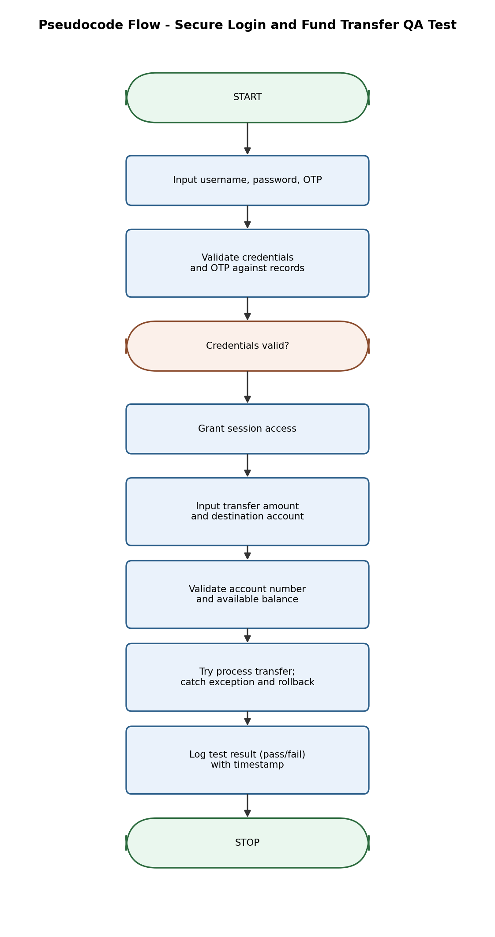
Figure 1: Flow of the QA Test for Secure Login and Fund Transfer
Question 2 – E-Commerce Shopping Platform
Features: Product Search, Shopping Cart, Payment Gateway.
Task: Design pseudocode for a usability testing evaluation that measures customer interaction efficiency, including product search time, checkout completion time, and navigation complexity, and explain how the algorithm collects and analyzes user behaviour data.
Pseudocode
BEGIN Usability_Test_ECommerce
INITIALIZE searchTimes = [], checkoutTimes = [], clickCounts = [], errorCount = 0
FOR EACH testUser IN userGroup
// Measure Search Efficiency
startSearch = CURRENT_TIME()
testUser.ENTER_KEYWORD(product)
WAIT_UNTIL results DISPLAYED
endSearch = CURRENT_TIME()
searchTimes.ADD(endSearch - startSearch)
IF results IS EMPTY THEN
errorCount = errorCount + 1
END IF
// Track Navigation Complexity
clicks = 0
startCheckout = CURRENT_TIME()
WHILE testUser.CURRENT_PAGE != "Order Confirmed"
testUser.CLICK(nextStep)
clicks = clicks + 1
IF clicks > 10 THEN
errorCount = errorCount + 1
BREAK // user stuck / lost in navigation
END IF
END WHILE
endCheckout = CURRENT_TIME()
checkoutTimes.ADD(endCheckout - startCheckout)
clickCounts.ADD(clicks)
END FOR
// Analyse Collected Data
avgSearchTime = AVERAGE(searchTimes)
avgCheckoutTime = AVERAGE(checkoutTimes)
avgClicks = AVERAGE(clickCounts)
errorRate = errorCount / COUNT(userGroup)
GENERATE_REPORT(avgSearchTime, avgCheckoutTime, avgClicks, errorRate)
END
How the Algorithm Collects and Analyses User Behaviour Data
The algorithm runs the same set of tasks — searching for a product and completing checkout — for every test user, and records three kinds of data for each of them: how long the search takes, how many clicks it takes to reach order confirmation, and how long checkout itself takes. A click counter with an upper limit (10 clicks) is used to automatically detect when a user seems to be lost or stuck in navigation, which is logged as an error rather than requiring a human observer to notice it. Once every test user has completed the tasks, the algorithm calculates averages across the whole group instead of relying on just one person's experience, which gives a fair picture of overall usability. The final report — average search time, average checkout time, average clicks, and error rate — gives the design team concrete numbers to compare against the usability targets (like the 3-step checkout goal), instead of vague opinions about whether the app 'feels' easy to use.
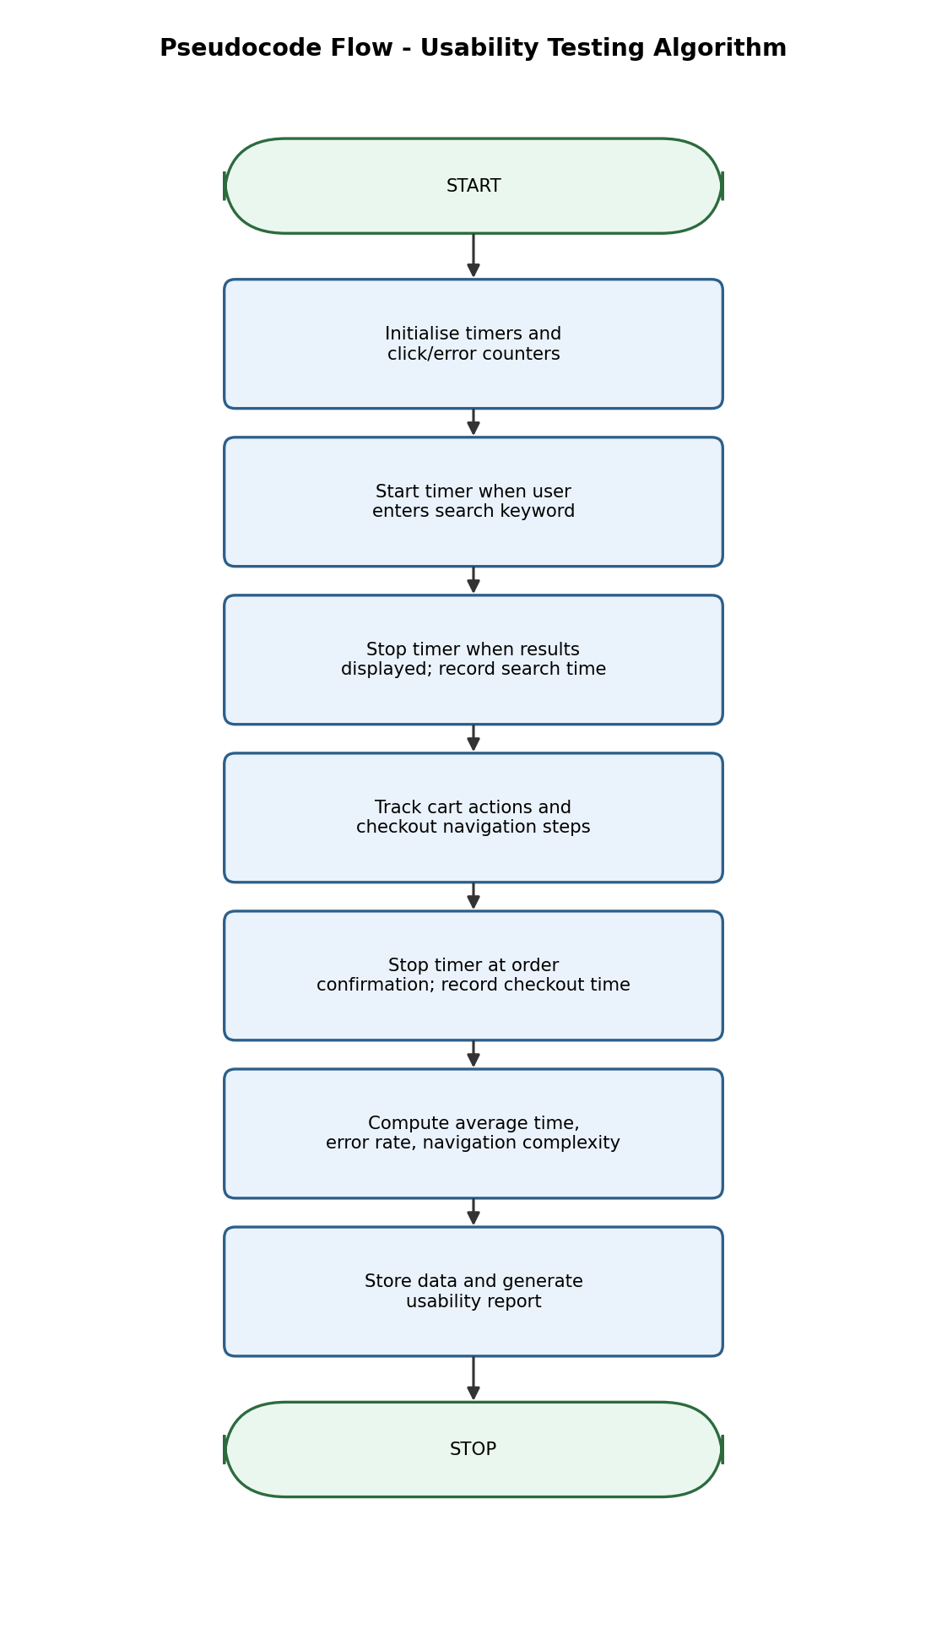
Figure 2: Flow of the Usability Testing Algorithm
Question 3 – Hospital Management System
Modules: Patient Registration, Appointment Scheduling, Medical Records.
Task: Write pseudocode to generate and execute test cases for appointment scheduling functionality, including validation of doctor availability, appointment conflicts, patient information accuracy, and system responses to invalid requests.
Pseudocode
BEGIN Test_AppointmentScheduling
INPUT patientID, doctorID, requestedDate, requestedTime
// Test Case 1: Patient Information Accuracy
patientRecord = GET_PATIENT(patientID)
IF patientRecord IS NULL THEN
LOG_TEST("TC1", "FAIL - Patient record not found")
EXIT
ELSE IF patientRecord.name IS EMPTY OR patientRecord.age <= 0 THEN
LOG_TEST("TC1", "FAIL - Incomplete/invalid patient data")
EXIT
ELSE
LOG_TEST("TC1", "PASS - Patient data valid")
END IF
// Test Case 2: Doctor Availability
IF IS_DOCTOR_ON_LEAVE(doctorID, requestedDate) THEN
LOG_TEST("TC2", "FAIL - Doctor unavailable on requested date")
EXIT
ELSE
LOG_TEST("TC2", "PASS - Doctor available")
END IF
// Test Case 3: Appointment Conflict Check
existingAppointments = GET_APPOINTMENTS(doctorID, requestedDate)
FOR EACH appt IN existingAppointments
IF appt.time == requestedTime THEN
LOG_TEST("TC3", "FAIL - Slot already booked, conflict detected")
SUGGEST_ALTERNATE_SLOTS(doctorID, requestedDate)
EXIT
END IF
END FOR
LOG_TEST("TC3", "PASS - No conflict, slot free")
// Test Case 4: Successful Booking
TRY
CREATE_APPOINTMENT(patientID, doctorID, requestedDate, requestedTime)
LOG_TEST("TC4", "PASS - Appointment booked successfully")
CATCH SystemError
LOG_TEST("TC4", "FAIL - Booking system error, request not saved")
END TRY
// Test Case 5: Invalid Request Handling
IF requestedDate < TODAY() THEN
LOG_TEST("TC5", "FAIL-EXPECTED - Past date correctly rejected")
END IF
GENERATE_TEST_SUMMARY()
END
Explanation
This pseudocode is organised as five separate, clearly labelled test cases (TC1 to TC5) instead of one long block, because in real QA work each check needs its own pass/fail result so a failure can be traced back to the exact rule that broke. TC1 checks that the patient's own data is complete before anything else happens. TC2 and TC3 are the two checks most specific to scheduling — doctor availability and slot conflicts — and TC3 also calls a helper to suggest alternate slots, which is a realistic and useful behaviour rather than just rejecting the request. TC4 tests the actual booking action inside a TRY-CATCH so a backend failure is caught and logged as a system error rather than crashing the whole test run. TC5 is a negative test case — it deliberately checks that an invalid request, like booking an appointment in the past, is correctly rejected, which is just as important as testing that valid requests succeed.
Question 4 – Airline Reservation System
Modules: Passenger Registration, Flight Booking, Seat Allocation.
Task: Develop pseudocode for a constraint-based testing approach where booking requests must satisfy conditions such as valid passenger information, seat availability, and payment confirmation, showing how invalid booking scenarios are detected and handled.
Pseudocode
BEGIN Test_FlightBooking_Constraints
INPUT passengerName, passportID, flightID, seatNumber, paymentDetails
// Constraint 1: Valid Passenger Information
IF passengerName IS EMPTY OR NOT IS_VALID_PASSPORT(passportID) THEN
LOG_TEST("FAIL - Invalid passenger information")
REJECT_BOOKING("Invalid passenger details")
EXIT
END IF
// Constraint 2: Seat Availability (with locking to avoid double booking)
LOCK(seatNumber, flightID)
IF IS_SEAT_TAKEN(flightID, seatNumber) THEN
UNLOCK(seatNumber, flightID)
LOG_TEST("FAIL - Seat already booked")
SUGGEST_ALTERNATE_SEATS(flightID)
EXIT
END IF
// Constraint 3: Payment Confirmation
TRY
paymentStatus = PROCESS_PAYMENT(paymentDetails)
IF paymentStatus != "CONFIRMED" THEN
UNLOCK(seatNumber, flightID)
LOG_TEST("FAIL - Payment not confirmed")
REJECT_BOOKING("Payment failed")
EXIT
END IF
CATCH PaymentGatewayError
UNLOCK(seatNumber, flightID)
LOG_TEST("FAIL - Payment gateway error, booking not completed")
EXIT
END TRY
// All constraints satisfied - confirm booking
CONFIRM_SEAT(flightID, seatNumber, passengerName)
UNLOCK(seatNumber, flightID)
GENERATE_TICKET(passengerName, flightID, seatNumber)
LOG_TEST("PASS - Booking confirmed, all constraints satisfied")
END
How Invalid Scenarios Are Detected and Handled
The pseudocode checks the three given constraints strictly in order, and stops immediately the moment one fails, instead of continuing and creating a half-valid booking. Passenger information is checked first because there is no point locking a seat for an invalid passenger. Seat availability uses a LOCK before checking, which is important — this is what stops two passengers from being allocated the same seat if they book at nearly the same moment, a very common source of double-booking bugs in real airline systems. Payment is handled inside a TRY-CATCH so that both a declined payment and a payment gateway crash are treated as booking failures, and in both cases the seat lock is released so it becomes available to other passengers again instead of staying wrongly reserved. Only when all three constraints pass does the system generate the ticket, which guarantees that every confirmed ticket in the system is genuinely valid on all three fronts.
Question 5 – Smart Library Management System
Features: Book Search, Book Reservation, Borrow/Return Services.
Task: Write pseudocode for integrating quality assurance and usability testing where the system evaluates both functional correctness (reservation and borrowing operations) and user experience factors such as response time, ease of navigation, and accessibility.
Pseudocode
BEGIN Integrated_QA_Usability_Test_Library
INITIALIZE responseTimes = [], navigationErrors = 0, functionalErrors = 0
// ---- PART A: Functional (QA) Testing ----
bookID = SEARCH_BOOK(keyword)
IF bookID IS NULL THEN
functionalErrors = functionalErrors + 1
LOG_TEST("QA-1", "FAIL - Book not found for valid keyword")
END IF
TRY
IF IS_BOOK_AVAILABLE(bookID) THEN
RESERVE_BOOK(bookID, memberID)
LOG_TEST("QA-2", "PASS - Reservation successful")
ELSE
ADD_TO_WAITLIST(bookID, memberID)
LOG_TEST("QA-2", "PASS - Waitlisted correctly, book unavailable")
END IF
BORROW_BOOK(bookID, memberID)
dueDate = CALCULATE_DUE_DATE()
LOG_TEST("QA-3", "PASS - Borrow recorded, due date set")
RETURN_BOOK(bookID, memberID)
LOG_TEST("QA-4", "PASS - Return processed, status updated")
CATCH SystemError
functionalErrors = functionalErrors + 1
LOG_TEST("QA-Error", "FAIL - Exception during borrow/return cycle")
END TRY
// ---- PART B: Usability Testing ----
FOR EACH testUser IN userGroup
startTime = CURRENT_TIME()
testUser.SEARCH(keyword)
endTime = CURRENT_TIME()
responseTimes.ADD(endTime - startTime)
IF testUser.CLICKS_TO_COMPLETE("Reserve") > 4 THEN
navigationErrors = navigationErrors + 1
END IF
IF NOT testUser.CAN_READ_TEXT_CLEARLY() THEN
LOG_TEST("Accessibility", "FAIL - Low readability for " + testUser.ageGroup)
END IF
END FOR
avgResponseTime = AVERAGE(responseTimes)
navErrorRate = navigationErrors / COUNT(userGroup)
// ---- Combined Report ----
GENERATE_COMBINED_REPORT(functionalErrors, avgResponseTime, navErrorRate)
END
Explanation
This pseudocode is split into two clearly separate parts inside one integrated test, which mirrors how real QA teams often work — functional correctness and user experience are different concerns but need to be evaluated together for a complete picture of software quality. Part A is standard functional QA: it tests search, reservation (including the waitlist case when a book is already taken, which is a common real-world scenario), borrowing, and returning, each wrapped in error handling so a crash in one operation doesn't stop the whole test. Part B is usability-focused: it measures how fast the search responds for a group of test users, counts how many clicks it takes to complete a reservation (flagging anything over 4 clicks as a navigation problem), and checks text readability across different age groups to test accessibility, directly matching the goal of evaluating response time, navigation ease and accessibility together. Combining both parts into one final report gives a single, complete quality picture — a system could pass every functional test and still fail usability if it's slow or hard to navigate, so testing them together is more meaningful than testing them separately.

— End of Assessment Tool 2 Answers —

