SIMATS ENGINEERING
ASSESSMENT TOOL 3

COURSE NAME: OBJECT ORIENTED ANALYSIS AND DESIGN
COURSE CODE: CSA1102

COURSE OUTCOME COVERED
CO5: Analyze object-oriented software using quality assurance and usability testing
techniques. (BL4, BL5)

Assessment Tool Weightage: 40%
QUESTIONS: 05 Total Marks: 40

Annexure A
MOCK INTERVIEW

Code of Conduct:
I Kanishk C (Name / Reg No) 192511278 certify that this submission is my original work
and that I have adhered to the guidelines specified for this assessment.
I understand that any violation of academic integrity rules will result in disciplinary action.
Signature of the student: Kanishk C

ANNEXURE A – MOCK INTERVIEW ANSWERS
This document contains prepared answers for the Mock Interview assessment (Assessment Tool 3) for Object Oriented Analysis and Design (CSA1102), Course Outcome 5. The answers are written the way I would actually speak them in the interview, covering self-introduction, technical concepts, UML modelling, case studies, and HR questions.
SECTION A – SELF INTRODUCTION (5 Marks)
1. Tell me about yourself.
Good morning/afternoon. My name is Kanishk C, and I'm currently pursuing my engineering degree in Computer Science at SIMATS Engineering. I have a strong interest in software design, especially in how large systems are broken down into smaller, manageable components. Over the past semesters I've worked on academic projects that involved both programming and system design, which is what pulled me towards Object Oriented Analysis and Design as one of my favourite subjects. Outside academics, I enjoy exploring new tools and frameworks and try to apply whatever I learn in class to small personal projects, because I understand concepts much better when I actually build something with them.
2. Why did you choose Computer Science?
I chose Computer Science because I've always liked solving problems in a structured, logical way, and programming gives me the tools to actually build a solution instead of just thinking about one. Even in school, I was drawn to subjects like mathematics and logic. Computer Science felt like the natural next step because it combines that logical thinking with the ability to create something useful — an app, a system, a tool — that other people can actually use. The field also keeps evolving, so there's always something new to learn, which keeps me motivated.
3. Explain your favorite subject in OOAD.
My favourite part of OOAD is UML modelling, especially class diagrams and use case diagrams. What I like about it is that before writing even a single line of code, you can visually plan out how a whole system will work — what the classes are, how they relate to each other, and what a user can actually do with the system. It forces you to think about the design properly instead of jumping straight into coding and fixing problems later. I also enjoy design principles like encapsulation and abstraction, because they explain why good software is organized the way it is.
4. What software development tools have you used?
I've worked with tools like Visual Studio Code and Eclipse for writing and debugging code, Git and GitHub for version control, and StarUML/draw.io for creating UML diagrams like class and use case diagrams. I've also used MySQL for handling databases in my projects, and basic testing approaches to check that my code behaves correctly before submitting it. I'm comfortable picking up new tools quickly since most IDEs and version control systems follow similar underlying concepts once you understand the basics.
5. Describe a project where you applied object-oriented concepts.
In one of my academic projects, I worked on a small library management application. I designed it using OOP concepts right from the start — I created separate classes for Book, Member, and Librarian, each with their own attributes and responsibilities, instead of writing one large block of code that did everything. I used inheritance where a general 'Person' class was extended by 'Member' and 'Librarian', since both share common attributes like name and contact number but have different responsibilities. This made the code much easier to maintain, and whenever I needed to add a new feature, like a fine calculation system, I could add it as a new class without disturbing the existing ones.
SECTION B – TECHNICAL QUESTIONS (15 Marks)
Q1. What is Object-Oriented Analysis and Design?
Object-Oriented Analysis and Design, or OOAD, is an approach to understanding a problem and designing a software solution around real-world objects rather than just functions and data separately. Analysis is the phase where we study the problem and identify what objects, their properties, and their behaviours are needed. Design is the phase where we decide how those objects will actually be structured and how they will interact with each other to build the working system. Together, OOAD helps developers build software that is modular, reusable, and easier to maintain.
Q2. Differentiate between Analysis and Design.
Analysis focuses on understanding 'what' the system needs to do — it involves gathering requirements, identifying objects, and understanding the problem domain, usually documented using use case diagrams. Design focuses on 'how' the system will actually achieve that — deciding the class structure, relationships, algorithms and architecture, usually documented using class diagrams and sequence diagrams. In short, analysis is problem-oriented and design is solution-oriented.
Q3. Explain Encapsulation with an example.
Encapsulation means wrapping data (attributes) and the methods that operate on that data into a single unit, a class, while restricting direct access to some of the internal details. For example, in a BankAccount class, the balance attribute is usually kept private, and it can only be changed through public methods like deposit() and withdraw(), instead of allowing any other part of the program to directly modify it. This protects the data from accidental or unauthorized changes and keeps the internal implementation hidden from the outside.
Q4. What is Inheritance? Mention its types.
Inheritance is a mechanism where one class (child/subclass) acquires the properties and behaviours of another class (parent/superclass), allowing code reuse and building a hierarchy between related classes. For example, a Car class and a Bike class can both inherit from a common Vehicle class. The main types of inheritance are: Single inheritance (one child, one parent), Multiple inheritance (one child, multiple parents — supported through interfaces in languages like Java), Multilevel inheritance (a chain, like grandparent-parent-child), Hierarchical inheritance (multiple child classes from one parent), and Hybrid inheritance (a combination of two or more types).
Q5. Define Polymorphism and its benefits.
Polymorphism means 'many forms' — it allows the same method name or interface to behave differently depending on the object calling it. For example, a draw() method can behave differently for a Circle object and a Square object, even though both call it the same way. The two main types are compile-time (method overloading) and runtime (method overriding) polymorphism. The main benefits are flexibility and extensibility — you can add new object types that fit into existing code with minimal changes, and it makes code more readable since you don't need separate method names for very similar operations.
Q6. What is Abstraction?
Abstraction means showing only the essential features of an object while hiding the unnecessary internal details from the user. For example, when we drive a car, we only need to know how to use the steering wheel, accelerator and brake — we don't need to know how the engine internally works. In programming, this is achieved using abstract classes and interfaces, where we define what a class should do without specifying exactly how, leaving the implementation details to the subclasses.
Q7. Difference between Aggregation and Composition.
Both are types of association that represent a 'has-a' relationship between classes, but they differ in the strength of the relationship. Aggregation is a weaker relationship where the child object can exist independently of the parent — for example, a Department has Professors, but if the department is removed, the professors can still exist elsewhere. Composition is a stronger relationship where the child object cannot exist without the parent — for example, a House has Rooms, and if the house is destroyed, the rooms cease to exist too. In short, composition implies ownership and lifecycle dependency, while aggregation does not.
Q8. What is Coupling and Cohesion?
Coupling refers to how much one class depends on another class. Low coupling is desirable because it means classes are more independent, so a change in one class is less likely to break another. Cohesion refers to how closely related and focused the responsibilities within a single class are. High cohesion is desirable because it means a class does one job well, rather than trying to handle many unrelated responsibilities. Good object-oriented design always aims for low coupling and high cohesion, since it makes the system easier to understand, test and maintain.
Q9. What is a Class and an Object?
A class is a blueprint or template that defines the attributes (data) and methods (behaviour) that its objects will have — it doesn't occupy memory for actual data by itself. An object is a real instance of a class, created using that blueprint, and it does occupy memory and hold actual values. For example, 'Car' can be a class defining attributes like colour and speed, while 'myRedCar' would be an actual object of that class with colour = red and a specific speed value.
Q10. Explain Object Responsibility.
Object responsibility refers to the specific tasks or behaviours that an object is accountable for within a system — essentially, what an object 'knows' (its data) and what it 'does' (its methods). Assigning clear responsibilities to each object is a core part of good OOAD, because it avoids overlapping duties between classes and makes sure each object has a well-defined, single purpose. For example, in a library system, the Book object is responsible for holding book details, while the BookIssue object is responsible for managing the borrowing process — keeping these responsibilities separate makes the whole system easier to design, test and extend.
SECTION C – UML MODELING (15 Marks)
Q11. What is UML?
UML stands for Unified Modeling Language. It is a standardized, general-purpose visual modelling language used in object-oriented software engineering to specify, visualize, construct, and document the artifacts of a software system. Instead of everyone drawing diagrams in their own style, UML gives a common set of notations — like class diagrams, use case diagrams, sequence diagrams — so that developers, designers and stakeholders can all understand the system design in the same way.
Q12. When would you use a Use Case Diagram?
A use case diagram is used early in the analysis phase, when we want to capture the functional requirements of a system from the end user's point of view. It's most useful when we need to identify who the actors (users or external systems) are and what actions (use cases) they can perform with the system, without going into the internal implementation details. For example, before designing an online shopping system, a use case diagram helps clarify that a customer can browse products, add items to cart, and make payment — giving a clear scope of what the system needs to do.
Q13. Draw and explain a Class Diagram for a Library Management System.
A class diagram for a Library Management System typically includes classes like Book, Member, Librarian, BookIssue, Fine, and Catalog. The Book class holds attributes like bookId, title, author and availability status. The Member class holds member details and can borrow books, which creates a relationship with the BookIssue class that tracks issue date, due date and return date. The Librarian class manages the books and handles fines when a book is returned late, which is tracked through the Fine class. The Catalog class is used by BookIssue to search and organize books. The diagram below shows these classes along with their attributes, methods, and the relationships between them.
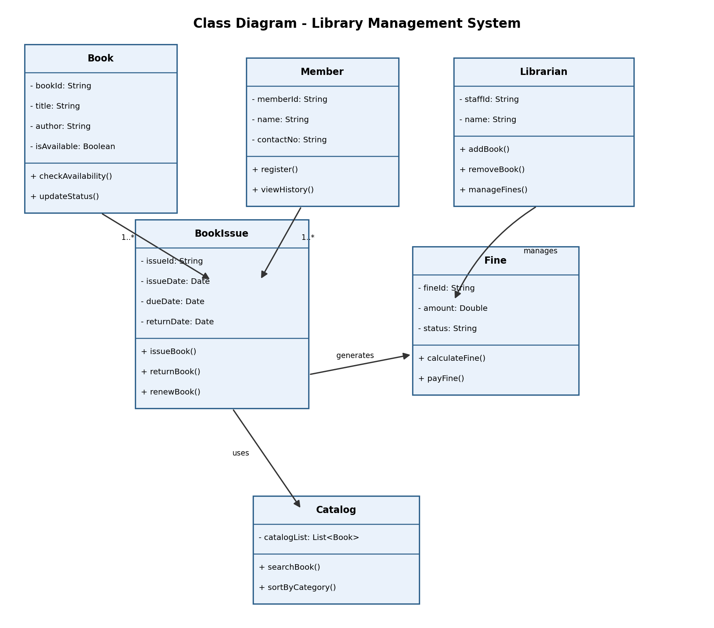
Figure 1: Class Diagram - Library Management System
Q14. Differentiate Sequence Diagram and Activity Diagram.
A sequence diagram shows the interaction between objects over time, focusing on the order of messages exchanged between different objects to complete a specific scenario — it emphasizes 'who talks to whom, and when'. An activity diagram, on the other hand, shows the flow of control or workflow of a process, focusing on the sequence of activities/actions and decision points, similar to a flowchart — it emphasizes 'what happens step by step', without necessarily showing which object sends which message. In short, sequence diagrams are object-interaction focused, while activity diagrams are process-flow focused.
Q15. Explain State Diagram with an example.
A state diagram (or state machine diagram) shows the different states an object can be in during its lifetime, and the events or conditions that cause it to transition from one state to another. For example, in an Order object in an e-commerce system, the states could be: Placed, Confirmed, Shipped, Delivered, and Cancelled. The order moves from 'Placed' to 'Confirmed' once payment succeeds, and from 'Confirmed' to 'Shipped' once the seller dispatches it. This diagram is very useful for objects whose behaviour heavily depends on their current state, like an order, a ticket, or a bank account.
Q16. What is a Deployment Diagram?
A deployment diagram shows the physical architecture of a system — how software components are deployed onto hardware, such as servers, devices and network connections. It represents nodes (physical hardware like a web server, database server or client device) and the artifacts (software components) that run on each node, along with how these nodes communicate with each other. It's mainly used in the implementation phase to plan and visualize the actual infrastructure needed to run the system, which is different from the logical class structure shown in a class diagram.
Q17. How do Component Diagrams help software architects?
A component diagram shows how a system is divided into modular, reusable components (like a payment module, authentication module, or reporting module) and the dependencies and interfaces between them. This helps software architects because it gives a high-level, organized view of the whole system's structure without going into class-level detail, making it easier to plan how the system will be built, which teams will work on which component, and how components will communicate with each other through well-defined interfaces. It also makes it easier to identify components that can be reused in other projects.
Q18. What is Multiplicity in UML?
Multiplicity in UML defines how many instances of one class can be associated with a single instance of another class in a relationship. It is usually written near the association line, using notations like 1 (exactly one), 0..1 (zero or one), 1..* (one or many), or 0..* (zero or many). For example, in a Library system, the relationship between Member and BookIssue might have a multiplicity of 1 to 0..* — meaning one member can have zero or many book issue records, but each book issue record belongs to exactly one member. Multiplicity is important because it clearly defines the rules and constraints of a relationship in the system.
SECTION D – CASE STUDY / PROBLEM SOLVING (10 Marks)
Case Study 1 – Hospital Management System
The hospital wants a system to manage Patients, Doctors, Appointments, and Billing.
1. Identify the classes.
The core classes for this system would be: Patient (holds patient details like name, age, contact, medical history), Doctor (holds doctor details like specialization and availability), Appointment (links a patient and a doctor with a date/time), and Billing (handles charges for consultations, tests and treatments). Supporting classes could also include MedicalRecord and Payment, depending on how detailed the system needs to be.
2. Draw a simple class diagram.
At a conceptual level: Patient (- patientId, - name, - age, - contactNo / + registerPatient(), + viewHistory()), Doctor (- doctorId, - name, - specialization / + viewAppointments(), + updateAvailability()), Appointment (- appointmentId, - date, - time, - status / + bookAppointment(), + cancelAppointment()), Billing (- billId, - amount, - status / + generateBill(), + processPayment()). Patient and Doctor are both connected to Appointment (each appointment links exactly one patient and one doctor), and Appointment is connected to Billing (each completed appointment generates one bill).
3. Suggest relationships among classes.
Patient and Appointment share an association (one patient can have many appointments — a 1 to 0..* relationship). Doctor and Appointment share a similar association (one doctor can have many appointments). Appointment and Billing share a composition-like relationship, since a bill is generated specifically for that appointment and doesn't make sense independently. Doctor and Patient don't need a direct relationship since they only interact through the Appointment class, which keeps the design clean and avoids unnecessary coupling.
4. Which UML diagrams would you use for analysis?
For this system, I would use a Use Case Diagram to capture what actions patients, doctors and admin staff can perform (like booking an appointment or generating a bill), a Class Diagram to define the structure of Patient, Doctor, Appointment and Billing, a Sequence Diagram to show the exact flow of messages when a patient books an appointment, and a State Diagram to show how an Appointment moves between states like Scheduled, Confirmed, Completed and Cancelled.
5. Explain how inheritance can be applied.
Inheritance can be applied by creating a general Person class with common attributes like name, age and contactNo, which is then extended by both Patient and Doctor classes, since both are fundamentally people with some shared attributes but different specific responsibilities. This avoids repeating the same attributes in both classes and keeps the design consistent — if a new common attribute needs to be added later, like an address, it can be added once in the Person class and both Patient and Doctor will automatically inherit it.
Case Study 2 – Online Shopping System
The online shopping system supports Customers, Products, Cart, Orders, and Payments.
1. Identify actors and use cases.
The main actor is the Customer, and a secondary actor would be the Payment Gateway (an external system). The key use cases for the Customer are: Login/Register, Browse Products, Manage Cart, Place Order, Make Payment, and Track Order. The Payment Gateway actor is involved specifically in the Make Payment use case, since it's an external system the shopping application communicates with to process transactions.
2. Design a use case diagram.
The use case diagram places the Customer actor on the left and the Payment Gateway actor on the right, with the Online Shopping System boundary in the middle containing the use cases: Login/Register, Browse Products, Manage Cart, Place Order, Track Order, and Make Payment. The Place Order use case includes the Make Payment use case (shown with an <<include>> relationship), since a customer cannot complete placing an order without going through payment. This is shown in the diagram below.
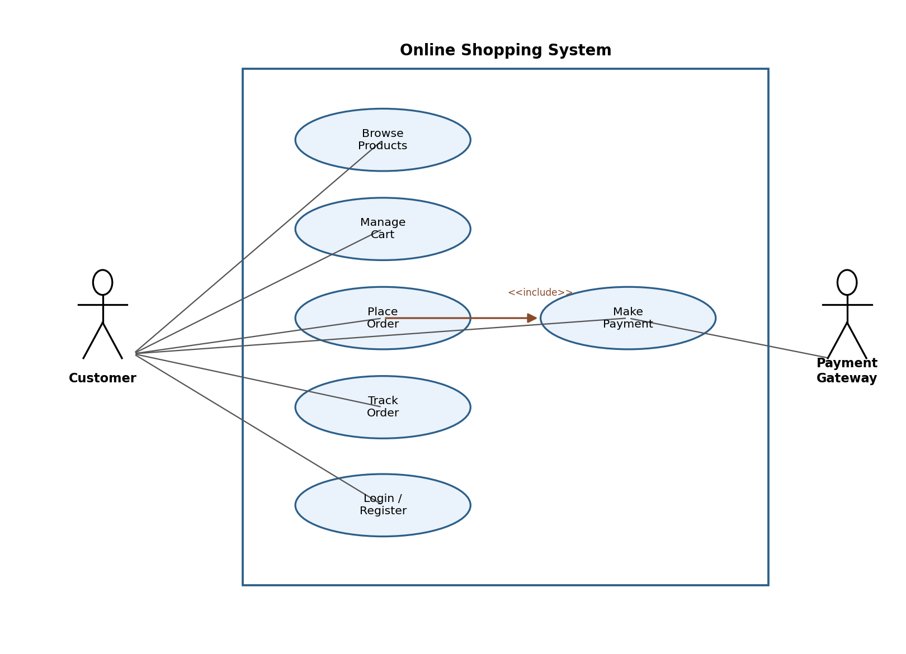
Figure 2: Use Case Diagram - Online Shopping System
3. Suggest suitable design patterns.
A few design patterns fit naturally here. The Singleton pattern can be used for the Shopping Cart, ensuring each customer session has exactly one cart instance instead of multiple conflicting ones. The Factory pattern can be used to create different types of Payment objects (credit card, UPI, wallet) without the rest of the code needing to know the exact implementation details. The Observer pattern can be used to notify the customer (via email/SMS) automatically whenever their order status changes, since multiple parts of the system may need to react to that single event.
4. Explain how polymorphism can be used in payment processing.
Polymorphism is very useful here because a shopping system needs to support multiple payment methods — credit card, debit card, UPI, wallet — but the checkout process should be able to call the same method, like processPayment(), regardless of which one the customer chose. This can be done by creating a common Payment interface or abstract class, and then having CreditCardPayment, UPIPayment, and WalletPayment classes each implement their own version of processPayment(). The rest of the application just calls payment.processPayment() without worrying about which specific subclass it is, and the correct implementation runs automatically based on the actual object type — this is runtime polymorphism, and it makes it very easy to add a new payment method later without changing the existing checkout code.
SECTION E – HR & PROFESSIONAL QUESTIONS (5 Marks)
Q19. Why should we hire you?
I bring a genuine interest in software design combined with a willingness to learn quickly and adapt to new tools and technologies. I focus not just on writing code that works, but on writing code that is well-structured and easy for others to maintain, which comes from taking subjects like OOAD seriously rather than just studying them for exams. I also work well in a team, communicate clearly when I face a problem instead of struggling silently, and I'm genuinely excited about contributing to real, practical projects rather than just theoretical ones.
Q20. What are your strengths and weaknesses?
One of my strengths is logical problem-solving — I enjoy breaking a big problem down into smaller, manageable parts, which fits well with object-oriented thinking. I'm also disciplined about meeting deadlines and organizing my work in advance. As for a weakness, I sometimes spend a bit too much time trying to perfect a small detail before moving forward, so I've been actively working on setting time limits for myself on smaller tasks so I can focus my energy on the bigger picture of a project.
Q21. How do you handle project deadlines?
I usually start by breaking the project into smaller milestones with their own mini-deadlines, instead of treating it as one large task due at the end. This way I can track progress early and know quickly if I'm falling behind, giving me time to adjust rather than rushing at the last moment. I also prioritize the core functionality first and treat extra features as a secondary goal, so that even if time runs short, I have a working solution rather than an incomplete one.
Q22. Have you worked in a team project? Explain your role.
Yes, I've worked in team projects during my coursework. In one such project, my role was mainly focused on the design and backend logic — I helped plan the class structure and relationships before the team started coding, which saved us time later since everyone had a clear idea of how the components would fit together. I also took responsibility for integrating the different modules that teammates built individually, which taught me a lot about communication and making sure everyone's code follows a consistent structure.
Q23. Where do you see yourself in five years?
In five years, I see myself as a confident and capable software developer or systems designer, having gained solid hands-on experience with real-world projects and possibly specializing further in software architecture or design. I'd like to have grown not just technically but also in terms of taking more ownership and responsibility within a team, and hopefully mentoring newer developers the way I've learned from others. I'm keeping my path flexible for now, but the constant thread is that I want to keep building things that are genuinely useful.

— End of Assessment Tool 3 Answers —

