SIMATS ENGINEERING
ASSESSMENT TOOL 1

COURSE NAME: OBJECT ORIENTED ANALYSIS AND DESIGN
COURSE CODE: CSA1102

COURSE OUTCOME COVERED
CO4: Implement object-oriented system layers using design principles and patterns, and
integrate access and view layers with OODBMS (BL3)

Assessment Tool Weightage: 30%
QUESTIONS: 15 Total Marks: 30

Annexure A
CLASS TEST

Code of Conduct:
I Kanishk C (Reg No: 192511278) certify that this submission is my original work and that I have adhered to the guidelines specified for this assessment.
I understand that any violation of academic integrity rules will result in disciplinary action.

Signature of the student: Kanishk C

Annexure A
CLASS TEST
Name: Kanishk C Registration No: 192511278

Q1. Define architectural patterns in object-oriented systems. List any two common patterns. Explain how the Model-View-Controller (MVC) architecture improves modularity and maintainability.
An architectural pattern is a general, reusable solution to a commonly occurring problem in software architecture. It describes how the major parts of a system should be organised and how they should talk to each other, so that developers do not have to invent the same structural solution again and again. Architectural patterns work at a much bigger scale than design patterns, because they decide the overall shape of the application rather than the behaviour of a single class.
Two common architectural patterns used in object-oriented systems are:
- Model-View-Controller (MVC) - separates data, presentation and control logic into three parts.
- Layered (N-Tier) Architecture - organises the system into horizontal layers such as presentation, business and data access.
In the MVC pattern, the Model holds the application data and business rules, the View is responsible only for displaying information to the user, and the Controller receives user input, updates the Model and chooses which View should be shown next. Because each part has one clear job, a change in the way data is stored (Model) does not force any change in the screens (View), and a change in the look of a screen does not touch the business rules. This separation increases modularity, since the three parts can be developed, tested and reused independently. It also improves maintainability, because a bug or a new requirement usually affects only one of the three parts instead of the whole application, and new views (for example a mobile screen in addition to a web screen) can be added without touching the Model at all.
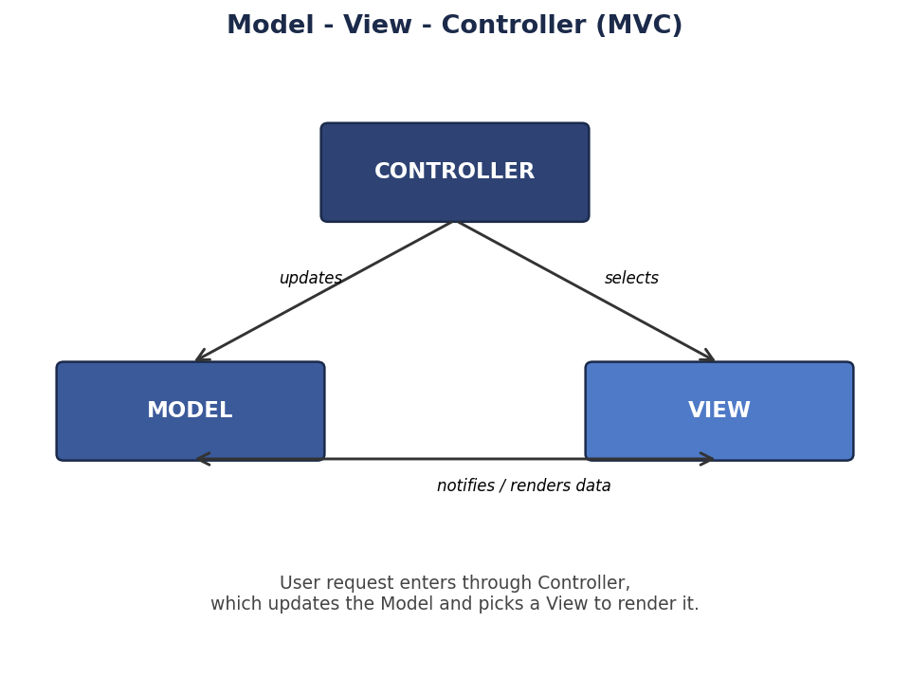
Figure 1.1 - Model-View-Controller Architecture

Q2. What is the Data Access Object (DAO) Pattern? Mention two advantages. Explain how DAO separates database-related operations from application logic.
The Data Access Object (DAO) Pattern is a structural design pattern that is used to isolate all the database or persistence-related code (such as SQL queries, OODBMS calls, or file operations) inside a separate object called a DAO. Instead of writing queries directly inside a business class, the business class simply calls methods like save(), find() or delete() on the DAO, and the DAO takes care of how the data is actually stored or retrieved.
Two advantages of using the DAO pattern are:
- It hides the low-level details of the storage technology, so if the organisation moves from one OODBMS to another, only the DAO implementation needs to change.
- It makes unit testing easier, because the business logic can be tested with a fake or mock DAO instead of connecting to a real database.
DAO achieves separation of concerns by placing an interface, for example StudentDAO, between the business logic and the actual persistence code. The business class depends only on this interface and never on the concrete database commands. A concrete class such as StudentDAOImpl implements the interface and contains all the OODBMS-specific instructions. Because of this arrangement, the application logic remains clean, readable and focused only on business rules, while everything about how and where the data is stored is pushed down into one dedicated layer.
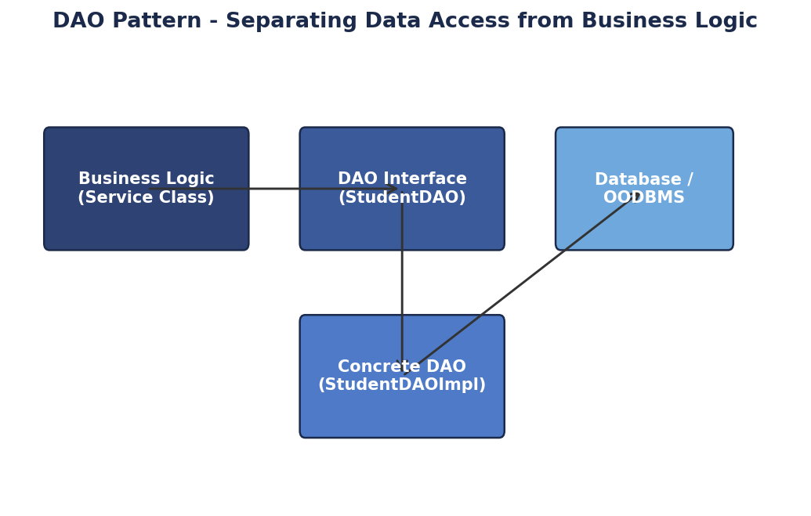
Figure 2.1 - DAO Pattern separating business logic from persistence

Q3. What are object-oriented design guidelines? Identify any two categories of design guidelines. Explain the role of the Liskov Substitution Principle (LSP) in developing reusable software components.
Object-oriented design guidelines are a set of recommended practices that help a developer produce classes and object structures that are easy to understand, extend and reuse. They are not strict rules but experience-based advice that reduces the chance of creating a design that is fragile or hard to change later.
Two broad categories of design guidelines are:
- Design principles - fundamental rules such as the SOLID principles (SRP, OCP, LSP, ISP, DIP) that guide how classes and interfaces should be structured.
- Naming and documentation guidelines - conventions for meaningful class, method and variable names, along with proper comments, that make the code self-explanatory to other developers.
The Liskov Substitution Principle (LSP) states that objects of a subclass should be usable wherever objects of the parent class are expected, without breaking the correctness of the program. In simple words, if class B is a subclass of class A, then anywhere the program uses an object of type A, it should be possible to place an object of type B instead, and the program should still behave correctly. LSP plays an important role in building reusable components because it guarantees that inheritance hierarchies behave predictably. When LSP is respected, a developer can safely reuse a base class reference in new contexts without checking the exact subtype being used, which makes polymorphism reliable and reduces the need for type-checking code such as 'if object is of type X'. Violating LSP, for example by making a subclass throw an exception for a method the parent class supports, breaks reusability because client code that trusted the parent class contract can suddenly fail.

Q4. Define database persistence in object-oriented applications. Mention two persistence mechanisms. Explain how an Object-Relational Mapping (ORM) framework supports persistent object management.
Database persistence refers to the ability of an object to continue existing and keep its state even after the program that created it has stopped running. In an object-oriented application, persistence means saving the values held inside an object (its attributes) into permanent storage such as a database, so that the same object can be reconstructed and used again later.
Two common persistence mechanisms are:
- Serialization - converting an object into a byte stream or a file format (such as JSON or XML) that can be written to disk and later read back.
- Object-Relational Mapping (ORM) - automatically converting objects into rows of relational tables and back, without the developer writing manual SQL for every operation.
An ORM framework, such as Hibernate, sits between the application's domain objects and the underlying database. It reads simple mapping information (through annotations or configuration files) that tells it which class corresponds to which table and which attribute corresponds to which column. Once this mapping is defined, the developer can simply call save(object) or find(id) in plain object-oriented code, and the ORM framework automatically generates and executes the correct insert, update, select or delete statements behind the scenes. This means the developer works entirely with objects and does not need to write repetitive SQL, the framework manages relationships (such as one-to-many associations) automatically, and it also manages caching and transactions, which makes persistent object management far more productive and less error-prone.

Q5. What is an Application Layer? State two major responsibilities. Explain how the Application Layer coordinates use cases without directly implementing domain business rules.
The Application Layer is a thin layer that sits between the presentation layer and the domain layer in a layered architecture. It is responsible for coordinating a particular use case or user action, such as 'place an order' or 'register a student', by calling the correct domain objects and services in the right sequence, without itself containing detailed business rules.
Two major responsibilities of the Application Layer are:
- Coordinating a use case - receiving a request from the presentation layer, calling the required domain objects in order, and returning a result.
- Managing transaction boundaries - deciding where a business operation starts and ends, and making sure related steps succeed or fail together.
The Application Layer coordinates a use case without implementing business rules itself by delegating all decision-making to the domain layer. For example, when a 'transfer funds' request arrives, the Application Layer does not decide the interest rate or check the withdrawal limit on its own; instead it calls methods on Account and Transaction domain objects, which contain that logic. The Application Layer only decides the order in which these calls happen and handles things like starting a transaction, catching errors and sending a response back to the presentation layer. This keeps business rules concentrated inside the domain layer, so the same rules stay consistent no matter how many different use cases call them, and the Application Layer stays thin, easy to read and easy to change.

Q6. Explain the structure of a three-tier architecture consisting of Presentation, Business, and Data layers. Analyze the flow of a customer transaction through these layers in an e-commerce application.
A three-tier architecture divides an application into three separate layers, each with a clear responsibility, so that a change in one layer has minimal effect on the others.
- Presentation Layer - the user interface (web pages, mobile screens) that collects input from the user and displays results.
- Business Layer - contains the business rules, validations and calculations, and decides what should happen with the data received from the presentation layer.
- Data Layer - responsible for storing and retrieving data from the database, without knowing anything about business rules or the user interface.
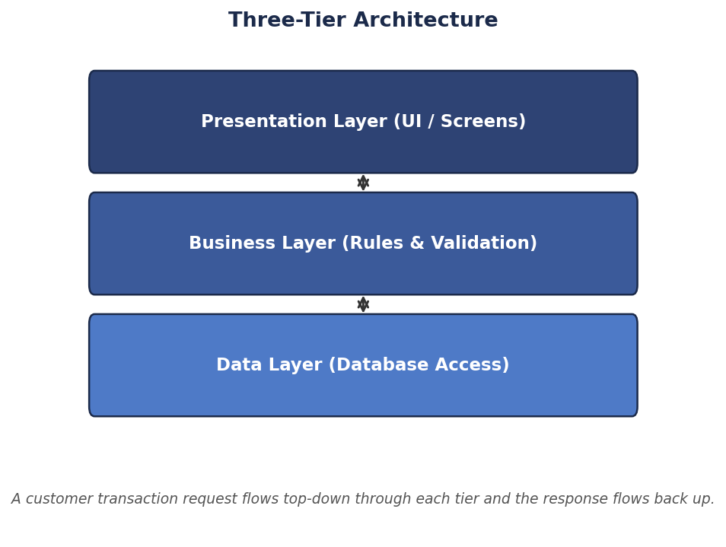
Figure 6.1 - Three-Tier Architecture
Consider a customer placing an order on an e-commerce website. The customer selects products and clicks 'Checkout' on the Presentation Layer, which packages this input and sends it to the Business Layer. The Business Layer checks whether the items are in stock, applies discount rules, calculates the total price including tax, and validates the customer's payment details. Once the transaction is approved, the Business Layer calls the Data Layer to permanently store the order, update the inventory count and record the payment. The Data Layer executes the required database operations and returns a confirmation back to the Business Layer, which formats the result (for example, an order confirmation message) and passes it back to the Presentation Layer, where the customer finally sees the 'Order Placed Successfully' screen. At every step, each layer only talks to the layer directly above or below it, which keeps the design clean, testable, and easy to scale as the number of customers grows.

Q7. What is the role of a Business Logic Layer? List two important functions. Explain how it validates and processes requests received from the presentation layer.
The Business Logic Layer is the part of a layered application that contains the core rules and decision-making of the system. It stands between the presentation layer, which only handles input and output, and the data layer, which only handles storage, and makes sure that every operation follows the rules of the organisation before any data is changed or saved.
Two important functions of the Business Logic Layer are:
- Validating incoming data - checking that the values sent from the presentation layer are complete, correctly formatted and within allowed limits.
- Applying business rules and calculations - such as calculating interest, discounts, tax, or eligibility, based on the organisation's policies.
When a request arrives from the presentation layer, for example a request to withdraw money from a bank account, the Business Logic Layer first validates the request: it checks that the amount is a positive number, that the account exists, and that the account is active. If any of these checks fail, the Business Logic Layer immediately rejects the request and sends an error message back to the presentation layer, without touching the database. If the request passes validation, the layer then applies the relevant business rule, such as checking whether the withdrawal amount is within the daily limit and whether sufficient balance is available. Only after all rules are satisfied does the Business Logic Layer instruct the Data Access Layer to update the stored balance. This two-step approach of validate-then-process protects the integrity of the data and keeps the presentation layer free of any business decision-making.

Q8. Explain the significance of cohesion and coupling in object-oriented design. Analyze how high cohesion and low coupling contribute to software maintainability and reusability.
Cohesion measures how closely the responsibilities inside a single class are related to one another, while coupling measures how much one class depends on the internal details of another class. These two ideas are among the most important quality measures in object-oriented design, because together they decide how easy or difficult a system will be to understand, change and reuse.
A class with high cohesion has a single, well-defined purpose; for example, an Invoice class that only deals with invoice items and totals is highly cohesive, whereas a class that also handles email sending and file logging is doing too many unrelated jobs and has low cohesion. Low coupling means that classes interact through simple, well-defined interfaces and do not depend on each other's internal implementation; for example, a Service class that talks to a DAO only through an interface is loosely coupled, whereas a class that directly manipulates another class's private data structures is tightly coupled.
High cohesion improves maintainability because when a requirement changes, the developer usually knows exactly which class to open, since each class does one job well; there is no need to search through unrelated code mixed into the same class. Low coupling improves maintainability because a change inside one class, such as switching from a list to a database table, does not force changes in other classes that use it, as long as the interface stays the same. Together, high cohesion and low coupling also improve reusability, because a class that does one clear job and does not depend heavily on other specific classes can be picked up and used in a different project or a different part of the same application with very little modification. This is why, together, they are considered the foundation of a healthy, flexible object-oriented design.

Q9. What is encapsulation in an object-oriented system? Explain how encapsulation protects object state and compare it with data hiding using a suitable example.
Encapsulation is the object-oriented principle of bundling an object's data (attributes) and the methods that operate on that data into a single unit, called a class, and controlling how that data can be accessed from outside the class. Instead of allowing other parts of the program to read or change an attribute directly, the class exposes only specific public methods, usually called getters and setters, through which the outside world is allowed to interact with the object.
Encapsulation protects the state of an object by preventing uncontrolled or invalid changes to its attributes. For example, consider a BankAccount class with a private attribute balance. If balance were public, any other class could set it to a negative number directly. With encapsulation, balance is kept private, and a method withdraw(amount) is provided instead; this method can check that the amount is positive and that sufficient balance exists before changing the value. In this way, the object's internal state can never move into an invalid condition, because every change must pass through the validation logic written inside the class.
Data hiding is closely related to encapsulation but refers specifically to the act of restricting direct access to an object's internal data by marking attributes as private or protected. Encapsulation is the broader concept of combining data and behaviour into one unit and controlling access to it, while data hiding is the specific technique (using access modifiers) used to achieve part of that goal. In the BankAccount example, marking balance as private is the data hiding technique, while the entire class design, that bundles balance together with deposit() and withdraw() and exposes only safe methods, is the encapsulation.

Q10. Design a layered object-oriented system for an online banking application. Identify the major layers, recommend suitable design patterns, and justify how the architecture improves security, scalability, and maintainability.
An online banking application can be organised into five layers, each with a distinct responsibility, so that user interface concerns, business rules and database access never mix together.
- Presentation Layer - web and mobile banking screens that collect login details, transaction requests and display statements.
- Business/Service Layer - validates requests, checks fraud rules, applies transaction limits and coordinates fund transfer, bill payment and loan operations.
- Domain Layer - contains core objects such as Account, Customer, Transaction and Loan, along with the rules that belong to them.
- Data Access Layer - implemented using the Repository or DAO pattern, responsible for saving and retrieving these objects from the OODBMS.
- Database (OODBMS) - the persistent store that keeps all account and transaction records safely.
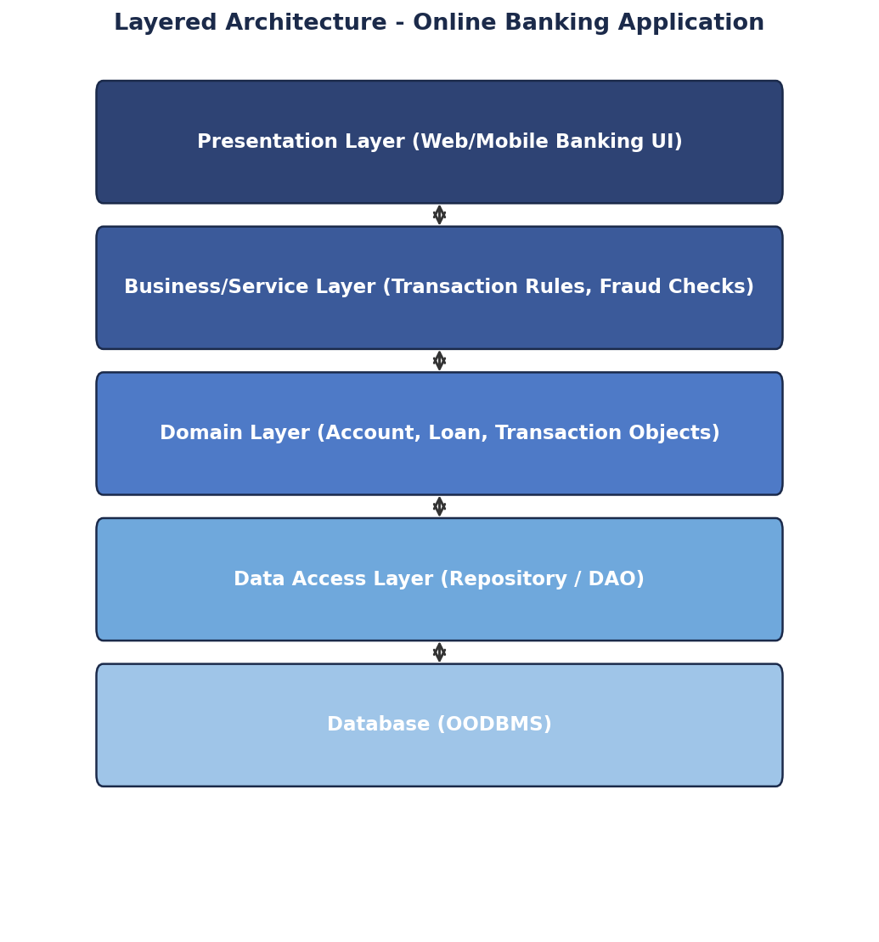
Figure 10.1 - Layered Architecture for Online Banking
Several design patterns fit naturally into this architecture. The Factory Pattern can be used in the Domain Layer to create different account types (Savings, Current, Fixed Deposit) without the Service Layer needing to know the construction details. The Strategy Pattern can be used to plug in different interest-calculation or fraud-detection algorithms without changing the Service Layer's code. The Observer Pattern is useful for sending real-time alerts, for example notifying a customer by SMS whenever a large withdrawal occurs. The Repository Pattern in the Data Access Layer keeps all OODBMS queries in one place.
This layered design improves security because sensitive operations such as fund transfer are validated in one central Business Layer, and the presentation layer never talks to the database directly, which reduces the chance of an unauthorised or malformed request reaching the data store. It improves scalability because each layer can be scaled independently; for instance, more presentation servers can be added during peak login hours without changing the business or data layers. Finally, it improves maintainability because a new feature, such as adding UPI payments, mainly involves adding a new class in the Service and Domain layers, without disturbing the existing presentation screens or database access code.

Q11. What is the role of the Infrastructure Layer in object-oriented architecture? List two responsibilities. Explain how it supports technical services such as database access and external system communication.
The Infrastructure Layer is the part of a layered architecture that provides all the low-level technical support the rest of the system needs, without containing any business logic of its own. It acts as a bridge between the application's domain and business layers and the outside technical world, such as databases, file systems, email servers and third-party APIs.
Two responsibilities of the Infrastructure Layer are:
- Providing database connectivity and persistence support, often through DAO or Repository implementations.
- Handling communication with external systems, such as payment gateways, SMS gateways or third-party web services.
When the Business or Domain layer needs to save an object or call an external service, it does not talk to the database driver or the network API directly. Instead, it calls a simple interface, and the Infrastructure Layer, sitting underneath, performs the actual technical work: opening a database connection, converting the object into rows for the OODBMS, or formatting and sending an HTTP request to a payment gateway and interpreting the response. Because this technical complexity is isolated in one layer, the rest of the application remains focused only on business meaning, and if a technical detail changes, for example the database vendor or a payment gateway is replaced, only the Infrastructure Layer needs to be updated.

Q12. Define the Singleton Design Pattern. Mention its major characteristics. Explain its appropriate use in managing shared resources and discuss one limitation of the pattern.
The Singleton Design Pattern is a creational design pattern that ensures a class has only one instance throughout the lifetime of the application and provides a single, global point of access to that instance.
The major characteristics of the Singleton pattern are:
- A private constructor, so that no other class can directly create a new object of the Singleton class using the 'new' keyword.
- A private static variable that holds the one and only instance of the class.
- A public static method (commonly getInstance()) that creates the instance the first time it is needed and returns the same instance on every later call.
The Singleton pattern is appropriate for managing shared resources where having more than one instance would waste resources or cause conflicts. For example, a database connection manager, a configuration reader, or a logging service is often implemented as a Singleton, because the whole application should share one connection pool, one set of configuration values, or one log file writer, rather than each class creating its own separate copy.
One well-known limitation of the Singleton pattern is that it can make unit testing difficult. Because the Singleton hides its creation logic and provides a global instance, it becomes hard to replace it with a mock or fake object during testing, and tests that use the same Singleton can accidentally affect each other's results if the shared state is not reset between tests. For this reason, many modern designs prefer to use Dependency Injection to supply a single shared instance instead of relying purely on the classic Singleton pattern.

Q13. What is dependency injection in object-oriented design? List two benefits. Analyze how dependency injection reduces tight coupling between classes and improves testability.
Dependency Injection (DI) is a design technique in which an object does not create the other objects it depends on by itself; instead, those dependencies are supplied ('injected') to it from outside, usually through a constructor, a setter method, or a dependency injection container/framework.
Two benefits of dependency injection are:
- It reduces tight coupling, because a class depends only on an interface or abstraction, not on a specific concrete implementation.
- It makes automated testing much easier, because a real dependency can be swapped for a mock or stub object during a test.
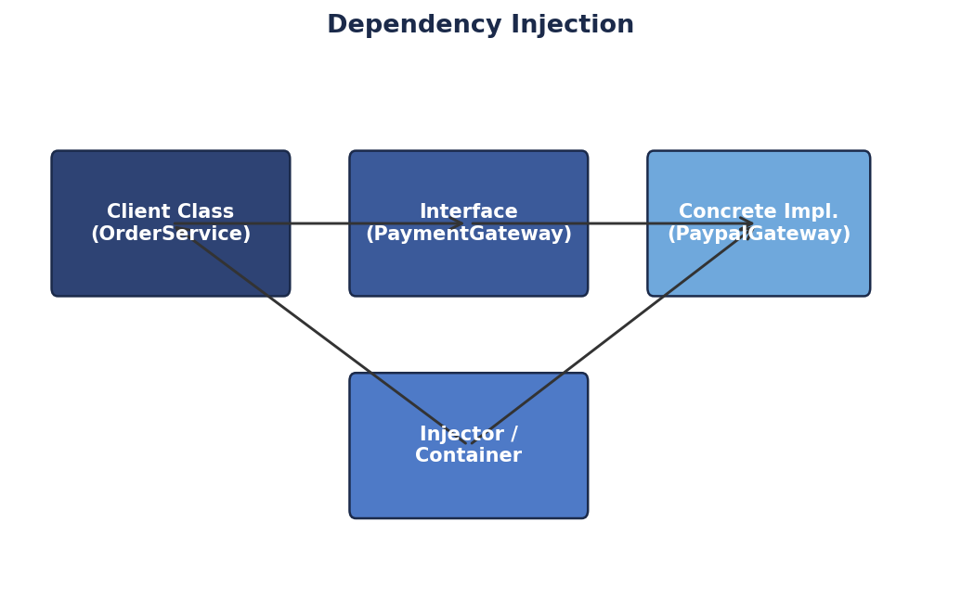
Figure 13.1 - Dependency Injection
Without dependency injection, a class such as OrderService might directly create a new PaypalGateway() object inside its own code, which means OrderService is now permanently tied to that one specific payment provider. With dependency injection, OrderService instead depends only on a PaymentGateway interface, and the actual implementation, whether it is PaypalGateway, RazorpayGateway, or a test double, is passed in from outside by an injector or container. This reduces coupling because OrderService no longer needs to know which concrete class it is working with; it only needs to know the methods defined in the interface. It also improves testability, because during unit testing, a fake PaymentGateway can be injected that always returns a successful payment, allowing the OrderService logic to be tested in isolation, quickly and reliably, without needing a real payment gateway or network connection.

Q14. Explain the working of the Strategy Design Pattern. Compare the roles of Context and Strategy with a suitable real-world application example.
The Strategy Design Pattern is a behavioural design pattern that defines a family of interchangeable algorithms, encapsulates each one in its own class, and allows the algorithm being used to be selected or changed at run time without altering the code that uses it.
The pattern has two key roles. The Context is the class that needs to perform an operation but does not want to hard-code exactly how that operation is done; it holds a reference to a Strategy object and simply calls a common method on it whenever the operation is required. The Strategy is an interface (or abstract class) that declares the method every concrete algorithm must implement, and each Concrete Strategy class provides its own specific version of that algorithm.
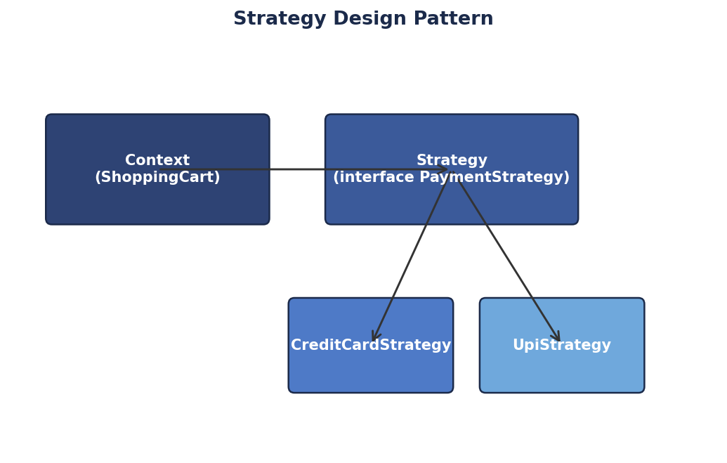
Figure 14.1 - Strategy Pattern applied to online payments
A good real-world example is an online shopping cart that supports multiple payment methods. Here, ShoppingCart acts as the Context: it does not know or care how a payment is actually processed, it only calls pay(amount) on whatever PaymentStrategy object it currently holds. PaymentStrategy is the Strategy interface, and CreditCardStrategy and UpiStrategy are Concrete Strategies that each implement pay(amount) in their own way, one talking to a card network and the other to a UPI gateway. At checkout, the customer's choice of payment method decides which Concrete Strategy object is passed to the ShoppingCart. If a new payment method, such as a digital wallet, needs to be added later, a new Concrete Strategy class is written and plugged in, while the ShoppingCart class itself never needs to be changed. This clearly shows how the Context stays stable and reusable while the Strategy classes carry the varying behaviour.

Q15. Design a layered architecture for a Library Management System. Identify suitable layers, recommend relevant design patterns, and justify how your proposed architecture supports flexibility and maintainability.
A Library Management System can be structured using the same five-layer approach used in most enterprise object-oriented applications, so that issuing books, managing members and generating fine reports are all handled in a clean and organised way.
- Presentation Layer - screens used by the librarian to search books, issue/return items, and screens used by members to check their loan history.
- Business Layer - applies rules such as maximum books per member, due-date calculation and fine calculation.
- Domain Layer - core objects such as Book, Member, Loan and Fine, each carrying its own relevant attributes and behaviour.
- Data Access Layer - BookDAO and MemberDAO classes that handle saving and retrieving these objects.
- Database (OODBMS) - stores books, member records and loan history persistently.
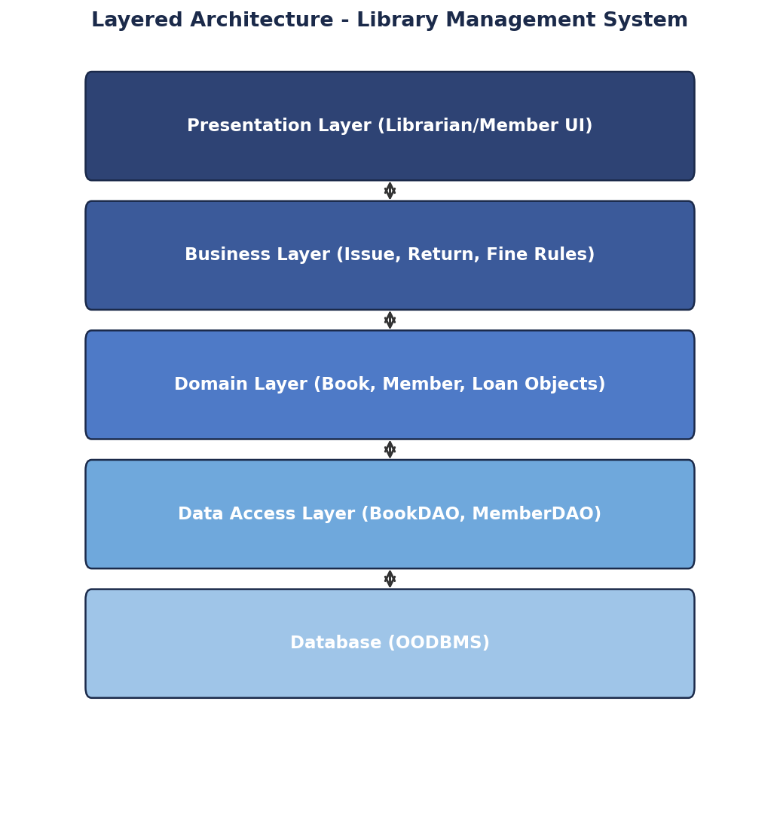
Figure 15.1 - Layered Architecture for Library Management System
For design patterns, the DAO Pattern is recommended for the Data Access Layer, giving separate, focused classes for book records and member records. The Observer Pattern can be used so that when a reserved book becomes available, all members who reserved it are automatically notified. The Strategy Pattern can be applied to fine calculation, since different membership types (student, faculty, guest) may have different fine rules, and a new fine policy can be added as a new Strategy class without touching existing code.
This layered design supports flexibility because each layer depends only on the layer directly below it through simple interfaces; for example, if the library later needs to move from a local OODBMS to a cloud-based database, only the Data Access Layer needs to change, and the Business and Presentation layers remain untouched. It supports maintainability because responsibilities are clearly separated: a change in fine policy is made only in the Business Layer, a change in the book search screen is made only in the Presentation Layer, and developers can locate and fix issues quickly without reading through unrelated code, which keeps the system easy to extend as the library grows, for example by adding e-book lending in the future.

RUBRICS FOR CALCULATION
CLASS TEST

Criteria | Weightage | Level 4 (Exemplary) | Level 3 (Proficient) | Level 2 (Developing) | Level 1 (Beginning)
Understanding of Concepts | 25% | Thorough, accurate understanding of concepts | Good understanding with minor gaps | Basic understanding with some misconceptions | Poor understanding; major misconceptions
Explanation | 25% | Detailed, well-explained answers with relevant examples | Clear explanation with adequate details | Limited explanation; lacks depth | Poor or unclear explanation
Application | 20% | Effectively applies concepts with strong analytical ability | Applies concepts with minor errors | Limited application with weak analysis | No application or incorrect analysis
Organization | 15% | Well-structured answers with logical flow and coherence | Organized with minor issues in flow | Basic structure, lacks clarity | Poor organization, incoherent answers
Accuracy | 10% | Completely accurate and covers all required points | Mostly accurate with minor omissions | Partially correct with missing points | Incorrect answers with major gaps
Clarity | 5% | Clear, neat, professional presentation | Understandable with minor issues | Limited clarity, readability issues | Poorly written, difficult to understand

