SIMATS ENGINEERING
ASSESSMENT TOOL 2

COURSE NAME: OBJECT ORIENTED ANALYSIS AND DESIGN
COURSE CODE: CSA1102

COURSE OUTCOME COVERED
CO4: Implement object-oriented system layers using design principles and patterns, and
integrate access and view layers with OODBMS (BL5)

Assessment Tool Weightage: 40%
QUESTIONS: 5 Total Marks: 40

Annexure A
Industry Problem Solving Task

Code of Conduct:
I Kanishk C (Reg No: 192511278) certify that this submission is my original work and that I have adhered to the guidelines specified for this assessment.
I understand that any violation of academic integrity rules will result in disciplinary action.

Signature of the student: Kanishk C

Annexure A
Industry Problem Solving Task
Name: Kanishk C Registration No: 192511278

1. Smart Banking and Financial Management System
Question: Analyze how object-oriented principles, layered architecture, and design patterns contribute to the scalability, security, flexibility, and maintainability of the banking system. Explain how the application layers communicate with the OODBMS to store and retrieve persistent banking objects.
The Smart Banking and Financial Management System is built on a layered object-oriented architecture consisting of a Presentation Layer, a Service Layer, a Domain Layer and a Data Access Layer, all connected to an OODBMS. This structure separates the concerns of user interaction, business processing, core banking rules, and persistence, which is essential for an application that handles sensitive financial data and must run reliably for thousands of customers at once.
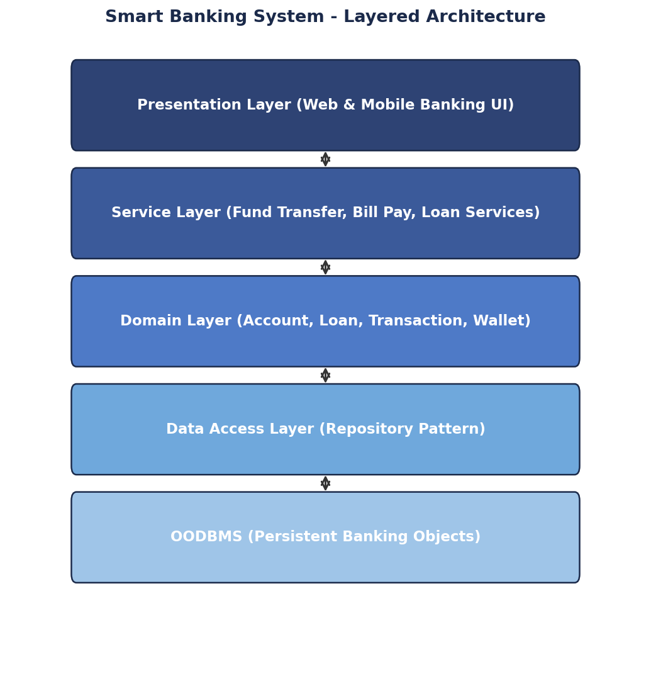
Figure 1.1 - Layered Architecture of the Smart Banking System
Object-oriented principles play a central role in the design. Encapsulation keeps attributes such as account balance and PIN hidden inside the Account and Customer classes, exposing them only through controlled methods like deposit() and withdraw(), which protects sensitive data from unauthorised modification. Inheritance allows different account types, such as Savings Account and Current Account, to share common attributes and behaviour from a base Account class while overriding specific rules like minimum balance. Polymorphism allows the Service Layer to call a common method, for example calculateInterest(), on any account object and have the correct account-specific logic execute automatically.
Several design patterns strengthen the architecture further. The Factory Pattern is used to create different account types without the Service Layer needing to know the exact class being instantiated, which makes it simple to add a new account type later, such as a Recurring Deposit account, without modifying existing code. The Strategy Pattern is applied to loan-interest and payment-calculation policies, allowing the bank to plug in a new interest calculation formula or a new payment schedule as a separate class, rather than rewriting existing logic with conditional statements. The Observer Pattern supports transaction and fraud alerts; whenever a transaction occurs, registered observers such as an SMS-alert service and a fraud-monitoring service are automatically notified, without the core transaction code needing to know about every alerting mechanism. The Repository Pattern manages all communication with the persistent banking objects, hiding OODBMS-specific operations behind simple methods such as save() and findById().
Together, these choices support scalability because each layer can be scaled independently, for example running additional Presentation Layer servers during peak hours while the Domain and Data Access layers remain unchanged. They support security because sensitive operations pass through a single, well-controlled Service Layer, and encapsulated domain objects prevent direct, uncontrolled access to account data. They support flexibility because new account types, interest policies or alert channels can be added as new classes through the Factory, Strategy and Observer patterns without touching the existing, tested code, which follows the Open-Closed Principle. They support maintainability because a bug or a change request usually maps clearly to a single layer or a single class, making it faster and safer to fix or extend the system, for example when adding upcoming services such as investment management or digital wallets.
Communication with the OODBMS happens strictly through the Data Access Layer. When the Service Layer needs to persist a change, for example after a fund transfer, it calls a method on the Repository interface such as accountRepository.save(account). The Repository implementation converts the in-memory Account object into the corresponding persistent object structure and issues the necessary OODBMS operations to store it, and later, when the object is needed again, the Repository retrieves it and reconstructs it back into a fully usable Account object for the Domain and Service layers. Because the Presentation and Service layers never talk to the OODBMS directly, the bank could replace or upgrade its database technology in the future by changing only the Repository implementation, without any impact on the rest of the system.

2. Smart Retail and Inventory Management System
Question: Evaluate how object-oriented design principles, layered architecture, and design patterns improve the flexibility, scalability, and maintainability of the retail system. Explain how the different layers interact with the OODBMS for efficient inventory persistence and retrieval.
The Smart Retail and Inventory Management System follows a layered object-oriented architecture with Presentation, Business, Domain and Data Access layers, all connected to an OODBMS, to manage products, suppliers, customers, purchase orders, sales transactions and warehouse stock in a structured and reliable way.
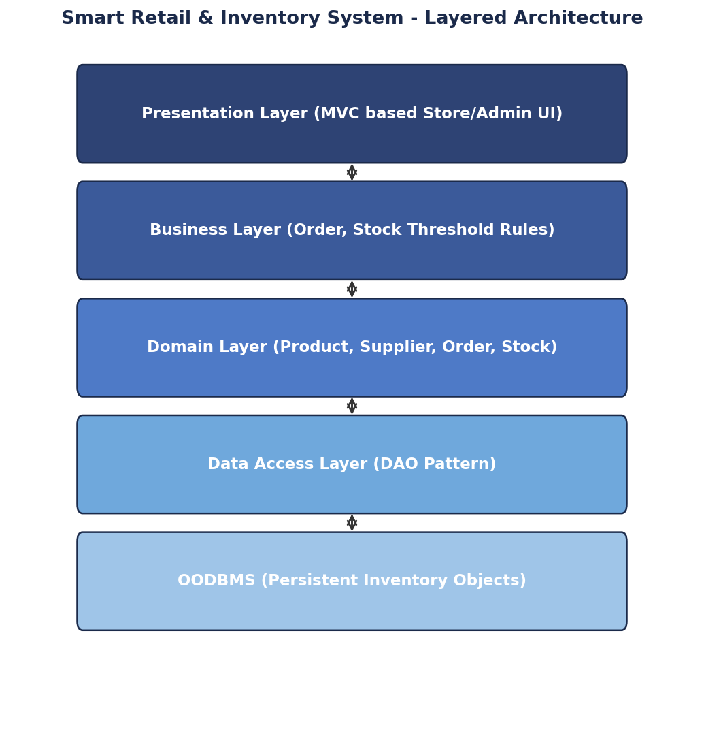
Figure 2.1 - Layered Architecture of the Smart Retail and Inventory System
Object-oriented design principles keep the system organised as it grows. Encapsulation protects attributes such as stock quantity and price inside the Product class, allowing changes only through validated methods such as reduceStock(quantity), which prevents stock levels from becoming negative or incorrect. Inheritance is used so that different product categories, such as Electronics and Groceries, share a common base Product class while adding their own specific attributes, such as warranty period or expiry date. Abstraction is used throughout the Business Layer so that it interacts with products, suppliers and orders through simple, meaningful operations rather than low-level data manipulation.
The system applies the MVC Pattern in the Presentation Layer, which separates the store and admin screens (View) from the data being displayed (Model) and the logic that responds to user actions (Controller), making the user interface easier to update independently of business rules. The Factory Pattern is used to create different product category objects, so adding a new category in the future only requires a new class and a small addition to the factory, not changes throughout the codebase. The Observer Pattern notifies managers automatically when inventory reaches a minimum threshold; the Product or Stock object simply raises an event, and any number of observers, such as an email-alert service or a dashboard widget, can react to it without the core stock-reduction logic knowing anything about how the alert is delivered. The DAO Pattern handles all communication with persistent inventory objects, keeping OODBMS queries out of the Business Layer entirely.
This combination improves flexibility because new product categories, alert mechanisms, or user-interface changes can be introduced as new classes without modifying the tested core logic, directly supporting the Open-Closed Principle. It improves scalability because the Presentation Layer, which usually receives the highest traffic from customers browsing products, can be scaled up independently of the Data Access Layer, and the DAO pattern allows caching or query optimisation to be added in one place without affecting the rest of the application. It improves maintainability because responsibilities are clearly divided: a change to a discount rule is made only in the Business Layer, and a change to how stock is stored is made only in the Data Access Layer, which keeps the impact of any single change small and predictable, and also allows the future addition of automated stock prediction and robotic warehouse management with minimal disruption to existing code.
For persistence, when a sale is completed, the Business Layer calculates the new stock level and calls a DAO method such as productDAO.updateStock(productId, newQuantity). The DAO translates this call into the appropriate OODBMS operation, ensuring the stock record is updated safely, and when the Presentation Layer needs to display current stock, it goes through the Business Layer, which calls productDAO.findById(productId) to retrieve the latest object. Since every layer only talks to the OODBMS through the DAO, inventory data stays consistent and centrally controlled, and efficient retrieval techniques, such as indexing frequently searched products, can be optimised inside the DAO layer alone.

3. Smart Hotel and Hospitality Management System
Question: Analyze how object-oriented principles and design patterns support flexibility, reusability, and maintainability in the hotel management system. Explain how the layered architecture coordinates reservation processing and communicates with the OODBMS for persistent data management.
The Smart Hotel Management System manages guest registration, room reservations, check-in/check-out, payments, room services and customer feedback using a layered object-oriented architecture made up of Presentation, Service, Domain and Data Access layers, all connected to an OODBMS.
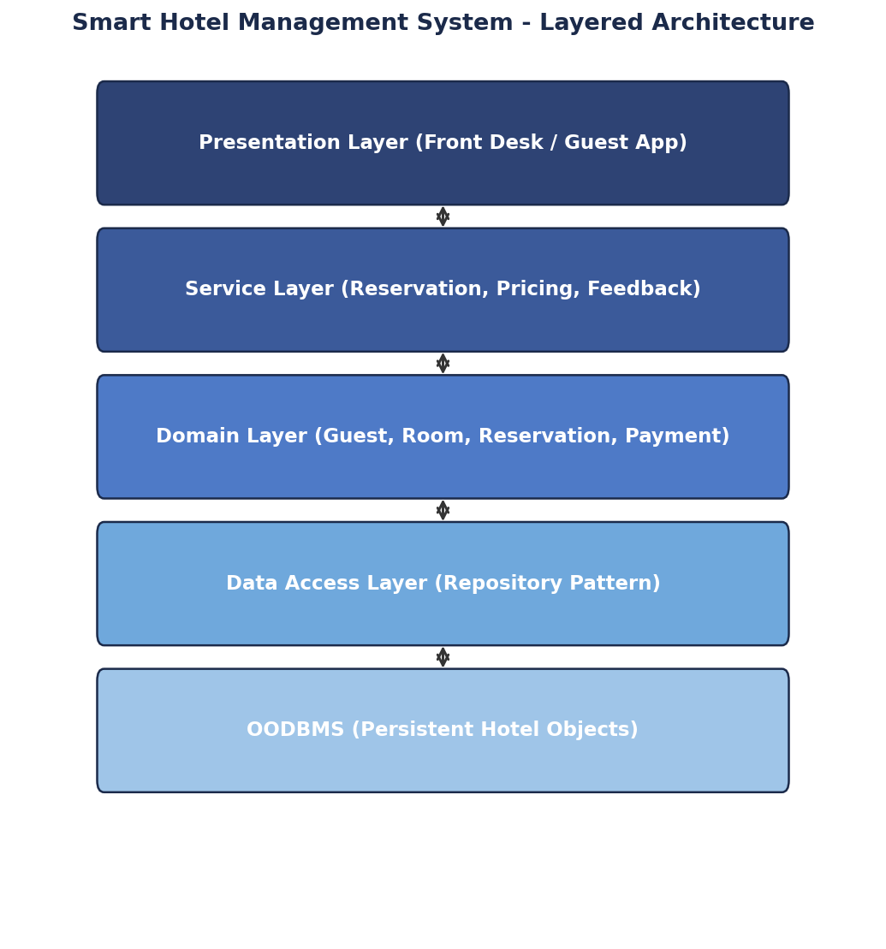
Figure 3.1 - Layered Architecture of the Smart Hotel Management System
Object-oriented principles give the system a strong, reusable foundation. Encapsulation keeps details such as room availability status and guest contact information private inside the Room and Guest classes, exposed only through safe methods such as bookRoom() and updateContact(). Inheritance allows different room types, for example Deluxe Room and Suite, to extend a common Room class while adding their own pricing and amenities. Polymorphism allows the Service Layer to call a single calculatePrice() method on any room or service object and automatically get the correct price based on the specific type of room or service being booked.
The Strategy Pattern is used for different pricing and discount policies, so the hotel can switch between a seasonal pricing strategy, a loyalty-member discount strategy, or a weekend-rate strategy simply by selecting a different Strategy object, without changing the reservation code itself. The Factory Pattern creates room and service objects, so introducing a new room category or a new spa/service package only requires adding a new class recognised by the factory. The Observer Pattern manages reservation and service notifications: when a reservation is confirmed or a room-service request is placed, observers such as the front-desk dashboard and the guest's mobile notification service are informed automatically. The Repository Pattern simplifies communication between the business components and the persistent hotel objects, offering simple methods to save and fetch guests, rooms, reservations and payments.
This design supports flexibility because new pricing rules, room types, or notification channels can be added as new classes that plug into the existing Strategy, Factory, and Observer structures, without editing the core reservation workflow. It supports reusability because common behaviour, such as pricing calculation logic in the Room hierarchy, is written once in the base class and reused by every subclass, reducing duplicate code across different room and service types. It supports maintainability because the clear separation between layers means that a change to how discounts are calculated only touches the Strategy classes in the Service Layer, and a change to the database technology only touches the Repository implementation in the Data Access Layer, which also makes it easier to add planned future enhancements such as smart-room automation and personalised guest services.
For reservation processing, when a guest requests a booking through the Presentation Layer, the request travels to the Service Layer, which checks room availability by calling the Domain Layer's Room objects, applies the correct pricing Strategy, and then calls the Repository to check and update the persistent reservation record. The Repository Pattern performs the actual OODBMS read and write operations, retrieving the Room and Reservation objects when checking availability and saving the updated Reservation object once the booking is confirmed. Because the Service Layer never issues OODBMS commands directly, the hotel chain can extend its reservation system to additional properties or migrate its database in the future by modifying only the Repository layer.

4. Smart Logistics and Delivery Management System
Question: Examine how object-oriented design principles, layered architecture, and design patterns improve the adaptability, scalability, and maintainability of the logistics system. Explain how the layers communicate with the OODBMS to manage persistent shipment, vehicle, and delivery information.
The Smart Logistics and Delivery Management System manages shipment registration, warehouse operations, vehicle allocation, delivery tracking and customer notifications through a layered object-oriented architecture with Presentation, Business, Domain and Data Access layers connected to an OODBMS.
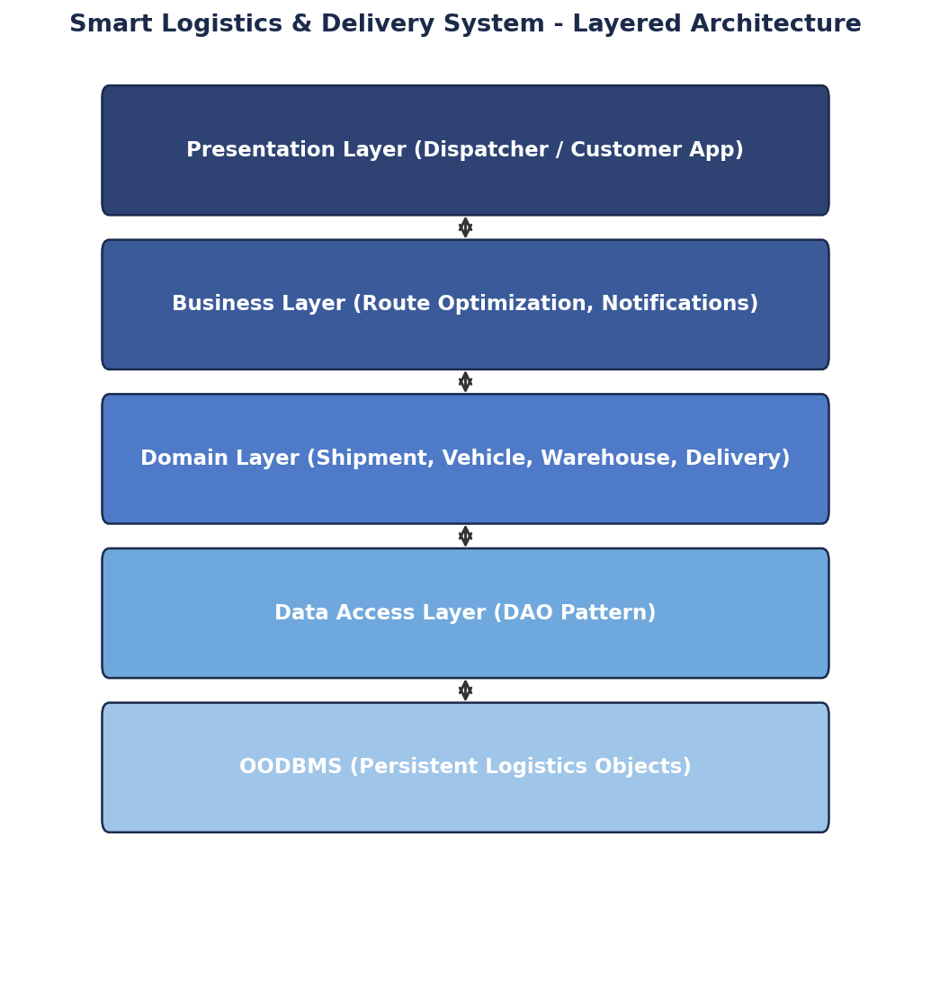
Figure 4.1 - Layered Architecture of the Smart Logistics System
Object-oriented design principles keep the growing number of shipment types and vehicle categories manageable. Encapsulation hides internal details such as a vehicle's current load and location inside the Vehicle class, exposed only through methods like updateLocation() and assignShipment(). Inheritance allows different shipment types, such as Fragile Shipment and Bulk Shipment, to extend a common Shipment class while adding their own handling rules. Abstraction lets the Business Layer work with a general Shipment or Vehicle interface without needing to know every specific detail of each subtype.
The Strategy Pattern is used for selecting optimal delivery routes, allowing the system to switch between a shortest-distance strategy, a fastest-time strategy, or a fuel-efficient strategy depending on business needs, without altering the delivery-scheduling code. The Factory Pattern creates different shipment type objects, so a new shipment category, such as temperature-controlled shipment, can be introduced by adding one new class. The Observer Pattern supports real-time delivery status notifications; as a Shipment object changes state (picked up, in transit, delivered), registered observers such as the customer notification service and the dispatch dashboard are updated automatically, without the shipment tracking logic needing direct knowledge of every notification channel. A DAO Pattern manages persistent shipment and vehicle information, offering focused methods for saving and retrieving this data.
This design improves adaptability because new delivery strategies or shipment types can be added as new classes that conform to existing interfaces, which is especially valuable for a company planning to integrate autonomous delivery vehicles and AI-based route optimisation in the future, since these can be introduced as new Strategy implementations. It improves scalability because the Business Layer, which performs route calculations and assignment logic, can be scaled or optimised separately from the Presentation Layer used by dispatchers and customers, and the DAO layer can be tuned for high-volume shipment data independently. It improves maintainability because vehicle allocation rules, route logic, and notification handling are each isolated in their own classes, so a change in one area, such as an updated fuel-efficiency formula, does not risk breaking unrelated features like customer notifications.
For persistence, when a shipment is created or its status changes, the Business Layer calls DAO methods such as shipmentDAO.save(shipment) or vehicleDAO.updateStatus(vehicleId, status). The DAO layer converts these calls into the appropriate OODBMS operations, storing shipment, vehicle and delivery records in a consistent, centrally managed way, and when the Presentation Layer needs to display live tracking information, the Business Layer retrieves the latest Shipment and Vehicle objects through the same DAO methods. Because all persistence flows through this one layer, the system can efficiently manage large volumes of delivery data and can be extended to support new tracking requirements without disturbing the layers above it.

5. Smart Energy Management System
Question: Evaluate how object-oriented principles, layered architecture, and design patterns contribute to the scalability, extensibility, and maintainability of the energy management system. Explain the interaction between the system layers and the OODBMS for storing, retrieving, and managing persistent energy-monitoring objects.
The Smart Energy Management System monitors electricity consumption, manages smart meters, analyses energy usage, and generates alerts for abnormal consumption. It uses a layered object-oriented architecture in which the Presentation Layer provides dashboards, the Business Layer performs energy analysis, the Domain Layer manages energy-related rules, and the Data Access Layer communicates with an OODBMS.
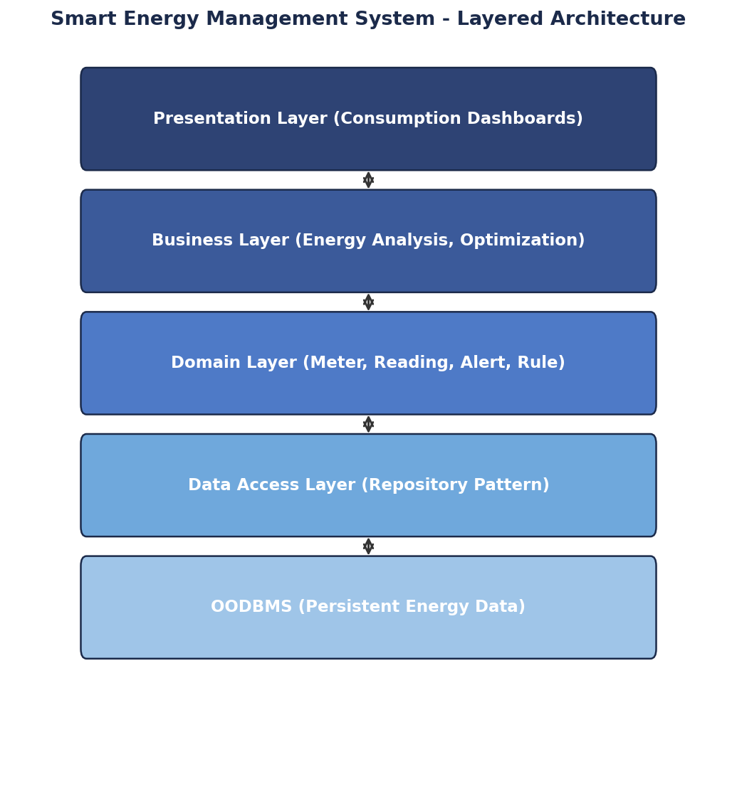
Figure 5.1 - Layered Architecture of the Smart Energy Management System
Object-oriented principles help the system handle continuous streams of sensor data cleanly. Encapsulation keeps raw reading values and calibration details hidden inside the SmartMeter class, exposed only through controlled methods such as recordReading() and getCurrentUsage(). Inheritance allows different meter types, such as Residential Meter and Industrial Meter, to share a common SmartMeter base class while adding type-specific behaviour, such as different alert thresholds. Polymorphism allows the Business Layer to call a single analyseUsage() method on any meter object and receive correctly tailored analysis regardless of the meter's specific type.
The Observer Pattern is used for consumption alerts, so that whenever a meter reading crosses a defined threshold, the meter object notifies all registered observers, such as a customer alert service and a utility-company monitoring dashboard, automatically and without the reading-processing logic needing to know how each alert is delivered. The Strategy Pattern supports different energy-optimisation algorithms, letting the system switch between, for example, a peak-shaving strategy and a load-balancing strategy without modifying the core analysis workflow. The Factory Pattern creates different smart-meter objects, so a new meter model or a renewable-energy monitoring device can be introduced by adding a new class recognised by the factory. A Repository Pattern manages persistent energy data, offering simple methods for the Business Layer to store and retrieve meter and reading information.
This architecture improves scalability because the system can be expected to handle a very large number of smart meters sending frequent readings, and the layered structure allows the Data Access Layer and underlying OODBMS to be optimised or scaled for high write volume independently of the Business Layer's analysis logic. It improves extensibility because new optimisation algorithms, new meter types, or new alerting mechanisms can be added as new classes through the Strategy, Factory and Observer patterns, which is particularly useful for the planned future addition of renewable-energy monitoring and AI-based consumption prediction, since these can be introduced without rewriting the existing, tested analysis code. It improves maintainability because energy rules live in the Domain Layer, analysis logic lives in the Business Layer, and persistence lives in the Data Access Layer, so a correction to how alerts are triggered, for example, does not risk introducing errors into how data is stored.
For persistence, whenever a new reading arrives, the Business Layer passes it to the Domain Layer for validation and rule application, and once processed, it is handed to the Repository Pattern, for example energyRepository.save(reading), which performs the actual OODBMS write operation. When the dashboards in the Presentation Layer need historical usage trends, the Business Layer requests this data through the Repository, for example energyRepository.findByMeterAndDateRange(meterId, start, end), and the Repository retrieves and reconstructs the relevant reading objects from the OODBMS. Because this is the only path through which persistent energy data is stored or retrieved, the system maintains consistent, well-managed records even as the number of connected smart meters continues to grow.

RUBRICS FOR CALCULATION
Industry Problem Solving Task

Criteria | Weightage | Level 4 - Exemplary | Level 3 - Proficient | Level 2 - Developing | Level 1 - Beginning
Understanding of Industry Problem | 20% | Comprehensive understanding of real-world problem and constraints | Good understanding with minor gaps in requirements | Basic understanding; some requirements unclear | Poor understanding; misinterprets problem context
Application of Engineering Concepts | 25% | Applies advanced and relevant concepts effectively to solve the problem | Applies appropriate concepts with minor errors | Limited application of concepts | Incorrect or no application of concepts
Solution Design | 25% | Innovative, practical, and feasible solution aligned with industry standards | Logical and feasible solution with minor gaps | Basic solution with limited feasibility | Unclear or impractical solution
Use of Tools | 15% | Effective use of modern tools, technologies, and real data | Appropriate use of tools with correct implementation | Limited or inconsistent use of tools | Minimal or incorrect use of tools
Analysis | 10% | Thorough analysis with validated results and performance evaluation | Good analysis with reasonable validation | Basic analysis with limited validation | Poor or no analysis
Professionalism | 5% | Highly professional, well-documented, and clearly presented work | Good documentation and presentation | Basic documentation with some gaps | Poor documentation and presentation

