SIMATS ENGINEERING
ASSESSMENT TOOL 3

COURSE NAME: OBJECT ORIENTED ANALYSIS AND DESIGN
COURSE CODE: CSA1102

COURSE OUTCOME COVERED
CO4: implement object-oriented system layers using design principles and patterns, and
integrate access and view layers with OODBMS (BL5)

Assessment Tool Weightage: 30%
QUESTIONS: 6 Total Marks: 30

Annexure A
Reverse Engineering Task

Code of Conduct:
I Kanishk C (Reg No: 192511278) certify that this submission is my original work and that I have adhered to the guidelines specified for this assessment.
I understand that any violation of academic integrity rules will result in disciplinary action.

Signature of the student: Kanishk C

Annexure A
Reverse Engineering Task
Name: Kanishk C Registration No: 192511278

1. Legacy E-Learning Management System
Question: Reverse engineer the existing system by identifying appropriate classes, responsibilities, attributes, methods, and relationships. Redesign the system using object-oriented principles and layered architecture, and explain how the redesigned structure improves cohesion, coupling, maintainability, and scalability.
The existing E-Learning Management System has large, tightly coupled modules that mix student registration, course management, content delivery, assignment evaluation and result generation together with the user interface, making even a small change risky and time-consuming. To reverse engineer this system, the first step is to study the existing functionality and pull out the natural, real-world entities hidden inside the large modules.
By analysing the responsibilities of the legacy modules, five main classes can be identified: Student, Enrollment, Course, Assignment and Result. The Student class is responsible for holding learner details and would carry attributes such as studentId, name and email, along with methods such as register() and viewGrades(). The Enrollment class connects a student to a course and carries an enrollId and date, with methods enroll() and drop(). The Course class manages course content, carrying courseId and title, with a method addContent(). The Assignment class handles submission and evaluation, carrying assignId and dueDate, with methods submit() and evaluate(). The Result class manages the final outcome, carrying resultId and grade, with methods generate() and publish().
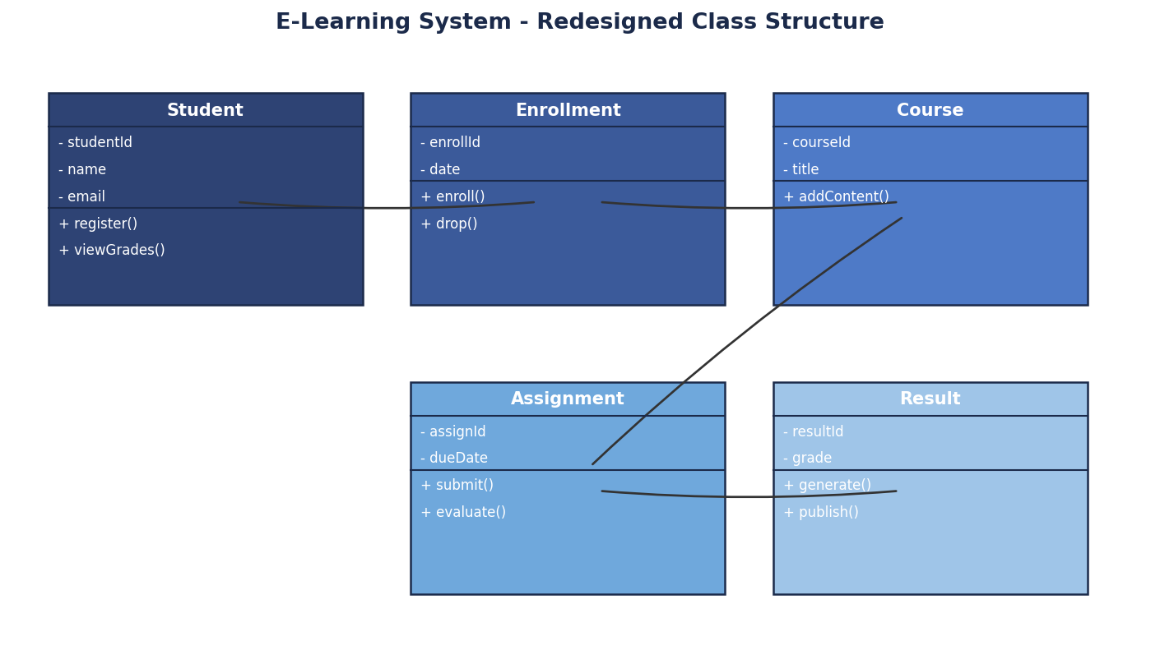
Figure 1.1 - Redesigned Class Structure for the E-Learning System
The relationships between these classes follow the natural flow of a student's journey: a Student is linked to one or more Enrollment records, each Enrollment is linked to a Course, each Course can have several Assignment objects, and each Assignment leads to a Result once it is evaluated. Instead of keeping all of this logic inside one giant module together with the screens, the redesigned system is organised into a layered architecture with a Presentation Layer (registration and dashboard screens), a Business Layer (enrollment rules, evaluation rules, result calculation), a Domain Layer (the five classes described above) and a Data Access Layer that saves and retrieves these objects from the database.
This redesign significantly improves cohesion, because each class now has one clear responsibility; for example, the Assignment class only manages assignment-related data and behaviour, instead of being mixed with registration or result logic as it was in the legacy monolithic module. It reduces coupling, because the Presentation Layer no longer contains business rules directly, and classes such as Course and Assignment interact with each other through simple, well-defined methods rather than shared, tangled code. This structure improves maintainability, since a change to how assignments are evaluated only affects the Assignment class and the Business Layer, without risking damage to registration or result generation. It also improves scalability, because new features, such as a new type of Quiz alongside Assignment, or a new reporting module, can be added as new classes that plug into the existing layered structure without rewriting the whole system.

2. Legacy Customer Support System
Question: Analyze the existing implementation and identify its object-oriented design limitations. Reverse engineer and refactor the system using suitable behavioral design patterns, and explain how the redesigned solution improves flexibility, extensibility, loose coupling, and maintainability.
The existing customer support application handles support requests coming through email, chatbot, telephone and social media using multiple conditional statements (long if-else or switch blocks) inside what is likely a single class. This is a classic object-oriented design limitation: the class violates the Single Responsibility Principle because it is responsible for handling every channel at once, and it violates the Open-Closed Principle because adding a new channel, such as WhatsApp support, requires editing this same large block of conditional logic and touching several other modules that also branch on channel type.
To reverse engineer this system, the underlying responsibility can be identified as 'handle a support ticket according to its channel', which is a perfect fit for the Strategy behavioural design pattern. In the redesigned system, a SupportTicket class is created to hold the common ticket information such as ticketId and status, with methods open() and close(). A ChannelHandler interface is introduced, declaring a single method handle(ticket). Four concrete classes, EmailHandler, ChatbotHandler, TelephoneHandler and SocialMediaHandler, each implement this interface with their own channel-specific handling logic.
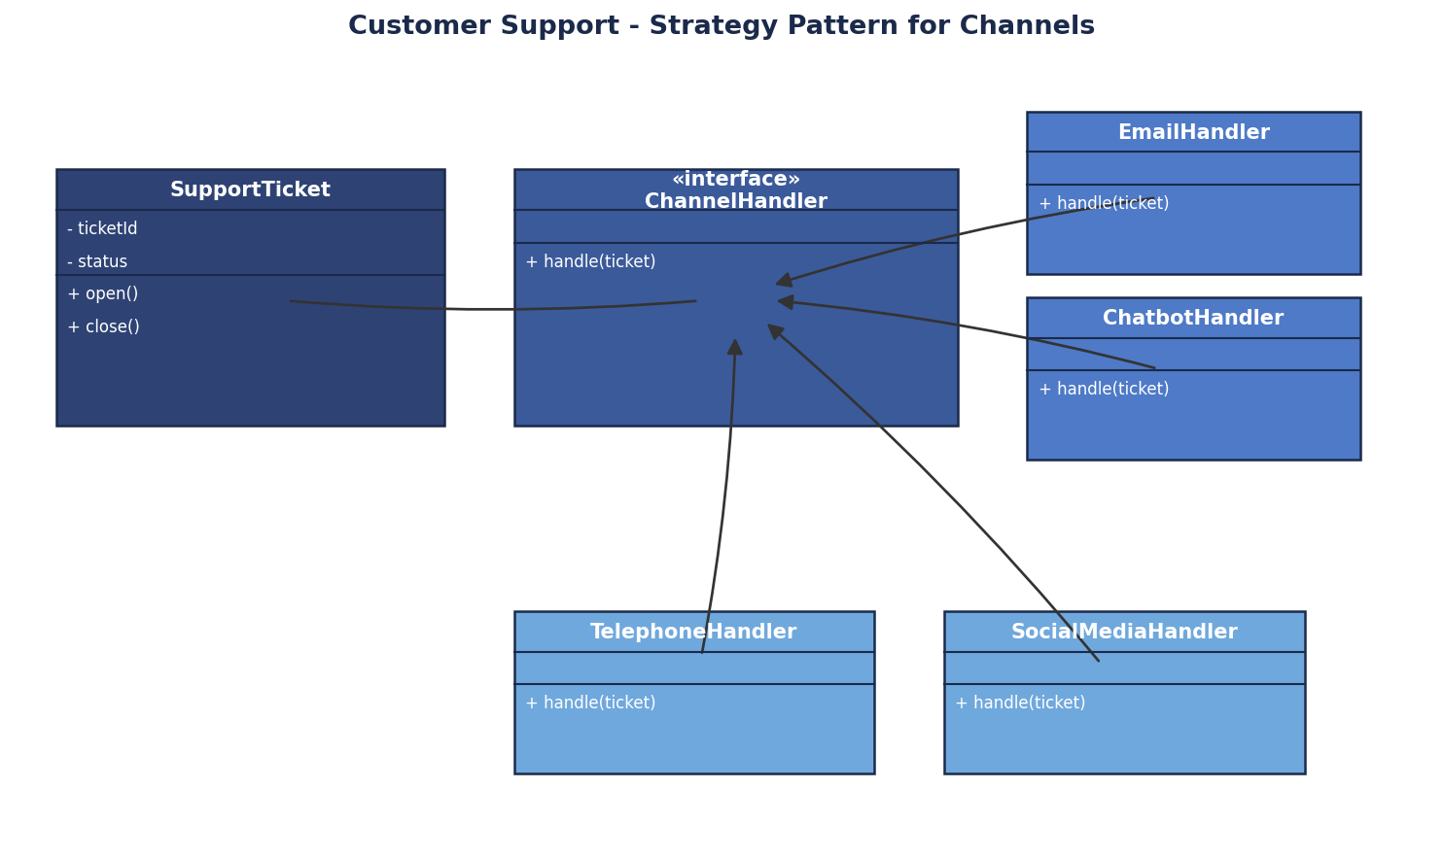
Figure 2.1 - Refactored Design using the Strategy Pattern
With this design, the SupportTicket (or a surrounding TicketProcessor class) simply holds a reference to whichever ChannelHandler is appropriate for the incoming request and calls handle(ticket) on it, without needing to know which specific channel class is being used. The correct handler can be chosen using a small Factory, or simply assigned when the ticket is created based on its channel type, removing the need for repeated conditional statements scattered across multiple modules.
This redesigned solution improves flexibility because the behaviour for each channel is isolated in its own class, so a channel's handling logic can be changed independently, for example improving the ChatbotHandler's automated responses, without touching the email or telephone logic at all. It improves extensibility because adding a brand-new channel, such as WhatsApp, only requires writing one new class that implements ChannelHandler, following the Open-Closed Principle, instead of modifying several existing modules as the legacy system required. It improves loose coupling because the code that processes a ticket depends only on the ChannelHandler interface, not on any specific channel class, so channel implementations can be added, removed or replaced freely. Finally, it improves maintainability because each handler class is small, focused and easy to test on its own, and a bug in one channel's handling logic cannot silently affect the behaviour of another channel, unlike in the original tangled conditional structure.

3. Legacy Banking Transaction System
Question: Reverse engineer the system by identifying appropriate domain classes, service classes, and data access components. Redesign the application using suitable layers and design patterns, and explain how the redesigned architecture improves separation of concerns, testability, and system maintainability.
The existing banking application contains account management, transaction validation, fund transfer, loan processing and transaction reporting all inside a few tightly coupled classes, with database operations embedded directly inside business methods. This means a single class might both calculate a loan's interest and also open a raw database connection to save the result, which makes the class very difficult to read, test, or safely modify.
Reverse engineering this system starts by separating what the legacy classes are actually doing into three natural groups. The domain classes represent the real banking concepts: Account (with attributes such as balance and accountType, and methods debit() and credit()) and Loan (with attributes such as principal and interestRate). The service classes represent the business operations performed on these domain objects: a TransactionService that validates and processes fund transfers, and a LoanService that processes loan applications. The data access components are responsible only for storage: an AccountRepository that knows how to save and load Account and Loan objects from the OODBMS.
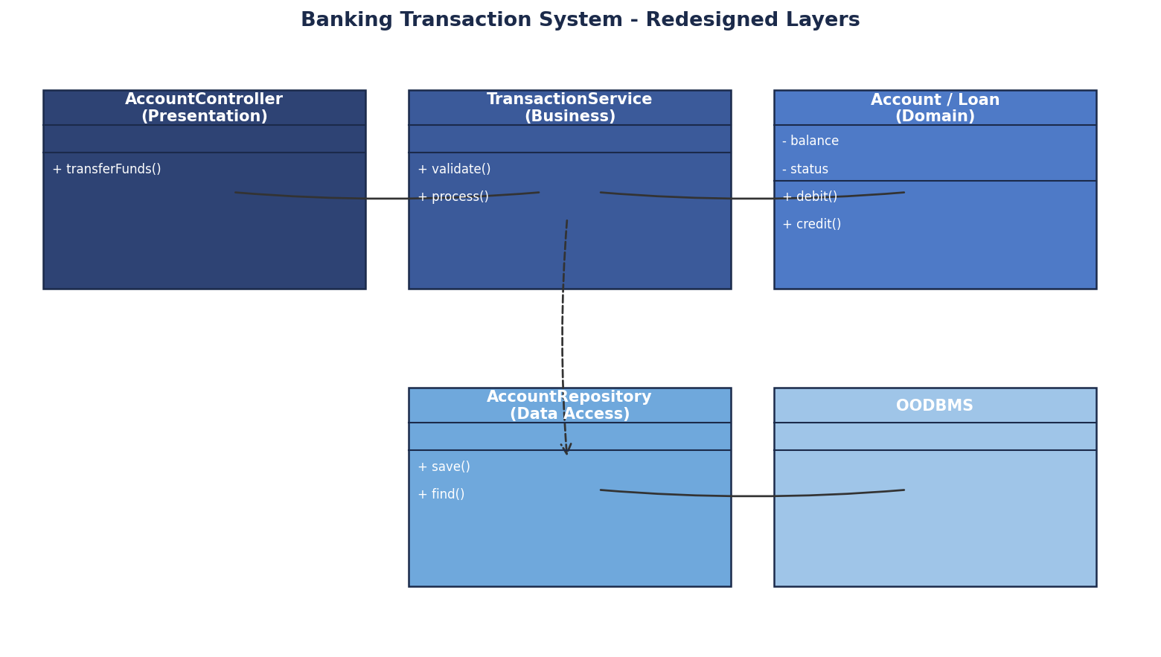
Figure 3.1 - Redesigned Layers for the Banking Transaction System
In the redesigned architecture, an AccountController in the Presentation Layer receives a request such as 'transfer funds' and passes it to the TransactionService in the Business Layer. The TransactionService validates the request (sufficient balance, valid accounts) and then works with the Account and Loan domain objects to apply the actual banking rules. Once the operation is complete, the TransactionService calls the AccountRepository, which is the only component that talks to the OODBMS, to persist the updated account state. The Repository Pattern is used here, so all database operations are grouped behind simple methods such as save() and findById(), completely removing embedded database code from the business methods.
This redesigned architecture greatly improves separation of concerns, because each class now does exactly one job: the Account and Loan classes hold banking data and simple rules, the TransactionService and LoanService coordinate business operations, and the AccountRepository handles persistence, with no overlap between these responsibilities as there was in the legacy design. It improves testability, because the TransactionService can now be tested using a fake or mock AccountRepository, allowing business rules such as insufficient-balance checks to be verified quickly without needing a real database connection, something that was almost impossible when database calls were embedded directly inside the same methods. It improves system maintainability, because a change to how transactions are stored, for example moving to a different OODBMS, only requires changing the AccountRepository implementation, and a change to a business rule, such as a new loan eligibility check, only requires changing the LoanService, keeping each change small, safe and isolated.

4. Legacy Hotel Reservation System
Question: Analyze the existing architecture and identify problems related to coupling, duplication, and persistence management. Reverse engineer the system by introducing suitable DAO, Repository, or Data Access patterns, and explain how the redesigned solution improves modularity, reusability, and OODBMS integration.
The existing hotel reservation application performs OODBMS operations directly from the reservation screens, meaning the user-interface code itself contains queries for rooms, guests, bookings and payments. Because these same queries are written separately inside multiple modules (for example, a query to fetch room details might be written once on the booking screen and again on the billing screen), the system suffers from three clear problems: tight coupling between the presentation layer and the database, duplication of near-identical query logic in several places, and poor persistence management, since there is no single place responsible for how hotel data is stored or retrieved.
To reverse engineer this system, the repeated query logic scattered across the reservation screens can be recognised as the responsibility of a data access component that was never properly separated out. The redesign introduces a RoomRepository interface, declaring standard methods such as find() and save(), with a concrete RoomRepositoryImpl class that contains the actual OODBMS operations for rooms, guests, bookings and payments. A ReservationService class is introduced between the screens and the repository, coordinating the reservation workflow, such as checking availability and confirming a booking.
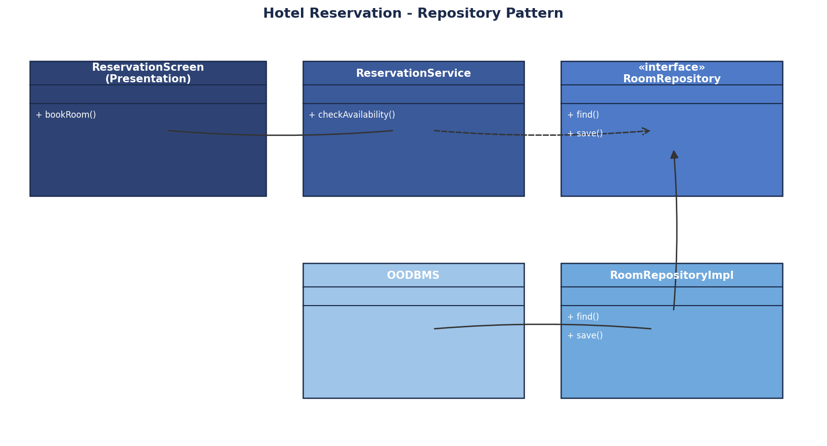
Figure 4.1 - Redesigned Architecture using the Repository Pattern
In the redesigned flow, the ReservationScreen (Presentation Layer) no longer touches the database at all; it simply calls methods on the ReservationService, which in turn calls the RoomRepository interface whenever it needs to check availability or save a booking. Because every other module, such as the billing screen or the guest-management screen, also goes through the same RoomRepository instead of writing its own queries, the duplicated database logic found throughout the legacy system is eliminated and replaced with one trusted, reusable component.
This redesigned solution improves modularity, because the reservation screens, the business coordination logic, and the persistence logic are now cleanly separated into their own classes, each of which can be changed, tested or replaced without directly affecting the others. It improves reusability, because the same RoomRepository methods, such as find() and save(), can be reused by any screen or service that needs room, guest, booking or payment data, instead of every module writing its own version of similar queries as in the legacy system. It improves OODBMS integration, because all persistence logic is now centralised behind the Repository interface, meaning the specific details of how the OODBMS is queried, connected to, or optimised can be managed and improved in one place, and if the hotel chain ever changes its database technology, only the RoomRepositoryImpl class needs to be rewritten, leaving the reservation screens and the ReservationService completely untouched.

5. Legacy Transportation Management System
Question: Reverse engineer the system by identifying common abstractions, classes, and object relationships. Apply suitable creational design patterns, such as Factory Method or Abstract Factory, to redesign object creation and explain how the new design improves extensibility, scalability, and code reuse.
The existing transportation application contains separate modules for buses, trains, taxis and rental vehicles, and the logic for creating objects of each transportation type is duplicated across several parts of the application. This means that whenever a new booking screen or reporting module needs to create, for example, a Taxi object, it repeats the same construction logic that already exists elsewhere, which makes the system harder to extend, since introducing a new transportation type (such as a ride-share bike) would require finding and updating every single place where transportation objects are created.
Reverse engineering this system starts by identifying the common abstraction shared by all four transportation types: every one of them can be booked and has a fare that can be calculated, even though the details differ. This leads naturally to a Transport interface declaring methods such as book() and calculateFare(), with four concrete classes, Bus, Train, Taxi and RentalVehicle, each implementing this interface in their own way, for example, Taxi might calculate fare based on distance while Train might calculate fare based on class of travel.
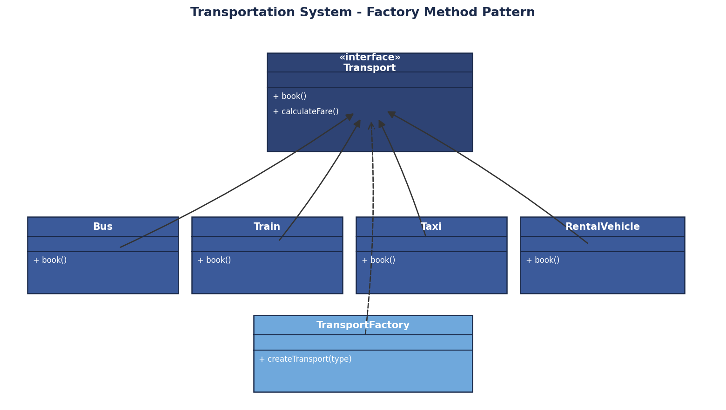
Figure 5.1 - Redesigned System using the Factory Method Pattern
To fix the duplicated object-creation logic, the Factory Method creational design pattern is introduced through a TransportFactory class with a single method, createTransport(type), that takes a transportation type as input and returns the correct concrete Transport object (Bus, Train, Taxi or RentalVehicle). Every part of the application that previously created transportation objects on its own, such as the booking module and the reporting module, is redesigned to call this one factory method instead, so the object-creation logic exists in exactly one place.
This new design improves extensibility, because adding a brand-new transportation type, such as a ride-share bike, only requires creating one new class that implements the Transport interface and registering it inside the TransportFactory, without modifying any of the modules that use transportation objects, which follows the Open-Closed Principle. It improves scalability, because as the range of transportation services grows, the system does not become more tangled; the Factory simply grows to recognise more types while the rest of the application code, which only ever calls createTransport(type), stays exactly the same size and complexity. It improves code reuse, because the object-creation logic that used to be copied into multiple modules now lives in a single, shared TransportFactory class, so every module automatically benefits from any bug fix or improvement made to how transportation objects are constructed, eliminating the risk of some modules using outdated or slightly different creation logic than others.

6. Legacy Healthcare Monitoring System
Question: Reverse engineer the application by identifying violations of SOLID principles, particularly SRP, OCP, and DIP. Redesign the classes using suitable abstractions, interfaces, and design patterns, and explain how the redesigned system improves cohesion, loose coupling, flexibility, testability, and maintainability.
The existing healthcare monitoring application collects patient information, processes sensor readings, generates alerts, stores medical records and produces reports, with several classes performing multiple unrelated tasks and directly depending on concrete implementations of monitoring devices and storage components. Reverse engineering this system for SOLID violations reveals three clear problems. First, the Single Responsibility Principle (SRP) is violated, because a single class appears to both process sensor readings and also handle storage and report generation, meaning the class has more than one reason to change. Second, the Open-Closed Principle (OCP) is violated, because supporting a new monitoring device most likely requires editing existing code rather than adding a new class, since the system was not designed around a common device abstraction. Third, the Dependency Inversion Principle (DIP) is violated, because the alert-generation logic and storage logic depend directly on specific, concrete device and storage classes instead of depending on abstractions, which makes the system rigid and hard to test.
To correct these violations, the redesigned system separates responsibilities into focused classes: a PatientRecordManager, responsible only for storing and retrieving patient records, and an AlertGenerator, responsible only for checking sensor thresholds and raising alerts, resolving the SRP violation by ensuring each class now has a single, clear reason to change. To resolve the OCP and DIP violations together, a MonitoringDevice interface is introduced, declaring a method such as readSensor(), with concrete device classes such as ECGDevice and OxygenSensor implementing it; similarly, a Storage interface is introduced, declaring a method such as save(), which any storage implementation can provide.
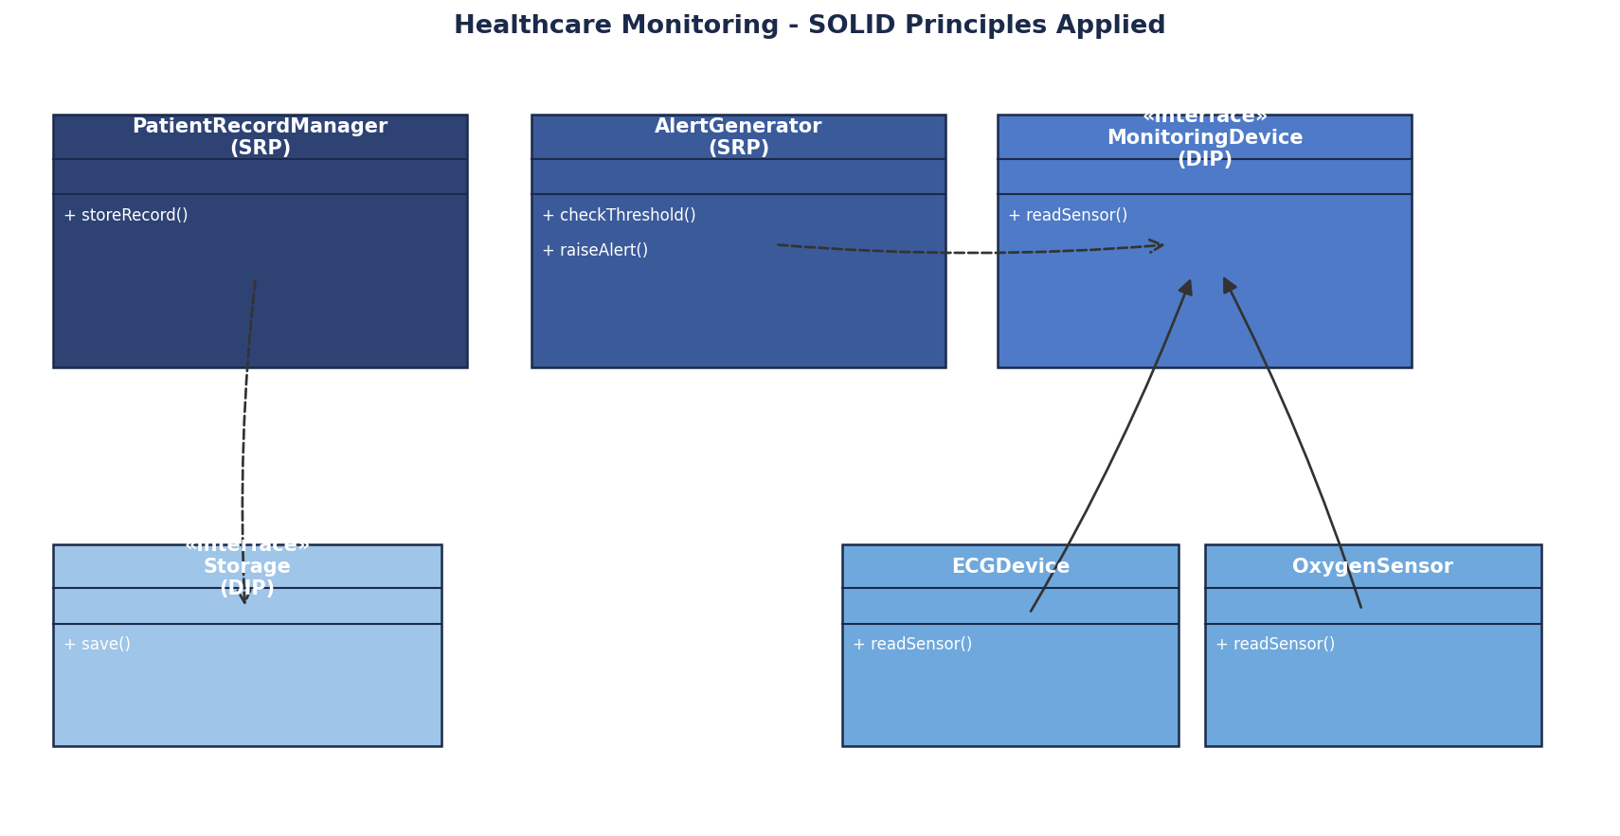
Figure 6.1 - Redesigned System Applying SOLID Principles
With this redesign, the AlertGenerator depends only on the MonitoringDevice interface rather than on any specific device class, so a new type of sensor, such as a blood-pressure monitor, can be added simply by writing a new class that implements MonitoringDevice, without modifying AlertGenerator at all, which satisfies both OCP (open for extension, closed for modification) and DIP (high-level alert logic depends on an abstraction, not on low-level device details). Similarly, PatientRecordManager depends only on the Storage interface, so the underlying storage technology, whether it is an OODBMS, a file system, or a cloud service, can be changed or swapped by providing a new implementation of the Storage interface, without touching PatientRecordManager's own code.
This redesigned system improves cohesion, because each class, such as AlertGenerator or PatientRecordManager, now performs one clear, related set of tasks instead of the mixed responsibilities found in the legacy classes. It improves loose coupling, because the high-level classes depend only on interfaces (MonitoringDevice and Storage) and never on concrete device or storage classes directly. It improves flexibility, because new devices or new storage mechanisms can be introduced as new classes that simply implement the existing interfaces, supporting the hospital's need to work with different equipment vendors over time. It improves testability, because AlertGenerator and PatientRecordManager can be tested using fake MonitoringDevice and Storage implementations that simulate sensor readings or storage behaviour, without needing real medical devices or a real database connection. Finally, it improves maintainability, because a bug or an update related to one specific device, or one specific storage mechanism, is isolated to its own small class, and does not risk breaking the alert-generation or record-keeping logic that depends only on the stable, unchanging interfaces.

RUBRICS FOR CALCULATION
Reverse Engineering Task

Criteria | Weightage | Exemplary (4) | Proficient (3) | Developing (2) | Beginning (1)
Understanding of System | 20% | Demonstrates clear and in-depth understanding of the system/product and its functionality | Shows good understanding with minor gaps | Partial understanding; misses key aspects | Lacks understanding of the system/product
Decomposition | 25% | Effectively breaks down the system into components with detailed analysis | Decomposes system with minor gaps in analysis | Limited or incomplete decomposition | Unable to analyze or break down system
Identification of Components | 20% | Accurately identifies all components and explains their functions clearly | Identifies most components with minor errors | Identifies few components; explanations are weak | Unable to identify components or functions
Reconstruction | 20% | Successfully reconstructs or models the system with accuracy and logic | Reconstruction is mostly correct with minor issues | Partial reconstruction; lacks clarity | Unable to reconstruct or model system
Documentation | 15% | Well-organized, clear documentation with diagrams and structured explanation | Documentation is adequate with minor issues | Poorly organized or incomplete documentation | No proper documentation or presentation

