SIMATS ENGINEERING
Saveetha Institute of Medical and Technical Sciences
ASSESSMENT TOOL 1
Experiments

Course Name | Object Oriented Analysis and Design
Course Code | CSA11
Course Outcome | CO3 – Analyse system requirements using object-oriented techniques to identify classes, attributes, and relationships and develop use case models (BL4)
Assessment Weightage | 40%
Student Name | Kanishk C
Registration Number | 192511278
Code of Conduct
I, Kanishk C (Reg. No. 192511278), certify that this submission is my original work and that I have adhered to the guidelines specified for this assessment. I understand that any violation of academic integrity rules will result in disciplinary action.
Signature of the student: Kanishk C
Question 1: Book Bank Process

1. Understanding the Problem
A book bank is a facility in the college where students can borrow textbooks for the semester instead of buying them. Before this system existed, the whole process would have been done manually with registers, which is slow and prone to mistakes. The goal here is to build a small system where the administrator enters the student's details, the central computer checks those details and decides whether to approve the request, and the office finally hands over the books once approval is given. Since there is a clear verification step involved before any book leaves the shelf, the system has to be modelled carefully so that no student gets a book without being verified first.

2. Actors Identified
Actor | Role in the System
Student | Requests the required books from the book bank.
Administrator | Collects the student's details and forwards them to the central computer for verification.
Central Computer | Verifies the student's eligibility and details, then sends approval to the office.
Office Staff | Receives the approval and physically issues the books to the student; maintains book records.

3. Use Case Diagram
The diagram below shows how each actor interacts with the system. The administrator submits the student's details, which are verified by the central computer (this is why “Verify Student Details” is connected using an <<include>> relationship, since verification always happens as part of submitting the details). Once verified, the request is approved, and the office staff take over from there to issue the book and keep the records updated.
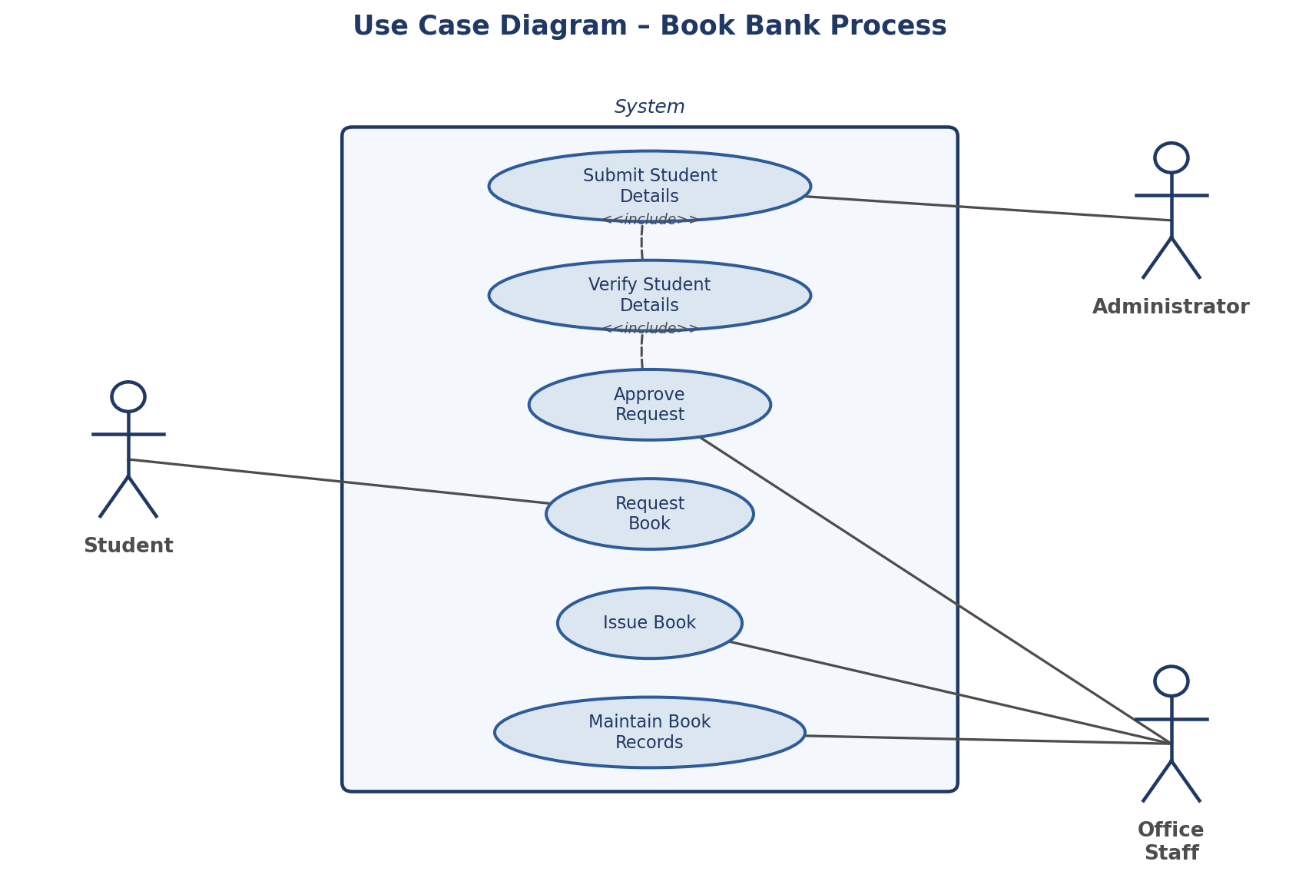
Fig 1.1 - Use Case Diagram for the Book Bank Process

4. Class Diagram
The class diagram identifies the main classes needed to build this system along with their attributes and methods. The Student class holds basic details like student ID, name and department. The Administrator class is responsible for collecting and forwarding these details. The CentralComputer class does the actual verification and decides whether to approve the request. The Office class issues the book once it gets the approval, and the Book class stores information about the book itself, such as its ID, title, author and current status (issued or available).
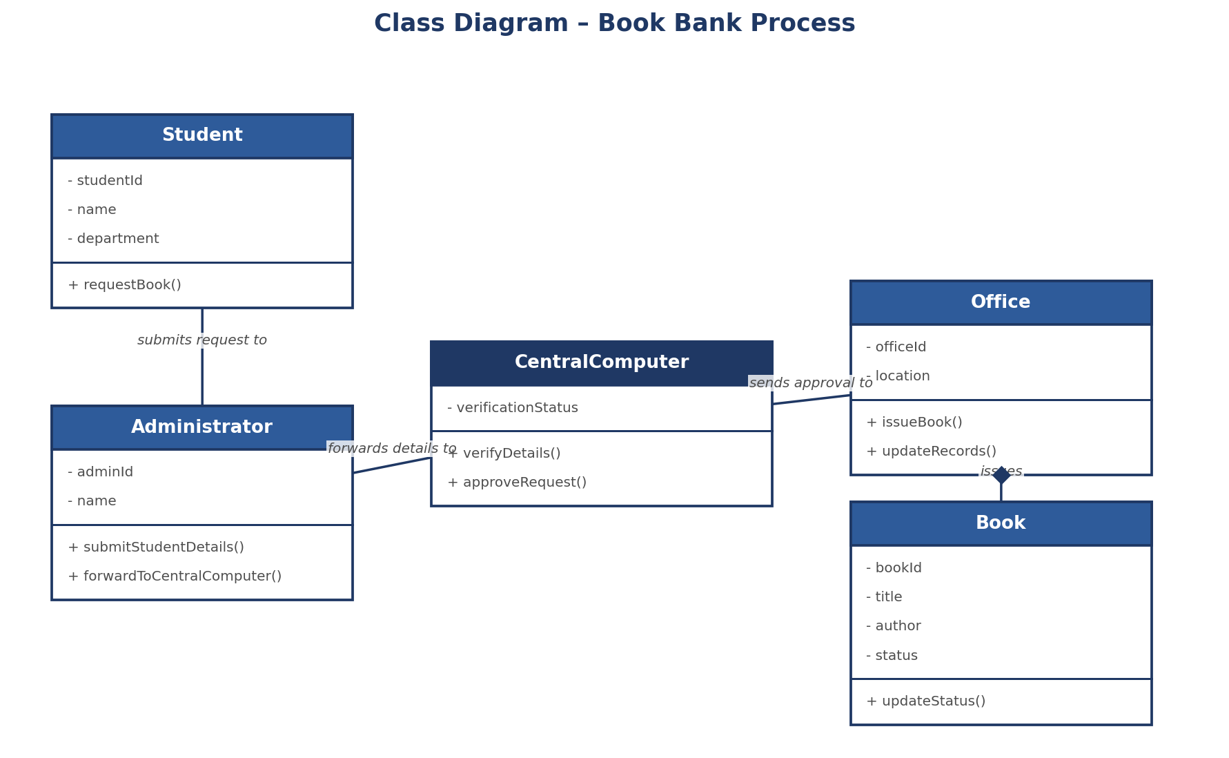
Fig 1.2 - Class Diagram for the Book Bank Process

5. Step-by-Step Workflow
- Step 1: The student approaches the administrator and requests to borrow the required books.
- Step 2: The administrator enters the student's details (student ID, name, department) into the system.
- Step 3: The central computer receives these details and checks them against the college database to verify that the student is genuine and eligible for the book bank.
- Step 4: If the verification is successful, the central computer sends an approval message to the office.
- Step 5: The office staff, upon receiving the approval, issues the requested books to the student and updates the book's status from “available” to “issued”.
- Step 6: The book record is updated in the system so that the inventory always shows the correct number of available copies.

6. Conclusion
This small case shows a very common pattern used in many real-life systems – request, verify, approve, and then deliver. By separating the verification logic into its own class (CentralComputer) instead of mixing it with the administrator or the office, the design stays clean and each class has one clear job to do. This also makes it easy to later plug in a new verification method, like an automated ID scanner, without disturbing the rest of the system.
Question 2: Exam Registration Portal

1. Understanding the Problem
This case is very similar in structure to the Book Bank problem, but instead of books, the system deals with exam hall tickets. A candidate wants to register for an exam. The administrator collects the candidate's details and passes them to the central computer, which verifies the candidate and approves the registration. Once approved, the office issues the hall ticket to the candidate. The main challenge here is again to make sure no hall ticket is generated for a candidate whose details have not been verified, since this could lead to unauthorized candidates appearing for the exam.

2. Actors Identified
Actor | Role in the System
Candidate | Wants to register for the examination and eventually receive a hall ticket.
Administrator | Collects the candidate's details and forwards them for verification.
Central Computer | Verifies candidate eligibility and details, then approves the registration.
Office Staff | Generates and issues the hall ticket once approval has been received.

3. Use Case Diagram
As shown below, the flow begins with the administrator submitting the candidate's details. This use case includes the verification step, since one cannot happen without the other in this system. Once verification is complete, the registration is approved and the candidate can register for the exam, after which the office issues the hall ticket and keeps the candidate records updated.
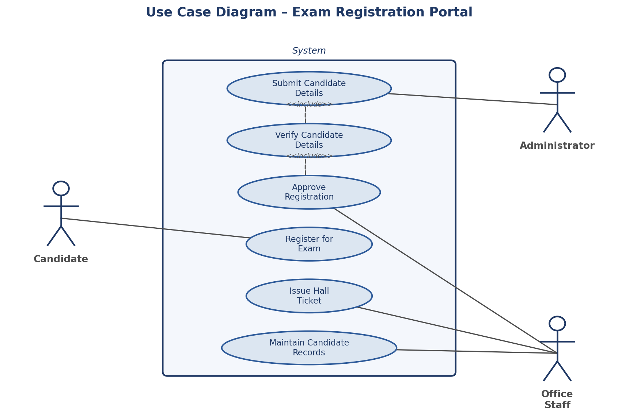
Fig 2.1 - Use Case Diagram for the Exam Registration Portal

4. Class Diagram
The Candidate class stores the candidate's ID, name and course. The Administrator class submits these details onward. The CentralComputer class is again the class that performs verification and approval, keeping this logic separate from the other classes. The Office class is responsible for generating the hall ticket, and the HallTicket class stores details such as the ticket ID, exam date, venue and its current status.
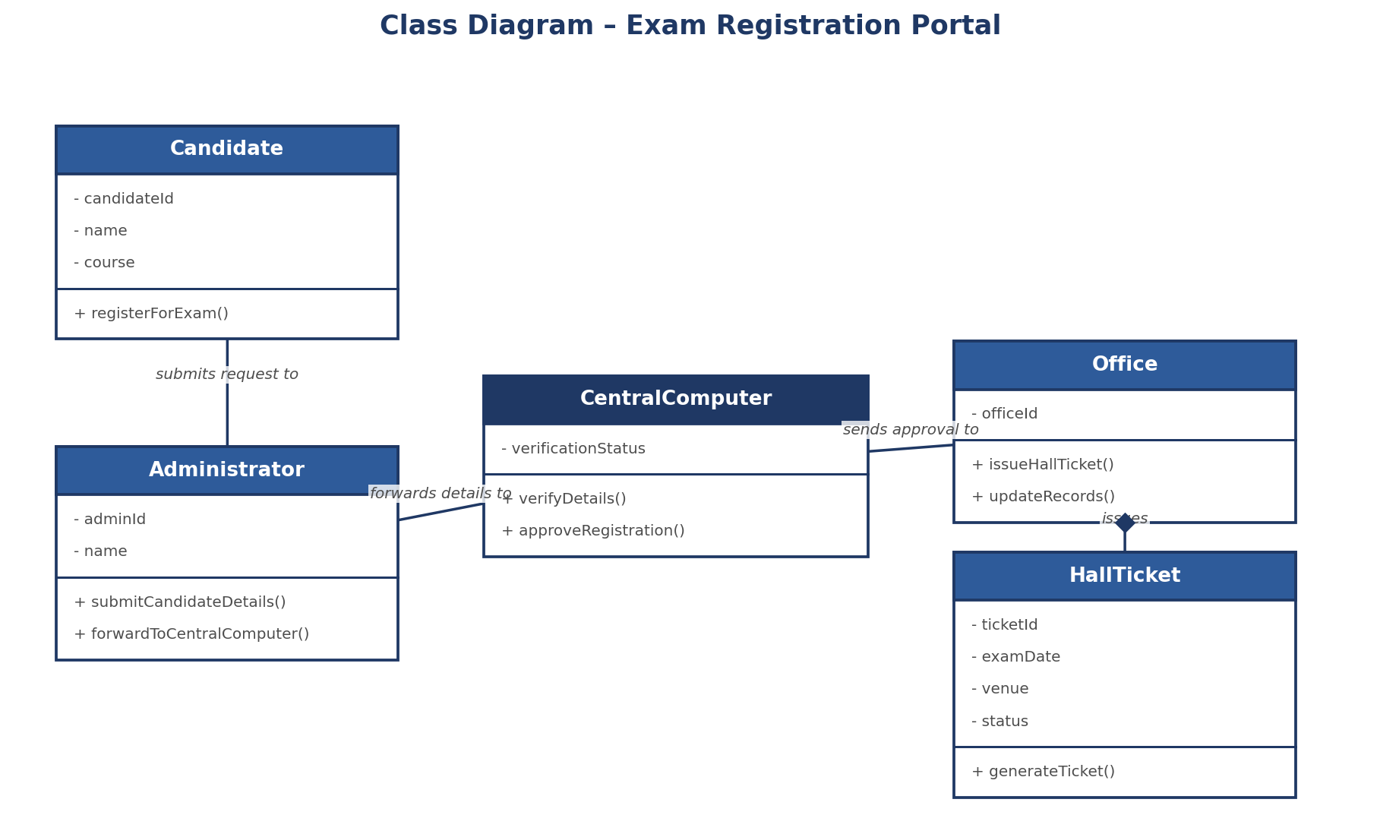
Fig 2.2 - Class Diagram for the Exam Registration Portal

5. Step-by-Step Workflow
- Step 1: The candidate approaches the administrator to register for the upcoming examination.
- Step 2: The administrator records the candidate's ID, name and course details into the system.
- Step 3: These details are sent to the central computer, which checks them against existing student and fee-payment records.
- Step 4: If everything checks out, the central computer approves the registration and forwards this approval to the office.
- Step 5: The office generates the hall ticket with the exam date, time and venue, and issues it to the candidate.
- Step 6: The candidate's registration record is updated to reflect that the hall ticket has been issued.

6. Conclusion
This portal follows the same verify-then-approve pattern seen in the book bank case, which shows how the same object-oriented design idea can be reused across different real-world problems. Keeping verification as a separate responsibility of the CentralComputer class means that the same class design could, with very little change, be used for other registration-based systems in the college, such as workshop or event registrations.
Question 3: Stock Maintenance System

1. Understanding the Problem
In this case, a customer wants to place an order and purchase items with the help of a stock dealer and a central stock system. The order first needs to be verified, and once it is verified the items are delivered to the customer. After delivery, the stock details need to be updated so that the system always shows the correct quantity of items remaining. This is a fairly common scenario in any retail or wholesale business that keeps track of its inventory electronically.

2. Actors Identified
Actor | Role in the System
Customer | Places an order for items and receives the delivery.
Stock Dealer | Verifies the order and approves the delivery of items to the customer.
Central Stock System | Maintains the actual stock quantities and updates them once an order is delivered.

3. Use Case Diagram
The customer places an order, which is verified by the stock dealer before it is approved and delivered. Once the items are delivered, the stock details are updated automatically, which is why “Update Stock Details” is linked with an <<include>> relationship to the delivery step – the update should always happen right after a delivery is completed.
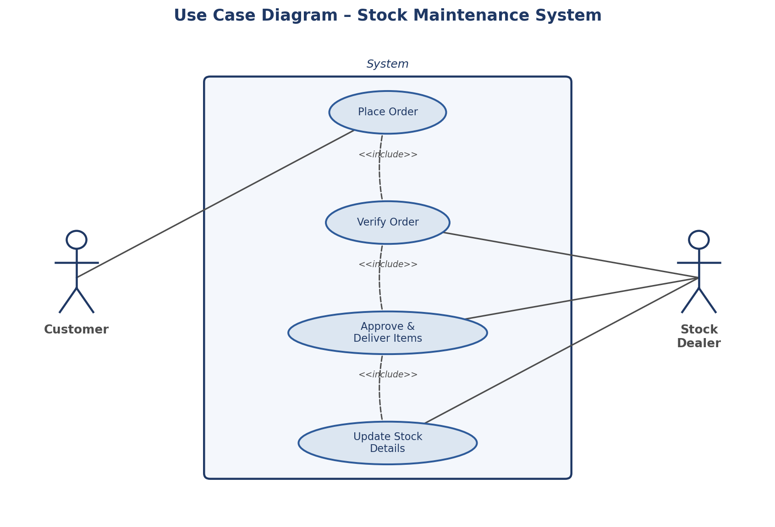
Fig 3.1 - Use Case Diagram for the Stock Maintenance System

4. Class Diagram
The Customer class stores the customer's ID, name and address, and is responsible for placing orders. The Order class holds the order ID, the items requested, the quantity and the current status of the order. The StockDealer class verifies and approves each order, while the CentralStockSystem class keeps track of the available quantity for every item and updates it whenever an order is delivered.
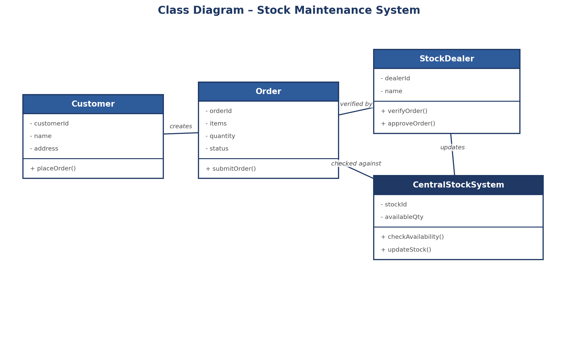
Fig 3.2 - Class Diagram for the Stock Maintenance System

5. Step-by-Step Workflow
- Step 1: The customer selects the items they want and places an order.
- Step 2: The order is sent to the stock dealer, who checks whether the requested items and quantities are valid.
- Step 3: The stock dealer verifies the order against the central stock system to confirm that enough stock is available.
- Step 4: If stock is available, the order is approved and the items are delivered to the customer.
- Step 5: Once delivery is completed, the central stock system automatically reduces the available quantity for each item that was delivered.
- Step 6: The updated stock levels are saved so that future orders always see the correct available quantity.

6. Conclusion
The main design decision in this case was to keep the verification and stock-tracking responsibilities in separate classes – the StockDealer handles order approval, while the CentralStockSystem is purely responsible for the numbers. This separation makes the system easier to maintain, because if the business later wants to change how stock is tracked (for example, moving to a barcode-based system), only the CentralStockSystem class would need to change.
Question 4: Online Course Reservation System

1. Understanding the Problem
This system allows a student to browse the list of available courses and select the one they are interested in. The university (through its central management system) then checks whether a seat is available in that course. If a seat is available, the student gets enrolled; if not, the enrollment cannot go through. This case is a good example of a system where the outcome of one step (checking seat availability) directly decides whether the next step (enrollment) can happen at all.

2. Actors Identified
Actor | Role in the System
Student | Browses the available courses, selects one and gets enrolled if a seat is available.
University (Central Management System / Admin) | Maintains the course records and oversees the enrollment process.

3. Use Case Diagram
The student browses courses and selects one, which triggers a seat-availability check (shown with an <<include>> relationship, since checking availability is always part of selecting a course). Enrollment itself is shown as an <<extend>> of the availability check because enrollment only happens in the special case where a seat actually exists – it is not a compulsory next step.
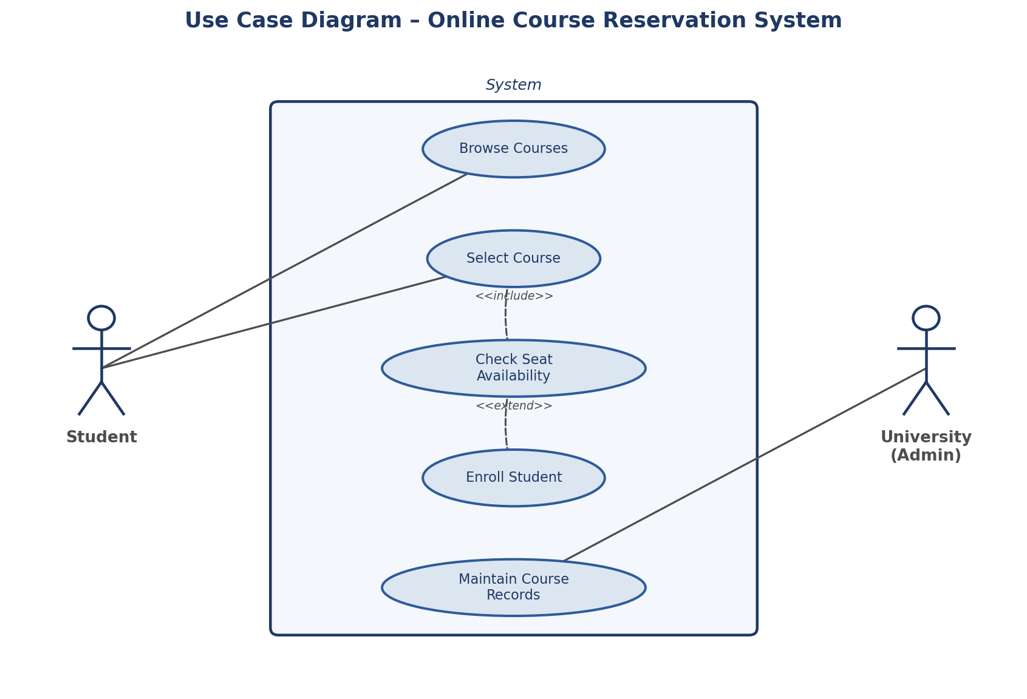
Fig 4.1 - Use Case Diagram for the Online Course Reservation System

4. Class Diagram
The Student class stores the student's ID, name and department, and is responsible for browsing and selecting courses. The Course class holds the course ID, title and the number of seats currently available. The CentralManagementSystem class is responsible for checking seat availability and confirming enrollment, while the Enrollment class stores the actual enrollment record, including its status and date once a student is successfully enrolled.
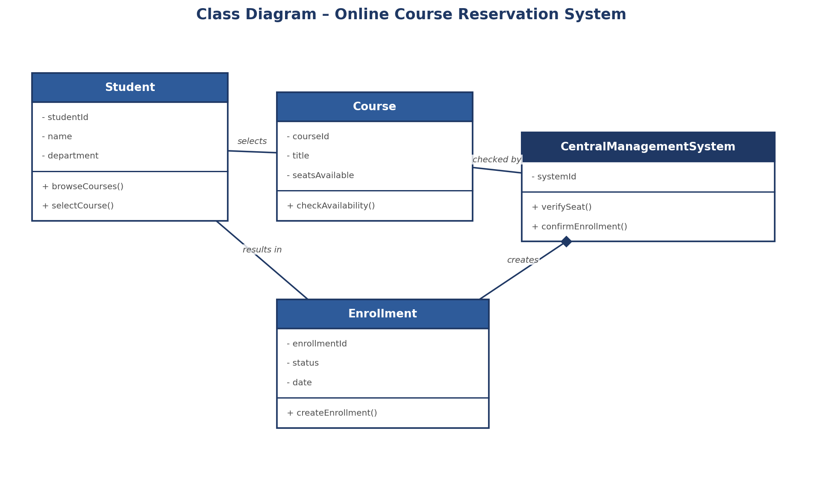
Fig 4.2 - Class Diagram for the Online Course Reservation System

5. Step-by-Step Workflow
- Step 1: The student logs into the portal and browses the list of courses offered by the university.
- Step 2: The student selects the course they wish to enroll in.
- Step 3: The central management system checks the number of seats remaining for that course.
- Step 4: If a seat is available, the system creates an enrollment record and confirms it to the student.
- Step 5: If no seat is available, the student is informed that the course is full and the enrollment does not proceed.
- Step 6: The course record is updated to reflect the reduced number of available seats after every successful enrollment.

6. Conclusion
This case highlights how the <<extend>> relationship is useful when a use case only happens conditionally. Modelling enrollment as an extension of the availability check, rather than a step that always happens, keeps the diagram honest about how the system actually behaves – a student who selects a full course will never reach the enrollment step at all.

