SIMATS ENGINEERING
Saveetha Institute of Medical and Technical Sciences
ASSESSMENT TOOL 2
Case Study

Course Name | Object Oriented Analysis and Design
Course Code | CSA11
Course Outcome | CO3 – Analyse system requirements using object-oriented techniques to identify classes, attributes, and relationships and develop use case models (BL4)
Assessment Weightage | 40%
Student Name | Kanishk C
Registration Number | 192511278
Code of Conduct
I, Kanishk C (Reg. No. 192511278), certify that this submission is my original work and that I have adhered to the guidelines specified for this assessment. I understand that any violation of academic integrity rules will result in disciplinary action.
Signature of the student: Kanishk C
Question 1: Online Hotel Reservation System (10 Marks)
Case Description: A travel company plans to develop an online hotel reservation platform where customers can search hotels, book rooms, make payments, and provide reviews. Hotel managers can update room availability and pricing, while administrators manage users and transactions.

1. Understanding the Case
This system has three different kinds of users – customers who search and book rooms, hotel managers who keep the room and price information up to date, and administrators who oversee the whole platform. Since all three of them are essentially “users” of the system but perform very different actions, this is a good example of where object-oriented design, especially inheritance, naturally fits. Each type of user logs in the same way but has a different set of permissions and actions once inside the system.

2. Applying Object-Oriented Principles
Principle | How it is applied in this system
Encapsulation | Sensitive data such as a customer's payment details or a room's live price is kept private inside the Booking and Room classes. Other classes cannot directly change this data; they must go through public methods like bookRoom() or updatePrice(). This protects the data from being altered incorrectly from outside the class.
Inheritance | Customer, HotelManager and Administrator are all built from a common parent class called User, since they share attributes like userId, name and email, and behaviours like login() and logout(). Each child class then adds its own specific behaviour – for example, only HotelManager can call updateAvailability().
Polymorphism | The Payment class exposes a processPayment() method, but the actual working of this method changes depending on the payment type used – credit card, UPI or net banking. Each payment type overrides processPayment() with its own logic while the rest of the system just calls the same method name, without needing to know which type of payment is being processed underneath.

3. Class Diagram
The diagram below shows the User class at the top, with Customer, HotelManager and Administrator inheriting from it. A Customer creates a Booking, which reserves a Room and generates a Payment record. This structure keeps the shared login/logout behaviour in one place while letting each user type specialise.
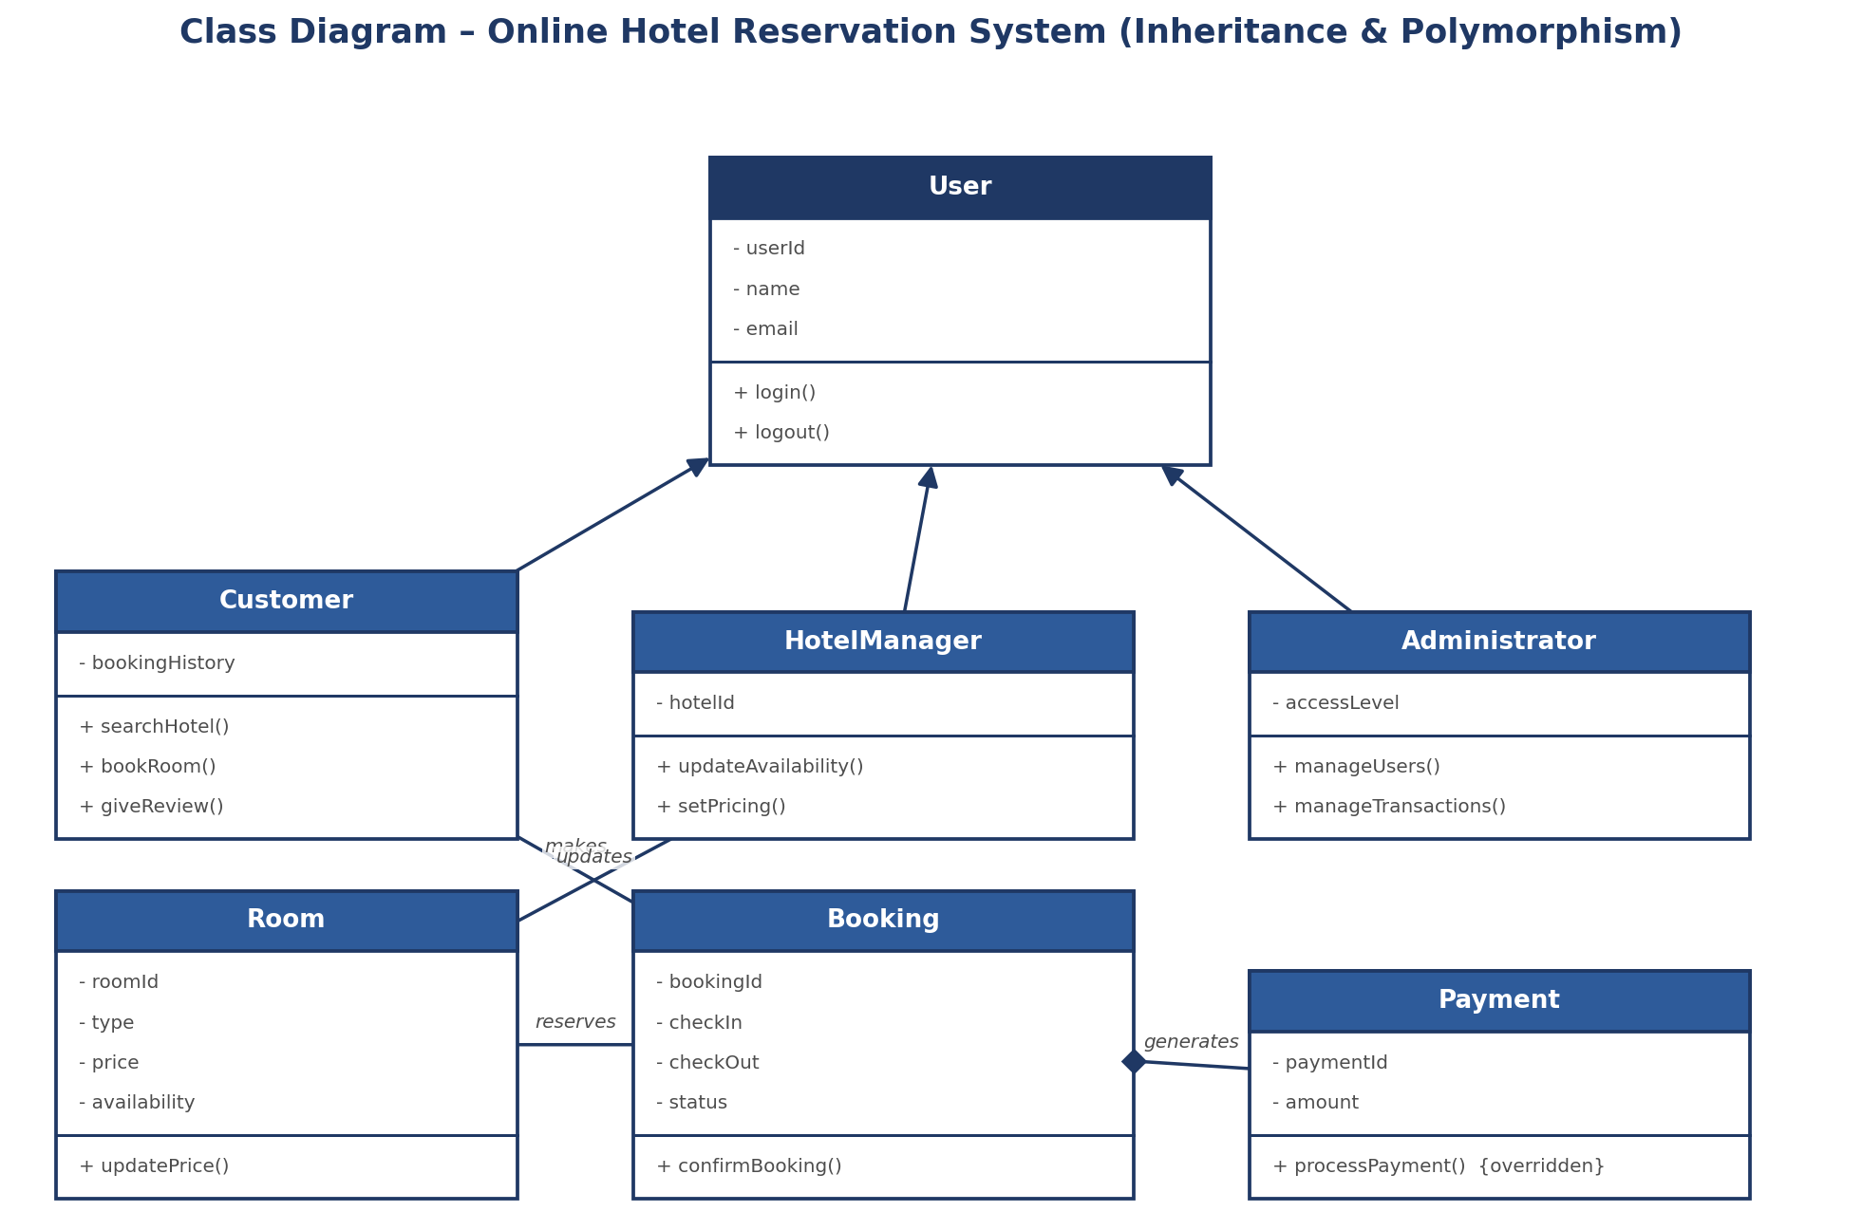
Fig 1.1 - Class Diagram for the Online Hotel Reservation System

4. Recommended SDLC Model – Incremental Model
For this system, the Incremental Model is the most suitable choice. A hotel booking platform has a fairly clear set of core features (search and book a room) that the company will want live as soon as possible to start generating revenue, while other features like payments, reviews and the admin dashboard can reasonably be added afterward without changing the core structure. Building the whole thing in one long phase (as the Waterfall Model would require) would delay the launch unnecessarily, since none of the pieces depend heavily on each other.
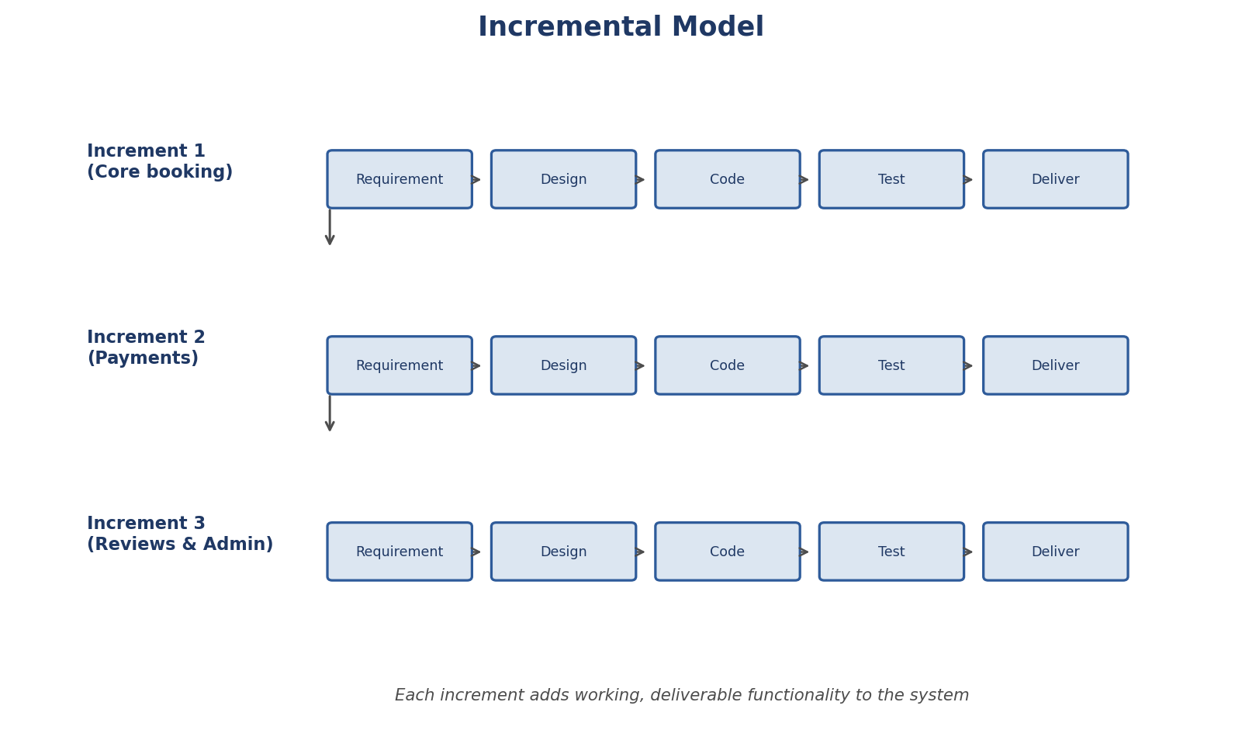
Fig 1.2 - Incremental Model applied to the Hotel Reservation System
Justification: Splitting the project into increments – first the core search-and-booking flow, then payments, and finally reviews and the admin module – means the travel company can launch a usable product early and start collecting real user feedback, which can then guide how the later increments are built. It also reduces risk, because problems in one increment do not block the delivery of the increments that came before it.

Question 2: University Management System (10 Marks)
Case Description: A university intends to automate its operations including student admissions, course registration, examination management, and result processing. Different users such as students, faculty members, examination staff, and administrators interact with the system.

1. Structured Object-Oriented Approach
Since this system involves four different types of people using it – students, faculty, examination staff and administrators – the first step is to identify what is common between them and what is different. All four are “people who log into the university system”, so a shared Person class makes sense as a base. From there, each role branches off into its own class with its own specific responsibilities, which keeps the design organised as more features get added later.

2. Key Classes and Relationships
Principle | How it is applied in this system
Person (base class) | Holds shared attributes such as personId, name and email, and the login() method common to every type of user.
Student | Inherits from Person; can registerCourse() and viewResult(). Has a relationship with Course (registers for) and Result (receives).
Faculty | Inherits from Person; can uploadMarks() and teaches a Course.
ExamStaff | Inherits from Person; conducts an Examination and processes results through processResult().
Administrator | Inherits from Person; manages admissions through manageAdmissions().
Course, Examination, Result | Supporting classes that hold the actual academic data – course details, exam schedule and student marks/grades respectively.

3. Class Diagram
The diagram shows Person as the base class from which Student, Faculty, ExamStaff and Administrator all inherit, which avoids repeating the same login-related attributes and methods in four different places. Notice how both Faculty and ExamStaff have their own version of behaviour connected to processing results, which is an example of polymorphism – the exact steps for “processing a result” can differ depending on who is doing it, even though the method name stays the same.
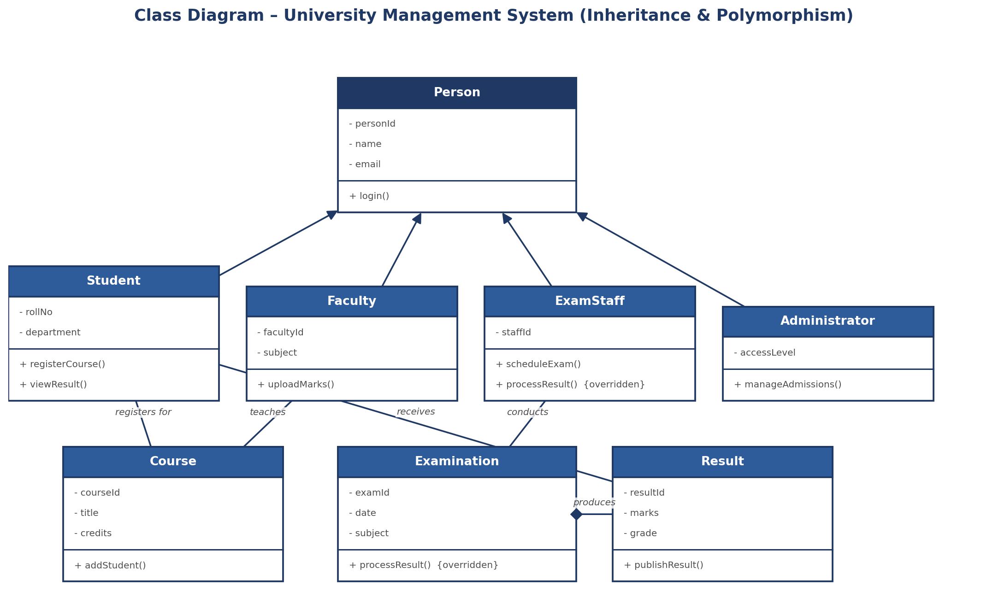
Fig 2.1 - Class Diagram for the University Management System

4. Recommended SDLC Model – Waterfall Model
For a university management system, the Waterfall Model is the more appropriate choice. Unlike a startup product where requirements might change quickly, a university's academic processes – admissions, registration, exams and results – are well established, documented in university regulations, and do not change very often within a single academic year. This means the requirements can be gathered thoroughly upfront, making a sequential, phase-by-phase model practical rather than risky.
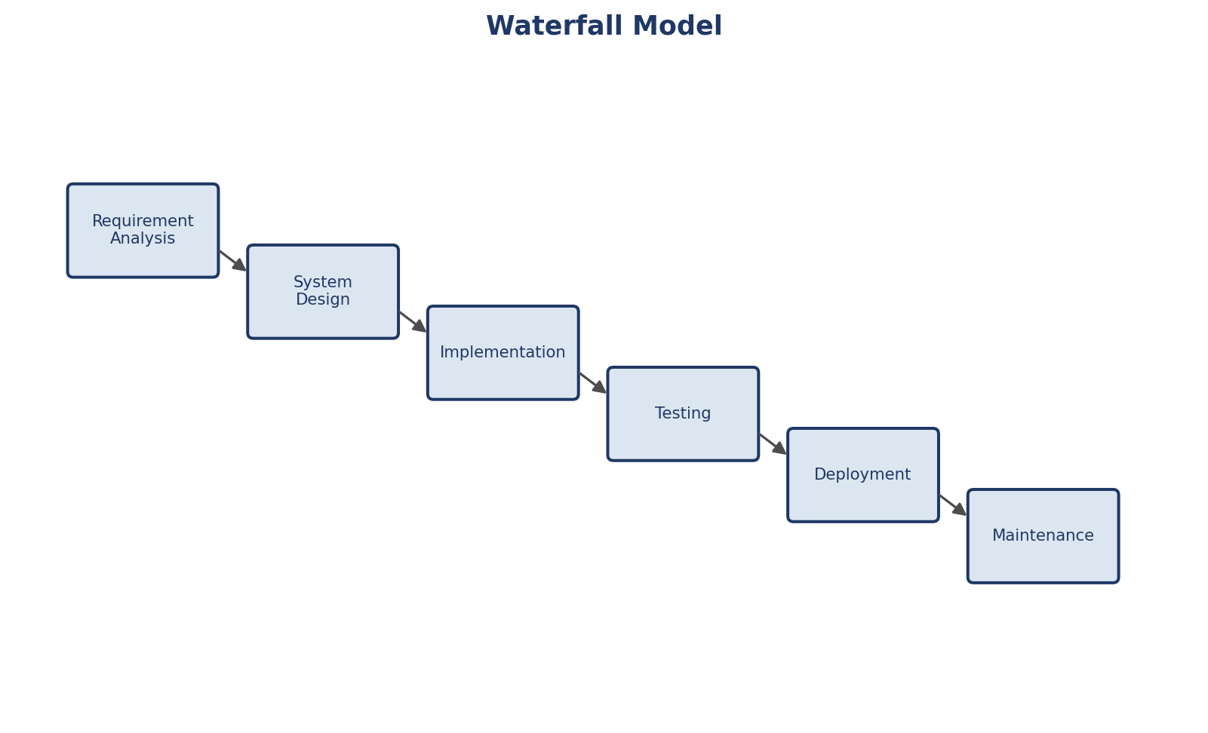
Fig 2.2 - Waterfall Model applied to the University Management System
Justification: Because each stage of the university's academic calendar depends on the previous one being completed correctly (for example, examination management cannot begin before course registration is finalised), a model that emphasises careful planning and complete documentation before moving to the next phase fits naturally. The Waterfall Model's structured, phase-wise approach also matches how university IT departments typically approve and audit new systems before they go live.
Question 3: Online Retail Shopping Platform (10 Marks)
Case Description: A retail company wants to develop an e-commerce platform where customers can browse products, place orders, track deliveries, and make online payments. Vendors manage product catalogs, while administrators monitor transactions and inventory.

1. Achieving Modular Design through Object-Oriented Techniques
Modular design means breaking a large system into smaller, independent pieces that can be developed, tested and updated without disturbing the rest of the system. Object-oriented techniques make this possible mainly through encapsulation and class-based separation of concerns. In this platform, the Product catalogue, the Order processing and the Payment handling are each modelled as their own class, so a change in how payments are processed, for example, does not require touching the Product or Order classes at all.

2. How the Principles Apply Here
Principle | How it is applied in this system
Encapsulation | The Product class keeps its stock count private and only allows it to change through updateStock(), so no other part of the system can accidentally corrupt inventory numbers.
Inheritance | Customer, Vendor and Administrator all inherit shared login behaviour from a common User class, avoiding duplicate code across the three roles.
Polymorphism | Just like in the hotel case, processPayment() behaves differently depending on whether the customer pays by card, wallet or UPI, but the Order class simply calls processPayment() without needing separate logic for each payment type.

3. Class Diagram
The Order class is connected to Product using an aggregation relationship (a hollow diamond), since an order is made up of products but the products themselves can continue to exist independently of any particular order. The Order to Payment relationship, on the other hand, is a stronger composition relationship, because a payment record only makes sense in the context of the order that created it.
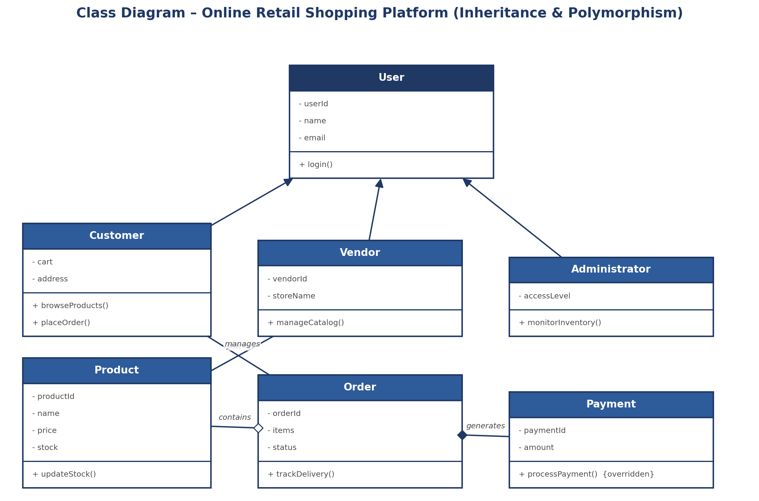
Fig 3.1 - Class Diagram for the Online Retail Shopping Platform

4. Evaluating SDLC Models and Recommendation – Agile Model
A Waterfall approach would be risky here because e-commerce platforms live in a very competitive space where customer expectations and market trends shift quickly – new payment options, delivery partners or discount schemes can appear at any time. A Spiral Model could work but adds more risk-analysis overhead than a retail platform really needs. The Agile Model fits best, since it allows the platform to be built in short sprints, each delivering a working piece of the system that can be tested with real users and adjusted quickly.
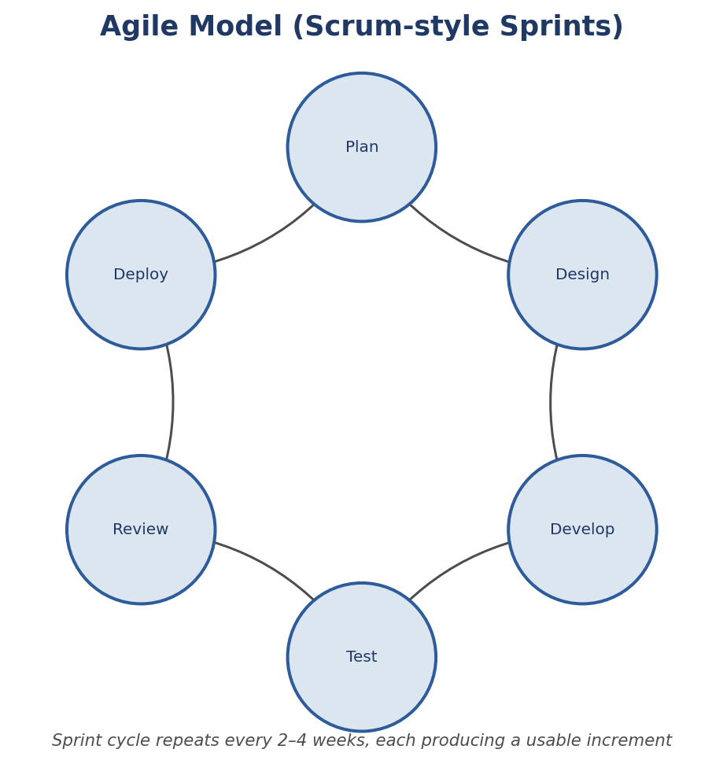
Fig 3.2 - Agile Model applied to the Online Retail Shopping Platform
Justification: Agile's short, repeating sprint cycles (plan, design, develop, test, review, deploy) mean the retail company can release the browsing and ordering features first, gather feedback from actual shoppers, and continuously refine the delivery-tracking and payment modules in later sprints without waiting for the entire platform to be finished. This matches how most modern e-commerce companies actually operate.

Question 5: Smart Healthcare Management System (10 Marks)
Case Description: A multi-specialty hospital plans to develop a Smart Healthcare Management System where patients can book appointments, consult doctors, access medical records, and make online payments. Doctors update patient diagnoses and prescriptions, while hospital administrators manage departments, staff, and billing information.

1. Understanding the Case
A hospital system is more sensitive than a typical booking or shopping platform because it deals with people's medical information, which must be handled carefully and correctly. There are three main roles here – patients who book appointments and view their own records, doctors who update diagnoses and prescriptions, and administrators who manage the hospital's departments, staff and billing. Getting the class design right matters more in this case because mistakes in a healthcare system can have real consequences for patients.

2. Applying Object-Oriented Principles
Principle | How it is applied in this system
Encapsulation | A patient's medicalHistory and diagnosis details are kept private inside the Patient and MedicalRecord classes. These can only be read or changed through controlled methods like updateRecord(), which can include checks on who is allowed to make the change – this is especially important for protecting patient privacy.
Inheritance | Patient, Doctor and Administrator all inherit from a common Person class that holds shared details like name and contact information, avoiding repetition and keeping the shared login behaviour consistent across all three roles.
Polymorphism | Both MedicalRecord and Billing expose methods (updateRecord() and processPayment()) that are overridden to behave differently depending on the exact type of record or payment involved, while the rest of the system can call these methods in the same way regardless of the underlying details.

3. Class Diagram
As shown below, Patient, Doctor and Administrator inherit from the base Person class. A Patient books an Appointment, which connects to a Doctor. The Doctor updates the MedicalRecord, and the Patient's Billing record is generated once services have been provided.
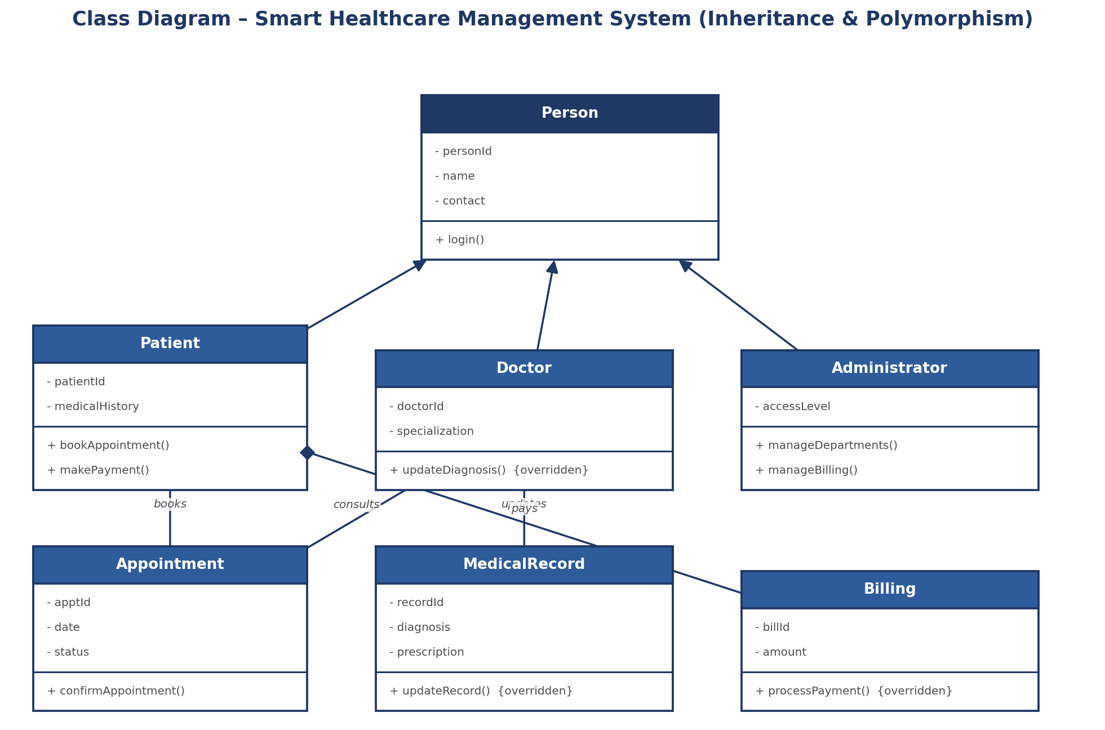
Fig 5.1 - Class Diagram for the Smart Healthcare Management System

4. Recommended SDLC Model – Spiral Model
Healthcare systems carry a higher level of risk than most other software projects because they handle sensitive patient data and must comply with medical data-protection regulations, while also needing to stay flexible as hospital departments and workflows evolve over time. The Spiral Model is well suited here because it is built specifically around repeated cycles of risk analysis, which matters a lot for a system where a mistake (like a wrong prescription being recorded) can have serious consequences.
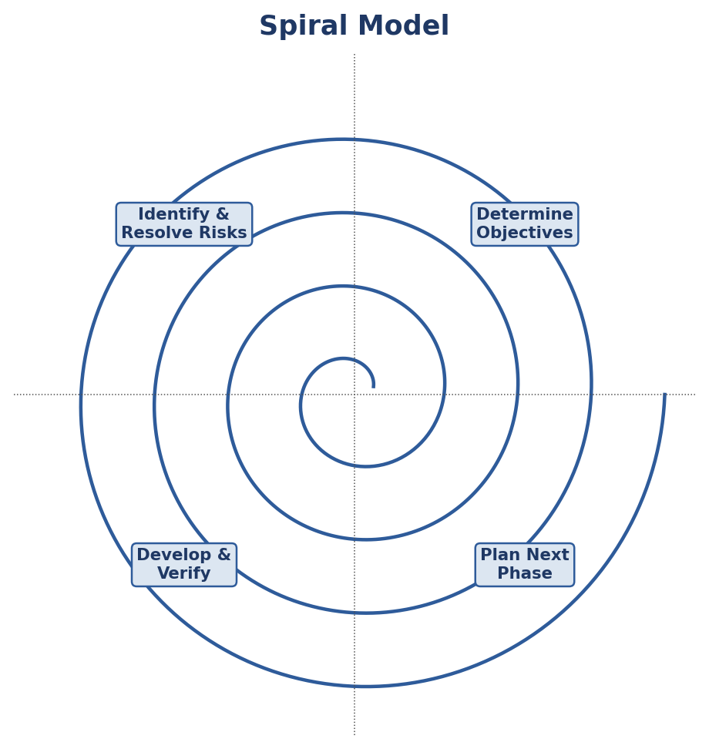
Fig 5.2 - Spiral Model applied to the Smart Healthcare Management System
Justification: Each loop of the spiral – determining objectives, identifying and resolving risks, developing and verifying, then planning the next phase – allows the hospital's IT team to carefully evaluate risks such as data security and regulatory compliance before committing further development effort. This is much safer for a healthcare setting than an Agile approach that moves quickly with less formal risk review, or a Waterfall approach that would lock in decisions too early, before the hospital's real workflow needs are fully understood.

