SIMATS ENGINEERING
Department of Computer Science & Engineering
ASSESSMENT TOOL 1 - ANALYTICAL PROBLEM SOLVING
Course Code: | CSA12 | Course Title: | Computer Architecture
CO Assessed: | CO3 | Assessment: | Tool 1 - Experiments
Weightage: | 45% | Total Marks: | 25
Student Name: | Kanishk C | Reg. No.: | 192511278
Department: | Computer Science & Engineering | Date: | 16-08-2026
CO3 Statement: Register transfers, Arithmetic and logic operations. Multiple Bus Organization: Data transfer among multiple buses. Pipelining: Stages of pipelining, Pipeline performance, hazards (data, instruction). (BL3)

ANNEXURE A - EXPERIMENT ANSWERS
All five experiments listed below were designed and simulated using Logisim, a free digital logic circuit simulator. Each experiment section covers the aim, the software and components used, the underlying theory, the circuit design with a labelled diagram, the step-by-step procedure that was followed, the observation table recorded from the simulation, and the final result.

Experiment 1: Register Transfer Unit (RTU)
Design and implement a Register Transfer Unit (RTU) to demonstrate data transfer between registers. Perform operations such as R2 <- R1, R3 <- R1 + R2, and R4 <- R3. Verify the contents of registers after each transfer.
Aim
To design and build a Register Transfer Unit in Logisim that can move data between four registers (R1 to R4) and to check that the register contents are correct after each transfer operation.
Components / Software Used
Logisim digital simulator, four 4-bit registers (R1, R2, R3, R4), a common data bus, tri-state buffers, a 4-bit full adder used as the ALU block, an input/output select decoder, a clock source, and hex/LED probes to view register values.
Theory
A register transfer unit moves data from one register to another using a set of control signals. In most simple designs, all the registers share one common bus. Only one register can place its value on the bus at a time - this is decided by an output-select line connected to a tri-state buffer at each register. In the same clock cycle, one (or more) other registers can be told to load whatever value is currently sitting on the bus, using an input-select line connected to the load/enable input of that register. When the transfer also involves a calculation, for example R3 <- R1 + R2, the value from the bus is first sent into an adder circuit together with a second operand, and the sum is placed back onto the bus so that it can be loaded into the destination register. This is exactly how simple CPUs move and combine values inside the datapath before an instruction result is written back.
Circuit Design
All four registers are connected to a common data bus through tri-state buffers. A 2-line output-select decoder chooses which register drives the bus, and a separate input-select line (combined with the clock) decides which register captures the value from the bus. For the addition transfer, the bus is also wired into one input of a 4-bit adder, with the second operand register wired into the other input; the adder's output is fed back so it can be loaded into the destination register on the next clock pulse.
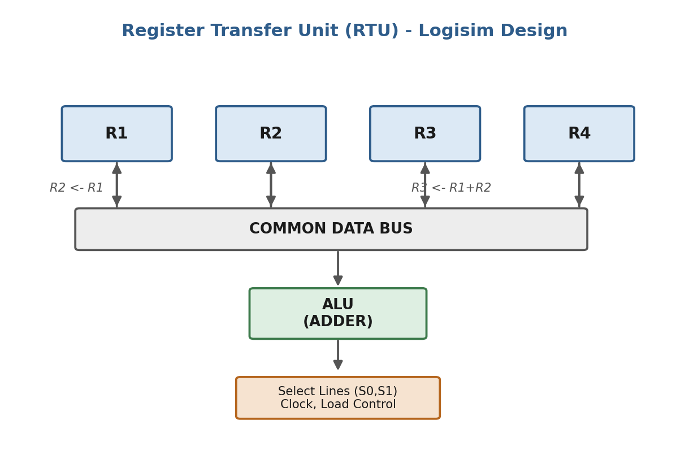
Fig 1.1: Block diagram of the Register Transfer Unit built in Logisim
Procedure
- Open Logisim and place four 4-bit register components on the canvas, and label them R1, R2, R3 and R4.
- Connect the output of every register to a common bus using tri-state buffers, and wire the buffer's enable input to an output-select decoder.
- Wire the bus into a 4-bit adder block so that arithmetic transfers such as R3 <- R1 + R2 can be performed.
- Connect the adder output (and the bus itself, for simple copy transfers) back to the data input of each register through an input-select AND gate tied to the clock.
- Set R1 to 0101 (5) and R2 to 0011 (3) using input switches, and load them using the clock.
- Enable R1's output onto the bus and enable R2's input to perform R2 <- R1, then pulse the clock and note R2's new value.
- Enable R1 and R2 onto the adder inputs, enable R3's input from the adder output to perform R3 <- R1 + R2, then pulse the clock and note R3's value.
- Enable R3's output onto the bus and enable R4's input to perform R4 <- R3, then pulse the clock and note R4's value.
- Record every register value at each step in the observation table using the hex/LED probes.
Observation Table
Register | Initial Value | After R2<-R1 | After R3<-R1+R2 | After R4<-R3
R1 | 0101 (5) | 0101 (5) | 0101 (5) | 0101 (5)
R2 | 0011 (3) | 0101 (5) | 0101 (5) | 0101 (5)
R3 | 0000 (0) | 0000 (0) | 1010 (10) | 1010 (10)
R4 | 0000 (0) | 0000 (0) | 0000 (0) | 1010 (10)
Result
The Register Transfer Unit was implemented successfully in Logisim. All three transfer operations - R2 <- R1, R3 <- R1 + R2, and R4 <- R3 - produced the expected values shown in the observation table, which confirms that the common bus and the control logic worked correctly.

Experiment 2: Arithmetic and Logic Unit (ALU)
Design and implement an Arithmetic and Logic Unit (ALU) to perform arithmetic operations such as addition and subtraction and logical operations such as AND, OR, XOR, and NOT. Display and verify the output for different input combinations.
Aim
To design a 4-bit ALU in Logisim that can perform addition, subtraction, AND, OR, XOR and NOT, and to verify the result and flag outputs for different sets of input values.
Components / Software Used
Logisim digital simulator, two 4-bit input pins (A and B), a 4-bit adder/subtractor block built from full adders and XOR gates, individual AND/OR/XOR/NOT gate arrays, a multiplexer for function selection, a 3-bit function-select switch, and a 4-bit hex display with Zero and Carry flag indicators.
Theory
An ALU is the part of the processor that actually performs calculations. Instead of building six separate circuits and connecting them one at a time, a real ALU computes several operations in parallel and then uses a multiplexer to select which result is passed to the output, based on a function-select code. Subtraction is done using two's complement: the B input is inverted with XOR gates and a carry-in of 1 is added, which is the same as computing A + (-B). The Zero flag is set when every output bit is 0, and the Carry flag reflects the carry-out of the final adder stage, which is also treated as a borrow indicator during subtraction.
Function Select Table
S2 | S1 | S0 | Operation
0 | 0 | 0 | ADD (A + B)
0 | 0 | 1 | SUB (A - B)
0 | 1 | 0 | AND (A . B)
0 | 1 | 1 | OR (A + B)
1 | 0 | 0 | XOR (A xor B)
1 | 0 | 1 | NOT A
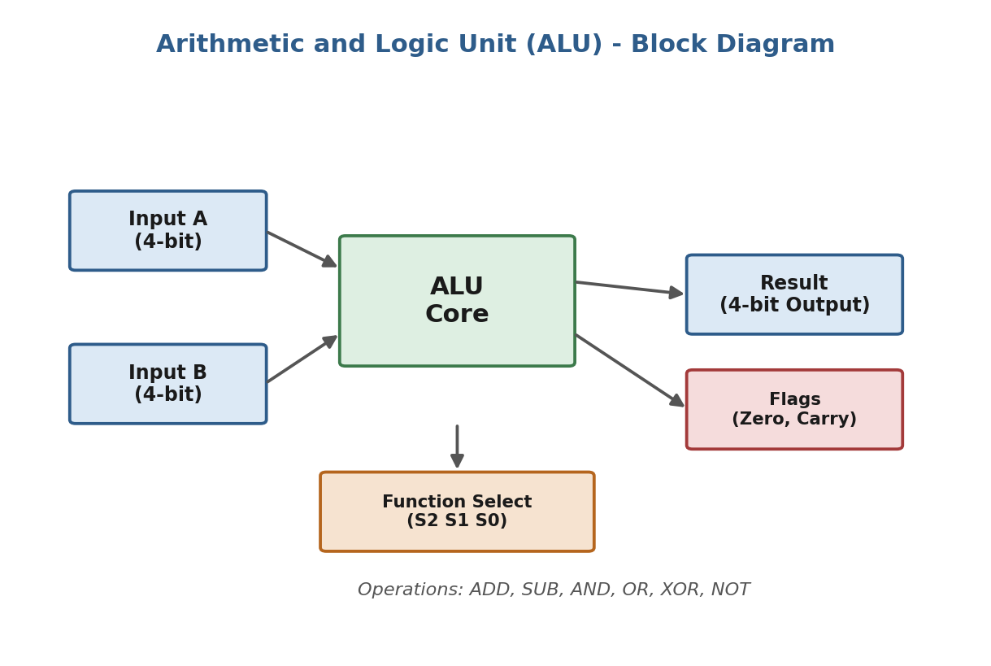
Fig 2.1: Block diagram of the 4-bit ALU
Procedure
- Place two 4-bit input pins A and B on the Logisim canvas.
- Build a 4-bit adder-subtractor using full adders and a row of XOR gates that invert B when the subtract control is 1, with carry-in tied to the same control bit.
- Build separate 4-bit AND, OR, XOR gate arrays and a 4-bit NOT gate array, all fed from A and B.
- Feed the outputs of the adder-subtractor and all four logic blocks into a multiplexer.
- Connect a 3-bit function-select switch (S2 S1 S0) to the multiplexer's select lines.
- Connect the multiplexer output to a 4-bit hex display for the result.
- Add a NOR gate across all result bits to generate the Zero flag, and tap the adder's carry-out for the Carry flag.
- Set A = 1010 and B = 0110, cycle through each function-select code, and record the result and flags for every operation.
Observation Table (A = 1010, B = 0110)
Operation | Result (Binary) | Result (Decimal) | Carry / Borrow | Zero Flag
ADD | 0000 | 0 (16 with carry) | 1 | 1
SUB | 0100 | 4 | 0 | 0
AND | 0010 | 2 | - | 0
OR | 1110 | 14 | - | 0
XOR | 1100 | 12 | - | 0
NOT A | 0101 | 5 | - | 0
Result
The 4-bit ALU was designed and tested successfully in Logisim. All six operations - ADD, SUB, AND, OR, XOR and NOT - gave the correct results for the chosen input combination, and the Zero and Carry flags matched the expected values, confirming that the function-select logic and the arithmetic circuit both worked as intended.

Experiment 3: Multiple Bus Organization
Implement a Multiple Bus Organization for a CPU data path. Demonstrate the transfer of data among registers through multiple buses and perform an arithmetic operation using the ALU. Verify the register contents after each operation.
Aim
To build a CPU data path with three separate buses (Bus A, Bus B and Bus C) in Logisim, and to show that two registers can be read and an ALU result written back in a single clock cycle, instead of the multiple cycles a single-bus design would need.
Components / Software Used
Logisim digital simulator, four 4-bit registers, three separate buses with tri-state buffers on every register output, a 4-bit ALU block, and an input-select decoder on the destination register.
Theory
In a single-bus organization, only one register value can travel on the bus at a time, so a register-to-register ALU operation such as R4 <- R1 + R2 needs several clock cycles: one to move R1 onto a temporary buffer, another to move R2 into the ALU, and a third to write the result back. A multiple bus organization solves this by giving the datapath three buses at once. Two registers can be read out simultaneously - one drives Bus A and the other drives Bus B - and both are fed directly into the ALU in the same cycle. The ALU result is placed on a third bus, Bus C, and written into the destination register, also within that same cycle. This is why multiple bus datapaths are noticeably faster for register-to-register instructions.
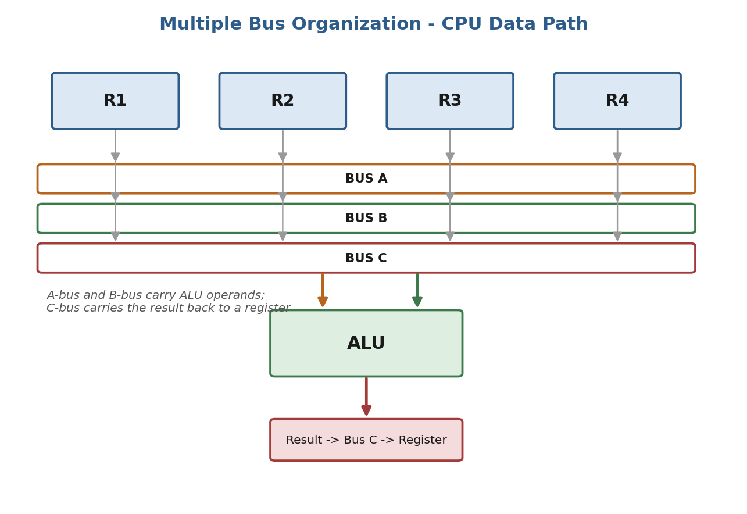
Fig 3.1: CPU data path with multiple bus organization
Procedure
- Place four registers (R1-R4) on the canvas and connect each output to three separate tri-state buffers, one for each bus (A, B and C).
- Wire Bus A and Bus B into the two operand inputs of the ALU block.
- Wire the ALU output into Bus C.
- Connect Bus C to the data input of every register through an input-select decoder so the result can be written into any chosen register.
- Load R1 = 0111 (7) and R2 = 0011 (3).
- Enable R1's Bus-A buffer and R2's Bus-B buffer, set the ALU function to ADD, and enable R4 to load from Bus C.
- Pulse the clock once and read R4's new value.
- Repeat with a different register pair and operation to confirm the design works generally, not just for one case.
Observation Table
Operation | Bus A (source) | Bus B (source) | ALU Function | Bus C (result) | Destination
R4 <- R1 + R2 | R1 = 0111 (7) | R2 = 0011 (3) | ADD | 1010 (10) | R4 = 1010 (10)
For comparison, the same operation on a single-bus datapath would need 3 clock cycles (move R1 to a buffer, move R2 into the ALU, then write the result back), while the multiple bus datapath completed it in just 1 cycle.
Result
The multiple bus data path was implemented successfully. The operation R4 <- R1 + R2 was completed in a single clock cycle, which verifies that reading two registers and writing a third one can happen at the same time when separate buses are used, giving a clear performance advantage over a single-bus design.

Experiment 4: 4-Stage Instruction Pipeline
Design and simulate a 4-stage instruction pipeline consisting of Instruction Fetch (IF), Instruction Decode (ID), Execute (EX), and Write Back (WB). Demonstrate the execution of multiple instructions simultaneously and calculate the pipeline speedup.
Aim
To design a 4-stage instruction pipeline in Logisim with IF, ID, EX and WB stages, to show four instructions moving through the pipeline at the same time, and to calculate the speedup gained compared to running the instructions one after another with no overlap.
Components / Software Used
Logisim digital simulator, four functional blocks representing IF, ID, EX and WB, a set of pipeline (latch) registers placed between each pair of stages to hold intermediate results, and a common clock driving every stage and latch together.
Theory
Pipelining works like an assembly line: instead of waiting for one instruction to finish all four stages before starting the next one, a new instruction is allowed to enter the Fetch stage on every clock cycle while earlier instructions move forward into Decode, Execute and Write Back. A pipeline register is placed after every stage so that the result of that stage is held steady and safely passed to the next stage on the following clock edge. Once the pipeline is full, one instruction finishes every single cycle, even though each individual instruction still takes 4 cycles to complete from start to end. This overlap is what gives pipelining its speed advantage.
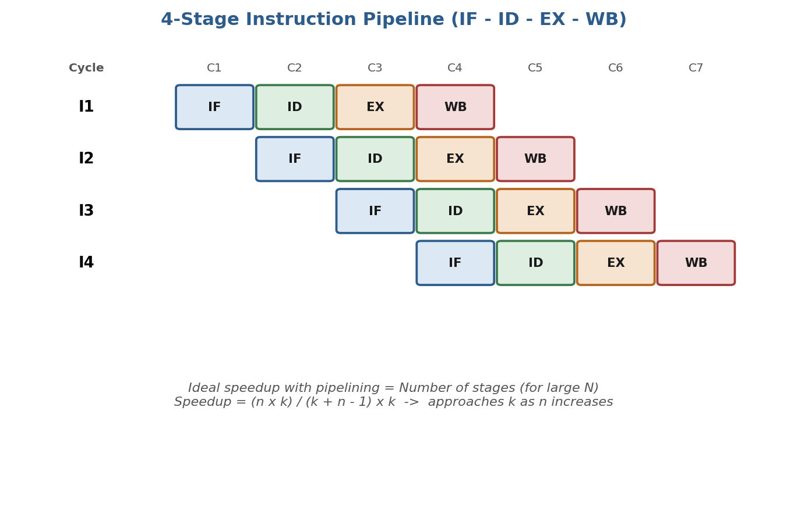
Fig 4.1: Four instructions moving through the 4-stage pipeline
Procedure
- Build four functional blocks for IF, ID, EX and WB and connect them in a straight line.
- Place a pipeline (latch) register between IF-ID, ID-EX and EX-WB, all driven by the same clock.
- Feed instructions I1, I2, I3 and I4 into the IF stage one at a time, one new instruction per clock cycle.
- Pulse the clock repeatedly and, after every pulse, note which stage each instruction is sitting in.
- Continue until all four instructions have passed through the WB stage.
- Use the recorded cycle numbers to calculate the pipelined execution time and compare it with the non-pipelined case.
Observation Table
Instruction | Cycle 1 | Cycle 2 | Cycle 3 | Cycle 4 | Cycle 5 | Cycle 6 | Cycle 7
I1 | IF | ID | EX | WB | - | - | -
I2 | - | IF | ID | EX | WB | - | -
I3 | - | - | IF | ID | EX | WB | -
I4 | - | - | - | IF | ID | EX | WB
Speedup Calculation
Number of instructions, n = 4. Number of pipeline stages, k = 4.
Non-pipelined execution time = n x k = 4 x 4 = 16 cycles (each instruction would need to finish completely before the next one starts).
Pipelined execution time = k + (n - 1) = 4 + 3 = 7 cycles (as shown in the observation table above).
Speedup = 16 / 7 = 2.29 (approximately).
Result
The 4-stage instruction pipeline was designed and simulated successfully. Four instructions were completed in 7 cycles instead of 16, giving a speedup of about 2.29. This value is less than the ideal speedup of 4 because the pipeline takes a few cycles to fill up at the start, which matters more when only a small number of instructions is used; the speedup would move closer to 4 as more instructions are pushed through the pipeline.

Experiment 5: Pipeline Hazards - Stalling and Forwarding
Implement and analyze pipeline hazards using a set of dependent instructions. Demonstrate data hazards and instruction hazards, and apply appropriate techniques such as stalling, forwarding, or branch handling to resolve them. Compare the pipeline performance before and after hazard resolution.
Aim
To demonstrate a data hazard between two dependent instructions in the 4-stage pipeline, resolve it first with stalling and then with forwarding, and compare how many cycles each method takes.
Components / Software Used
The same 4-stage pipeline circuit built in Experiment 4, with an added hazard-detection block that compares source and destination register numbers, a stall/bubble control signal, and a forwarding multiplexer placed at the ALU input of the EX stage.
Theory
A data hazard happens when an instruction needs a value that an earlier instruction has not produced yet. For example, I1: R1 <- R2 + R3 followed by I2: R4 <- R1 + R5 is a Read-After-Write (RAW) hazard, because I2 needs R1 before I1 has actually written it. One way to fix this is stalling: the pipeline detects the dependency and holds I2 in the Decode stage for one extra cycle (a bubble) until R1 is ready. A faster way is forwarding: the result coming out of I1's EX stage is sent directly into I2's EX stage through an extra data path, without waiting for it to be written back to the register file first. An instruction hazard (also called a control hazard) is a different kind of problem, caused by branch instructions - the pipeline does not know which instruction to fetch next until the branch outcome is known, so it may need to stall, guess the direction with a branch predictor, or throw away wrongly-fetched instructions if the guess turns out to be incorrect.
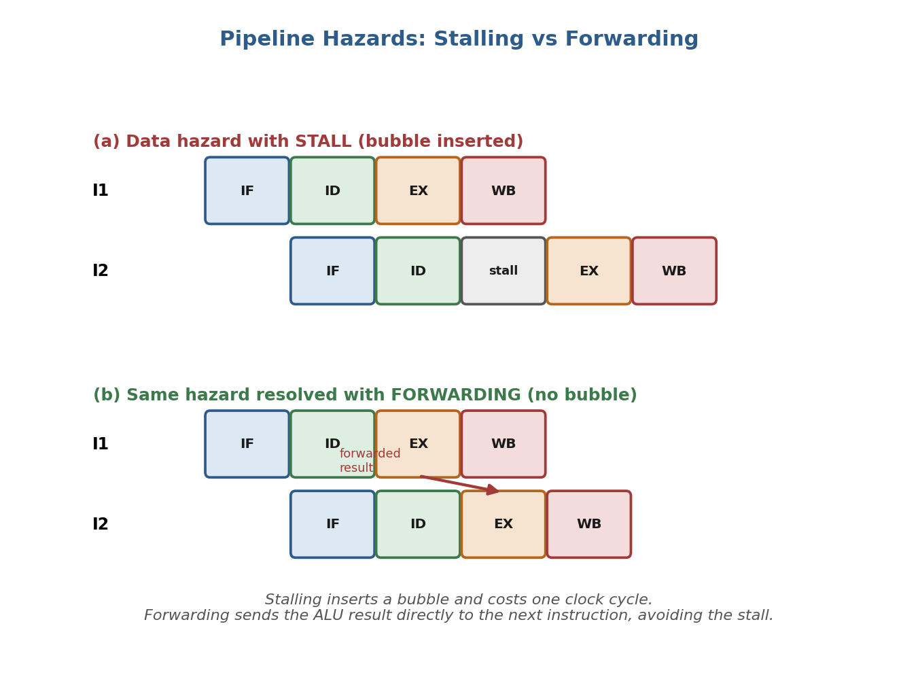
Fig 5.1: Data hazard resolved using stalling versus forwarding
Procedure
- Load two dependent instructions, I1: R1 <- R2 + R3 and I2: R4 <- R1 + R5, into the pipeline.
- Run the pipeline with forwarding disabled and note that the hazard-detection block inserts a bubble in I2's pipeline row before it can enter EX.
- Record the cycle at which I2 finally completes the WB stage.
- Now enable the forwarding multiplexer, which taps the EX/WB latch of I1 and feeds it into I2's ALU input.
- Run the same two instructions again and note that I2 no longer needs a bubble.
- Compare the total number of cycles taken in both runs.
- Separately, load a branch instruction followed by two dependent instructions to observe a control hazard, and note the stall introduced before the branch outcome is known.
Observation Table
Method | I1 completes (WB) | I2 completes (WB) | Bubble/Stall Inserted | Total Cycles for 2 Instructions
Stalling only | Cycle 4 | Cycle 6 | Yes (1 cycle) | 6
Forwarding | Cycle 4 | Cycle 5 | No | 5
Result
The data hazard between I1 and I2 was successfully identified and resolved using two different techniques. Stalling alone needed 6 cycles to complete both instructions because of the inserted bubble, while forwarding completed the same two instructions in 5 cycles by sending the ALU result directly to the next instruction. This confirms that forwarding is a faster hazard-resolution technique than stalling, since it removes the wasted bubble cycle while still producing the correct final register values.

