SIMATS ENGINEERING
Department of Computer Science & Engineering
ASSESSMENT TOOL 1 - ANALYTICAL PROBLEM SOLVING
Course Code: | CSA12 | Course Title: | Computer Architecture
CO Assessed: | CO3 | Assessment: | Tool 2 - MCQ
Weightage: | 20% | Total Marks: | 50
Student Name: | Kanishk C | Reg. No.: | 192511278
Department: | Computer Science & Engineering | Date: | 16-08-2026
CO3 Statement: Superscalar Processing: Out-of-order execution, Speculative execution, Dispatch and execution units. Advanced Features: Hyper-threading and simultaneous multithreading (SMT). (BL3)

ANNEXURE A - MCQ ANSWER KEY WITH EXPLANATIONS
This section carries the answer key for all 50 multiple-choice questions from Annexure A, along with a short explanation for each answer so that the underlying concept is clear and not just the option letter. The questions cover superscalar processing, out-of-order execution, register renaming, speculative execution and branch prediction, dispatch to execution units, and simultaneous multithreading (SMT). A few diagrams are included at the relevant points to make the harder concepts easier to visualise.
Part A: Superscalar Processing and Instruction-Level Parallelism (Q1-Q8)
A superscalar processor can fetch, decode and issue more than one instruction in a single clock cycle by using several execution units side by side. How much benefit this gives depends heavily on how independent the instructions actually are.
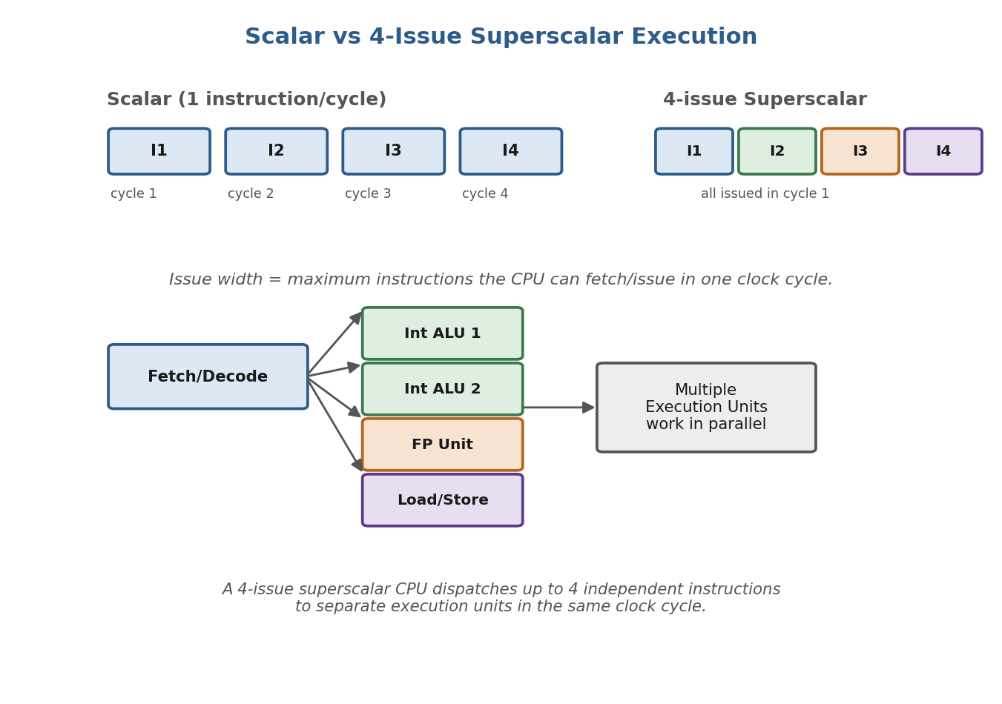
Fig A.1: Scalar vs 4-issue superscalar execution, and multiple execution units working in parallel
Q1. A 4-issue superscalar processor can ideally issue how many instructions per clock cycle?
Answer: C) 4
Explanation: By definition, a 4-issue superscalar processor is built to fetch, decode and issue up to 4 independent instructions in the same clock cycle, so the ideal case is 4.
Q2. A processor has four execution units, but only two independent instructions are available in a cycle. What is the maximum number of instructions that can be executed in that cycle?
Answer: B) 2
Explanation: Even though four execution units are free, only two instructions are actually ready and independent, so only those two can be executed in that cycle - the extra units simply stay idle.
Q3. Which situation most directly limits the performance of a superscalar processor?
Answer: C) Strong data dependencies
Explanation: When instructions depend heavily on each other's results, they cannot be issued together, so the processor cannot use its multiple execution units at the same time. This is the main limitation of superscalar designs, more than the number of units available.
Q4. Consider the instructions: I1: R1 <- R2 + R3 and I2: R4 <- R5 + R6. If sufficient execution units are available, what can happen?
Answer: B) Both can execute concurrently
Explanation: I1 and I2 use completely different registers and do not depend on each other's results, so with enough execution units both can run in the same cycle.
Q5. A 4-wide superscalar processor executes an average of 2 instructions per cycle. What is its effective IPC?
Answer: B) 2
Explanation: IPC (instructions per cycle) is simply the average number of instructions completed per cycle, which is given directly in the question as 2, regardless of the maximum issue width of 4.
Q6. If a processor's issue width is increased from 2 to 4 but the available instruction-level parallelism remains low, what is the likely result?
Answer: B) Performance may improve only slightly
Explanation: A wider issue width only helps if there are enough independent instructions to fill it. If the program does not have much parallelism, most of the extra issue slots go unused, so the gain is small.
Q7. Which mechanism dynamically identifies instructions that are ready for execution?
Answer: A) Scheduler
Explanation: The scheduler (also called the issue logic) continuously checks which instructions have all their operands available and sends only those ready instructions to the execution units.
Q8. Why are multiple execution units important in superscalar processors?
Answer: A) They allow independent operations to proceed simultaneously
Explanation: Having several execution units (integer ALUs, floating-point units, load/store units) means the processor can work on more than one independent instruction at the same time instead of one at a time.
Part B: Out-of-Order Execution and Register Renaming (Q9-Q21)
Out-of-order execution allows a processor to run ready instructions ahead of earlier ones that are still stalled, instead of leaving the pipeline idle. Register renaming and the Reorder Buffer (ROB) are the two hardware structures that make this possible without breaking the correctness of the program.
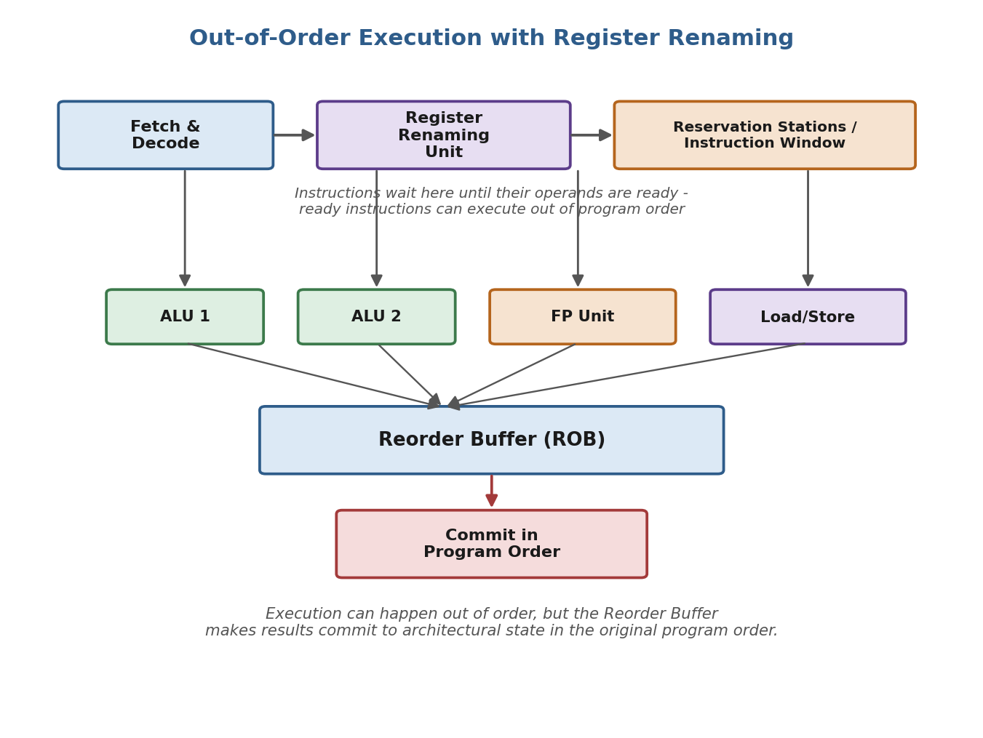
Fig B.1: Out-of-order execution pipeline showing register renaming, reservation stations and the Reorder Buffer
Q9. Consider: I1: R1 <- R2 + R3 and I2: R4 <- R1 x R5. Why can I2 not execute before I1 produces R1?
Answer: B) RAW dependency
Explanation: I2 needs to read R1 as an input, but R1 is only written by I1. This is a Read-After-Write dependency, and it forces I2 to wait until I1 has produced its result.
Q10. Which technique allows a processor to exploit instructions that are independent even when earlier instructions are delayed?
Answer: A) Out-of-order execution
Explanation: Out-of-order execution lets the processor skip past a stalled instruction and run a later, independent instruction first, instead of blocking the whole pipeline behind the delayed one.
Q11. Instruction I1 is waiting for memory data, while I2 is independent and ready. What can an out-of-order processor do?
Answer: B) Execute I2 while I1 waits
Explanation: Since I2 does not depend on I1, an out-of-order processor can send I2 to an execution unit immediately instead of leaving it idle behind the stalled I1.
Q12. What is the major advantage of out-of-order execution?
Answer: A) It keeps execution units busy
Explanation: By allowing ready instructions to run ahead of stalled ones, out-of-order execution reduces idle time in the execution units and improves overall throughput.
Q13. Consider the sequence: I1: R1 <- R2 + R3, I2: R4 <- R1 + R5, I3: R6 <- R7 + R8. If I1 is delayed, which instruction can potentially execute first?
Answer: B) I3 only
Explanation: I2 depends on R1 from I1, so it must wait. I3 does not depend on I1 or I2 at all, so it is the only one that can be executed first while I1 is still delayed.
Q14. Why is register renaming used in an out-of-order processor?
Answer: A) To eliminate false register dependencies
Explanation: Register renaming gives each new write a fresh physical register, which removes WAR and WAW hazards that exist only because two instructions happen to reuse the same architectural register name, not because they truly depend on each other.
Q15. Two instructions write to the same architectural register but have no true data dependency. Which hazard can occur?
Answer: C) WAW
Explanation: When two instructions both write to the same register without depending on each other's values, the danger is that they finish out of order and the wrong value is left in the register - this is a Write-After-Write hazard.
Q16. Register renaming primarily converts architectural registers into:
Answer: A) Physical registers
Explanation: Register renaming maps the small set of architectural (programmer-visible) register names onto a larger pool of physical registers inside the hardware, so multiple in-flight instructions can use the same architectural name safely.
Q17. Which dependency represents a true data dependency?
Answer: A) RAW
Explanation: A Read-After-Write dependency means an instruction genuinely needs a value produced by an earlier instruction, so it is the only one of the three hazard types that reflects a real data dependency rather than a naming conflict.
Q18. If instruction I2 reads a register before instruction I1 writes a new value to that register, the dependency is:
Answer: B) WAR
Explanation: This is a Write-After-Read situation: I2 must read the old value before I1 overwrites it with a new one. If the order is not respected, I2 could end up reading the wrong value.
Q19. Which structure helps an out-of-order processor preserve the original program order when committing results?
Answer: A) Reorder Buffer
Explanation: The Reorder Buffer (ROB) keeps track of instructions in their original program order and only allows them to update the visible architectural state in that same order, even though they may have executed out of order.
Q20. Why should results generally be committed in program order?
Answer: A) To maintain precise architectural state
Explanation: Committing in order guarantees that if an exception or interrupt occurs, the processor's visible state matches exactly what a simple in-order processor would have produced at that point, which is called a precise state.
Q21. An instruction has completed execution but cannot yet update the architectural state because an older instruction has not completed. Which mechanism can handle this situation?
Answer: A) Reorder Buffer
Explanation: The Reorder Buffer holds the finished result of the newer instruction until every older instruction ahead of it has also finished, and only then lets it commit, preserving program order.

Part C: Speculative Execution and Branch Prediction (Q22-Q32)
Branch instructions create a problem for pipelined processors because the next instruction to fetch is not known until the branch is resolved. Speculative execution deals with this by predicting the branch outcome and executing ahead, while keeping a way to undo the work if the guess is wrong.
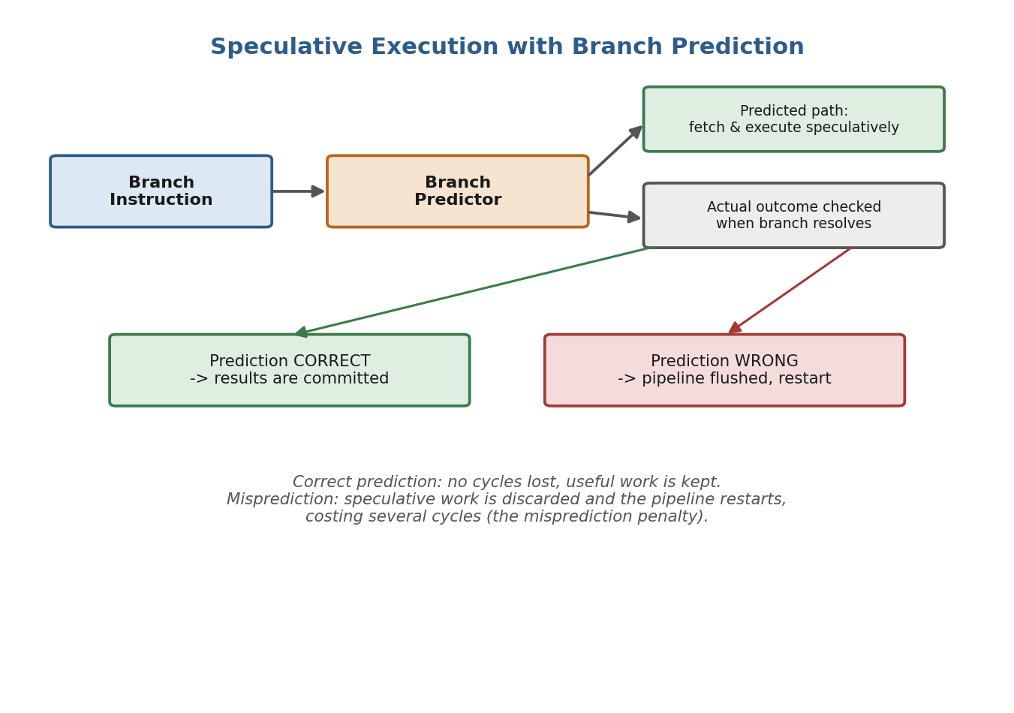
Fig C.1: Speculative execution following a predicted branch path, with recovery on misprediction
Q22. Which situation is most suitable for out-of-order execution?
Answer: A) Independent instructions with different execution delays
Explanation: Out-of-order execution gives the biggest benefit when instructions do not depend on each other but take different amounts of time to finish, since faster independent instructions can be completed while slower ones are still in progress.
Q23. Why does a processor use speculative execution?
Answer: A) To continue useful execution before branch outcomes are known
Explanation: Rather than stalling the pipeline until a branch is resolved, the processor guesses the likely outcome and keeps executing along that path, saving time if the guess is correct.
Q24. A branch predictor predicts that a conditional branch will be taken. What does the processor typically do?
Answer: A) Fetch and possibly execute instructions from the predicted path
Explanation: When the predictor says the branch will be taken, the processor starts fetching and speculatively executing instructions from the target address, without waiting to confirm the branch is actually taken.
Q25. What happens when speculative execution follows an incorrect branch prediction?
Answer: A) Incorrect speculative work is discarded
Explanation: If the prediction turns out to be wrong, all the speculative results computed along the wrong path are thrown away, the pipeline is flushed, and fetching restarts from the correct address.
Q26. A pipeline has a branch misprediction penalty of 5 cycles. If 10 branch mispredictions occur, how many cycles are lost, assuming no overlap?
Answer: C) 50 cycles
Explanation: Each misprediction costs 5 cycles, and with 10 mispredictions and no overlap between them, the total lost time is simply 5 x 10 = 50 cycles.
Q27. Which factor has the greatest impact on the effectiveness of speculative execution?
Answer: A) Branch prediction accuracy
Explanation: Speculative execution is only useful when the guess is usually correct. The more accurate the branch predictor is, the less often speculative work has to be thrown away, so prediction accuracy is the biggest factor in how well speculation pays off.
Q28. If branch prediction accuracy decreases significantly, what is the likely effect?
Answer: A) More pipeline flushes and reduced performance
Explanation: A less accurate predictor causes more wrong guesses, and each wrong guess means the pipeline has to be flushed and restarted, which wastes cycles and lowers overall performance.
Q29. Which prediction would generally be most beneficial for a branch executed 100 times and taken 95 times?
Answer: A) Predict taken
Explanation: Since the branch is taken 95 out of 100 times, predicting 'taken' every time will be correct 95% of the time, which is clearly the better strategy than predicting 'not taken' or guessing randomly.
Q30. Speculative instructions must not permanently change the architectural state until:
Answer: A) Their correctness is confirmed
Explanation: Because speculative instructions might later turn out to be on the wrong path, their results are held temporarily and are only allowed to update the real, visible processor state once the branch (or condition) they depended on is confirmed correct.
Q31. Which mechanism helps discard the results of incorrectly speculated instructions?
Answer: A) Recovery mechanism
Explanation: A recovery (or squash/flush) mechanism detects the misprediction, cancels the incorrect speculative instructions still in the pipeline, and restores the processor to the correct state before continuing.
Q32. What is the major performance benefit of accurate branch prediction?
Answer: A) Reduced control-flow stalls
Explanation: When branches are predicted correctly most of the time, the pipeline rarely has to stop and wait for a branch outcome, which reduces stalls caused by control-flow instructions.
Part D: Dispatch and Execution Units (Q33-Q38)
Once an instruction is decoded, the dispatch stage routes it to the execution unit that matches the type of work it needs to do - an integer ALU, a floating-point unit, or a load/store unit. An instruction can only run on a unit built for its own data type, so the mix of instructions being executed determines how well all the units are kept busy.
Q33. An instruction requiring floating-point addition is dispatched to which type of execution unit?
Answer: A) Floating-Point Unit
Explanation: Floating-point arithmetic needs specialised hardware for that format, so such instructions are sent specifically to the Floating-Point Unit rather than the integer ALU.
Q34. A load instruction generally requires which execution resource?
Answer: A) Load/Store Unit
Explanation: Load instructions read data from memory, and this job is handled by the dedicated Load/Store Unit, which manages memory addressing and access.
Q35. If all integer ALUs are busy but a floating-point unit is free, what is the likely result for a ready integer instruction?
Answer: A) It waits for an appropriate integer execution unit
Explanation: An integer instruction needs an integer ALU to execute; it cannot simply run on a free floating-point unit because the hardware is built for a different data format, so it must wait.
Q36. What is the primary role of the dispatch stage?
Answer: A) Send instructions toward appropriate execution resources
Explanation: The dispatch stage looks at each decoded instruction and directs it to the correct execution unit (integer ALU, FP unit, load/store unit, and so on) based on what type of operation it needs.
Q37. A processor has two integer ALUs and one floating-point unit. Which instruction mix can best utilize all three simultaneously?
Answer: A) Two integer operations and one floating-point operation
Explanation: With two integer ALUs and one FP unit available, sending two integer instructions and one floating-point instruction in the same cycle keeps every execution unit busy at once.
Q38. If execution units are frequently idle because instructions depend on previous results, the main limitation is:
Answer: A) Lack of instruction-level parallelism
Explanation: When most instructions must wait for earlier results, there simply are not enough independent instructions to keep the execution units busy, which is exactly what is meant by low instruction-level parallelism (ILP).

Part E: Hyper-Threading and Simultaneous Multithreading (Q39-Q50)
Simultaneous Multithreading (SMT), which Intel markets as Hyper-Threading, lets one physical core run two or more hardware threads at once by sharing its execution units and caches between them. This is different from multicore processing, where each thread gets its own independent physical core.
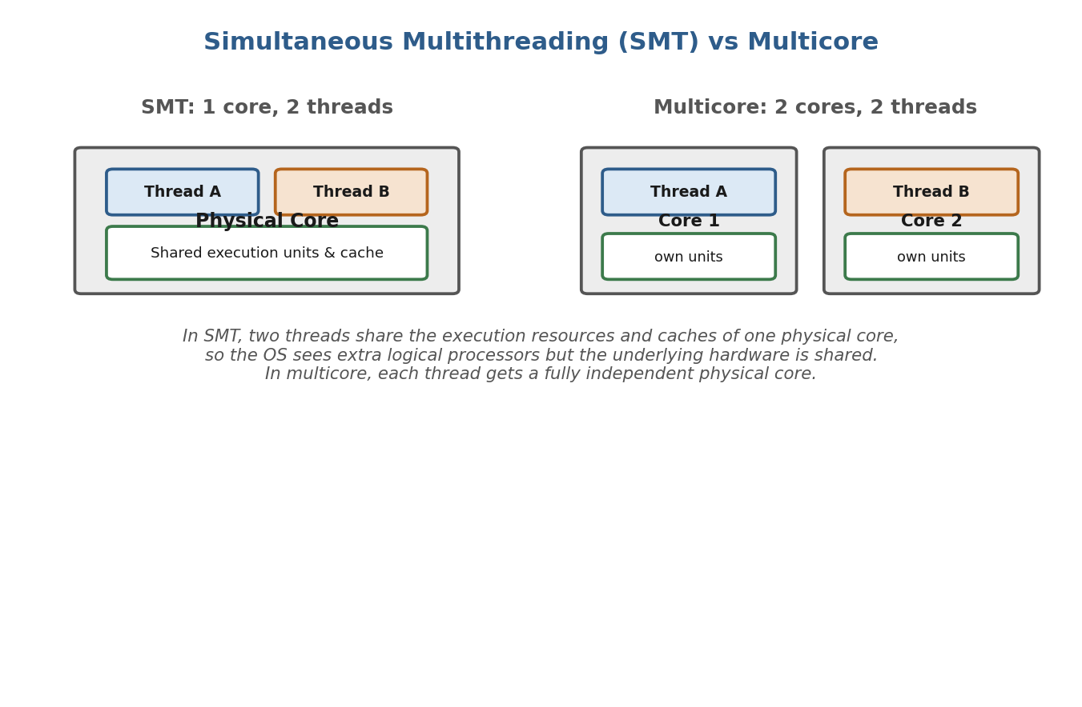
Fig E.1: SMT (shared core resources) compared with multicore processing (independent cores)
Q39. A physical CPU core supports two hardware threads using SMT. How many logical processors can the operating system typically see from that core?
Answer: B) 2
Explanation: With 2-way SMT, the single physical core presents itself to the operating system as two separate logical processors, one for each hardware thread it can run.
Q40. Two threads execute on the same SMT core. Which statement is correct?
Answer: A) They can share the core's execution resources
Explanation: SMT threads run on the same physical core and share its execution units, caches and other resources, taking turns or interleaving their use of those resources cycle by cycle.
Q41. SMT is most useful when:
Answer: A) One thread leaves some processor resources underutilized
Explanation: If a single thread cannot keep every execution unit busy on its own, SMT lets a second thread fill in those otherwise idle resources, improving overall utilisation.
Q42. Which statement best distinguishes SMT from multicore processing?
Answer: A) SMT allows multiple threads to share one physical core
Explanation: The key difference is that SMT runs multiple threads on the resources of a single physical core, while multicore processing gives each thread its own separate, independent physical core.
Q43. A single-threaded workload completely occupies all execution resources of a core. What is the likely benefit of enabling SMT for that workload?
Answer: A) Limited performance improvement
Explanation: If the one thread is already using almost all of the core's resources, there is very little left over for a second thread to use, so SMT does not help much in this case.
Q44. Two threads on the same SMT core compete heavily for the same execution resources. What is the likely result?
Answer: A) Performance may not scale linearly
Explanation: When both threads need the same resources at the same time, they end up competing rather than complementing each other, so the combined performance does not simply double as one might hope.
Q45. Which resources may be shared by multiple SMT threads?
Answer: A) Execution units and caches
Explanation: SMT threads on the same core commonly share the ALUs, floating-point units, and cache memory, since these are physically part of that one core.
Q46. Why does SMT generally provide less performance improvement than adding a completely independent physical core?
Answer: A) Threads share hardware resources within the same core
Explanation: Because SMT threads must share the same execution units and caches, they can slow each other down when both need the same resource, unlike a separate physical core which has its own dedicated hardware.
Q47. A processor has 4 physical cores and each core supports 2-way SMT. How many logical processors can the operating system typically detect?
Answer: C) 8
Explanation: Each of the 4 physical cores appears as 2 logical processors under 2-way SMT, so the total is 4 x 2 = 8 logical processors.
Q48. Which workload is most likely to benefit from SMT?
Answer: A) Multiple threads with complementary resource demands
Explanation: SMT works best when the threads sharing a core need different resources at different times (for example, one is heavy on integer work while the other is waiting on memory), so they fill in each other's gaps instead of competing.
Q49. Which combination best represents techniques used to exploit instruction and thread-level parallelism?
Answer: A) Superscalar execution and SMT
Explanation: Superscalar execution exploits instruction-level parallelism by issuing multiple instructions per cycle, while SMT exploits thread-level parallelism by running multiple threads on one core - together they represent both types of parallelism.
Q50. A processor combines superscalar execution, out-of-order execution, speculative execution, and SMT. What is the primary overall goal?
Answer: A) Maximize utilization of processor resources and improve throughput
Explanation: All of these techniques exist to keep the processor's execution units as busy as possible and complete more useful work per cycle, so together their overall goal is maximising resource utilisation and throughput.

