SIMATS ENGINEERING
ASSESSMENT TOOL 1
COURSE NAME: COMPUTER ARCHITECTURE COURSE CODE: CSA12
COURSE OUTCOME COVERED
CO1: Components of a computer system, including CPU, memory, and I/O. Basic Operational Concepts: Instruction execution cycle, instruction fetch and decode. Bus Structures: Single-bus, multi-bus, and hierarchical buses. Factors of Performance: CPU execution time, CPI, clock cycles, and benchmarking. 8085 and 8086 Architectures: Overview, instruction sets, and addressing modes. Modern Architectures: ARM Cortex, Intel Core, and AMD Ryzen. Instruction Sets, Formats, and Addressing Modes. Number Systems: Binary, hexadecimal, and their applications in computer systems. (BL4)

Assessment Tool Weightage: 40%
QUESTIONS: 5 Total Marks: 25

ANNEXURE A
APPLICATION BASED QUESTIONS
Code of Conduct:
I, Kanishk C (Reg. No: 192511278), certify that this submission is my original work and that I have adhered to the guidelines specified for this assessment. I understand that any violation of academic integrity rules will result in disciplinary action.
Signature of the student: Kanishk C

Question 1
A smart city surveillance system processes continuous video feeds from multiple cameras, where large volumes of data are transferred between I/O devices, memory, and CPU. During peak hours, the system experiences lag and delayed response in threat detection. Analyze how the interaction between CPU, memory, and I/O contributes to this issue, and explain how different bus structures (single-bus vs multi-bus) and improvements in instruction execution cycle can enhance system performance.
Answer:
In a surveillance system, the CPU, memory, and I/O devices (cameras) constantly work together. Every second, the cameras capture frames, these frames travel through the I/O interface, get temporarily placed in memory, and then the CPU picks them up for processing such as motion detection or face recognition. This entire chain depends on one shared resource, the system bus, which carries data, address, and control signals between these three units.
During peak hours, many cameras send data at the same time. If the system uses a single-bus architecture, only one device can use the bus at any given moment. This means while the CPU is reading a frame from memory, no camera can push new data in, and no other component can communicate. This creates a bottleneck because everything has to wait in a queue for its turn on the same physical wire. As more cameras are added, the waiting time grows, and this directly shows up as lag and delayed threat detection, because the alert-generating instructions cannot reach the CPU on time.
A multi-bus architecture solves this problem by providing separate paths for different types of transfers. For example, one bus can be dedicated purely to memory transfers while a different bus handles I/O communication. Because these buses work independently, the CPU can be reading a video frame from memory of camera 1 and receiving fresh data from camera 2 at the exact same time. This parallel movement of data reduces the queueing delay drastically and keeps the system responsive even under heavy camera load.
Along with the bus structure, the instruction execution cycle also plays an important role. The standard cycle of fetch, decode, and execute takes a fixed number of clock cycles for every instruction. If this cycle is optimized, for instance through pipelining where the fetch of the next instruction begins while the current instruction is still being decoded or executed, the CPU spends less idle time and can process the incoming frame data faster. Reducing memory access wait states, using cache memory to store frequently accessed frame data, and prefetching instructions are all improvements that shrink the effective execution time per instruction.
In short, replacing a single shared bus with a multi-bus structure removes the single point of congestion, and speeding up the instruction cycle through pipelining and caching reduces the per-instruction delay. Together, these two improvements let the surveillance system handle many simultaneous camera feeds without lag, ensuring that threat detection alerts are generated and delivered on time.
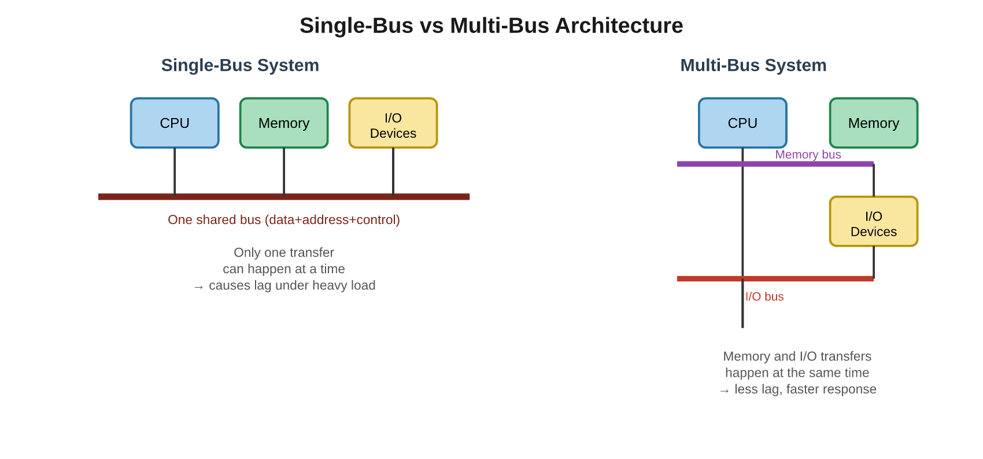
Fig 1.1: Comparison of single-bus and multi-bus data flow between CPU, memory and I/O

Question 2
A real-time stock trading application running on a processor executes millions of instructions per second, but users report delays in transaction processing during high load. The system has a high CPI due to frequent memory access and branch instructions. Examine how the fetch–decode–execute cycle impacts execution time in this scenario, and propose methods to reduce CPI and improve overall CPU performance using suitable architectural enhancements.
Answer:
Every instruction that the trading application runs, whether it is comparing stock prices or triggering a buy/sell order, must go through the same basic cycle: fetch the instruction from memory, decode it to understand what operation is needed, and execute it. The total execution time of the program depends on how many instructions are run, how many clock cycles each instruction takes on average (CPI, cycles per instruction), and how long each clock cycle lasts. This relationship is usually written as Execution Time = Instructions x CPI x Clock Cycle Time.
In this stock trading scenario, the CPI is high mainly because of two reasons. First, frequent memory access happens because the program constantly reads live price data and writes updated order information, and memory is much slower than the CPU itself, so the CPU often has to stall and wait for data to arrive. Second, branch instructions are heavy in this kind of application because decisions like "if price crosses this limit, execute the trade" require constant condition checking. Every wrong branch prediction forces the CPU to discard the instructions it had already started fetching and restart the fetch-decode-execute cycle from the correct path, which wastes several clock cycles.
Because of these stalls, even though the processor is technically capable of running millions of instructions per second, the effective throughput drops, and this appears to the user as a delay in transaction processing, especially when trading volume is high and many price updates or orders arrive together.
To reduce the CPI and improve performance, several architectural enhancements can help. Introducing a multi-level cache (L1, L2, L3) keeps recently used price and order data closer to the CPU, cutting down the number of slow main-memory accesses. Using pipelining allows the fetch of one instruction to overlap with the decode and execute of previous instructions, so the CPU is never sitting idle. For the branch problem, adding a branch predictor unit that learns the pattern of past decisions (for example, most orders in a bull run tend to be buy orders) reduces the number of incorrect guesses and therefore reduces the number of pipeline restarts. Techniques like out-of-order execution also help, because while the CPU waits for one slow memory read, it can continue executing other independent instructions instead of remaining idle.
By combining faster cache access, deeper pipelining, accurate branch prediction, and out-of-order execution, the average cycles needed per instruction come down significantly. This directly reduces the total execution time of the trading application and allows it to process transactions in real time, even during high-load trading periods.
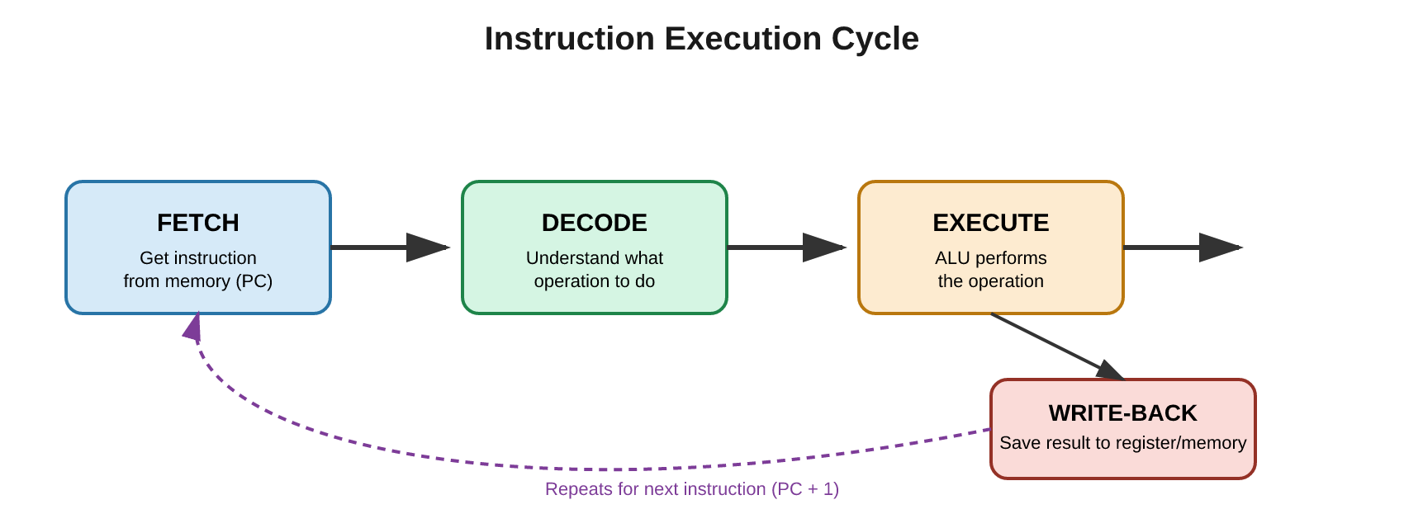
Fig 2.1: The Fetch-Decode-Execute-Writeback cycle repeated for every instruction

Question 3
An embedded system based on an 8085 microprocessor is used in an industrial temperature control unit, where sensors provide input and actuators respond accordingly. However, incorrect temperature readings are occasionally processed due to improper use of addressing modes in the program. Discuss how different addressing modes influence data access, identify possible causes of such errors, and suggest how the instruction set of 8085 can be effectively used to ensure accurate and reliable operation.
Answer:
The 8085 microprocessor supports several addressing modes, and each one decides where the CPU picks up the actual data from. In immediate addressing, the value is written directly inside the instruction itself, for example MVI A, 32H loads the fixed number 32H straight into the accumulator. In direct addressing, the instruction contains the exact memory address where the data is stored, for example LDA 2050H reads whatever value is sitting at memory location 2050H. In register addressing, data moves between two internal registers, such as MOV A, B. In indirect addressing, the address of the data is not written directly, but is held inside a register pair, usually HL, and the instruction MOV A, M reads from whatever memory address the HL pair currently points to.
In a temperature control unit, the sensor value usually keeps changing continuously, so the correct and natural way to fetch it is through indirect addressing, where the HL pair is updated to always point to the latest sensor reading in memory. If the programmer mistakenly uses direct addressing (a fixed address) instead of indirect addressing, the CPU keeps reading the same old memory location every single time, even though the actual sensor value has moved to a different memory location. This is one of the most common causes of incorrect temperature readings being processed: the program is technically running without any syntax error, but it is reading stale or wrong data because the addressing mode does not match how the data is actually organized in memory.
Another possible cause is confusing immediate addressing with direct or indirect addressing. If a constant test value gets hardcoded using MVI instead of reading the live sensor input through LDA or MOV A, M, the actuator will keep responding to a fixed dummy value instead of the real temperature, which explains why the system occasionally behaves incorrectly during actual operation.
To ensure accurate and reliable operation, the instruction set of the 8085 should be used carefully according to the nature of the data. The sensor reading, since its memory location changes as new samples arrive, should always be accessed using indirect addressing through the HL register pair, which is then updated after every read using instructions like INX H. Fixed reference values, such as the safe temperature threshold, can safely use immediate addressing since they never change. Communication with the actuator, which lives at a permanent output port, is best done using direct addressing or OUT instructions with a fixed port address. Choosing the addressing mode that matches how each piece of data behaves, instead of using one mode for everything, prevents the CPU from reading outdated values and ensures the actuator always receives an accurate, up-to-date response.
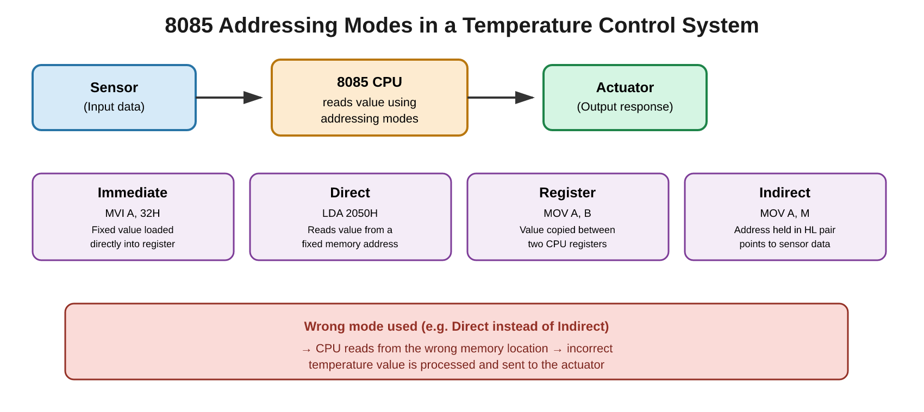
Fig 3.1: Addressing modes used by the 8085 CPU between sensor input and actuator output

Question 4
A computing system uses an 8086 microprocessor with segmented memory for executing multiple programs simultaneously, but it encounters issues like incorrect data access and stack overflow errors. Evaluate how segmentation (code, data, and stack segments) works in 8086, analyze how improper segment handling can lead to such problems, and explain how instruction execution and addressing modes must be managed to ensure correct program execution.
Answer:
The 8086 microprocessor can address a total of 1 MB of memory, but its internal registers are only 16 bits wide, which by themselves can address just 64 KB. To solve this, Intel introduced a segmented memory model, where the 1 MB memory space is divided into logical segments, each up to 64 KB in size. Four special segment registers keep track of the starting point of each segment: CS (Code Segment) holds the program instructions, DS (Data Segment) holds variables and data used by the program, SS (Stack Segment) manages the stack used for function calls, return addresses, and temporary storage, and ES (Extra Segment) is generally used for extra data, often during string operations.
To find the exact byte in memory, the CPU combines a segment register value with an offset value using the formula Physical Address = (Segment Register x 10H) + Offset. This means the same offset value can point to a completely different physical address depending on which segment register is currently being used, which is exactly why careful segment management matters.
When multiple programs run at the same time, each program is normally given its own set of segment values so that their code, data, and stack areas do not clash. If the operating system or the programmer accidentally reuses the same segment register value for two different programs, or updates the DS register without updating the corresponding offset properly, the CPU will end up reading or writing data from the wrong program's memory area. This is a common reason for incorrect data access, since the program thinks it is reading its own variable, but it is actually pointing into another program's data segment.
Stack overflow errors usually happen when the SS register and the stack pointer (SP) are not managed correctly. The stack grows downward in 8086, and every function call, interrupt, or PUSH instruction uses up more stack space. If a program keeps calling functions recursively, or pushes data onto the stack without matching POP instructions, the stack pointer keeps decreasing until it goes below the boundary of the stack segment and starts overwriting the data segment or code segment that sits right next to it in memory. This corrupts other parts of the program and is felt as a stack overflow error.
To avoid these problems, each running program should be allocated its own dedicated CS, DS, SS, and ES values that do not overlap with another program's segments, and these values should not be changed carelessly in the middle of execution. The stack segment should be sized generously enough for the expected depth of function calls, and every PUSH must be matched with a corresponding POP so the stack pointer returns to its original position. Addressing modes that use offsets, such as based or indexed addressing, must always be paired with the correct, currently intended segment register. Following this discipline keeps each program's code, data, and stack areas properly isolated, which prevents both incorrect data access and stack overflow errors.
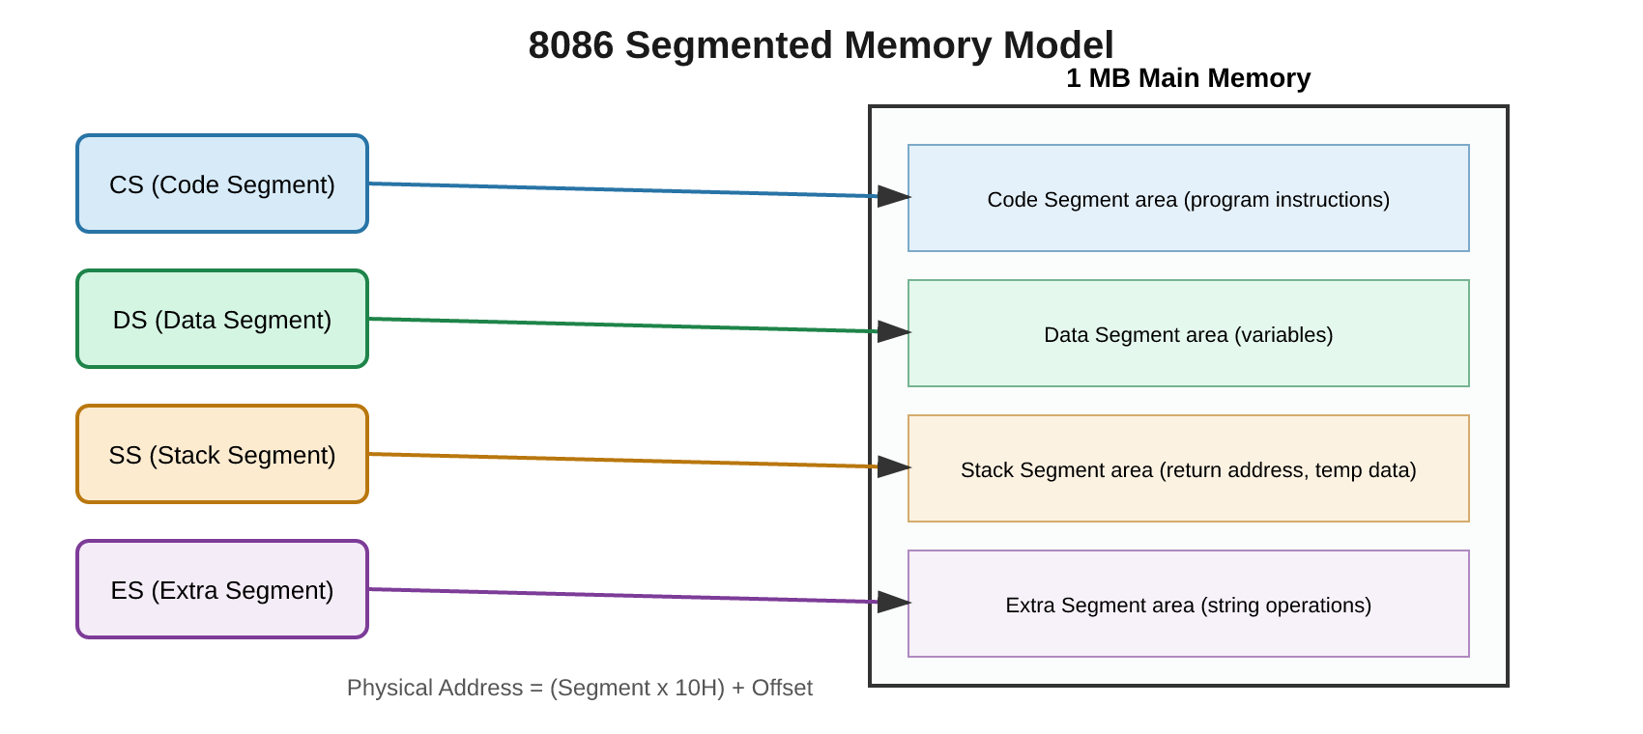
Fig 4.1: 8086 segment registers pointing to their respective areas in 1 MB memory

Question 5
A data communication system represents packet information in hexadecimal format for ease of debugging and transmission, but a software engineer mistakenly interprets values, leading to incorrect data processing. Analyze the importance of number system conversions between hexadecimal and binary in such systems, explain how errors in conversion can affect instruction execution, and discuss how efficient CPU design and benchmarking can help detect and minimize such issues in real-time systems.
Answer:
Computers internally store and process every piece of information, including data packets, purely as binary digits (0s and 1s). However, long binary strings are difficult for humans to read, write, and debug, so hexadecimal notation is used instead, since each hex digit conveniently represents exactly four binary bits (a nibble). For example, the hex value 4F directly maps to the binary pattern 0100 1111. This makes hexadecimal a shorthand that is easy for engineers to read while still being exactly equivalent to the binary data the CPU actually works with.
In a data communication system, packet headers and payload fields are often displayed and documented in hexadecimal for this reason. When a software engineer mistakenly misreads a hex value, for example swapping the digits of 4F to read it as F4, or misplacing where one byte ends and the next begins, the binary pattern that gets reconstructed is completely different from the intended one. Since the CPU has no way of knowing that a mistake was made, it treats this wrong binary value exactly as if it were correct, and processes it as-is.
This kind of conversion error can affect instruction execution in more than one way. If the misread value is part of an opcode field, the CPU may decode it as an entirely different instruction than the one intended, causing unexpected operations to run. If the misread value belongs to a data field, such as a sensor reading or an account number inside the packet, the system will process wrong data even though the instructions themselves are correct. In real-time systems, where decisions are made instantly based on incoming packets, such an error can propagate quickly, causing incorrect responses, corrupted transactions, or system instability before anyone notices the mistake.
Efficient CPU design helps guard against this in a few ways. Hardware-level checks, such as parity bits, checksums, and cyclic redundancy checks (CRC), are usually built into communication protocols and can automatically detect if a byte was corrupted or misread during transmission or interpretation, allowing the system to reject or re-request the packet instead of processing wrong data silently. Additionally, benchmarking the CPU and communication pipeline under realistic packet loads helps engineers measure how the system performs and behaves under stress, revealing weak points where conversion or timing errors are more likely to occur, for instance during peak throughput when engineers might be manually inspecting packets quickly.
Overall, correct conversion between hexadecimal and binary is essential because it is the bridge between how humans read data and how the CPU actually processes it. Combining careful conversion practices with hardware-level error detection and regular benchmarking under real-time load conditions greatly reduces the chances of such misinterpretation errors affecting the accuracy of the system.
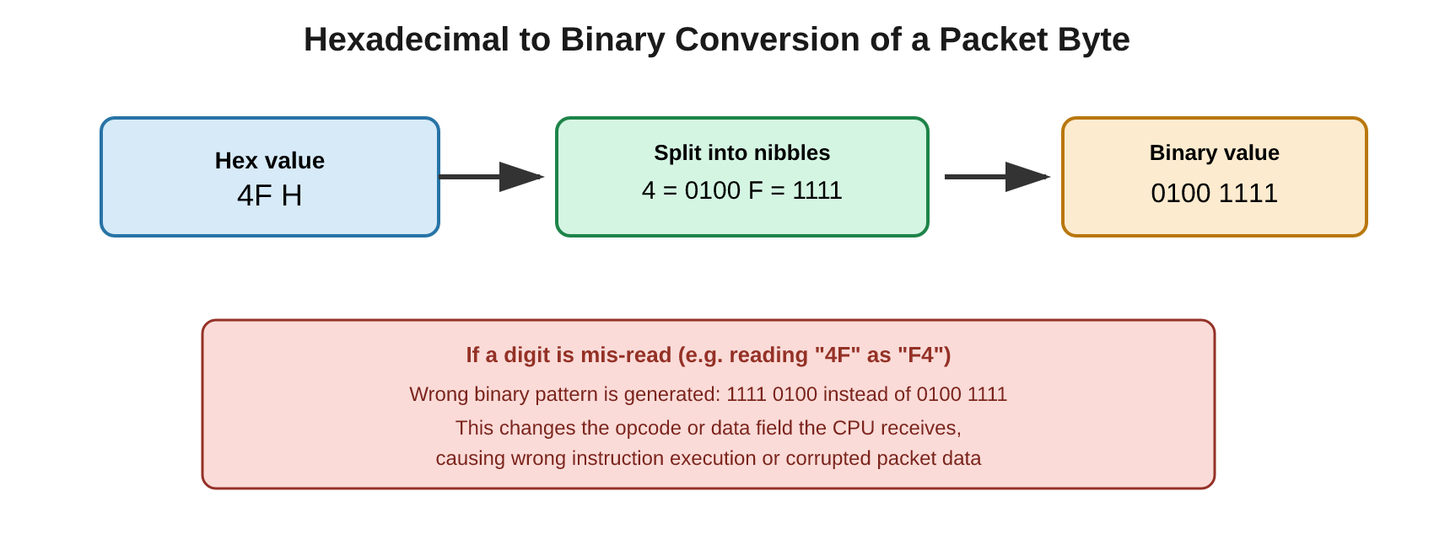
Fig 5.1: Correct hex-to-binary conversion of a packet byte, and the effect of a misread digit

