SIMATS ENGINEERING
ASSESSMENT TOOL 2
COURSE CODE: | CSA12 | COURSE NAME: | Computer Architecture

Student Name: Kanishk C Register Number: 192511278

Course Outcome Covered
CO1: Components of a computer system, including CPU, memory, and I/O. Basic operational concepts: instruction execution cycle, instruction fetch and decode. Bus structures: single-bus, multi-bus, and hierarchical buses. Factors of performance: CPU execution time, CPI, clock cycles, and benchmarking. 8085 and 8086 architectures: overview, instruction sets, and addressing modes. Modern architectures: ARM Cortex, Intel Core, and AMD Ryzen. Instruction sets, formats, and addressing modes. Number systems: binary, hexadecimal, and their applications in computer systems. (BL4)
Assessment Tool Weightage: 40%
Questions: 5 Total Marks: 25

Code of Conduct
I Kanishk C (Reg. No. 192511278) certify that this submission is my original work and that I have adhered to the guidelines specified for this assessment.
I understand that any violation of academic integrity rules will result in disciplinary action.
Signature of the student: Kanishk C

Question 1: CPU, Memory, I/O and the Instruction Execution Cycle
"Construct a concept map that connects the components of a computer system (CPU, memory, and I/O) with the instruction execution cycle. Clearly show how instruction fetch, decode, and execution stages interact with memory and input/output operations during program execution."
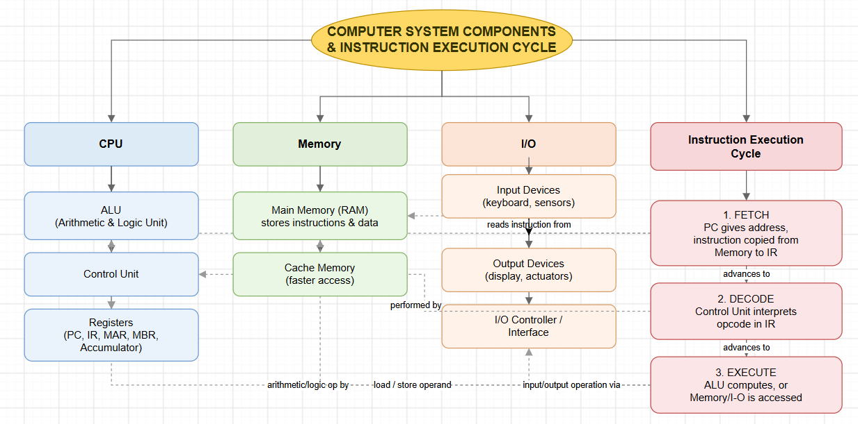
Figure 1: Concept map connecting CPU, memory and I/O with the instruction execution cycle

Explanation
This map has four branches coming off the central idea: the CPU, memory, I/O, and the instruction execution cycle itself. The CPU branch breaks down into the ALU, which does the actual arithmetic and logic work, the control unit, which manages timing and interprets instructions, and the registers — the Program Counter (PC), Instruction Register (IR), Memory Address Register (MAR), Memory Buffer Register (MBR), and the accumulator — which hold small pieces of data the CPU is actively working with.
The memory branch is kept simple on purpose: main memory (RAM) holds the program's instructions and data, and cache memory sits closer to the CPU to speed up repeated access. The I/O branch covers input devices, output devices, and the I/O controller that acts as the go-between so the CPU does not have to talk to physical hardware directly.
The fourth branch, the instruction execution cycle, is where the map earns its name — it does not just list fetch, decode, and execute as three boxes in a row, it links each stage back to the components that actually carry it out. Fetch pulls the next instruction from RAM using the address held in the PC, and loads it into the IR — this is shown with dashed arrows from Fetch to both RAM and Registers. Decode is the control unit's job, so a dashed arrow connects Decode straight to the Control Unit. Execute branches three ways depending on what the instruction actually does: if it is an arithmetic or logic instruction, the ALU carries it out; if it needs to read or write data, it goes back to memory; and if the instruction involves input or output, it is routed through the I/O controller. Showing all three of these possibilities under Execute, instead of picking just one, is what makes the map represent a real, general-purpose CPU rather than one narrow example.

Node and relationship summary
Concept Node | Relationship (Link Label) | Connected Concept
Instruction Execution Cycle | connects | CPU, Memory, I/O
CPU | includes | ALU, Control Unit, Registers (PC, IR, MAR, MBR, Accumulator)
Memory | includes | Main Memory (RAM), Cache Memory
I/O | includes | Input Devices, Output Devices, I/O Controller
Fetch | advances to | Decode → Execute
Fetch | reads instruction from / uses (dashed) | RAM / Registers (PC, IR)
Decode | performed by (dashed) | Control Unit
Execute | carried out by (dashed) | ALU (compute), RAM (load/store), I/O Controller (input/output)

Question 2: Bus Structures and Performance Factors
"Develop a concept map linking different bus structures (single-bus, multi-bus, hierarchical bus) with system performance factors such as CPU execution time, clock cycles, and CPI. Illustrate how bus design influences data transfer speed and overall system efficiency."
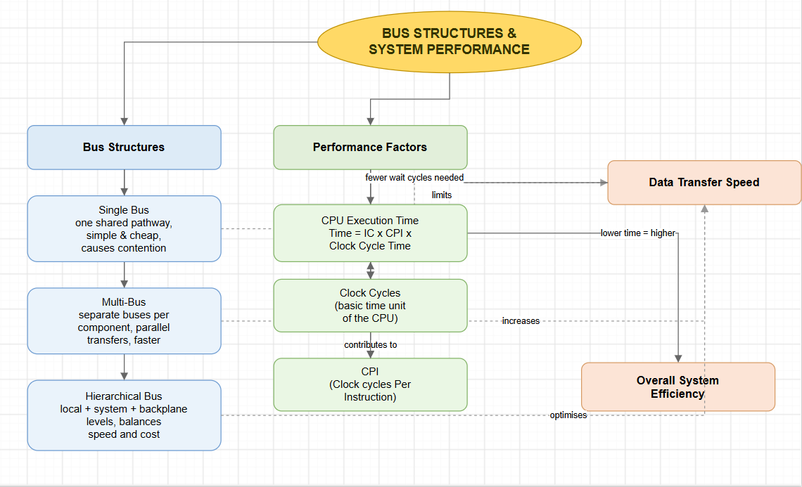
Figure 2: Concept map linking bus structures to performance factors

Explanation
This map has two main branches, Bus Structures and Performance Factors, that both feed into a short chain showing how one actually affects the other — this chain is what answers the second half of the question about efficiency, not just the comparison itself.
Under Bus Structures, a single bus is the simplest design: one shared pathway carries addresses, data, and control signals, which keeps the hardware cheap but means components have to take turns, causing contention when several devices want the bus at once. A multi-bus design solves that by giving different components separate paths, so transfers can happen in parallel and are generally faster, at the cost of more complex hardware. A hierarchical bus goes a step further, organising buses into levels — a fast local bus close to the CPU, a system bus for main memory, and a slower backplane bus for peripherals — which balances speed against cost by only paying for high speed where it is actually needed.
Under Performance Factors, the map lists CPU execution time, clock cycles, and CPI, and connects them using the standard performance formula: execution time equals instruction count multiplied by CPI multiplied by clock cycle time. The two branches are tied together with three dashed arrows: a single bus limits data transfer speed, a multi-bus increases it, and a hierarchical bus optimises it. Faster data transfer means the CPU spends fewer clock cycles waiting for data, which lowers CPI, which lowers execution time, which is shown as the final step leading to overall system efficiency. Reading the map left to right this way answers exactly what the question asks: how the choice of bus design flows all the way through to how efficient the whole system feels.

Node and relationship summary
Concept Node | Relationship (Link Label) | Connected Concept
Bus Structures | includes | Single Bus, Multi-Bus, Hierarchical Bus
Performance Factors | includes | CPU Execution Time, Clock Cycles, CPI
Single Bus | limits (dashed) | Data Transfer Speed
Multi-Bus | increases (dashed) | Data Transfer Speed
Hierarchical Bus | optimises (dashed) | Data Transfer Speed
Data Transfer Speed | reduces wait, affects | Clock Cycles
Clock Cycles | contributes to | CPI
CPI | determines | CPU Execution Time
CPU Execution Time | lower time means higher | Overall System Efficiency

Question 3: 8085 / 8086 Compared with Modern Architectures
"Create a concept map that compares 8085 and 8086 architectures with modern architectures like ARM Cortex, Intel Core, and AMD Ryzen. Show relationships in terms of instruction sets, addressing modes, processing capability, and architectural advancements."
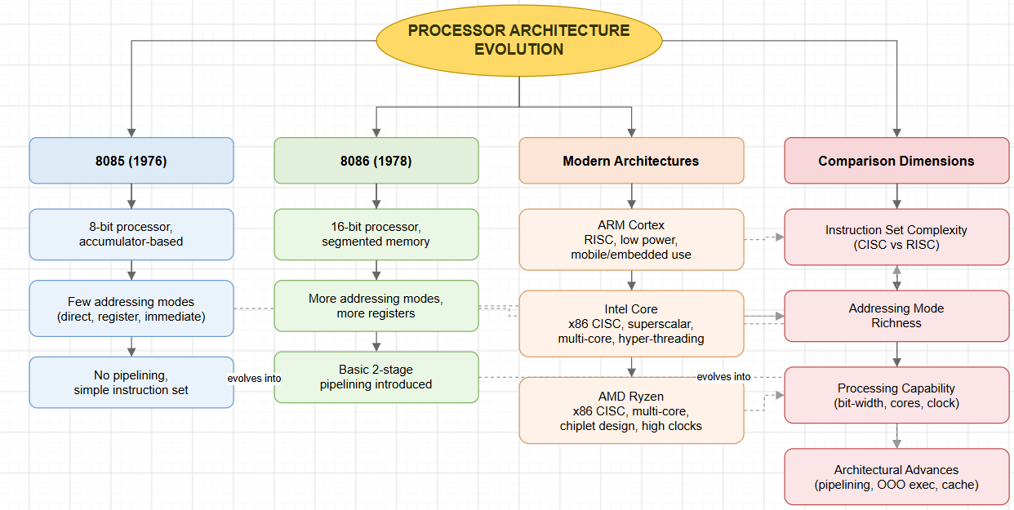
Figure 3: Concept map comparing 8085 and 8086 with modern processor architectures

Explanation
This map is laid out as four parallel branches — 8085, 8086, Modern Architectures, and a fourth branch called Comparison Dimensions — because the question asks for a comparison, not just a description of each processor on its own. The comparison dimensions branch is what actually forces the map to compare rather than list.
The 8085, released in 1976, is shown as an 8-bit, accumulator-based processor with only a few addressing modes (direct, register, and immediate) and no pipelining at all — every instruction is fetched, decoded, and executed one at a time with nothing overlapping. The 8086, from 1978, is one step up: it moved to 16 bits, introduced segmented memory to address more than 64KB, added more registers and addressing modes, and introduced a basic two-stage pipeline so that fetching the next instruction could begin while the current one was still executing.
The modern architectures branch covers three processors that each represent a different design philosophy: ARM Cortex uses a RISC (Reduced Instruction Set Computer) approach with a smaller, simpler instruction set that suits low-power mobile and embedded devices; Intel Core is a CISC (Complex Instruction Set Computer) design with superscalar execution, multiple cores, and hyper-threading that lets one core handle two instruction streams at once; and AMD Ryzen is also x86 CISC, but built using a chiplet design that lets AMD combine multiple smaller dies into one processor package to push core counts and clock speeds higher without one enormous, expensive chip.
The dashed arrows connect specific processors to specific comparison dimensions rather than connecting everything to everything, which keeps the comparison focused: the 8085's lack of pipelining evolves into the 8086's basic pipelining, which itself evolves into the much deeper pipelining and out-of-order execution used in modern chips; the addressing modes of both older processors feed into the general addressing-mode-richness dimension; and ARM/Intel connect to instruction set complexity because RISC versus CISC is precisely their defining difference, while Ryzen connects to processing capability because multi-core chiplet design is its most distinctive architectural trait.

Node and relationship summary
Concept Node | Relationship (Link Label) | Connected Concept
8085 (1976) | is | 8-bit, accumulator-based, no pipelining, few addressing modes
8086 (1978) | is | 16-bit, segmented memory, more registers, basic 2-stage pipelining
Modern Architectures | includes | ARM Cortex (RISC), Intel Core (CISC, superscalar), AMD Ryzen (CISC, chiplet)
Comparison Dimensions | includes | Instruction Set Complexity, Addressing Mode Richness, Processing Capability, Architectural Advances
8085 pipelining | evolves into (dashed) | 8086 pipelining
8086 pipelining | evolves into (dashed) | Modern Architectural Advances
8085 / 8086 addressing modes | feed into (dashed) | Addressing Mode Richness
ARM / Intel | define (dashed) | Instruction Set Complexity (RISC vs CISC)
AMD Ryzen | defines (dashed) | Processing Capability (multi-core, chiplets)

Question 4: Instruction Sets, Formats, Addressing Modes and Number Systems
"Design a concept map that integrates instruction sets, instruction formats, and addressing modes with number systems (binary and hexadecimal). Explain how instructions are represented, decoded, and executed using these number systems in a computer."
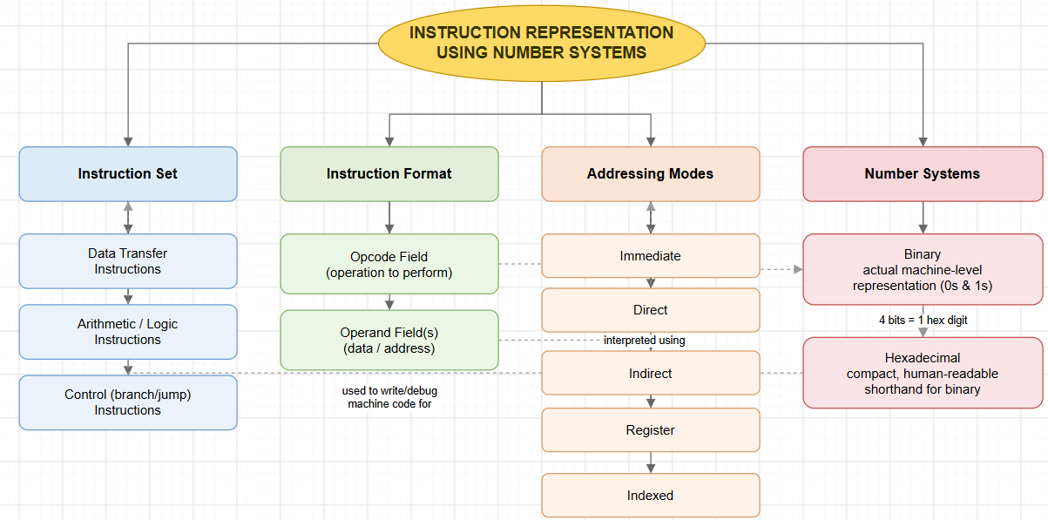
Figure 4: Concept map integrating instruction sets, formats, addressing modes and number systems

Explanation
This map has four branches: Instruction Set, Instruction Format, Addressing Modes, and Number Systems. The instruction set branch groups instructions into three broad families — data transfer instructions (moving values between registers and memory), arithmetic/logic instructions (calculations and comparisons), and control instructions (branches and jumps that change the order of execution).
The instruction format branch breaks a single instruction into its two working parts: the opcode field, which tells the CPU what operation to perform, and the operand field, which supplies the data or the address the operation needs. The addressing modes branch lists five common ways an operand's address can be worked out — immediate (the value is given directly), direct (the address is given directly), indirect (the address points to another address), register (the operand is inside a register), and indexed (an offset is added to a base address).
The number systems branch is where the question's real point comes together: binary is described as the actual machine-level representation, the literal 0s and 1s that the CPU's circuits respond to, while hexadecimal is described as a compact, human-readable shorthand for that same binary, useful for writing and debugging machine code without having to read out long strings of 0s and 1s. Four dashed arrows tie all four branches together into one explanation: the opcode field is stored and decoded as binary, because that is the only language circuitry actually understands; the operand field is interpreted using whichever addressing mode the instruction specifies; binary groups neatly into hexadecimal because every 4 bits corresponds to exactly one hex digit; and hexadecimal in turn is used to write and debug the very instruction set the map started with, closing the loop between the abstract idea of an instruction and its physical representation inside the computer.

Node and relationship summary
Concept Node | Relationship (Link Label) | Connected Concept
Instruction Set | includes | Data Transfer, Arithmetic/Logic, Control (branch/jump) Instructions
Instruction Format | includes | Opcode Field, Operand Field(s)
Addressing Modes | includes | Immediate, Direct, Indirect, Register, Indexed
Number Systems | includes | Binary, Hexadecimal
Opcode Field | stored & decoded as (dashed) | Binary
Operand Field | interpreted using (dashed) | Addressing Modes
Binary | grouped as 4 bits = 1 digit into (dashed) | Hexadecimal
Hexadecimal | used to write/debug machine code for (dashed) | Instruction Set

Question 5: Benchmarking and Performance Metrics Across Architectures
"Prepare a concept map that connects benchmarking techniques with performance metrics such as CPU execution time, CPI, and clock cycles, and relate these to different architectures (8085, 8086, and modern processors). Demonstrate how performance evaluation varies across different system designs."
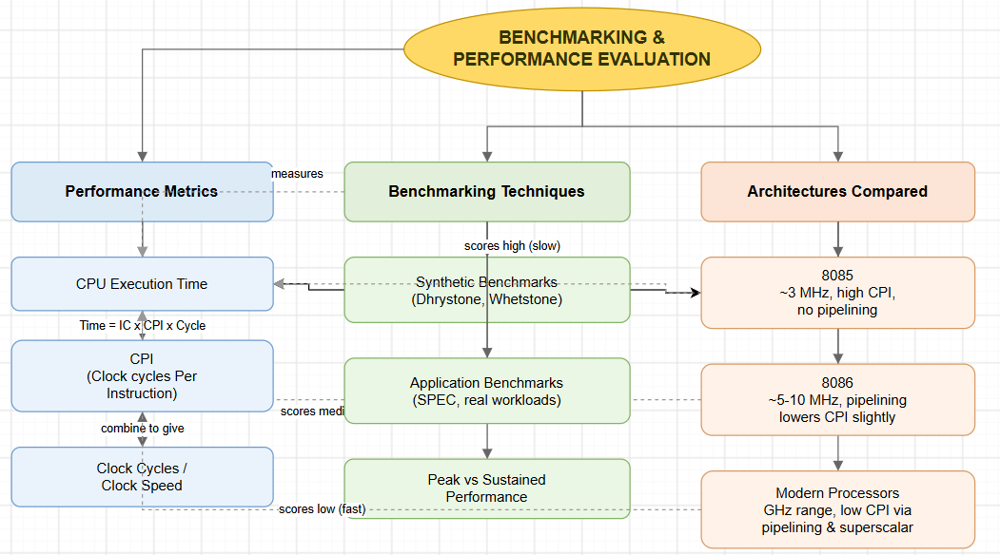
Figure 5: Concept map connecting benchmarking techniques, performance metrics, and architectures

Explanation
This map ties together three branches: Performance Metrics, Benchmarking Techniques, and Architectures Compared, using the same execution-time formula that appeared in Question 2, but this time applying it across different generations of hardware rather than different bus designs.
Performance metrics covers CPU execution time, CPI, and clock cycles/clock speed — the raw numbers any benchmark is trying to measure. Benchmarking techniques covers three approaches: synthetic benchmarks like Dhrystone and Whetstone, which run artificial workloads designed purely to stress specific operations; application benchmarks like SPEC, which run real, representative software instead of artificial code; and the distinction between peak performance (the best-case number a processor can reach) and sustained performance (what it actually delivers over a longer, realistic workload).
The architectures compared branch is where the map demonstrates that performance evaluation is not the same for every processor generation, which is exactly what the question asks for. The 8085, running at around 3MHz with no pipelining, has a comparatively high CPI and is shown scoring high (meaning slow) on execution time. The 8086, running faster and with basic pipelining, lowers CPI slightly and scores medium. Modern processors, running in the gigahertz range with pipelining and superscalar execution that can complete more than one instruction per clock cycle, achieve a much lower CPI and score low (meaning fast) on execution time. Connecting all three architecture nodes to the same Execution Time node, rather than giving each one its own separate metric node, is what visually demonstrates the comparison the question is asking for — one shared yardstick, three very different results.

Node and relationship summary
Concept Node | Relationship (Link Label) | Connected Concept
Performance Metrics | includes | CPU Execution Time, CPI, Clock Cycles/Clock Speed
Benchmarking Techniques | includes | Synthetic Benchmarks, Application Benchmarks, Peak vs Sustained Performance
Architectures Compared | includes | 8085, 8086, Modern Processors
Benchmarking Techniques | measures (dashed) | CPU Execution Time
Clock Cycles | combine to give | CPI
CPI | determines (Time = IC x CPI x Cycle Time) | CPU Execution Time
8085 | scores high / slow on (dashed) | CPU Execution Time
8086 | scores medium on (dashed) | CPU Execution Time
Modern Processors | scores low / fast on (dashed) | CPU Execution Time

Overall Reflection
Across all five maps, the same handful of ideas keep reappearing in different combinations — clock cycles and CPI show up in both the bus-structure map and the benchmarking map, and pipelining shows up in both the architecture-comparison map and the instruction-cycle map. That repetition is not accidental; it reflects how a real computer architecture course builds up one small set of core ideas (the fetch-decode-execute cycle, the performance formula, and the CISC/RISC distinction) and keeps reapplying them to new situations, from a single instruction all the way up to a benchmark comparing entire processor families. Building the maps this way, with explicit relationship labels rather than just grouped boxes, was what made those repeated connections visible instead of leaving them as five separate, disconnected topics.

