SIMATS ENGINEERING
ASSESSMENT TOOL
____________________________________________________
Course Name: Theory of Computation Course Code: CSA13
Course Outcome Covered: CO1: Analyze fundamental mathematical concepts of automata theory for formal languages and decision problems (BL:3)
Assessment Tool: Technical Presentation Weightage: 10%
Questions: 4 Total Marks: 20 Duration: 1 Hour
____________________________________________________
Code of Conduct
I Kanishk C (Reg. No: 192511278) certify that this submission is my original work and that I have adhered to the guidelines specified for this assessment.
I understand that any violation of academic integrity rules will result in disciplinary action.
Name: Kanishk C
Registration Number: 192511278
Signature of the student: Kanishk C

Question 1: NFA to DFA Conversion (Subset Construction)
Concept: Why NFA to DFA conversion is needed
A Non-Deterministic Finite Automaton (NFA) is a machine where, for a given state and input symbol, the machine is allowed to move to more than one next state, or even to no state at all. This is very useful for designing automata quickly, because we do not have to worry about every possible transition. However, an NFA is only a theoretical convenience, because a real computer or a real program cannot literally be in many states at the same time. This is why every NFA is converted into an equivalent Deterministic Finite Automaton (DFA) before it is implemented in a compiler, a text search tool, or a hardware controller. A DFA has exactly one transition for every state and input symbol, so its behaviour is completely predictable and it can be simulated directly by a computer program using a single current state variable.
The Subset Construction Method
The standard technique used to convert an NFA into a DFA is called the Subset Construction Method (also called the Powerset Construction). The core idea is simple: instead of tracking a single NFA state, we track the set of all NFA states that could possibly be active after reading a given input string. Each such set becomes a single state of the new DFA. The method works as follows:
- Start with the set containing only the NFA start state. This becomes the DFA start state.
- For every DFA state (which is a set of NFA states) and every input symbol, compute the union of the NFA transitions of all states in that set for that symbol. This union is the next DFA state.
- Repeat this process for every newly discovered set of states until no new sets appear.
- Any DFA state (set of NFA states) that contains at least one NFA final state is marked as a final state of the DFA.
The number of DFA states can, in the worst case, become as large as 2^n for an NFA with n states, but in practice only the reachable subsets are constructed, so the resulting DFA is usually much smaller.
Challenges Involved in NFA to DFA Conversion
- State explosion: the number of DFA states can grow exponentially with respect to the number of NFA states, which increases memory usage.
- Bookkeeping complexity: every subset of NFA states must be tracked carefully, and it is easy to miss a transition or a reachable subset while doing the construction by hand.
- Unreachable or dead states: some subsets that theoretically exist may never actually be reached from the start state, and identifying and discarding them requires care.
- Loss of intuitive meaning: a single DFA state, being a set of several NFA states, no longer has an obvious real-world meaning, which can make debugging harder.
Worked Example: Given NFA
Consider the NFA given in the question, defined over the alphabet Σ = {0, 1}, with start state A and final state C. Reading the diagram carefully, the transition function of this NFA is:
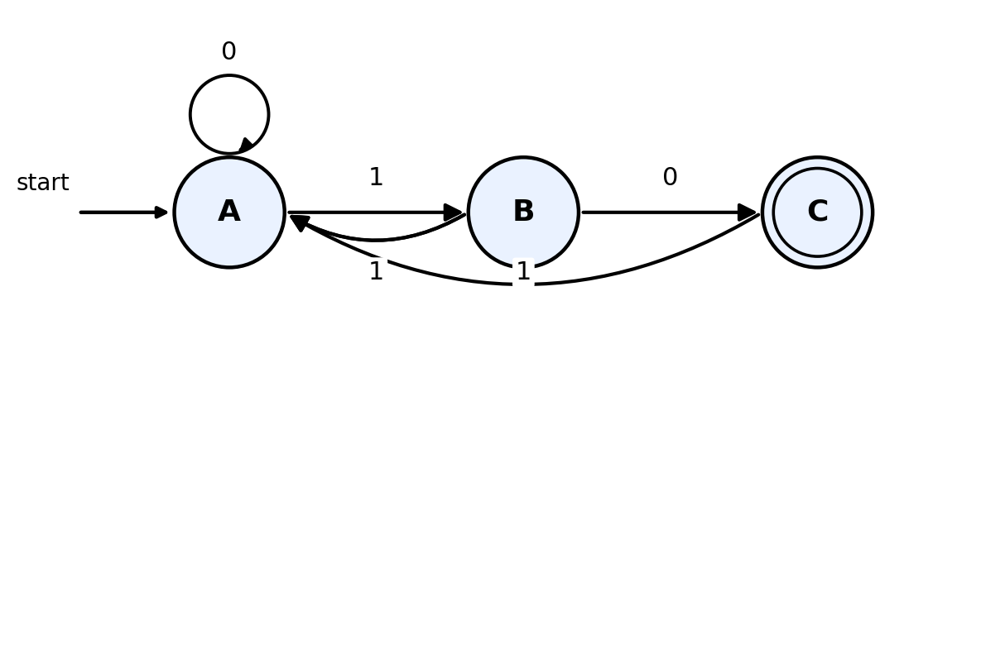
Figure 1.1 - The given NFA with start state A and final state C
State | On input 0 | On input 1
A | {A} | {B}
B | {A, C} | {A}
C | { } | {A}

Here, state B has two possible moves on input 0 (to A and to C), which is exactly the kind of non-determinism that the subset construction removes.
Applying the Subset Construction
Starting from {A}, we compute the reachable subsets step by step:
DFA State (subset of NFA states) | On input 0 | On input 1 | Final?
{A} (start) | {A} | {B} | No
{B} | {A, C} | {A} | No
{A, C} | {A} | {A, B} | Yes (contains C)
{A, B} | {A, C} | {A, B} | No

No new subsets appear after {A, B}, so the construction is complete. Renaming {A} as A, {B} as B, {A,C} as AC and {A,B} as AB for readability, the equivalent DFA is shown below.
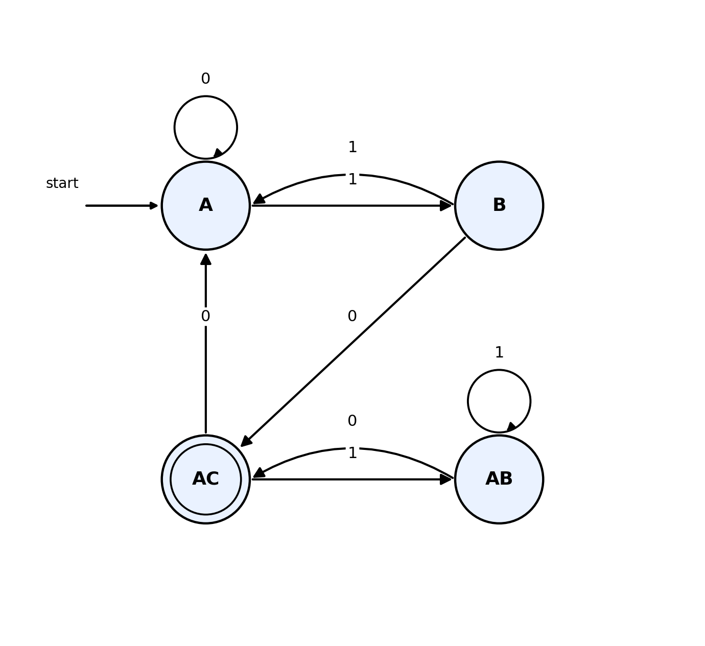
Figure 1.2 - Equivalent DFA obtained by subset construction (start state A, final state AC)
This DFA has exactly one outgoing transition for each symbol from every state, so it is fully deterministic, and it accepts exactly the same language as the original NFA.

Question 2: Mathematical Induction for Strings and Languages
Role of Mathematical Induction in Automata Theory
Mathematical induction is one of the most important proof tools in automata theory because almost every property of strings and languages is defined recursively, in terms of shorter strings. For example, a string of length n is usually built by adding one symbol to a string of length n-1. Regular expressions, context-free grammars, and even the states reached while an automaton reads a string are all defined by this kind of recursive, step-by-step process. Since induction is exactly the proof technique that matches recursive definitions, it becomes the natural way to prove that a certain property holds for all strings, for all reachable states, or for all values of a parameter n.
In practice, induction is used to prove statements such as: a DFA reaches a particular state after reading any string with a certain property, a regular expression generates exactly a certain language for every length of string, or a numeric formula about strings (like the one below) is correct for every positive integer n. The proof always has two parts, the base case and the inductive step, and together they guarantee the statement is true for every n, without having to check every value one by one.
Statement to Prove
For all positive integers n: 1² + 2² + 3² + ... + n² = n(n+1)(2n+1) / 6
Step 1: Base Case (n = 1)
When n = 1, the left-hand side of the statement is simply 1² = 1.
The right-hand side is 1(1+1)(2×1+1)/6 = 1×2×3/6 = 6/6 = 1.
Since the left-hand side equals the right-hand side (1 = 1), the statement is true for n = 1. This establishes the base case.
Step 2: Inductive Hypothesis
Assume that the statement is true for some arbitrary positive integer n = k. That is, assume:
1² + 2² + 3² + ... + k² = k(k+1)(2k+1) / 6
This assumption is called the inductive hypothesis. We do not know yet that it is true for k+1; we only assume it for k so that we can use it to prove the next case.
Step 3: Inductive Step (Prove for n = k + 1)
We must show that the statement also holds for n = k + 1, that is:
1² + 2² + ... + k² + (k+1)² = (k+1)(k+2)(2k+3) / 6
Starting from the left-hand side and using the inductive hypothesis to replace the first k terms:
1² + 2² + ... + k² + (k+1)² = [k(k+1)(2k+1)/6] + (k+1)²
Taking (k+1) as a common factor from both terms:
= (k+1) [ k(2k+1)/6 + (k+1) ]
= (k+1) [ (k(2k+1) + 6(k+1)) / 6 ]
= (k+1) [ (2k² + k + 6k + 6) / 6 ]
= (k+1) (2k² + 7k + 6) / 6
The quadratic 2k² + 7k + 6 factors as (k+2)(2k+3), which can be checked by expanding: (k+2)(2k+3) = 2k² + 3k + 4k + 6 = 2k² + 7k + 6. Substituting this factorisation gives:
= (k+1)(k+2)(2k+3) / 6
This is exactly the right-hand side of the statement for n = k + 1. Hence the statement is proved true for n = k + 1, assuming it was true for n = k.
Step 4: Conclusion
Since the statement is true for n = 1 (base case), and since its truth for n = k always implies its truth for n = k + 1 (inductive step), by the principle of mathematical induction the statement 1² + 2² + ... + n² = n(n+1)(2n+1)/6 is true for every positive integer n. This same style of reasoning, base case followed by an inductive step, is exactly how properties of strings and languages are proved in automata theory: we prove a property for the empty string or for a string of length one, and then we show that if the property holds for a string of length k, it must also hold when one more symbol is appended, thereby proving it for every string.

Question 3: Epsilon Transitions and Elimination of Epsilon-NFA
Role of Epsilon (ε) Transitions
An epsilon transition lets an automaton move from one state to another without reading any input symbol at all. Its purpose is purely to make automata easier and more compact to design. Epsilon transitions are extremely useful for combining smaller automata into bigger ones, for example when we join two regular expressions with a union (choice) or make one part of a machine optional. They also allow an automaton to skip directly to a later state, representing free choices in the machine's structure. Although epsilon transitions add convenience, they do not add any extra computing power, because it can always be proved that for every ε-NFA there exists an equivalent NFA (and DFA) without epsilon transitions that accepts exactly the same language.
Method: Removing Epsilon Transitions
The standard method to remove epsilon transitions from an ε-NFA has two main steps:
- Compute the epsilon-closure of every state, that is, the set of all states reachable from it using only epsilon transitions (including the state itself).
- For every state q and every real input symbol a, define the new transition as the epsilon-closure of the union of all states reachable by first taking any epsilon moves, then reading a. Formally: new-delta(q, a) = ε-closure( union of delta(p, a) for every p in ε-closure(q) ).
- A state is marked as final in the new NFA if its epsilon-closure contains at least one original final state, because this means the machine could silently 'jump' to acceptance without consuming any more input.
Given ε-NFA
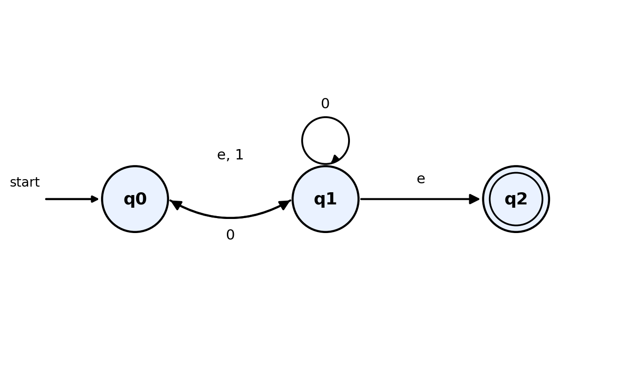
Figure 3.1 - Given epsilon-NFA (start state q0, final state q2)
From the diagram, the transition function of the given machine is:
State | On 0 | On 1 | On ε
q0 | { } | {q1} | {q1}
q1 | {q0, q1} | { } | {q2}
q2 | { } | { } | { }

Step 1: Epsilon-Closures
- ε-closure(q0) = {q0, q1, q2} (q0 reaches q1 by ε, and q1 reaches q2 by ε)
- ε-closure(q1) = {q1, q2}
- ε-closure(q2) = {q2}
Step 2: New Transitions (no epsilon)
Since q0's epsilon-closure and q1's epsilon-closure both contain the final state q2, both q0 and q1 must also become final states in the epsilon-free NFA, in addition to q2 itself. Applying the formula new-delta(q,a) = ε-closure(union of delta(p,a) for p in ε-closure(q)) for every state and symbol gives:
State | On 0 | On 1 | Final?
q0 | {q0, q1, q2} | {q1, q2} | Yes
q1 | {q0, q1, q2} | { } | Yes
q2 | { } | { } | Yes

The resulting epsilon-free NFA is shown below. All three states are marked final, because every state's epsilon-closure in the original machine included the accepting state q2.
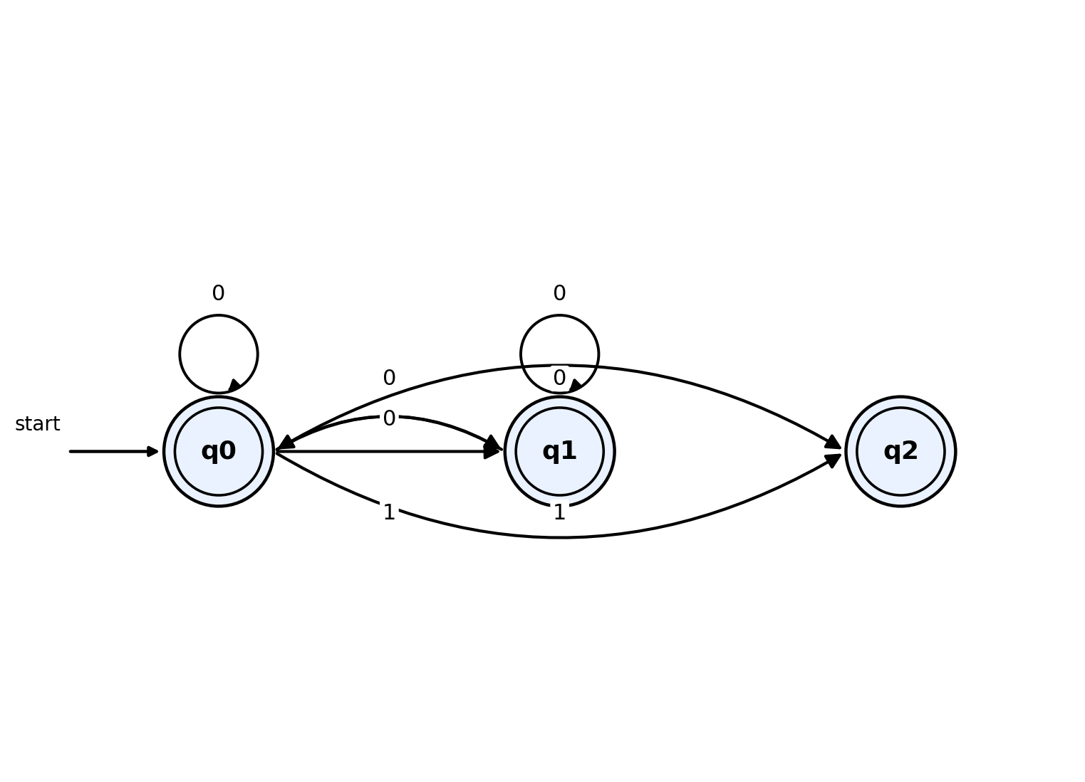
Figure 3.2 - Equivalent NFA without epsilon transitions
This machine has exactly the same behaviour as the original ε-NFA, because at every point where the old machine could silently jump ahead using ε, the new machine has already 'pre-computed' that jump directly into its transition table and into which states are marked as final.

Question 4: Epsilon-Closure and DFA Construction from an NFA with ε-transitions
Given NFA with ε-transitions
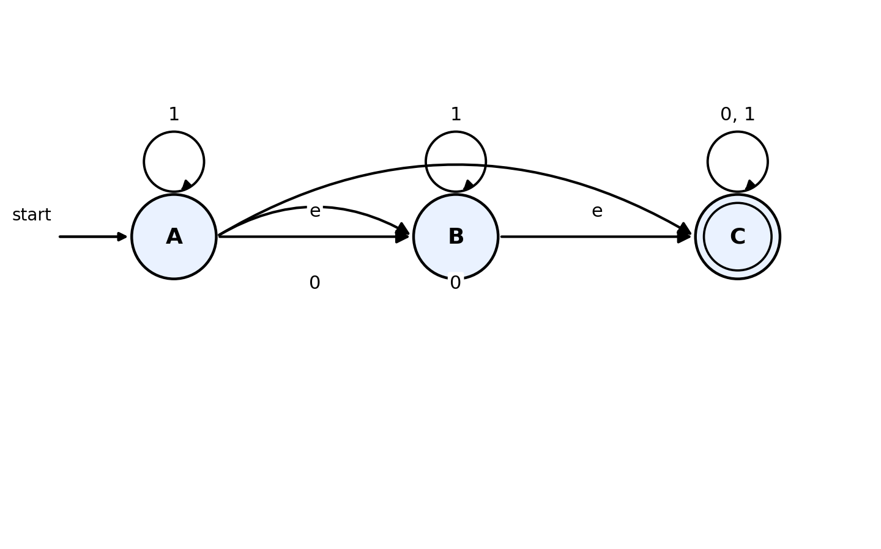
Figure 4.1 - Given NFA with epsilon transitions (start state A, final state C)
Reading the diagram, the transition function is:
State | On 0 | On 1 | On ε
A | {B, C} | {A} | {B}
B | { } | {B} | {C}
C | {C} | {C} | { }

Step 1: Epsilon-Closure of Each State
- ε-closure(A) = {A, B, C} (A reaches B by ε, and B reaches C by ε)
- ε-closure(B) = {B, C}
- ε-closure(C) = {C}
Step 2: Subset Construction to Build the Equivalent DFA
The DFA start state is the epsilon-closure of A, that is, S0 = {A, B, C}. Since this set contains the final state C, S0 is itself a final state of the DFA. We now compute the transitions of the new DFA states by moving on each symbol and then taking the epsilon-closure of the result:
DFA State | = NFA states | On 0 | On 1 | Final?
S0 (start) | {A, B, C} | S1 = {B, C} | S0 = {A, B, C} | Yes
S1 | {B, C} | S2 = {C} | S1 = {B, C} | Yes
S2 | {C} | S2 = {C} | S2 = {C} | Yes

No new subsets appear, so the construction terminates with exactly three DFA states: S0, S1 and S2. The resulting DFA, with its initial and final states marked, is shown below.
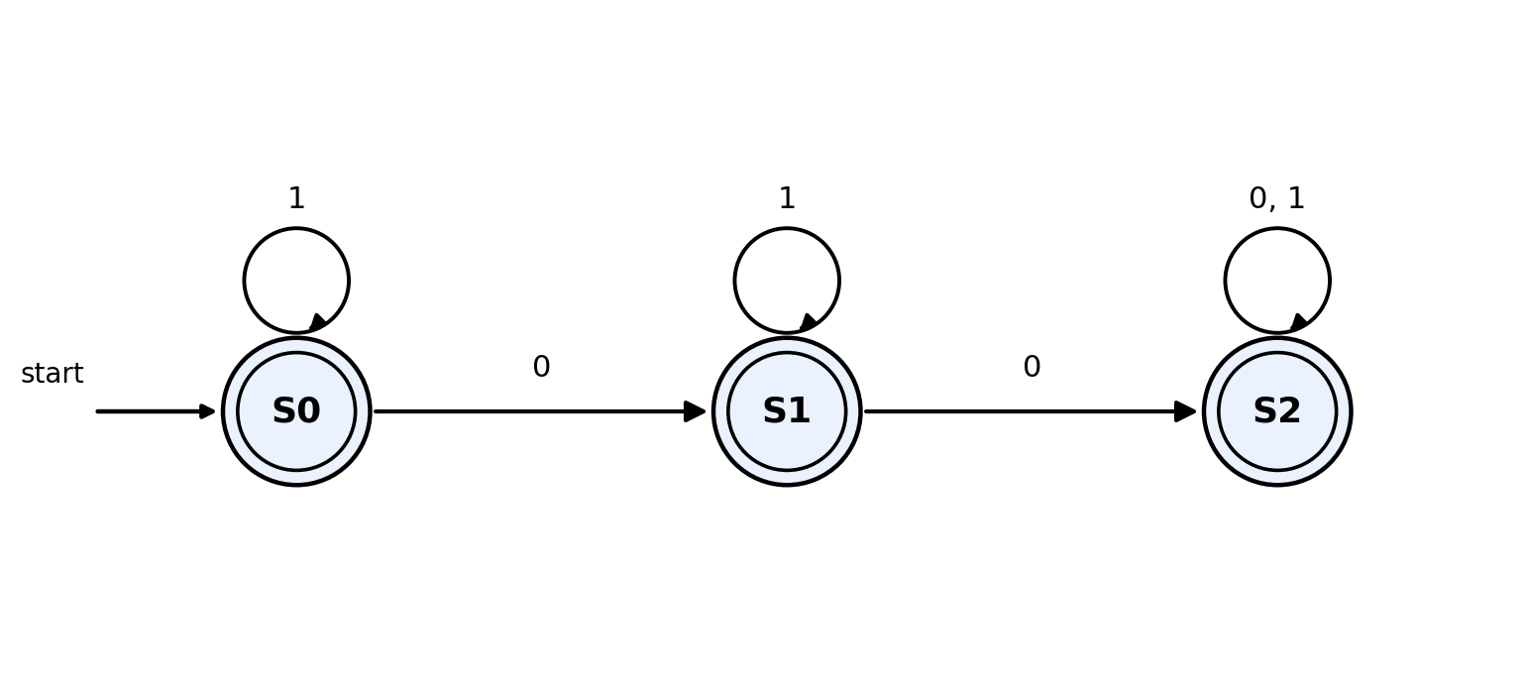
Figure 4.2 - Equivalent DFA (start state S0; S0, S1 and S2 are all final)
Interpretation of the Result
An interesting and useful observation here is that every reachable DFA state (S0, S1 and S2) turned out to be a final state, and the DFA is completely defined for both symbols 0 and 1 from every state. This means the DFA never gets stuck and it accepts every possible string over {0, 1}, including the empty string, because even the start state S0 is accepting. In other words, the language recognised by this automaton is Σ*, the set of all strings over {0, 1}. This matches the original ε-NFA, in which the start state A could reach the final state C purely through epsilon moves (A → B → C), so the empty string, and indeed every string, was always accepted.

Rubric Used for Self-Evaluation
The table below is the marking rubric provided for this assessment tool. It has been used to check that every answer above covers conceptual understanding, accuracy, correct application of the method, completeness, and clear presentation.
Criteria | Weightage | Level 4 - Exemplary | Level 3 - Proficient | Level 2 - Developing | Level 1 - Beginning
Conceptual Understanding | 30 | Clear and complete understanding | Good understanding, minor gaps | Basic understanding, some misconceptions | Poor or incorrect understanding
Accuracy of Answer | 25 | Completely correct, no errors | Mostly correct, minor errors | Partially correct, noticeable errors | Incorrect or irrelevant
Application of Knowledge | 20 | Correctly applies concepts | Applies concepts, minor mistakes | Limited or partial application | No or incorrect application
Completeness of Response | 15 | Covers all required parts | Covers most parts, minor omissions | Covers only some parts | Incomplete or missing
Clarity & Presentation | 10 | Clear, concise, well-organized | Understandable, minor issues | Somewhat unclear or poorly structured | Difficult to understand

