SIMATS ENGINEERING
ASSESSMENT TOOL
____________________________________________________
Course Name: Theory of Computation Course Code: CSA13
Course Outcome Covered: CO1: Analyze fundamental mathematical concepts of automata theory for formal languages and decision problems (BL:3)
Assessment Tool: Simulation Weightage: 20%
Questions: 5 Total Marks: 25 Duration: 1 Hour
____________________________________________________
Code of Conduct
I Kanishk C (Reg. No: 192511278) certify that this submission is my original work and that I have adhered to the guidelines specified for this assessment.
I understand that any violation of academic integrity rules will result in disciplinary action.
Name: Kanishk C
Registration Number: 192511278
Signature of the student: Kanishk C

Question 1: Non-Deterministic Finite Automaton for an Automatic Door System
Problem Understanding
An automatic door, of the kind found at the entrance of a shop or a lift lobby, can be modelled as a finite automaton because it only ever exists in one of a small, fixed number of physical states, and it moves between these states in response to a small set of sensor inputs. In this design, the door has four states, Closed, Opening, Open and Closing, and it reacts to two input symbols, P, meaning a person has been detected by the sensor, and N, meaning no person is currently detected. The system is modelled as a Non-Deterministic Finite Automaton (NFA) rather than a DFA because a real automatic door does not always behave in a single fixed way for a given sensor reading: for example, while fully open, the door might continue to stay open if a person is still detected, but it could also, depending on a timer or a slightly different sensor reading, begin to close. This kind of 'more than one legal next move for the same input' is exactly what non-determinism represents in automata theory, and it is a natural and honest way to model a physical system whose exact internal timing we do not want to pin down in the abstract design stage.
States and Alphabet
- Closed - the default, idle state; the door is shut and this is also the start state.
- Opening - the door has started to slide open after a person was detected.
- Open - the door is fully open.
- Closing - the door has started to slide shut.
- Input alphabet: Σ = {P, N}, where P means a person is detected and N means no person is detected.
Transition Design
The transition function of the NFA is defined below. Non-determinism is introduced deliberately at the Open state, to reflect that the door's next move is not fixed purely by the current sensor reading.
Current State | Input | Next State(s)
Closed | P | {Opening}
Opening | P | {Open}
Open | P | {Open}
Open | N | {Open, Closing}
Closing | N | {Closed}
Closing | P | {Opening}

The two entries for state Open on input N are the non-deterministic heart of the design: the machine may either remain in Open (perhaps because a short grace-period timer has not yet expired) or move to Closing (because no person has been detected and the door decides to begin shutting). Similarly, Closing responding to P by re-opening reflects real automatic doors, which reverse direction if someone steps into the doorway while it is closing, for safety.
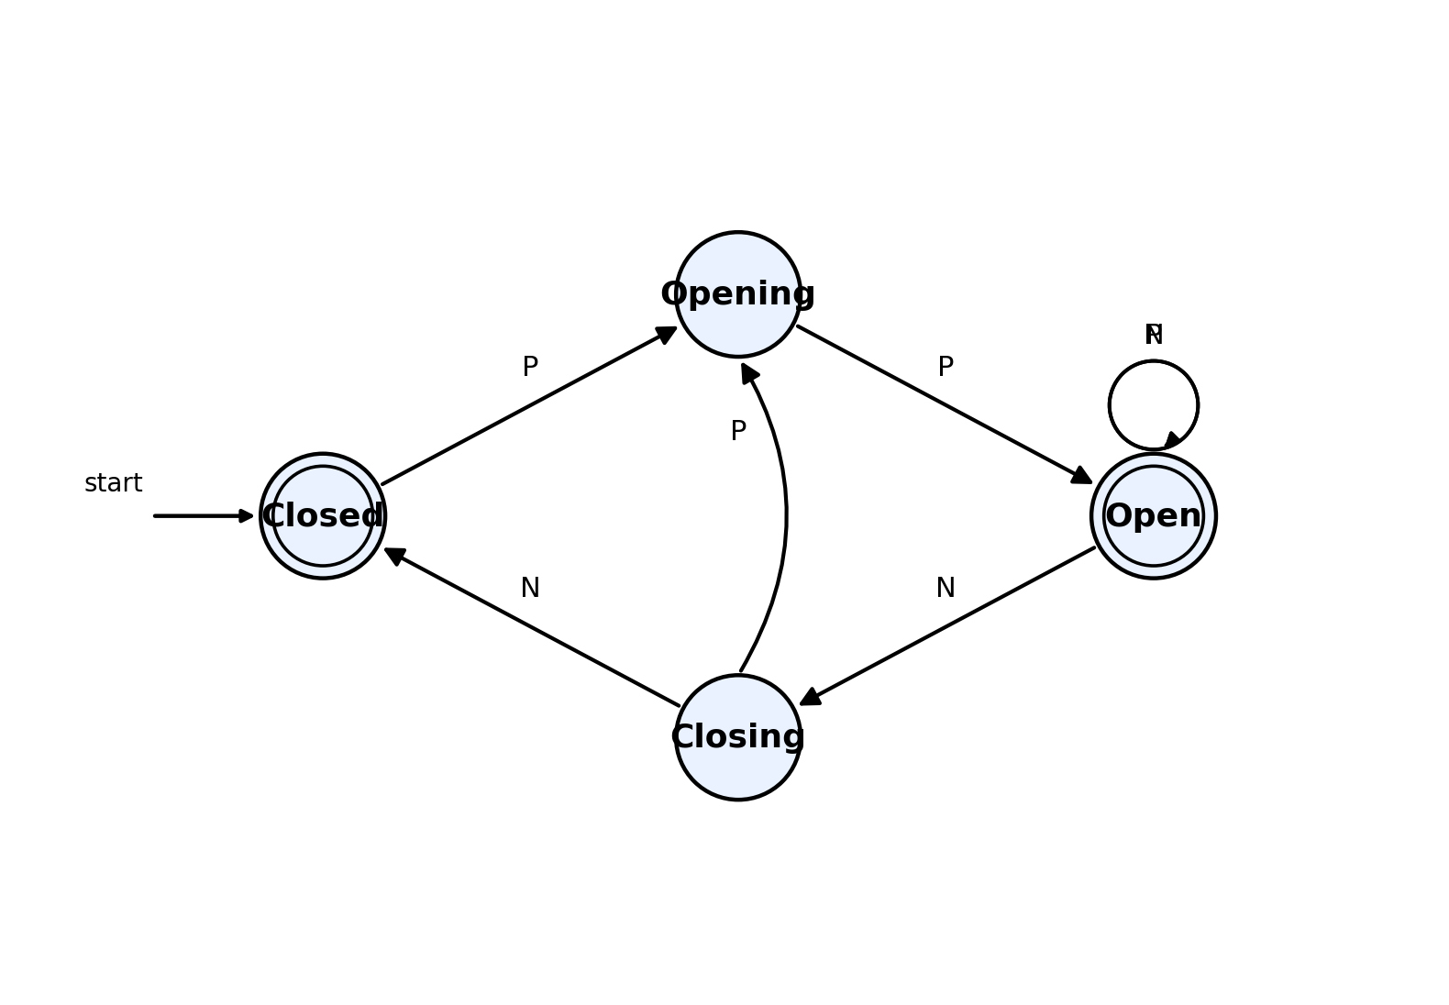
Figure 1.1 - NFA for the Automatic Door System (start state Closed)
Why This Is Genuinely Non-Deterministic
Unlike a DFA, where the next state is always uniquely fixed, this automaton allows the Open state to have two different valid next states on the same input symbol N. This is not a flaw in the design; it is intentional, because it lets the same abstract model describe several different concrete implementations (a door with a short delay before closing, and a door with no delay at all) without having to commit to exact timing values at the design stage. If we later needed to implement this system in real hardware or software, we would convert this NFA into an equivalent DFA using the subset construction method, which would force every ambiguous choice to be resolved into a single deterministic path, for example by adding an explicit timer state.

Question 2: Finite Automaton for a Traffic Light Control System
Modelling the Traffic Light
A basic traffic light at a road intersection cycles through exactly three colours in a fixed, repeating order: Red, then Green, then Yellow, then back to Red again. This is a textbook example of a finite automaton because the system has a small, fixed number of states, and the transition between states does not depend on the history of the system beyond the current state; it only depends on a timer signal telling the light that its current duration has elapsed. We use a single abstract input symbol t to represent 'the timer for the current light has expired', so the automaton reads a sequence of timer ticks and simply advances one state for every tick.
States, Alphabet and Transitions
Current State | Input | Next State | Typical Duration
Red | t | Green | 20-30 seconds
Green | t | Yellow | 15-20 seconds
Yellow | t | Red | 3-5 seconds

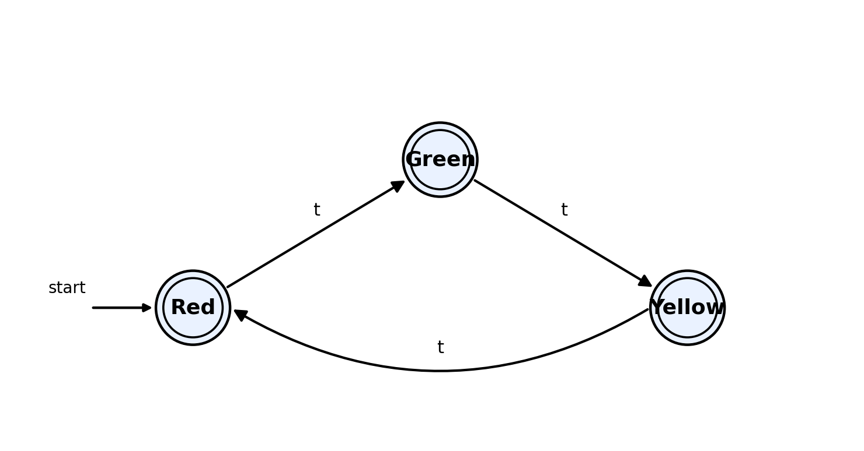
Figure 2.1 - Finite automaton for the traffic light cycle Red to Green to Yellow to Red
Because Red always leads to Green, Green always leads to Yellow, and Yellow always leads back to Red, this automaton cycles forever and never halts, which correctly models a traffic light that keeps operating continuously, day and night, as long as it has power. There is no 'final' state in the usual sense of language acceptance; instead, every state is treated as a valid, safe operating state of the system, and the machine is used descriptively rather than as a string acceptor.
Handling Timing Constraints
In a real controller, the timer signal t is not a single abstract symbol but is generated by a countdown circuit or software timer specific to each colour: the Red timer is usually set longer than the Yellow timer because vehicles need more time to safely cross, while the Yellow timer is deliberately kept short, just long enough to warn approaching traffic. Because our model treats the timer expiry as the only input, we can freely change the actual number of seconds represented by each timer without changing the structure of the automaton at all. This separation between 'logical state machine' and 'physical timer values' is exactly what makes finite automata such a convenient design tool for embedded traffic controllers.
Extending the Model
This basic three-state automaton can be extended in a straightforward way to handle more realistic intersections:
- Pedestrian crossing signal: add a Pedestrian-Walk state that can only be entered from Red (when vehicles are already stopped), together with a separate pedestrian countdown timer. A push-button input symbol B (button pressed) can be added so that the automaton only enters the Pedestrian-Walk state if a pedestrian has requested it during the Red phase, otherwise it proceeds straight to Green as before.
- Emergency vehicle override: add a new input symbol E representing an emergency vehicle signal (received wirelessly from an approaching ambulance or fire truck). From any state, on input E, the automaton can be designed to move immediately to an Emergency-Red state that holds all directions at red until the emergency vehicle has passed, after which it resumes the normal Red-Green-Yellow cycle from Red.
- Multiple approach directions: in a full intersection, several copies of this automaton run together, one per direction, and their Green states are never allowed to overlap; this is usually guaranteed by making the controller a single larger automaton whose states are combinations of the individual per-direction states, which is again handled using the product construction idea used for combining automata.
These extensions keep vehicle and pedestrian safety as the top priority: the added states and transitions are designed so that whenever a pedestrian or an emergency vehicle needs the right of way, the automaton can only reach a state where conflicting traffic is stopped, never a state that would let two directions move at once.

Question 3: DFA Accepting Strings That End With "ab" (Simulator: Autosim/JFLAP style)
Design of the DFA
We need a DFA over the alphabet Σ = {a, b} that accepts exactly the strings which end with the pattern 'ab'. The standard way to design such a DFA is to think of each state as representing 'how much of the pattern ab has been matched so far, using the most recent symbols read'. This gives three states:
- q0 - start state, meaning no useful progress towards 'ab' has been made yet (either nothing has been read, or the string so far does not end in 'a').
- q1 - meaning the most recently read symbol was 'a', so we are hopeful that the next symbol might complete the pattern 'ab'.
- q2 - accepting state, meaning the last two symbols read were exactly 'a' followed by 'b', so the string read so far ends with 'ab'.
Current State | On a | On b
q0 (start) | q1 | q0
q1 | q1 | q2 (final)
q2 (final) | q1 | q0

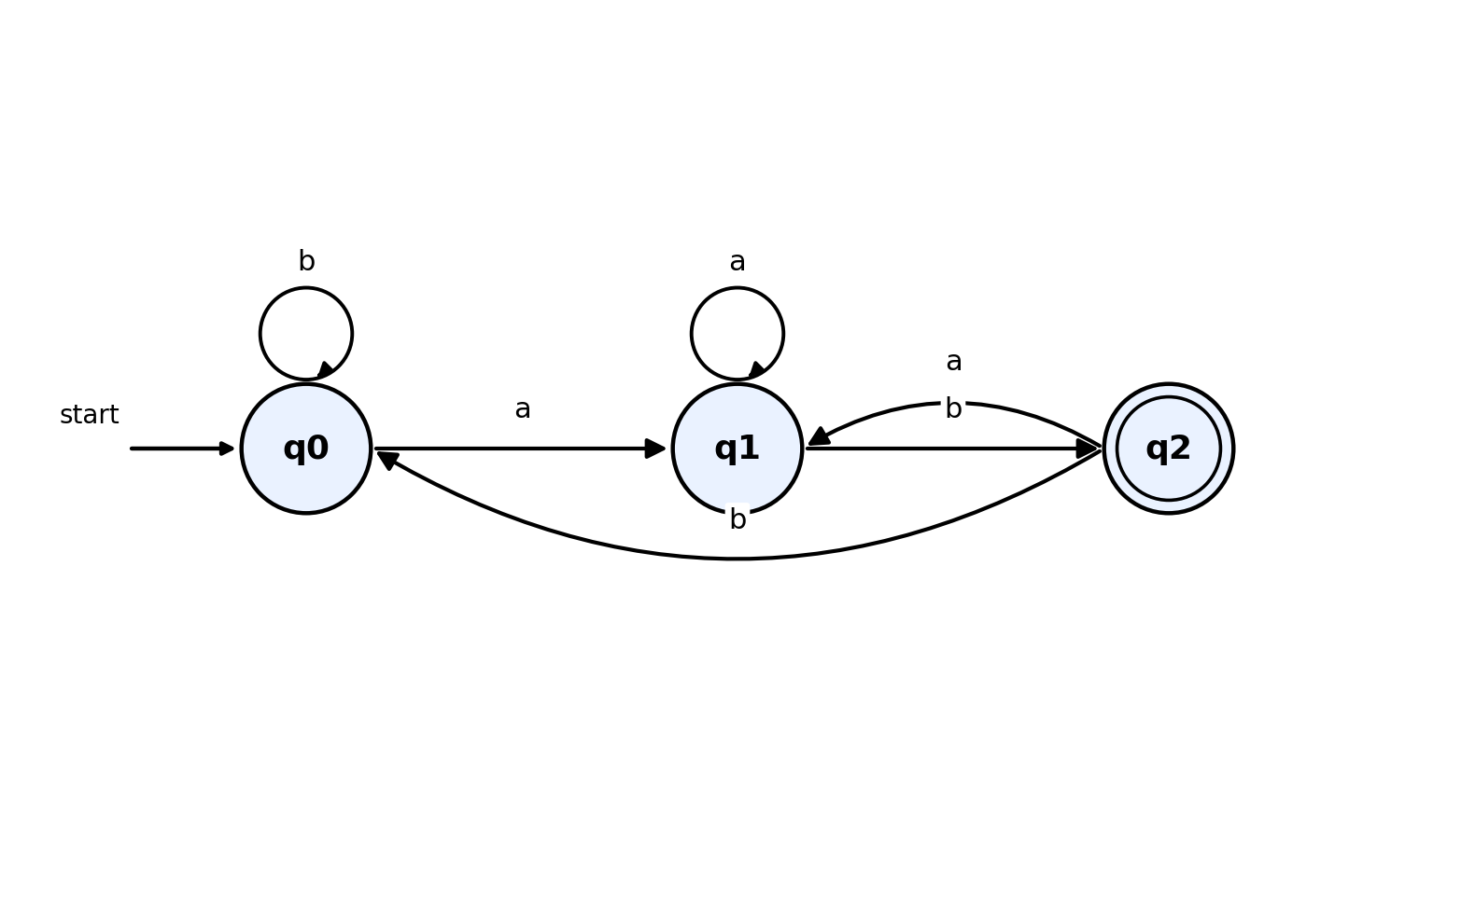
Figure 3.1 - DFA accepting all strings over {a, b} that end with "ab"
Simulating and Verifying with the String W = aaabab
To design this DFA using a simulator such as Autosim or JFLAP, we would create the three states above, mark q0 as the initial state and q2 as the only final state, add the six transitions from the table, and then use the simulator's step-by-step trace facility to run the machine on a test string. Tracing the given string W = a a a b a b symbol by symbol:
Step | Symbol Read | State Before | State After
1 | a | q0 | q1
2 | a | q1 | q1
3 | a | q1 | q1
4 | b | q1 | q2
5 | a | q2 | q1
6 | b | q1 | q2

After reading all six symbols of W = aaabab, the DFA is left in state q2, which is the accepting state. Therefore the simulator confirms that the string aaabab is accepted, which is correct because the string does indeed end with the pattern 'ab' (the last two characters are 'a' and 'b').

Question 4: DFA Accepting Exactly the Strings "c", "bc" and "bcaaa"
Design Approach
This problem is different from the previous one, because here the DFA must accept only three specific, complete strings, c, bc and bcaaa, and reject every other string, including any string that merely starts with one of these three as a prefix. The natural way to build such a DFA is to construct a 'trie' of states, one state for every distinct prefix of the accepted strings that we need to remember, mark the states corresponding to the exact accepted strings as final, and then send every unexpected symbol to a single dead (trap) state from which the machine can never escape.
States
- S - start state, before reading anything.
- B - reached after reading 'b'.
- C1 - reached after reading 'c' directly from S; this is a final state because 'c' alone is accepted.
- C2 - reached after reading 'b' then 'c'; this is a final state because 'bc' is accepted.
- A1, A2 - reached after 'bc' followed by one, then two extra a's.
- A3 - reached after 'bc' followed by three a's, i.e. after reading exactly 'bcaaa'; this is a final state.
- D - the dead/trap state; once entered, the machine can never reach a final state again, no matter what is read next.
State | On a | On b | On c | Final?
S (start) | D | B | C1 | No
B | D | D | C2 | No
C1 | D | D | D | Yes (accepts "c")
C2 | A1 | D | D | Yes (accepts "bc")
A1 | A2 | D | D | No
A2 | A3 | D | D | No
A3 | D | D | D | Yes (accepts "bcaaa")
D (dead) | D | D | D | No

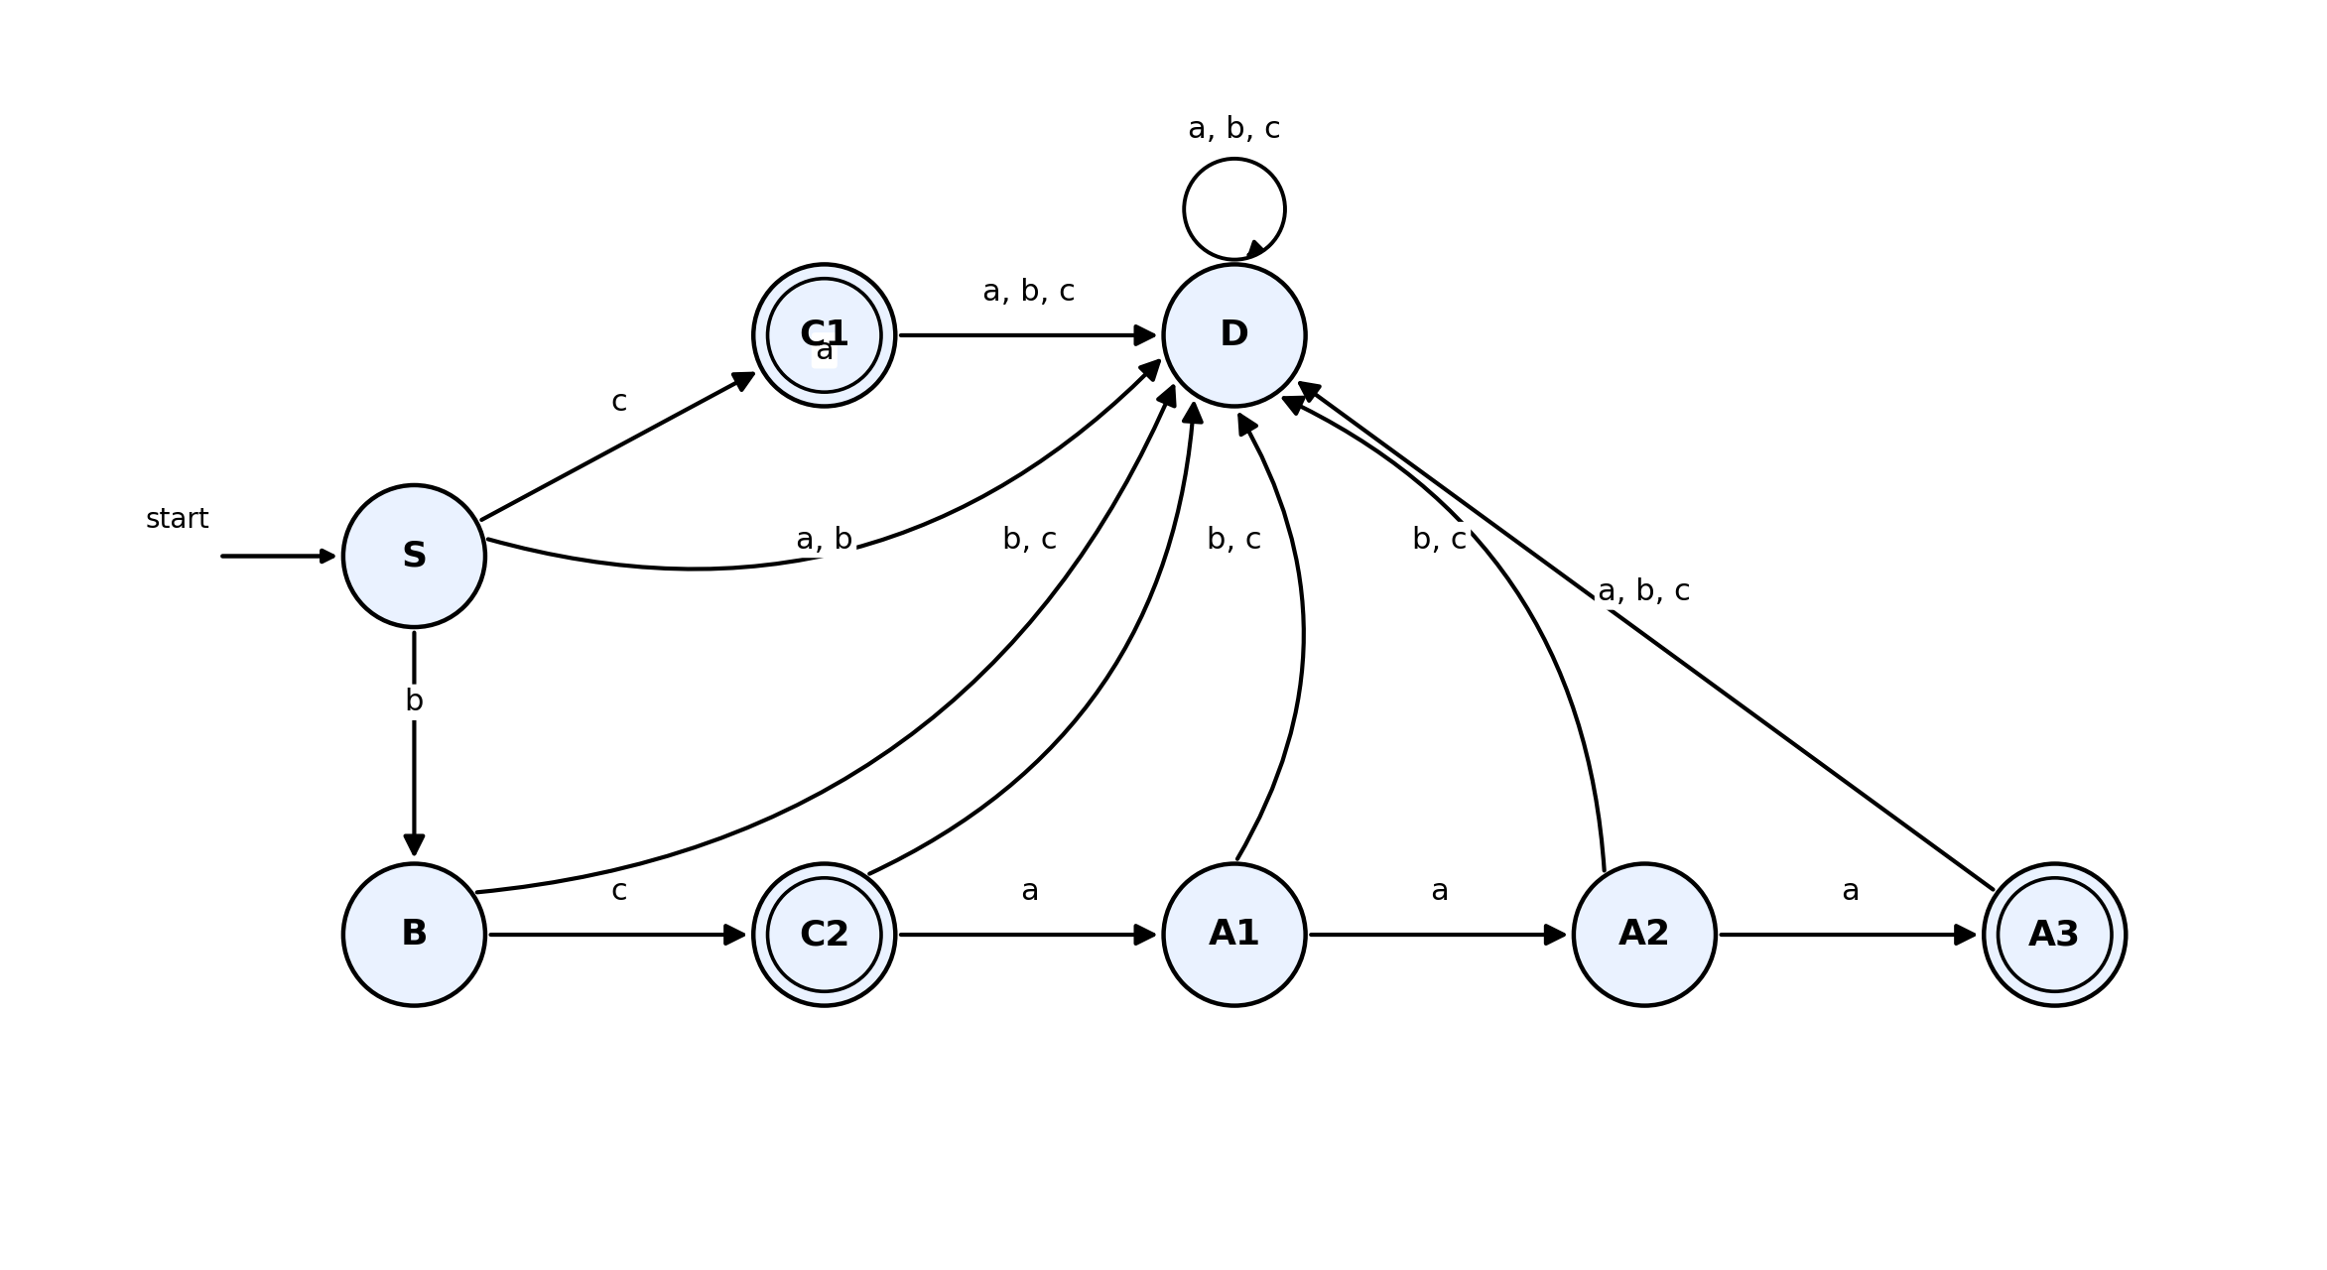
Figure 4.1 - DFA accepting exactly {c, bc, bcaaa}, with all unlisted transitions routed to the dead state D
Verifying the Design in a Simulator
When this machine is entered into a simulator such as Autosim, the start state is set to S, and the final states are set to C1, C2 and A3. Running the string 'c' ends in C1 (accepted); running 'bc' ends in C2 (accepted); running 'bcaaa' passes through B, C2, A1, A2 and ends in A3 (accepted). Any deviation is correctly rejected: for example the string 'bca' passes B, C2, A1 and stops in A1, which is not final, so it is rejected; the string 'bcaaaa' (one 'a' too many) passes through A1, A2, A3 and then, on the extra fourth 'a', moves from A3 into the dead state D, correctly rejecting it even though it started as a valid prefix.

Question 5: DFA Accepting All Strings Over {a, b} That Begin With "a" or "b"
Design
Since the alphabet is only Σ = {a, b}, every non-empty string necessarily begins with either 'a' or 'b', so this language is simply the set of all non-empty strings over {a, b}; the only string that must be rejected is the empty string, because it does not begin with any symbol at all. This makes the DFA extremely small and simple:
- q0 - start state, representing 'no symbol has been read yet'. This state is not final, so the empty string is correctly rejected.
- q1 - reached immediately after reading the very first symbol, whichever it is. This state is final, and it loops back to itself on every further symbol, since once a string has a first symbol, any continuation still counts as beginning with that symbol.
Current State | On a | On b | Final?
q0 (start) | q1 | q1 | No
q1 (final) | q1 | q1 | Yes

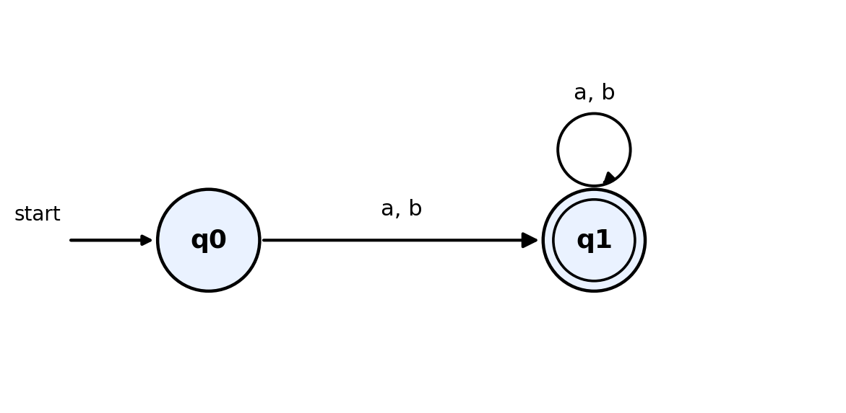
Figure 5.1 - DFA accepting all non-empty strings over {a, b}
Handling Empty or Invalid Input in a Simulator
This DFA is already total, meaning every state has an outgoing transition defined for every symbol of the alphabet, so no additional explicit dead state is mathematically required. However, some simulators such as Autosim require every state to have a visible transition arrow drawn for every input symbol before they will accept the machine as valid, and some also want an explicit way to show what happens on the empty string. In that case, a trap state can optionally be added purely for the simulator's bookkeeping, with q0 itself effectively acting as the 'reject on empty input' indicator, since q0 is simply left as the current state, and not final, if the input ends before any symbol is read. Verifying with the simulator: any string beginning with 'a', such as 'ab', 'aab' or just 'a', moves to q1 on the first symbol and stays there, ending in the accepting state; the same is true for any string beginning with 'b'. Only the empty string leaves the machine sitting in the non-final state q0, and is correctly rejected.

Rubric Used for Self-Evaluation
The table below is the marking rubric provided for this assessment tool. It has been used to check that every design above covers conceptual understanding, accuracy, correct application of the automaton-design method, completeness, and clear presentation.
Criteria | Weightage | Level 4 - Exemplary | Level 3 - Proficient | Level 2 - Developing | Level 1 - Beginning
Conceptual Understanding | 30 | Clear and complete understanding | Good understanding, minor gaps | Basic understanding, some misconceptions | Poor or incorrect understanding
Accuracy of Answer | 25 | Completely correct, no errors | Mostly correct, minor errors | Partially correct, noticeable errors | Incorrect or irrelevant
Application of Knowledge | 20 | Correctly applies concepts | Applies concepts, minor mistakes | Limited or partial application | No or incorrect application
Completeness of Response | 15 | Covers all required parts | Covers most parts, minor omissions | Covers only some parts | Incomplete or missing
Clarity & Presentation | 10 | Clear, concise, well-organized | Understandable, minor issues | Somewhat unclear or poorly structured | Difficult to understand

