SIMATS ENGINEERING
ASSESSMENT TOOL
____________________________________________________
Course Name: Theory of Computation Course Code: CSA13
Course Outcome Covered: CO2: Design Finite Automata DFA, NFA, ε-NFA and demonstrate their equivalence for recognizing regular languages (BL:3)
Assessment Tool: Application Based Question Weightage: 10%
Questions: 5 Total Marks: 25 Duration: 1 Hour
____________________________________________________
Code of Conduct
I Kanishk C (Reg. No: 192511278) certify that this submission is my original work and that I have adhered to the guidelines specified for this assessment.
I understand that any violation of academic integrity rules will result in disciplinary action.
Name: Kanishk C
Registration Number: 192511278
Signature of the student: Kanishk C

Question 1: DFA for Password Validation (Passwords Ending With "01") and Minimization
Real-World Context
Embedded security devices, ATM machines and authentication modules all need to check user-entered codes very quickly and with completely predictable behaviour, because they usually run on small, low-power hardware and cannot afford slow or unpredictable software. A DFA is an ideal tool for this kind of check, because every valid or invalid input is decided by simply moving through a small, fixed table of states, one symbol at a time, using a constant amount of memory no matter how long the password is.
DFA Design
We are asked to design a DFA over Σ = {0, 1} that accepts exactly the binary strings which end with the pattern '01'. As with the earlier 'ends with ab' example, each state represents how much of the ending pattern has been matched using the most recently read symbols:
- q0 - start state; the string so far does not end in a useful partial match.
- q1 - the most recent symbol read was 0, so the string could still end in '01' if a 1 comes next.
- q2 - accepting state; the last two symbols read were exactly '0' then '1'.
Current State | On 0 | On 1
q0 (start) | q1 | q0
q1 | q1 | q2 (final)
q2 (final) | q1 | q0

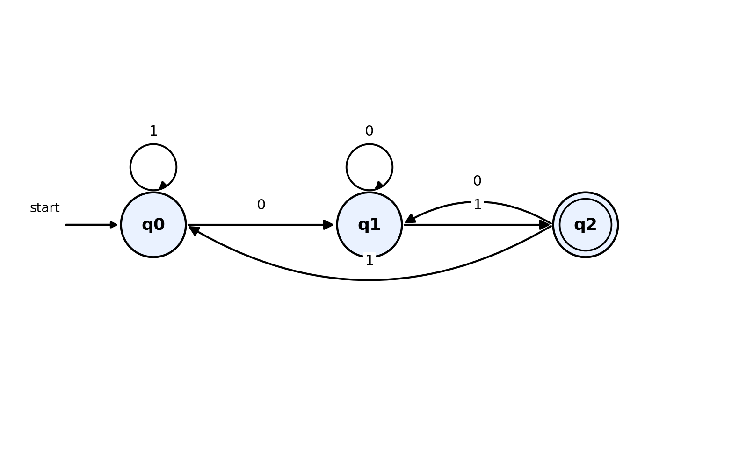
Figure 1.1 - DFA that accepts passwords ending with the pattern "01"
Minimizing the DFA
Minimization means merging any states that are functionally indistinguishable, so that the DFA has the smallest possible number of states while still accepting exactly the same language. The standard way to check this is the table-filling (state-equivalence) method: two states are marked as distinguishable if one is final and the other is not, or if, for some input symbol, they lead to two states that are already known to be distinguishable; otherwise the states are equivalent and can be merged.
Applying this to our three states: q2 is final while q0 and q1 are not, so q2 is immediately distinguishable from both q0 and q1. Comparing q0 and q1: on input 0, q0 goes to q1 and q1 goes to q1 (same state, no distinction yet); on input 1, q0 goes to q0 and q1 goes to q2, and since q0 and q2 are already known to be distinguishable (one is final, one is not), this forces q0 and q1 to also be marked distinguishable. Since every pair of states turns out to be distinguishable, no two states can be merged, and the three-state DFA shown above is already minimal. This is a common and reassuring outcome: for a simple 'ends with a fixed pattern of length k' language, the minimal DFA needs exactly k+1 states, one for every possible length of partial match, and our construction already achieved that lower bound.
Why This Matters for Hardware Efficiency
In an embedded security device or an ATM controller, every extra automaton state usually costs extra memory (to store the state's row of the transition table) and can add extra branching logic in the compiled code. A minimized DFA guarantees that no state, and therefore no hardware resource, is wasted on redundant bookkeeping. Because the transition table has a fixed, small size (3 states times 2 symbols in this example) and each step only performs one table lookup, the time taken to validate a password of length n is always directly proportional to n, with no wasted work, no backtracking and a completely predictable worst-case running time, which is exactly what is required for time-critical, resource-constrained embedded authentication hardware.

Question 2: Regular Expression for the Pattern "aaaabb" and Its Role in Input Validation
Building the Regular Expression
The task asks for a regular expression that validates the single, specific input pattern 'aaaabb' over Σ = {a, b}. Because only one exact string needs to be matched, and every character in it is fixed and known in advance, the regular expression is simply the literal concatenation of its six symbols:
Regular Expression: aaaabb
There is no need for any alternation (the | operator) or repetition (the * or + operators) here, because the requirement is to validate one exact fixed pattern, not a whole family of related strings. A finite automaton that recognises exactly this language is a simple straight-line chain of seven states, one per symbol position, as shown below.
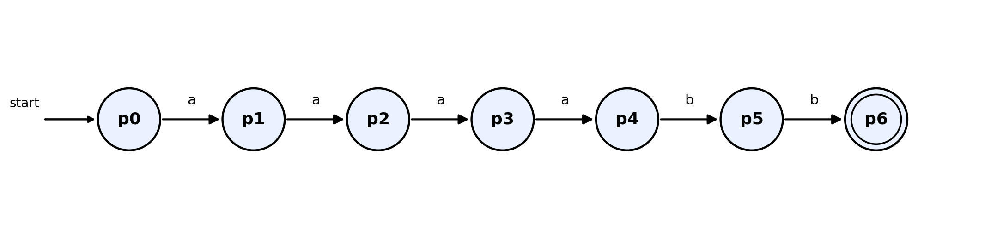
Figure 2.1 - Finite automaton recognising exactly the literal string "aaaabb"
Regular Languages and Web Input Validation
In real web applications, regular expressions are used everywhere as a lightweight, extremely fast first line of defence for checking whether user-submitted text has the right shape, before it is ever passed on to a database, a payment system or a server-side script. Because every regular expression corresponds to some finite automaton, and every finite automaton can process an input string in a single left-to-right pass without backtracking, a well-written regular expression check runs in time directly proportional to the length of the input string, which keeps input validation fast even for busy websites handling many requests per second.
Common uses of this idea in practice include checking that a username only contains letters and digits, that a phone number has the right number of digits in the right groups, or that a submitted code exactly matches a known fixed pattern, exactly as in this question. Because the corresponding automaton has a fixed, small number of states, the amount of memory needed to perform the check does not grow with the number of users or requests, which is an important property for systems that must scale to many simultaneous visitors.

Question 3: Converting the Regular Expression a*b* into an Equivalent Finite Automaton
Understanding the Regular Expression a*b*
The regular expression a*b* describes the language of all strings that consist of zero or more a's, followed by zero or more b's, in that order, with no b ever appearing before an a. This includes the empty string, strings of only a's, strings of only b's, and mixed strings such as 'aaabb', but it excludes any string in which a b is followed later by an a, such as 'ab a' or 'ba'.
Building the Equivalent Automaton
We can construct a small DFA directly, using one state to represent 'still reading the block of a's' and a second state to represent 'now reading the block of b's', plus a dead state to catch any a that illegally appears after a b has already been seen:
- q0 - start state and a final state (because the empty string, with zero a's and zero b's, is accepted); stays in q0 on a, moves to q1 on b.
- q1 - final state, reached once at least one b has been read; stays in q1 on b, but moves to the dead state on a, since an a is not allowed after a b in this language.
- D - dead/trap state; once entered, the automaton can never return to an accepting state.
Current State | On a | On b | Final?
q0 (start) | q0 | q1 | Yes
q1 | D | q1 | Yes
D (dead) | D | D | No

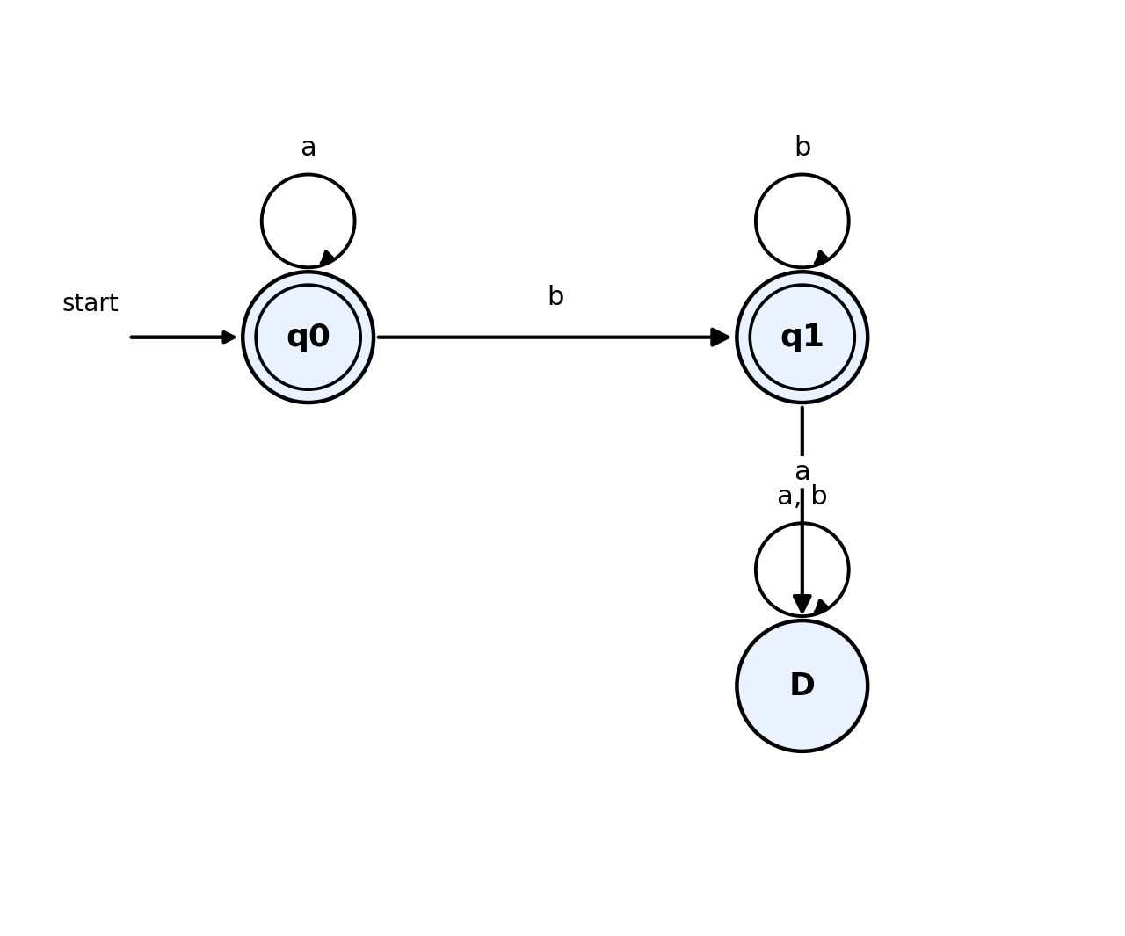
Figure 3.1 - Finite automaton equivalent to the regular expression a*b*
Why Regular Expressions and Finite Automata Are Equivalent
Regular expressions and finite automata are equivalent models of computation because it can be proved, in both directions, that every language describable by one can also be described by the other. Starting from a regular expression, Thompson's Construction algorithm builds an equivalent ε-NFA piece by piece, following the structure of the expression (concatenation, union and Kleene star each have a small, standard automaton pattern); conversely, starting from any finite automaton, the state elimination method (used again in Question 2 of the Scenario Based part of this course) can reconstruct an equivalent regular expression by removing states one at a time and merging the resulting paths into larger and larger expressions. Because a construction exists in each direction, the two notations describe exactly the same class of languages, the regular languages, even though a regular expression is a compact textual notation well suited for humans to write, while a finite automaton is an explicit state-and-transition machine well suited for a computer to execute directly.
Use in Real-Time Pattern and Intrusion Detection
Intrusion detection systems, compilers and other real-time monitoring tools rely on this equivalence heavily. A security analyst can write a readable regular expression describing a suspicious pattern of network traffic or log entries, and the detection engine automatically compiles that expression into a finite automaton, exactly the way we did above. Because the resulting automaton reads its input in a single pass with a fixed, small amount of memory and constant work per symbol, it can inspect a continuous, high-speed stream of packets or log lines in real time, flagging a match the instant the pattern completes, without ever needing to store the whole stream or look backwards.

Question 4: Pumping Lemma: Why L = { aⁿbⁿ | n ≥ 0 } Is Not Regular
Statement of the Pumping Lemma for Regular Languages
The pumping lemma says that if a language L is regular, then there must exist some number p (called the pumping length, which we can think of as being related to the number of states of a DFA that recognises L) such that every string w in L with length at least p can be split into three parts, w = xyz, satisfying three conditions at once: the middle part y must be non-empty, the combined length of x and y must be at most p, and, most importantly, for every possible number of repetitions i = 0, 1, 2, 3 and so on, the string x (y repeated i times) z must also belong to L. In simple terms, if L is regular, we must always be able to find some non-empty 'loop' near the front of any sufficiently long string in L, and freely repeat that loop any number of times, or even delete it completely, and the resulting string must still belong to L.
Applying the Pumping Lemma to L = { aⁿbⁿ | n ≥ 0 }
We use proof by contradiction. Assume, for the sake of contradiction, that L = { aⁿbⁿ | n ≥ 0 } is regular. Then, by the pumping lemma, there must exist a pumping length p such that every string in L of length at least p can be pumped as described above. Choose the specific string w = a^p b^p, which certainly belongs to L (it has exactly p a's followed by exactly p b's) and certainly has length at least p (its length is 2p).
By the pumping lemma, w must be splittable as w = xyz with |xy| ≤ p, |y| ≥ 1, and x(y^i)z in L for every i ≥ 0. Because |xy| ≤ p, and the first p characters of w = a^p b^p are all a's, both x and y must consist entirely of a's; write y = a^k for some k with 1 ≤ k ≤ p (y is non-empty, so k ≥ 1).
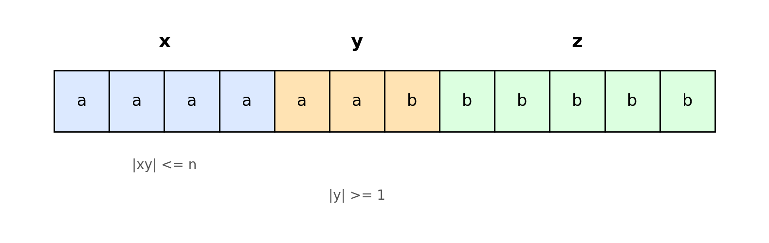
Figure 4.1 - The string w = a^p b^p split into x, y and z, with y confined to the block of a's
Now consider pumping with i = 2, that is, repeating y twice instead of once. The new string is x(y^2)z, which has p + k a's (the original p a's, plus k extra a's from the repeated y) followed by exactly p b's, because z, and therefore the entire block of b's, was never touched by the pumping. Since k ≥ 1, this new string has strictly more a's than b's, so it is of the form a^(p+k) b^p with p + k not equal to p. This string is therefore NOT of the form a^n b^n for any single n, so it does not belong to L.
This directly contradicts the pumping lemma's requirement that x(y^i)z must remain in L for every i, including i = 2. Since assuming L is regular leads to a contradiction, our assumption must be false, and we conclude that L = { aⁿbⁿ | n ≥ 0 } is not a regular language.
Implications for Compiler Design
This result has direct, practical consequences for building compilers. The language a^n b^n is a simplified model of the kind of matched-pair structure that appears constantly in real programming languages, matching opening and closing parentheses, matching begin and end keywords, or matching opening and closing braces in nested code blocks. Because this proof shows that no finite automaton, and therefore no regular expression, can correctly track and enforce this kind of unbounded nested matching, compiler designers know they cannot rely on a simple regular-expression-based lexer alone to check that brackets or blocks are properly balanced. Instead, compilers use a more powerful tool, context-free grammars and a stack-based parser (such as a pushdown automaton), specifically because a stack can remember an unbounded, growing count of unmatched open brackets, something a finite automaton's fixed, bounded set of states can never do. This is exactly why every real compiler's architecture is split into a fast regular-expression-based lexer for simple token patterns (identifiers, numbers, keywords), followed by a separate, more powerful context-free parser for structural correctness such as bracket matching.

Question 5: Closure Properties of Regular Languages for Combining Detection Rules
What Closure Properties Mean
A closure property tells us that if we take one or more regular languages and combine them using a particular operation, the result is guaranteed to still be a regular language. Regular languages are closed under a wide range of useful operations, including union (matching either rule), intersection (matching both rules at once), concatenation (matching one rule followed by another), complement (matching everything that does NOT satisfy a rule) and Kleene star (matching zero or more repetitions of a rule). Each of these closure properties can be proved constructively, by showing an explicit automaton-building recipe that combines the automata of the original languages into a new automaton for the combined language.
Combining Detection Rules Using Closure Properties
In systems such as intrusion detection, spam filtering and input validation, a single simple rule is rarely enough; real systems usually need to combine several pattern-matching rules together, for example 'flag the request if it matches suspicious pattern A OR suspicious pattern B' (union), or 'accept the input only if it matches the required format AND does not match any known malicious pattern' (intersection combined with complement). Because each individual rule is typically written as, or converted into, a regular expression or a small finite automaton, and because regular languages are closed under exactly these operations, we are guaranteed in advance that combining any number of such rules will always produce another regular language, one that can still be recognised by a single finite automaton.
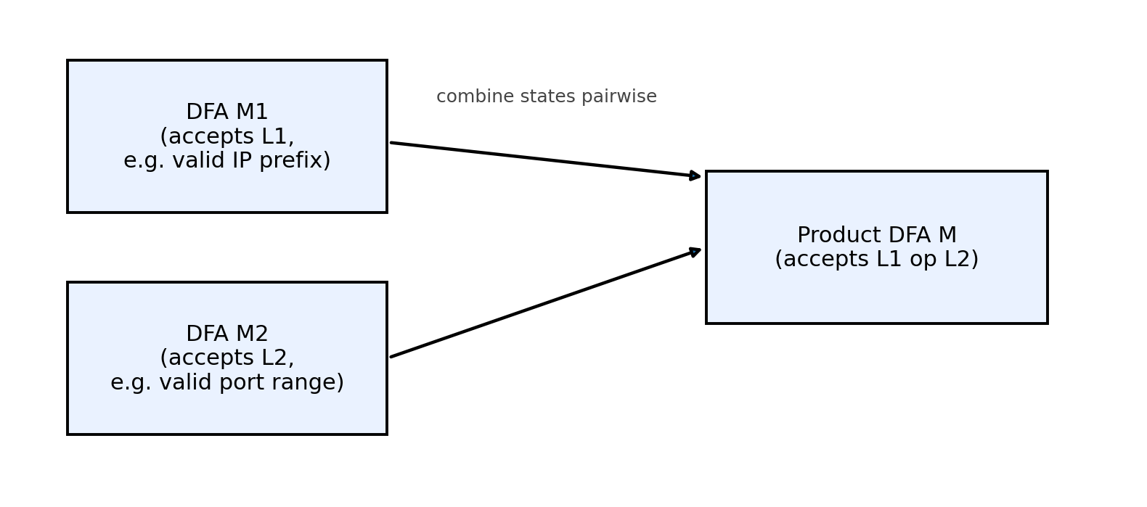
Figure 5.1 - Combining two rule-automata M1 and M2 into a single automaton M using the product construction
The standard technique used to build this combined automaton is the product construction: given two DFAs M1 (recognising language L1) and M2 (recognising language L2), we build a new DFA whose states are ordered pairs (state of M1, state of M2), and whose transition function moves both components in step, together, on every input symbol. Marking the pair-states as final in different ways gives different combined operations: marking a pair as final whenever either component is final gives the union L1 ∪ L2; marking a pair as final only when both components are final gives the intersection L1 ∩ L2.
Why the Result Stays Regular and Efficient
Because the product automaton's state set is simply the Cartesian product of the two original state sets, it has at most |M1| times |M2| states, which is still a fixed, finite number, so the combined machine remains a perfectly ordinary DFA. This is exactly why the resulting language after applying these operations is guaranteed to remain regular: the construction never needs anything beyond a finite table of states and transitions, no matter how many individual rules are combined together in this way (applying the construction repeatedly for three, four or more rules just multiplies the state counts further, but the result is still finite). In practice, this means a security system can maintain a whole library of separate, simple detection rules, each easy to write and easy to verify on its own, and then mechanically combine them into one single, efficient automaton that inspects each byte of network traffic or each character of user input exactly once, in real time, while still enforcing every rule simultaneously.

Rubric Used for Self-Evaluation
The table below is the marking rubric provided for this assessment tool. It has been used to check that every answer above covers conceptual understanding, accuracy, correct application of the method, completeness, and clear presentation.
Criteria | Weightage | Level 4 - Exemplary | Level 3 - Proficient | Level 2 - Developing | Level 1 - Beginning
Conceptual Understanding | 30 | Clear and complete understanding | Good understanding, minor gaps | Basic understanding, some misconceptions | Poor or incorrect understanding
Accuracy of Answer | 25 | Completely correct, no errors | Mostly correct, minor errors | Partially correct, noticeable errors | Incorrect or irrelevant
Application of Knowledge | 20 | Correctly applies concepts | Applies concepts, minor mistakes | Limited or partial application | No or incorrect application
Completeness of Response | 15 | Covers all required parts | Covers most parts, minor omissions | Covers only some parts | Incomplete or missing
Clarity & Presentation | 10 | Clear, concise, well-organized | Understandable, minor issues | Somewhat unclear or poorly structured | Difficult to understand

