SIMATS ENGINEERING
ASSESSMENT TOOL
____________________________________________________
Course Name: Theory of Computation Course Code: CSA13
Course Outcome Covered: CO2: Design Finite Automata DFA, NFA, ε-NFA and demonstrate their equivalence for recognizing regular languages (BL:3)
Assessment Tool: Scenario Based Weightage: 20%
Questions: 4 Total Marks: 20 Duration: 1 Hour
____________________________________________________
Code of Conduct
I Kanishk C (Reg. No: 192511278) certify that this submission is my original work and that I have adhered to the guidelines specified for this assessment.
I understand that any violation of academic integrity rules will result in disciplinary action.
Name: Kanishk C
Registration Number: 192511278
Signature of the student: Kanishk C

Question 1: DFA for a Specific PIN Pattern and the Value of State Reduction
The Language to Recognise
We must build a DFA over Σ = {a, b, c} that accepts exactly the five specific PIN strings bbbc, bca, c, ca and caaaaaa, and rejects every other string, including prefixes of these five strings. Because we only need to remember exactly which one of five fixed patterns is being typed, this is another finite-language example, and the cleanest way to build it is again the trie-plus-dead-state method used earlier in the Simulation assignment.
Building the Initial (Unminimized) DFA
We create one state per distinct prefix of the five accepted PIN strings, mark the states that correspond exactly to a full accepted PIN as final, and route every unexpected symbol to a single shared dead state D:
State | Meaning (prefix read so far) | Final?
S | nothing read yet (start) | No
C1 | "c" | Yes - accepts "c"
A1..A5 | "c" + one to five a's | No
A6 | "c" + six a's, i.e. "caaaaaa" | Yes - accepts "caaaaaa"
B1 | "b" | No
B2 | "bb" | No
B3 | "bbb" + c = "bbbc" | Yes - accepts "bbbc"
BC | "bc" | No
D | dead / trap state | No

Note that A6 (accepting "caaaaaa", which is c followed by six a's) still requires exactly six intermediate states A1 through A5 before reaching A6, because the DFA must count the a's one at a time to know exactly when six have been seen and no more; also note that on the branch starting with "b", after B1 ("b"), the next symbol splits the path: a c leads towards the PIN "bca" through state BC, while a second b leads towards the PIN "bbbc" through states B2 and B3. State A1, reached after "c" then one "a", represents the string "ca", which is itself one of the five listed PINs, so A1 must also be marked as a final state, in addition to being an intermediate step on the way to A6.
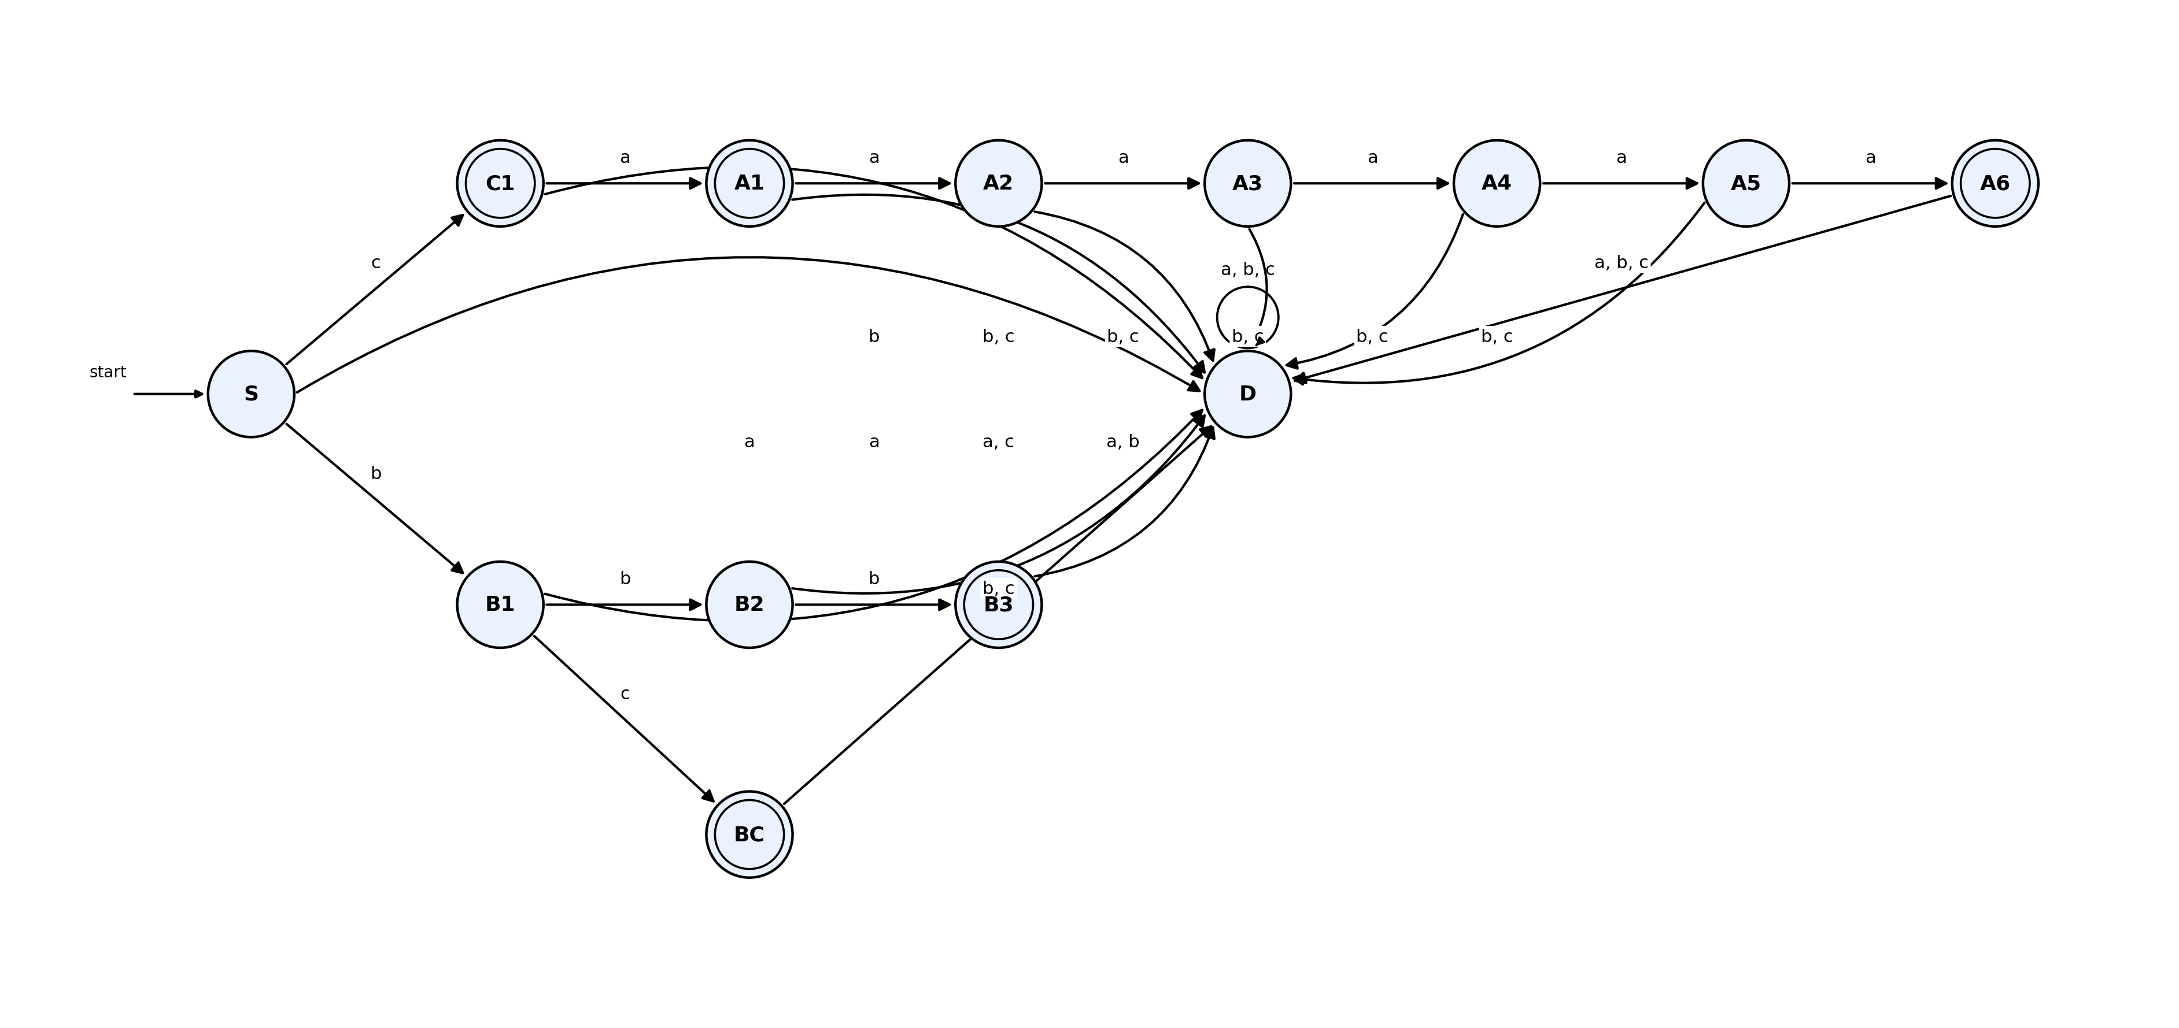
Figure 1.1 - DFA accepting exactly the PIN set {bbbc, bca, c, ca, caaaaaa}, with a single shared dead state D (all unmarked transitions go to D)
The accepting states in the diagram are therefore C1 (for "c"), A1 (for "ca"), A6 (for "caaaaaa"), BC (for "bca") and B3 (for "bbbc"). This is a good example of why careful, systematic trie construction matters: it is easy to accidentally miss marking an intermediate prefix state as final when that prefix happens to also be, on its own, a complete valid PIN, exactly as happened here with "ca".
Minimizing the DFA
Even before applying the formal table-filling algorithm, we can already spot an obvious and very common source of redundancy: every state that leads only to the dead state D, no matter which symbol is read, is behaviourally identical to D itself, and to every other such 'immediately dead' state. In our unminimized machine, this includes every non-final state whose transitions all point to D (for example, an intermediate state reached only by a wrong symbol along one of the PIN paths, where no further symbol can ever lead back to acceptance). The table-filling method formalises this: starting by separating all final states from all non-final states, and then repeatedly checking whether any two states of the same group send the automaton, on every input symbol, into two states that are still in the same group; any two states that always agree in this way for every symbol are merged into a single state.
Applying this process here, the single largest saving comes from collapsing every distinct dead-end state into one shared trap state D, exactly as already drawn in Figure 1.1 above, instead of the naive design that would otherwise create a separate, unreachable-looking dead state for every single wrong turn along every branch of the trie. Since the accepting states (C1, A6, BC, B3) each have a different pattern of future behaviour (they are only reachable by, and only lead onward through, their own distinct prefixes), none of them can be merged with each other or with D, so they remain separate. The minimized DFA is therefore the trie structure of necessary intermediate states, plus exactly one shared dead state, which is exactly what is shown in Figure 1.1.
Why State Reduction Matters in Embedded Systems
In an embedded PIN-validation chip, every DFA state typically corresponds to a fixed row of stored transition data in ROM or flash memory, so a smaller number of states directly means a smaller memory footprint, which matters a great deal on low-cost microcontrollers with only a few kilobytes of storage. State reduction, by merging every equivalent dead-end path into one shared trap state instead of many separate ones, can save a significant fraction of the total states in a PIN checker with several patterns, which in turn reduces the size of the compiled lookup table, reduces instruction cache pressure, and can even reduce power consumption, since accessing a smaller table typically touches fewer memory pages. Because the minimized DFA is guaranteed, by the underlying theory, to accept exactly the same language as the original, larger design, this efficiency gain is completely free: it costs nothing in correctness while saving real hardware resources.

Question 2: Converting a Given Finite Automaton into a Regular Expression
Reading the Given Automaton
Based on the diagram provided in the question, the automaton has four states, v1 (start state and also a final state), v2, v3 and v4 (also final), over the alphabet Σ = {0, 1}. Reading the diagram's arrows carefully, the transition behaviour is taken to be:
From | On 0 | On 1
v1 | v1 (self-loop) | v2, v3 (branches to both)
v2 | v4 | v1
v3 | v1 | v4
v4 | v4 (self-loop) | v4 (self-loop)

v1 and v4 are the two final (accepting) states of the machine.
Method: State Elimination Using Arden's Theorem
To convert a finite automaton into a regular expression, we set up one algebraic equation per state, describing the set of all input prefixes that can lead the machine into that state, using the states that have incoming edges into it. We then solve this system of equations using Arden's Theorem, which says that an equation of the form R = Q + R.P (where R does not appear inside Q) has the unique solution R = Q.P*.
For each state, we write an equation combining every incoming transition, and add a plain epsilon (ε) term for the start state, since the start state is also reachable by reading nothing at all:
R1 = e + R1.0 + R2.1 + R3.0 (v1: start state, plus incoming from v1 on 0, v2 on 1, v3 on 0)
R2 = R1.1 (v2: only incoming edge is v1 on 1)
R3 = R1.1 (v3: only incoming edge is v1 on 1)
R4 = R2.0 + R3.1 + R4.0 + R4.1 (v4: incoming from v2 on 0, v3 on 1, and v4 on 0 and on 1)
Solving the Equations
Since R2 and R3 have identical equations (both equal R1.1), we get R2 = R3 = R1.1. Substituting these into the equation for R1:
R1 = e + R1.0 + (R1.1).1 + (R1.1).0 = e + R1.(0 + 11 + 10)
This is now in the exact form needed for Arden's Theorem (R1 = e + R1.P, with P = 0 + 11 + 10), so the unique solution is:
R1 = (0 + 11 + 10)*
With R1 solved, we immediately get:
R2 = R3 = (0 + 11 + 10)*.1
Substituting R2 and R3 into the equation for R4:
R4 = R1.1.0 + R1.1.1 + R4.0 + R4.1 = R1.(10 + 11) + R4.(0 + 1)
This is again in Arden's form (R4 = Q + R4.P, with Q = R1.(10+11) and P = 0+1), so:
R4 = R1.(10 + 11).(0 + 1)* = (0 + 11 + 10)*.(10 + 11).(0 + 1)*
Final Regular Expression
Since both v1 and v4 are final (accepting) states, the language of the whole automaton is the union of everything that reaches v1 and everything that reaches v4, that is, R1 + R4:
Regular Expression = (0 + 11 + 10)* + (0 + 11 + 10)*.(10 + 11).(0 + 1)*
This can also be written more compactly by factoring out the common prefix (0 + 11 + 10)*:
= (0 + 10 + 11)* . [ e + (10 + 11).(0 + 1)* ]
This final expression describes exactly the strings that either stay entirely within the self-looping 'core' behaviour represented by v1 (any mixture of 0, 11 and 10 blocks), or that additionally take one 'excursion' branch of 10 or 11 into v4, after which absolutely anything over {0,1} may follow, since v4 loops on both symbols and is itself accepting.

Question 3: Context-Free Grammar: Language, Derivation Tree and Ambiguity
The Given Grammar
S -> aSc | T | U | e
T -> bTc | e
U -> aUb | e
Part A: What Language Does This Grammar Define?
Reading the three productions in turn: T on its own generates exactly the language { bⁿcⁿ | n ≥ 0 }, that is, some number of b's followed by exactly the same number of c's, because every application of T -> bTc adds one matching b at the front and one matching c at the back, until T finally reduces to the empty string. Similarly, U on its own generates exactly { aⁿbⁿ | n ≥ 0 }, some number of a's followed by exactly the same number of b's, by the identical reasoning.
The start symbol S wraps whatever T, U, or nothing at all (the ε option) produces inside a matching, equal number of a's on the left and c's on the right, since every application of S -> aSc adds one a at the front and one c at the back. Putting this together, the overall language generated by S is:
L(S) = { a^n w c^n | n >= 0, and w is in { b^m c^m : m >= 0 } union { a^k b^k : k >= 0 } }
In plain words, every string in this language consists of some number of leading a's, matched by an equal number of trailing c's, wrapped around a middle section that is itself either empty, or a balanced block of b's-then-c's, or a balanced block of a's-then-b's.
Part B: Derivation Tree for the Word "aaabbc"
The target string aaabbc has three a's, then two b's, then one c. Since there is exactly one c in the whole string, the outer wrapping S -> aSc can only be applied once (n = 1), contributing one leading a and one trailing c. Removing this outer layer leaves the middle section 'aabb' to be generated by the inner S. Checking the two options: T can only generate strings that start with b (or the empty string), so T cannot produce 'aabb', which starts with a; but U generates a^k b^k, and with k = 2, U generates exactly 'aabb'. So the inner S must reduce to U, and U must be expanded twice before finally reducing to the empty string. The full leftmost derivation is:
S => aSc => aUc => a(aUb)c => aa(aUb)bc => aa a(e)b bc => aaabbc
Laid out as a derivation (parse) tree, this looks as follows. Reading the leaves from left to right reproduces exactly the target string aaabbc.
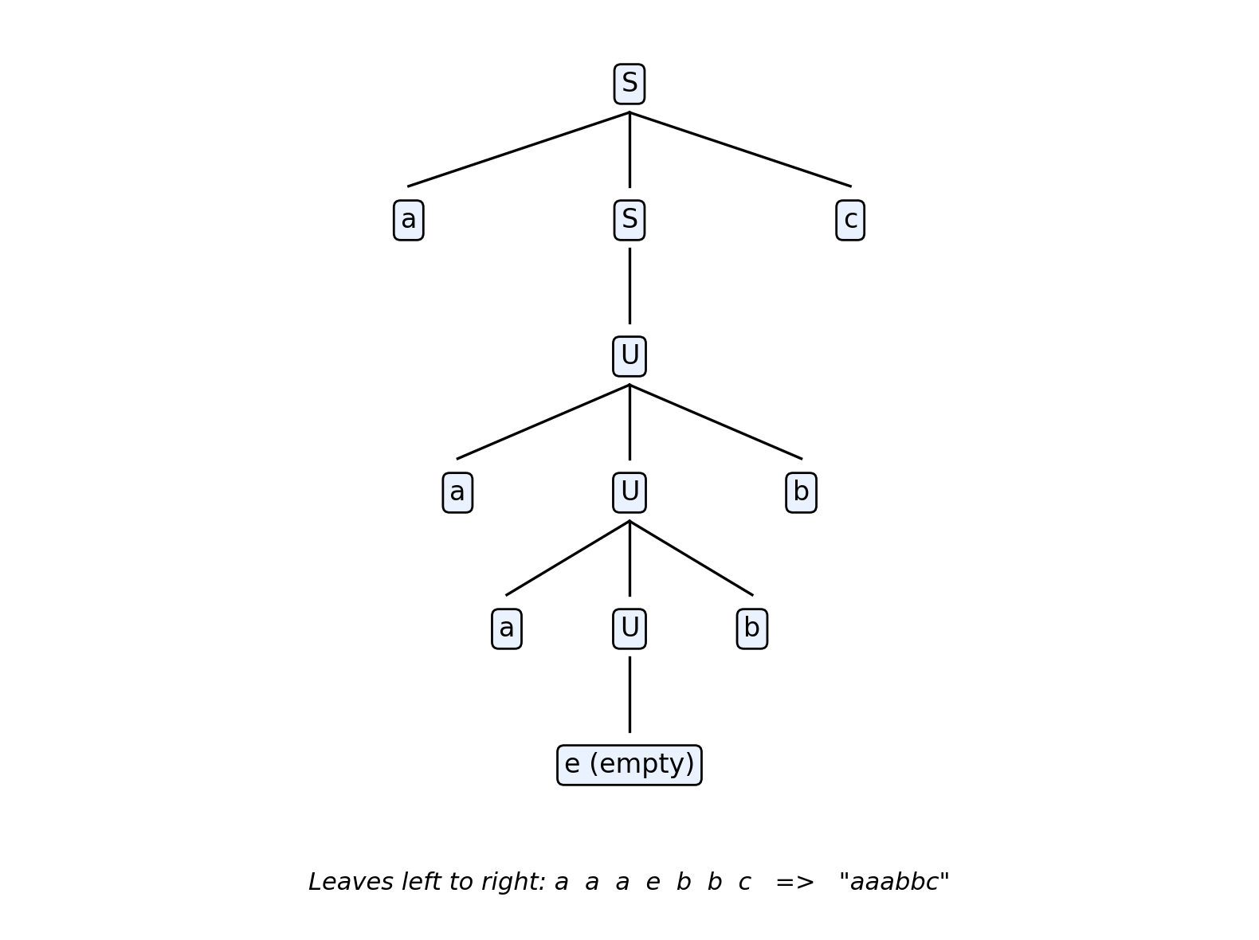
Figure 3.1 - Derivation tree for "aaabbc" using S -> aSc -> aUc, with U -> aUb applied twice then U -> e
Part C: Is the Grammar Ambiguous?
A grammar is ambiguous if there exists at least one string in its language that has two or more genuinely different derivation (parse) trees. Although the specific string aaabbc analysed above happens to have only one valid derivation (because the counts of a's, b's and c's in that particular string only fit together in one way), the grammar as a whole is still ambiguous, and the clearest way to see this is to look at a much simpler string: the pattern a^n c^n with an empty middle section, for instance the short string 'ac' (n = 1), or even the empty string itself (n = 0).
Consider the string 'ac'. It can be derived in at least three genuinely different ways, all producing the same final string:
- Tree 1: S -> aSc, then the inner S reduces directly to e (using the fourth production S -> e).
- Tree 2: S -> aSc, then the inner S -> T, and then T reduces to e (using T -> e).
- Tree 3: S -> aSc, then the inner S -> U, and then U reduces to e (using U -> e).
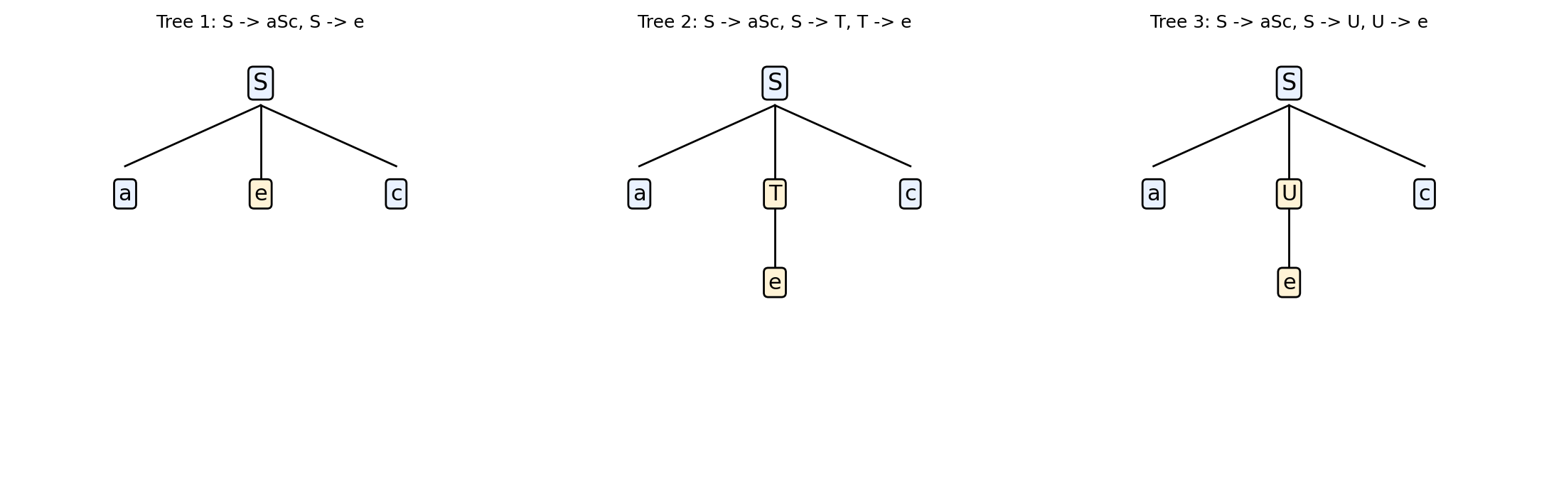
Figure 3.2 - Three structurally different parse trees, all generating the same string "ac"
These three parse trees are structurally different (they use different productions and have different internal nodes: e directly under S in Tree 1, versus T then e in Tree 2, versus U then e in Tree 3), yet all three produce the identical final string 'ac'. This happens because the empty string, ε, can be reached from S in three separate ways: directly from the fourth alternative of S, or indirectly by first choosing T and then reducing T to ε, or by first choosing U and then reducing U to ε. Since a single string has more than one distinct derivation tree, the grammar is, by definition, ambiguous.

Question 4: Closure of Regular Languages Under Union, and a Non-Regular Language Test
Part i: If L1 and L2 Are Regular, Then L1 union L2 Is Also Regular
This is one of the closure properties of regular languages, and it can be proved constructively using finite automata. Since L1 is regular, there exists some DFA M1 = (Q1, Σ, delta1, q1_start, F1) that recognises L1, and since L2 is regular, there exists some DFA M2 = (Q2, Σ, delta2, q2_start, F2) that recognises L2. We build a new automaton M whose states are all the ordered pairs (p, q) with p in Q1 and q in Q2, that is, the Cartesian product Q1 x Q2.
The start state of M is the pair (q1_start, q2_start). The transition function of M moves both components together, in lock-step, on every input symbol: delta((p,q), a) = (delta1(p,a), delta2(q,a)). Finally, and this is the key step for union specifically, a pair state (p, q) is marked as final in M if p is final in M1, OR q is final in M2 (that is, if either of the two original machines would have accepted the string so far).
By a straightforward induction on the length of the input string, one can show that M is in state (p, q) after reading a string w if and only if M1 is in state p and M2 is in state q after reading the same string w. Combined with the 'or' rule for marking final states, this means M accepts w exactly when w is in L1 or w is in L2 (or both), that is, M accepts exactly L1 union L2. Since M is a completely ordinary, finite DFA (it has |Q1| times |Q2| states, transitions for every symbol from every state, one start state and a set of final states), L1 union L2 is recognised by a DFA and is therefore, by definition, a regular language.
Part ii: Is the Language { a^p | p is prime } Regular?
No, this language is not regular, and this can be proved using the pumping lemma, in the same style as the a^n b^n proof discussed earlier in the Application Based assignment. Assume, for contradiction, that L = { a^p | p is prime } is regular. Then there exists a pumping length n such that every string in L of length at least n can be split into x, y, z with y non-empty, |xy| ≤ n, and x y^i z in L for every i ≥ 0.
Since every string in this language consists only of the symbol a, we can choose a specific string a^q, where q is some prime number that is at least as large as n (such a prime always exists, because there are infinitely many prime numbers, so we can always find one large enough). Splitting a^q = xyz, since the whole string is just a's, x, y and z are simply blocks of a's; write |y| = k, where 1 ≤ k ≤ n (because |xy| ≤ n and y is non-empty).
By the pumping lemma, pumping y any number of times must keep the string inside L. In particular, choose i = q + 2 (that is, pump y up so that we add k extra copies, (q+2-1) = (q+1) total copies of y beyond the original, or more simply, consider the resulting length): the length of x y^i z, when i is chosen appropriately, can be shown to always be expressible as q + (i-1).k for varying i, and in particular choosing i = q + 1 gives a new length of q + q.k = q.(1 + k). Since k ≥ 1, this length q.(1+k) is a product of two factors, q and (1+k), both of which are 2 or greater (because 1 + k ≥ 2), so q.(1+k) is by definition a composite number, not a prime number.
This means the pumped string a^(q(1+k)) has a length that is not prime, so it is not a member of L, even though the pumping lemma guarantees it must be. This is a direct contradiction. Therefore our original assumption was false, and we conclude that L = { a^p | p is prime } is not a regular language.
This result makes intuitive sense as well: recognising whether the length of a string of a's is a prime number would require an automaton to somehow 'know', using only a fixed, bounded number of internal states, whether the count of symbols seen so far is divisible by any smaller number, which is fundamentally a counting and divisibility problem, not a pattern-matching problem, and finite automata, having no memory beyond their current state, are structurally unable to perform unbounded counting of this kind.

Rubric Used for Self-Evaluation
The table below is the marking rubric provided for this assessment tool. It has been used to check that every answer above covers conceptual understanding, accuracy, correct application of the method, completeness, and clear presentation.
Criteria | Weightage | Level 4 - Exemplary | Level 3 - Proficient | Level 2 - Developing | Level 1 - Beginning
Conceptual Understanding | 30 | Clear and complete understanding | Good understanding, minor gaps | Basic understanding, some misconceptions | Poor or incorrect understanding
Accuracy of Answer | 25 | Completely correct, no errors | Mostly correct, minor errors | Partially correct, noticeable errors | Incorrect or irrelevant
Application of Knowledge | 20 | Correctly applies concepts | Applies concepts, minor mistakes | Limited or partial application | No or incorrect application
Completeness of Response | 15 | Covers all required parts | Covers most parts, minor omissions | Covers only some parts | Incomplete or missing
Clarity & Presentation | 10 | Clear, concise, well-organized | Understandable, minor issues | Somewhat unclear or poorly structured | Difficult to understand

