SAVEETHA SCHOOL OF ENGINEERING
SAVEETHA INSTITUTE OF MEDICAL AND TECHNICAL SCIENCES
DEPARTMENT OF COMPUTER SCIENCE AND ENGINEERING
COURSE NAME: Theory of Computation COURSE CODE: CSA13

COURSE OUTCOME COVERED
CO1: Apply mathematical foundations such as formal proofs, induction, and basic concepts of automata theory to solve computational problems. (BL:3)
Assessment Tool Weightage: 40%

QUESTIONS: 5 Total Marks: 50
Duration : 1 Hour
Analytical Problem

Code of Conduct:
I, Kanishk C (Reg. No.: 192511278), certify that this submission is my original work and that I have adhered to the guidelines specified for this assessment.
I understand that any violation of academic integrity rules will result in disciplinary action.
Signature of the student: Kanishk C

Question 1
Consider the NFA given below which accepts some language L over the alphabet Σ = {a, b}. Construct a DFA that represents the same language L.
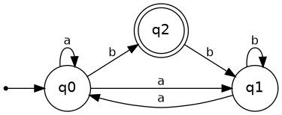
Figure 1.1 – Given NFA
Reading the diagram, the NFA has three states q0, q1 and q2, with q0 as the start state and q2 as the only final state. Writing down every arrow in the picture gives the transition function shown below.
State | a | b
→ q0 | {q0, q1} | {q2}
q1 | {q0} | {q1}
* q2 | ∅ | {q1}
(→ marks the start state, * marks the final state.)
To build the DFA we use the subset construction method. Every state of the DFA is a set of NFA states, and we start from the set containing only the start state q0. From there we keep computing where 'a' and 'b' take us until no new sets appear.
Step 1: {q0}
On a: q0 goes to {q0, q1}. On b: q0 goes to {q2}.
Step 2: {q0, q1}
On a: q0 gives {q0, q1}, q1 gives {q0}, union = {q0, q1}. On b: q0 gives {q2}, q1 gives {q1}, union = {q1, q2}.
Step 3: {q2}
On a: q2 has no a-move, so we land on the empty set (a trap/dead state). On b: q2 gives {q1}.
Step 4: {q1, q2}
On a: q1 gives {q0}, q2 gives ∅, union = {q0}. On b: q1 gives {q1}, q2 gives {q1}, union = {q1}.
Step 5: {q1}
On a: {q0}. On b: {q1}.
Step 6: ∅ (dead state)
On a and b it just stays at ∅.
No new subsets appear after this, so the construction stops here. Renaming the sets for a clean table:
DFA State | Corresponds to | a | b
→ A | {q0} | B | C
B | {q0, q1} | B | D
* C | {q2} | F | E
* D | {q1, q2} | A | E
E | {q1} | A | E
F | ∅ (trap) | F | F
A is the start state and C, D are final because their NFA-set contains q2.
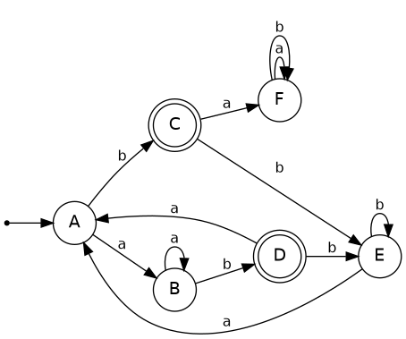
Figure 1.2 – Equivalent DFA

Question 2
Let L be the language of words of length at least 2 whose last two letters are different from each other. For example abaab is in L but not bb. Construct an NFA for L, then draw the equivalent DFA.
Since the condition only talks about the last two symbols of the string, the trick is to build an NFA that 'guesses' at which point the last two symbols begin. Before that point the machine just loops on both symbols, ignoring everything; then it commits to reading exactly two more symbols that are different from each other, and it must stop reading right there (no symbol is allowed after that pair).
NFA states used: q0 (start, reading the unimportant prefix), q1 (just read an 'a' that is being guessed as the second-last symbol), q2 (just read a 'b' that is being guessed as the second-last symbol), and qf (accepting state, reached only after the last two symbols were different).
State | a | b
→ q0 | {q0, q1} | {q0, q2}
q1 | ∅ | {qf}
q2 | {qf} | ∅
* qf | ∅ | ∅
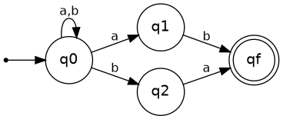
Figure 2.1 – NFA for L
Because qf has no outgoing edges, the machine can only accept if the two symbols that took it into q1/q2 and then into qf really were the last two symbols of the string, which is exactly the condition we want.
Now we convert this NFA to a DFA by subset construction.
{q0} — a → {q0, q1}, b → {q0, q2}
{q0, q1} — a → {q0, q1}, b → {q0, q2, qf}
{q0, q2} — a → {q0, q1, qf}, b → {q0, q2}
{q0, q2, qf} — a → {q0, q1}, b → {q0, q2}
{q0, q1, qf} — a → {q0, q1}, b → {q0, q2, qf}
All five subsets have now been generated, and both {q0, q2, qf} and {q0, q1, qf} are accepting states because they contain qf.
DFA State | Corresponds to | a | b
→ S1 | {q0} | S2 | S3
S2 | {q0, q1} | S2 | S4
S3 | {q0, q2} | S5 | S3
* S4 | {q0, q2, qf} | S2 | S3
* S5 | {q0, q1, qf} | S2 | S4
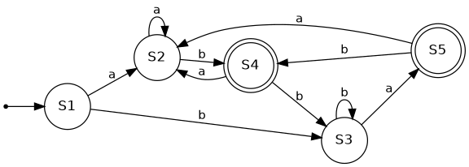
Figure 2.2 – Equivalent DFA
Quick check with the two examples given in the question:
abaab: S1 –a→ S2 –b→ S4 –a→ S2 –a→ S2 –b→ S4. We land on S4, which is accepting, so abaab ∈ L. This matches the question.
bb: S1 –b→ S3 –b→ S3. S3 is not accepting, so bb ∉ L, which also matches the question.

Question 3
Design a Nondeterministic Finite Automata (NFA) that takes a binary string as input and accepts the string only if the last two digits are the same (either 00 or 11). Write the formal definition of the NFA. Also show that the string 01011 is accepted by the NFA.
This uses the same idea as Question 2, except now the NFA should accept only when the last two symbols are equal instead of different.
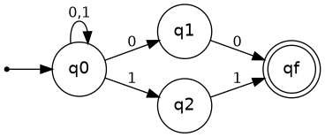
Figure 3.1 – NFA accepting strings ending in 00 or 11
Formal definition: N = (Q, Σ, δ, q0, F), where
Q = {q0, q1, q2, qf}
Σ = {0, 1}
q0 is the start state
F = {qf}
δ is given by the table below (any pair not listed maps to ∅):
State | 0 | 1
→ q0 | {q0, q1} | {q0, q2}
q1 | {qf} | ∅
q2 | ∅ | {qf}
* qf | ∅ | ∅
Showing that 01011 is accepted:
The last two digits of 01011 are the 4th and 5th symbols, which are '1' and '1' – the same digit, so intuitively the string should be accepted. We just need to find one accepting path through the NFA (that is enough, since an NFA accepts if at least one path works).
Read the string symbol by symbol: 0, 1, 0, 1, 1.
q0 –0→ q0 (1st symbol, self-loop, ignored as prefix)
q0 –1→ q0 (2nd symbol, self-loop, ignored as prefix)
q0 –0→ q0 (3rd symbol, self-loop, ignored as prefix)
q0 –1→ q2 (4th symbol, guess: this begins the last two digits)
q2 –1→ qf (5th symbol, matches the guess, and qf is a final state)
Every symbol of the string has been consumed and the machine has landed on qf ∈ F, so 01011 is accepted by this NFA.

Question 4
Consider the NFA given below which accepts the language representing the set of all strings having 001 as a substring over the alphabet Σ = {0, 1}. Construct a DFA that represents the same language.
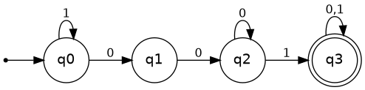
Figure 4.1 – Given NFA (strings containing 001)
The NFA states are q0 (start, still searching for the pattern), q1 (just saw a 0), q2 (just saw 00), and q3 (the pattern 001 has been found – final state, and it stays final forever no matter what comes after).
State | 0 | 1
→ q0 | {q0, q1} | {q0}
q1 | {q2} | ∅
q2 | {q2} | {q3}
* q3 | {q3} | {q3}
Applying subset construction:
{q0} — 0 → {q0, q1}, 1 → {q0}
{q0, q1} — 0 → {q0, q1, q2}, 1 → {q0}
{q0, q1, q2} — 0 → {q0, q1, q2}, 1 → {q0, q3}
{q0, q3} — 0 → {q0, q1, q3}, 1 → {q0, q3}
{q0, q1, q3} — 0 → {q0, q1, q2, q3}, 1 → {q0, q3}
{q0, q1, q2, q3} — 0 → {q0, q1, q2, q3}, 1 → {q0, q3}
Six distinct subsets appear in total, and every subset that contains q3 becomes a final state of the DFA.
DFA State | Corresponds to | 0 | 1
→ A | {q0} | B | A
B | {q0, q1} | C | A
C | {q0, q1, q2} | C | D
* D | {q0, q3} | E | D
* E | {q0, q1, q3} | F | D
* F | {q0, q1, q2, q3} | F | D
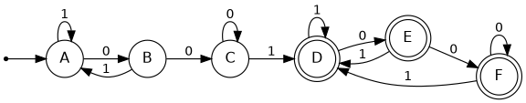
Figure 4.2 – Equivalent DFA
Once state D, E or F is reached, the DFA can never leave the 'accepting' side no matter what is read next, because 001 has already occurred somewhere in the string and cannot un-occur – this matches the definition of the language.

Question 5
A NFA with ε-transitions is given below. Find ε-closure for each state and design an equivalent DFA which accepts the same language. Draw its transition table and mark the initial and final states.
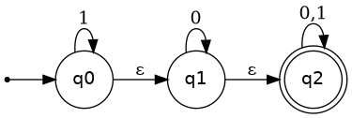
Figure 5.1 – Given ε-NFA
The machine has three states: q0 (start, self-loop on 1), q1 (self-loop on 0), and q2 (final, self-loop on both 0 and 1), connected by ε-transitions q0 → q1 and q1 → q2.
ε-closure of each state (the set of states reachable using only ε-edges, including the state itself):
State | ε-closure
q0 | {q0, q1, q2}
q1 | {q1, q2}
q2 | {q2}
Subset construction with ε-closures:
Start state of the DFA = ε-closure(q0) = {q0, q1, q2}. Call this A. Since q2 ∈ A, A is a final state.
A on 0: q0 has no 0-move, q1 –0→ q1, q2 –0→ q2, giving {q1, q2}; taking the ε-closure of that set gives {q1, q2}. Call this B (final, since it contains q2).
A on 1: q0 –1→ q0, q1 has no 1-move, q2 –1→ q2, giving {q0, q2}; ε-closure of {q0, q2} is {q0, q1, q2} = A. So A on 1 goes back to A.
B = {q1, q2} on 0: q1 –0→ q1, q2 –0→ q2, giving {q1, q2}; closure is {q1, q2} = B.
B on 1: q1 has no 1-move, q2 –1→ q2, giving {q2}; closure is {q2}. Call this C (final).
C = {q2} on 0: {q2}; closure {q2} = C.
C on 1: {q2}; closure {q2} = C.
Final DFA transition table (all three states are final because every one of them contains q2, which is reachable by ε from anywhere in this machine):
DFA State | Corresponds to | 0 | 1
→ * A | {q0, q1, q2} | B | A
* B | {q1, q2} | B | C
* C | {q2} | C | C
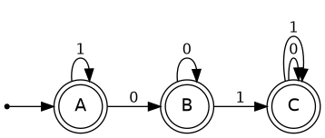
Figure 5.2 – Equivalent DFA (→ marks start, all states are also final)
An interesting observation here: because the start state A already contains the final state q2 (thanks to the ε-path q0 → q1 → q2), and every reachable DFA state also contains q2, all three DFA states end up being accepting. This means the language accepted by this particular NFA is actually Σ* – every binary string, including the empty string, is accepted.

