SIMATS ENGINEERING
ASSESSMENT TOOL 3: Application Based Questions
COURSE NAME: Cloud Computing and Big Data Analytics
COURSE CODE: CSA15
COURSE OUTCOME COVERED
CO2: Analyze virtualization architectures to identify performance and security issues in cloud computing environments. (BL3)
Assessment Tool Weightage: 10%
Dave's Taxonomy: Manipulation (Level 2)
Question Count: 5
Total Marks: 25

Code of Conduct
I Kanishk C (Reg. No: 192511278) certify that this submission is my original work and that I have adhered to the guidelines specified for this assessment.
I understand that any violation of academic integrity rules will result in disciplinary action.
Signature of the student: Kanishk C

Assessment Tasks — Application Based Questions
1. How would virtualization help a company reduce hardware cost and improve utilization in a new cloud datacenter?
When a company sets up a new datacenter without virtualization, it usually buys one physical server for every application it wants to run. In real use, most of these servers sit almost idle — studies of traditional datacenters commonly show CPU utilization in the range of 10 to 15 percent, because a server bought for the busiest day of the year is underused on every ordinary day. Virtualization solves this by allowing one physical machine to host many independent virtual machines at the same time, each with its own operating system and applications, isolated from the others by a hypervisor.
Because the hypervisor can allocate CPU, memory and storage dynamically between VMs based on actual demand, the company no longer needs to buy separate hardware for every workload. Instead, ten or twenty lightly used applications can be consolidated onto two or three well-utilized physical servers. This server consolidation directly lowers capital expenditure, since fewer machines need to be purchased, and it also lowers operating expenditure because there is less hardware to power, cool and physically maintain.
Utilization improves further because idle capacity on one VM can effectively be used by another VM that needs more resources at that moment, instead of that capacity being wasted inside a single dedicated box. Provisioning also becomes faster: a new VM can be created from a template in minutes instead of waiting weeks for new hardware to be procured and installed. Taken together, a new cloud datacenter built on virtualization gets more useful work out of the same physical footprint, spends less money on hardware, and can scale up or down without buying new machines every time demand changes.
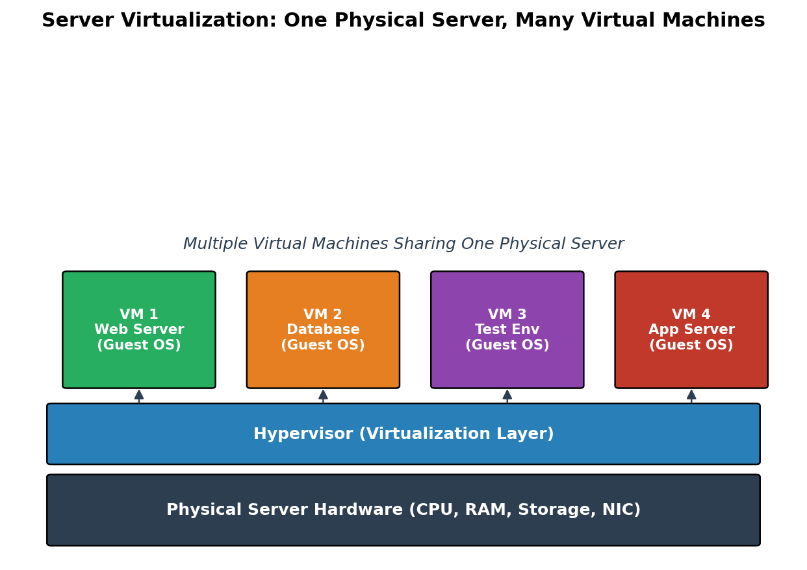
Figure 1: Multiple VMs consolidated on a single physical server through a hypervisor
2. A startup needs rapid server provisioning for testing and deployment. Explain how hypervisors and virtual machines support this requirement.
A startup that is testing and deploying software frequently needs new environments almost every day — a fresh server to test a build, a separate one to try a risky configuration change, another to demo a feature to a client. If every one of these required buying or physically configuring a new machine, the startup would lose days of time and a large amount of money for something that might only be used for a few hours.
This is exactly the problem hypervisors and virtual machines solve. A hypervisor sits on top of the physical hardware and can create a new virtual machine by simply allocating a slice of CPU, memory, disk and network resources and loading a pre-built VM image or template. Since no physical wiring or hardware installation is involved, this entire process takes only a few minutes rather than weeks. The startup can keep a small library of standard VM templates — for example, one for a Linux web server, one for a database, one for a CI/CD test runner — and spin up as many identical copies as needed on demand.
Because each VM is isolated from the others by the hypervisor, a broken or crashing test environment on one VM does not affect the production VM running next to it on the same physical host. When testing is complete, the VM can simply be deleted or paused, freeing its resources back to the pool for the next task, so the startup never pays for capacity it is not actually using. This combination of speed, isolation and elastic resource use is what lets a small engineering team provision, test and tear down environments continuously, matching the fast-moving pace that a startup needs without the overhead of managing physical servers by hand.
3. How can SOA help integrate cloud services developed by different teams? Explain with an application-oriented example.
Service Oriented Architecture (SOA) is a design approach in which each piece of functionality is built and exposed as an independent, well-defined service that communicates with other services through standard interfaces, usually over HTTP using protocols such as REST or SOAP. Instead of one large application where all the logic is tightly bound together, the system is broken into smaller services, each of which can be developed, deployed and scaled by a separate team.
This matters for cloud integration because in a real organization, different teams almost never build things the same way — one team may use Java, another Python, and they may even be hosted on different cloud providers. SOA solves this mismatch by hiding each service's internal implementation behind a published interface (an API contract). As long as every team agrees on the format of requests and responses, it does not matter what language or platform sits behind that interface, so services built independently can still talk to each other and be combined into one working system.
As an application example, consider an e-commerce platform being built by four different teams in the same company. The Payments team exposes a Payment Service that processes transactions, the Inventory team exposes a Stock Service that tracks product availability, the Logistics team exposes a Shipping Service that calculates delivery timelines, and the Frontend team builds the customer-facing website. None of these teams needs to know the internal code of the others. When a customer places an order, the website calls the Stock Service to confirm availability, then calls the Payment Service to charge the customer, and finally calls the Shipping Service to schedule delivery — three independently developed cloud services cooperating through SOA to complete one business process. If the Logistics team later rewrites their entire Shipping Service internally, nothing breaks for the other teams as long as the published interface stays the same, which is the real value SOA brings to multi-team cloud integration.
4. Explain how identity management and privacy controls should be applied in a federated cloud used by partner organizations.
A federated cloud is formed when two or more independent organizations connect their separate cloud environments so that users and services from one organization can access resources hosted in the other, without each organization having to fully trust or take over the other's infrastructure. Because multiple identity systems and multiple sets of sensitive data are now in contact with each other, identity management and privacy have to be handled very deliberately, not left to whatever each partner already does internally.
For identity management, the standard approach is Federated Identity Management using protocols such as SAML or OpenID Connect / OAuth 2.0. Each partner keeps its own Identity Provider (IdP) that authenticates its own users, and the partners agree on a trust relationship so that a login token issued by Organization A's IdP is accepted by Organization B's systems without the user needing a second separate account. Single Sign-On built this way means a user authenticates once with their home organization and can then access approved resources across the federation, while each organization still fully controls how its own users are authenticated. Role-based or attribute-based access control should sit on top of this, so that even an authenticated partner user only gets access to the specific resources their role is entitled to, following the principle of least privilege, rather than blanket access to everything in the partner's cloud.
For privacy, the federation agreement needs to explicitly define what data is shared, in what form, and for how long. Sensitive data should be minimized before it crosses the boundary — for example, sharing a token or a masked identifier instead of a full patient or customer record wherever the receiving service does not truly need the raw data. Data in transit between partners should always be encrypted, and access should be logged and audited on both sides so any misuse can be traced back to a specific identity. Because the two organizations may be subject to different data protection regulations, the federation should also define which jurisdiction's privacy rules apply to shared data, and include contractual terms on data retention and deletion once a partnership or a specific data-sharing need ends. Handled this way, federation gives partner organizations the convenience of working together while keeping each side accountable for who can see what.
5. A business wants to migrate from isolated physical servers to a software-defined datacenter. Explain the practical benefits they can expect.
In a traditional setup built on isolated physical servers, compute, storage and networking are each tied to specific pieces of hardware that were purchased and configured for one particular job. Adding capacity means buying and racking new machines, reconfiguring switches by hand, and provisioning storage arrays individually — all of which is slow and locks resources to whichever server they happen to sit on. A Software-Defined Datacenter (SDDC) changes this by virtualizing compute, storage and networking together and controlling all of it through a single software management layer, instead of through separate manual processes for each type of hardware.
The first practical benefit the business will see is much faster provisioning. Instead of waiting days or weeks to rack a new physical server, a new workload can be deployed by requesting a slice of already-pooled compute, storage and network capacity, which typically takes minutes. The second benefit is far better resource utilization, because compute, storage and network resources are pooled across all the underlying hardware and allocated to whichever workload actually needs them at a given moment, rather than being locked to one physical box that may be mostly idle. Third, network virtualization (software-defined networking) lets the business create, change or isolate virtual networks in software, so security zones and connectivity policies can be updated instantly instead of requiring someone to physically rewire switches.
A fourth benefit is easier scaling and disaster recovery: because everything is abstracted from the underlying hardware, workloads can be moved between physical hosts, or even between an on-premises SDDC and a public cloud, with far less friction, which also makes backup and failover simpler to automate. Finally, centralized management means IT staff can monitor, secure and automate the entire environment from one control plane instead of juggling separate tools for servers, storage and networking, which reduces both operating cost and the chance of human configuration error. Overall, moving to an SDDC gives the business the same physical hardware far more flexibility, speed and efficiency than isolated physical servers ever could.
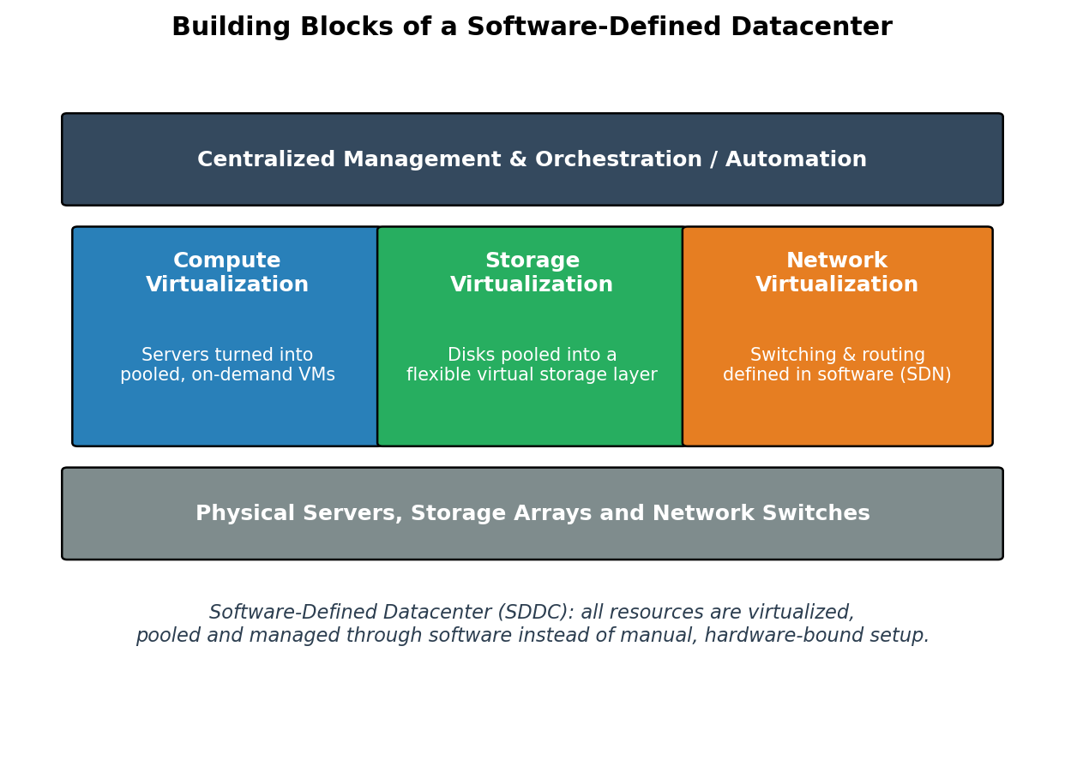
Figure 2: Compute, storage and network virtualization unified under a Software-Defined Datacenter

Application Based Questions Rubric
Criteria | Weightage | Level 4 - Exemplary | Level 3 - Proficient | Level 2 - Developing | Level 1 - Beginning
Relevance to Application | 25% | Response directly addresses the given use case with strong relevance | Mostly relevant response | Partially relevant | Weak relevance
Use of Cloud Concepts | 25% | Applies appropriate concepts accurately | Mostly accurate application | Basic application only | Incorrect concept usage
Practical Insight | 20% | Shows strong real-world understanding | Shows reasonable practical understanding | Limited practical insight | No practical insight
Completeness | 15% | Response covers all required aspects | Covers most aspects | Covers only basic aspects | Incomplete response
Clarity | 15% | Clear and concise answer | Generally clear | Some confusion in expression | Poor clarity

