SIMATS ENGINEERING
ASSESSMENT TOOL 2: Scenario-Based
COURSE NAME: Cloud Computing and Big Data Analytics
COURSE CODE: CSA15

COURSE OUTCOME COVERED
CO2: Analyze virtualization architectures to identify performance and security issues in cloud computing environments. (BL3)
Assessment Tool Weightage: 20%
Dave's Taxonomy: Manipulation (Level 2)
Question Count: 5
Total Marks: 25

Code of Conduct
I Kanishk C (Reg. No: 192511278) certify that this submission is my original work and that I have adhered to the guidelines specified for this assessment.
I understand that any violation of academic integrity rules will result in disciplinary action.
Signature of the student: Kanishk C

Assessment Tasks — Scenario-Based Questions
1. A university plans to virtualize its computer laboratory so that multiple operating systems can be provided on demand. Recommend a virtualization strategy, identify the suitable hypervisor type, and justify the decision.
The requirement here is that lab machines need to offer several operating systems on demand — for example a student may need Windows for one exercise and a Linux distribution for another, sometimes within the same session — and the university also wants this to run reliably for many students at once without the performance dropping. The right strategy is desktop/server virtualization using a bare-metal hypervisor, with each physical lab server or a small rack of servers hosting many VMs that students connect to through remote desktop or a VDI (Virtual Desktop Infrastructure) client, rather than installing a hypervisor as an application on top of Windows on every single lab PC.
A Type 1 (bare-metal) hypervisor such as VMware ESXi or Microsoft Hyper-V Server is the suitable choice, not a Type 2 hosted hypervisor such as VirtualBox. The reason is that a Type 1 hypervisor runs directly on the server hardware with no general-purpose host operating system underneath it, so it has direct access to CPU, memory and storage and a much smaller software layer between the hardware and the VMs. This gives noticeably better performance and lets one physical server support far more concurrent VMs than a Type 2 hypervisor could, which matters when dozens of students may be running VMs at the same time during a lab session.
The justification also covers manageability and reliability. Type 1 hypervisors are built for datacenter-style use — they support centralized management consoles, VM templates that can be cloned instantly to reset a lab to a clean state after every session, snapshots for quick rollback if a student breaks their environment, and resource controls that stop one VM from starving the others of CPU or memory. A Type 2 hypervisor is meant for a single user running a VM or two on their own laptop, and does not offer this level of centralized control across an entire lab of machines. For these reasons, a Type 1, bare-metal hypervisor deployed on a small number of powerful lab servers, delivering VMs to student terminals through VDI, is the most practical and scalable strategy for a university computer lab that needs multiple operating systems on demand.
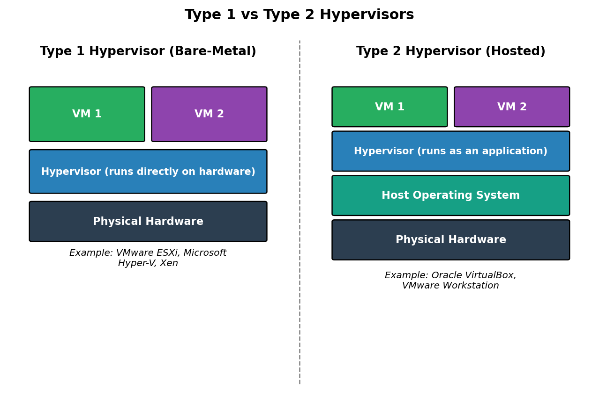
Figure 1: Type 1 (bare-metal) vs Type 2 (hosted) hypervisors — the university lab should use Type 1
2. A hospital cloud is facing VM escape and unauthorized snapshot access. Identify the major security risks and propose mitigation controls.
A hospital cloud typically stores highly sensitive patient data, so the two issues described here are serious. VM escape is an attack where malicious code running inside one virtual machine breaks out of that VM's isolation and gains access to the hypervisor or to other VMs on the same physical host. Because a hospital's cloud usually places multiple patient-facing systems and databases on shared infrastructure, a successful VM escape could let an attacker move from a low-value, poorly secured VM straight into a VM holding electronic health records, defeating the entire point of isolating workloads in separate VMs in the first place.
Unauthorized snapshot access is a related but separate risk. A snapshot captures the full state of a VM, including whatever was in its memory and disk at that moment — which for a hospital system frequently means unencrypted patient data sitting in application memory or temporary files. If snapshots are stored without proper access controls, anyone who can read the storage location, including a careless administrator account or a compromised backup service, can extract patient records directly from the snapshot file without ever having to attack the live, protected VM at all.
The mitigation controls should address both problems directly. For VM escape, the hospital should keep the hypervisor itself patched immediately as vendor security updates are released, since almost all documented VM escape exploits target specific unpatched hypervisor vulnerabilities. Hardware-assisted virtualization features (such as Intel VT-x/EPT or AMD-V) should be enabled, since they strengthen the isolation boundary at the CPU level. Workload isolation should also be improved by not mixing high-sensitivity VMs (patient databases) with low-sensitivity or externally-facing VMs on the same physical host, so that even if an escape does happen on a lower-value VM, it cannot reach critical data on the same hardware. For snapshot access, snapshots should always be encrypted at rest using keys the hypervisor administrator does not directly control, access to the snapshot storage location should be restricted through role-based access control and logged for audit, and snapshots should be deleted automatically once they are no longer needed rather than being left indefinitely. Together, patched hypervisors, strong isolation between workload sensitivity levels, and encrypted, access-controlled snapshots close both the VM escape and the unauthorized snapshot access risks.
3. A retail company wants to modernize its datacenter using Software Defined Datacenter principles. Explain how compute, storage, and network virtualization would be introduced in phases.
Trying to virtualize compute, storage and networking all at once is risky for a retail company that still needs its point-of-sale systems, inventory databases and e-commerce backend running every day without interruption. A phased rollout lets the company modernize gradually, proving each layer works before building the next one on top of it.
Phase 1 would focus on compute virtualization, since this delivers the fastest, lowest-risk return. The company would install a Type 1 hypervisor on its existing physical servers and begin consolidating individual application servers — inventory management, the POS backend, reporting servers — into VMs running on fewer physical machines. This phase alone typically frees up a large amount of underused hardware capacity and gives the IT team its first experience managing VM templates, snapshots and live migration, without yet touching storage or network design.
Phase 2 introduces storage virtualization once compute virtualization is stable. Instead of each application owning its own dedicated disks, the company would deploy a storage virtualization layer or software-defined storage (SDS) that pools all available storage — SAN, NAS, or local disks — into a single flexible resource. This lets VMs be allocated storage on demand, supports features like thin provisioning and storage-based snapshots, and makes it possible to move a VM's storage between physical arrays without downtime, which matters for keeping a 24/7 retail POS and e-commerce environment available.
Phase 3 introduces network virtualization (software-defined networking). At this stage the company defines virtual networks, firewalls and load balancers in software rather than through physical switch and router configuration. This is introduced last because it depends on having a stable virtualized compute and storage layer to attach to, and because SDN is what finally allows the retail company to create isolated network segments for the POS systems, the customer-facing store, and internal back-office systems purely through policy, and to spin up or reconfigure those network segments in minutes for a new store location or a seasonal campaign. Only once all three layers — compute, storage and network — are virtualized and tied together under one management platform does the environment become a true Software-Defined Datacenter, giving the retail company the flexibility and automation SDDC principles promise.
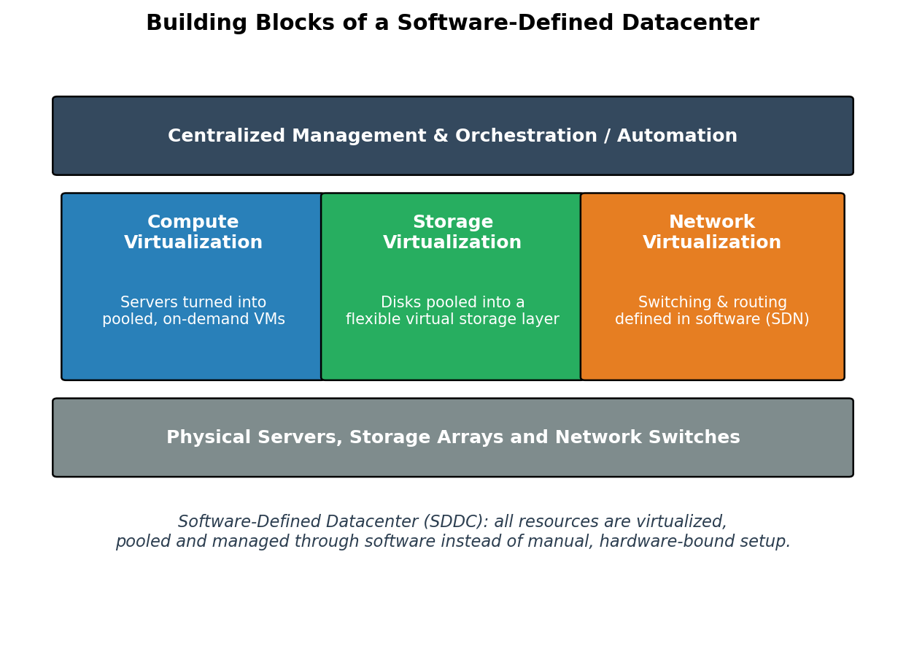
Figure 2: Compute, storage and network virtualization layered into a Software-Defined Datacenter
4. Two cloud providers want to interoperate through federation. Explain how trust, identity, and privacy issues should be handled in the federation design.
When two independent cloud providers federate, each one is effectively agreeing to let users and services it does not directly control interact with its own infrastructure, so the federation design has to establish trust, identity and privacy carefully rather than assuming good behaviour on both sides.
Trust between the two providers should be established through a formal federation agreement backed by a technical trust mechanism, most commonly a mutually trusted certificate authority or a signed metadata exchange between each provider's Identity Provider (IdP) and Service Provider (SP) components, as used in standards like SAML federation. Each provider issues digitally signed tokens for its own authenticated users, and the partner provider validates that signature against the agreed trust anchor before honoring the token, rather than blindly trusting any request that arrives. Trust should also be scoped and revocable — the agreement should define exactly which services are exposed to the federation, and either provider must be able to revoke trust or suspend the federation quickly if the partner suffers a breach.
Identity should be handled through Federated Identity Management, using open standards such as SAML 2.0 or OpenID Connect/OAuth 2.0, so that a user authenticated by Provider A's IdP can be recognized by Provider B's systems through a signed assertion or token instead of Provider B having to store and manage a duplicate password for that user. Access on the receiving side should always be governed by role-based or attribute-based access control mapped from the identity claims in the token, so a federated user only receives the minimum access their role justifies, following least-privilege, rather than being treated as a fully trusted internal user.
Privacy needs its own explicit rules within the federation design. The two providers should agree on a minimal data-sharing model, exchanging only the identity attributes and resource data genuinely required for the interoperating service to function, and encrypting all data in transit between the two clouds. Because the providers may operate under different regulatory regimes, the agreement should specify which jurisdiction's data protection rules govern shared data, how long shared data may be retained, and how it is deleted once no longer needed. Logging and auditing access on both sides ensures that if data is misused, the responsible identity and provider can be traced. Designed this way, federation lets the two cloud providers interoperate usefully while keeping authentication trustworthy, access properly scoped, and patient or customer data protected on both sides of the partnership.
5. An enterprise observes poor performance in a virtualized environment after overcommitting CPU and memory to multiple VMs. Analyze the scenario and recommend tuning actions.
Overcommitment happens when the hypervisor is configured to promise more virtual CPU or memory to its VMs than the physical host actually has available, based on the assumption that not every VM will need its full allocation at the same time. This is a normal and useful technique in virtualization, but when too many VMs are overcommitted at once, or several of them become busy simultaneously, the physical host cannot keep up with all the demand, and the enterprise experiences exactly the performance problems described in this scenario.
On the CPU side, the main symptom is a rise in what is usually called "CPU ready time" — the amount of time a VM's virtual CPU is ready to run but has to wait in a queue for a free physical core, because too many VMs are competing for too few physical CPUs. Applications inside the VM feel sluggish even though the guest operating system itself reports normal CPU usage, because the real bottleneck is time spent waiting for the hypervisor's scheduler rather than the work itself being slow. On the memory side, when the total memory promised to VMs exceeds physical RAM, the hypervisor falls back on techniques like memory ballooning (reclaiming memory from a VM that appears idle) or, worse, swapping memory pages out to disk, which is dramatically slower than RAM and causes noticeable application stalls once it starts happening under load.
The recommended tuning actions follow directly from the two causes. First, the enterprise should measure actual CPU ready time and memory usage per VM using the hypervisor's monitoring tools and identify which specific VMs are driving the contention, rather than treating the whole host as one uniform problem. Second, CPU allocation should be right-sized: VMs that were given more virtual CPUs than they actually use should be scaled down, since an oversized VM can actually make CPU scheduling harder without providing any real benefit. Third, resource pools and shares/limits/reservations should be configured so that critical VMs get a guaranteed minimum share of CPU and memory, protecting them even when the host is busy, while lower-priority VMs are allowed to be throttled first. Fourth, where overcommitment is genuinely too high for the hardware, the enterprise should either migrate some VMs to another physical host (using live migration, so this can be done without downtime) or add physical CPU and RAM capacity to the cluster. Finally, ongoing capacity planning — regularly reviewing utilization trends and setting a safe overcommitment ratio instead of allocating resources on an ad-hoc basis — prevents the same problem from reappearing as more VMs are added in the future.
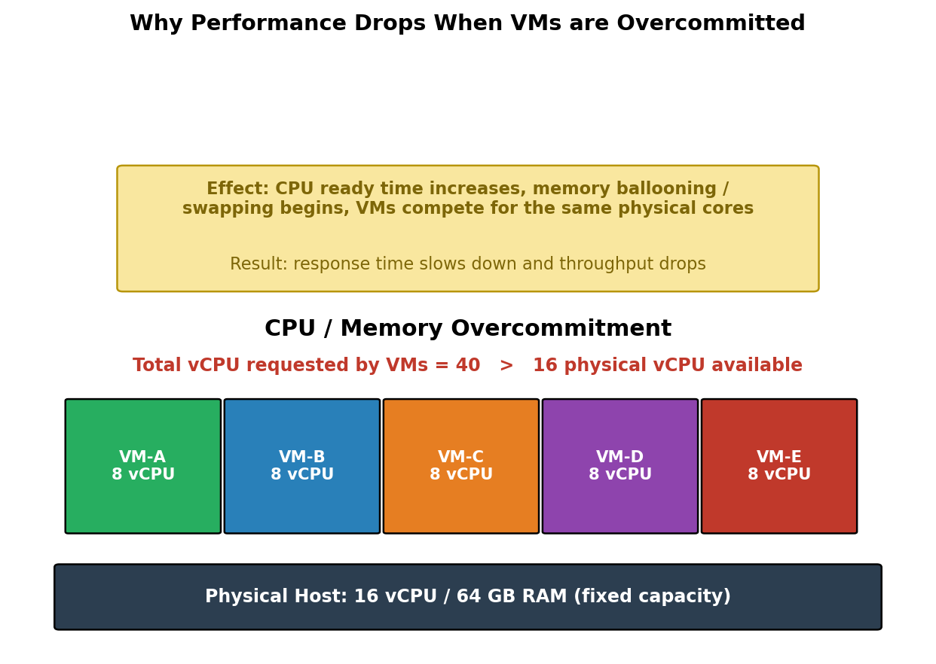
Figure 3: CPU overcommitment — VMs requesting more vCPU than the physical host can provide

Scenario-Based Rubric
Criteria | Weightage | Level 4 - Exemplary | Level 3 - Proficient | Level 2 - Developing | Level 1 - Beginning
Understanding of Scenario | 20% | Demonstrates complete understanding of the scenario context | Good understanding with minor gaps | Partial understanding | Fails to understand the scenario
Identification of Risks / Issues | 20% | Identifies all major issues correctly | Identifies most issues | Limited issue identification | Misses major issues
Application of Concepts | 25% | Applies virtualization concepts effectively | Applies concepts with minor mistakes | Partially correct application | Weak application
Decision Justification | 20% | Decisions are well justified and technically strong | Reasonable justification | Weak justification | No useful justification
Clarity | 15% | Clear and well-organized response | Generally clear | Somewhat unclear | Poorly presented

