SIMATS ENGINEERING
ASSESSMENT TOOL 1: Experiments
COURSE NAME: Cloud Computing and Big Data Analytics
COURSE CODE: CSA15
COURSE OUTCOME COVERED
CO3: Implement cloud-based solutions using cloud storage, web APIs, and platform services for real-world applications. (BL3)
Assessment Tool Weightage: 40%
Dave's Taxonomy: Precision (Level 3)
Question Count: 5
Total Marks: 40
Code of Conduct
I Kanishk C (Name / Reg No) 192511278 certify that this submission is my original work and that I have adhered to the guidelines specified for this assessment.
I understand that any violation of academic integrity rules will result in disciplinary action.
Signature of the student: Kanishk C

Assessment Tasks — Experiments
For each experiment below, I have covered the objective, an architecture sketch, the step-by-step procedure I followed, the expected output, and my conclusion, as asked in the question paper.

Experiment 1: Cloud Storage Comparison (Object vs Block vs File)
Objective
To compare the three major cloud storage models — object storage, block storage, and file storage — and to decide which model fits best for three common situations: keeping backups, attaching disks to virtual machines, and sharing documents across a company.
Architecture Sketch
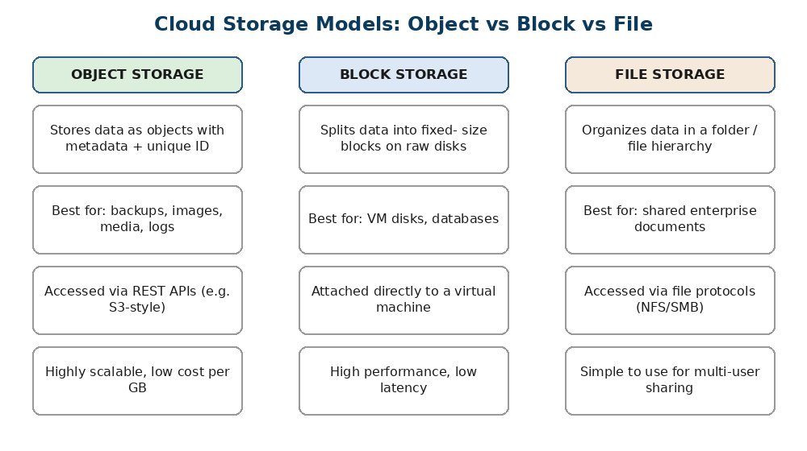
Figure 1.1 — Object, block, and file storage side by side
Procedure
- Step 1: Listed out the three storage types and noted how each one actually stores data underneath — object storage keeps data as a flat set of objects with metadata and a unique key, block storage breaks data into fixed-size blocks that sit on raw disk volumes, and file storage keeps data inside a normal folder/file tree.
- Step 2: Took the first use case — long-term backups. Since backups are large, rarely changed, and need to scale cheaply, I matched this to object storage because it is built for large unstructured data and costs less per GB.
- Step 3: Took the second use case — VM disks. Since a virtual machine needs fast, low-latency read/write access, I matched this to block storage, because block volumes attach directly to a VM the same way a physical hard disk would.
- Step 4: Took the third use case — shared enterprise documents. Since many employees need to open, edit, and organise files together using normal folder paths, I matched this to file storage, accessed through protocols such as NFS or SMB.
- Step 5: Put together a short comparison table (shown below) summarising cost, performance, and best-fit use case for each model.
Storage Model | How it stores data | Performance | Best Use Case
Object Storage | Objects + metadata, flat namespace | Good for large data, higher latency | Backups, images, media
Block Storage | Fixed-size blocks on raw volumes | High speed, low latency | VM disks, databases
File Storage | Hierarchical folders/files | Moderate, easy sharing | Shared enterprise documents
Expected Output
A clear mapping showing that object storage is the right choice for backups, block storage is the right choice for VM disks, and file storage is the right choice for shared enterprise documents, backed by a comparison table.
Conclusion
Each storage model is built for a different job. Object storage wins when data is large and does not change often, block storage wins when an application needs raw, fast disk access, and file storage wins when many users need to share and organise files together. Picking the right model saves cost and improves performance in a real cloud deployment.

Experiment 2: REST API Workflow for a Cloud-Based Student Portal
Objective
To design and demonstrate a simple REST API workflow for a student portal, covering how a request travels from the browser to the backend and back, including authentication and deployment.
Architecture Sketch
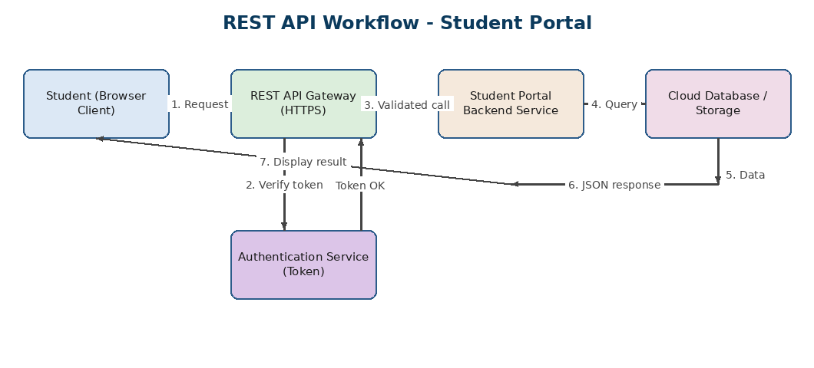
Figure 2.1 — Request/response flow for the student portal REST API
Procedure
- Step 1: The student logs in through the browser client. The client sends a login request to the REST API Gateway over HTTPS.
- Step 2: The API Gateway forwards the login details to the Authentication Service, which checks the username and password and issues a JSON Web Token (JWT) if they are correct.
- Step 3: The browser stores this token and attaches it to every future request (usually in the Authorization header) — this is how the API knows the student is genuine without asking for the password again.
- Step 4: When the student opens a page, for example 'My Attendance', the browser calls a REST endpoint such as GET /api/students/{id}/attendance.
- Step 5: The API Gateway checks the token, then passes the validated call to the Student Portal Backend Service.
- Step 6: The backend service queries the cloud database/storage for the attendance records.
- Step 7: The database returns the data to the backend, which formats it as JSON and sends it back through the gateway to the browser.
- Step 8: The browser renders the JSON response as a readable table on the screen for the student. For deployment, the API and backend services are packaged in containers and hosted on a cloud platform (e.g. a PaaS) so they can scale automatically as more students log in.
Sample Request/Response
Request: GET /api/students/192511278/attendance Header: Authorization: Bearer <token>
Response: 200 OK {"student": "192511278", "attendance": "92%", "status": "Eligible"}
Expected Output
A working request-response cycle where the student successfully logs in, receives a token, and retrieves data (such as attendance or timetable) from the backend through the REST API, all shown as JSON.
Conclusion
REST APIs give a clean, stateless way for a browser client to talk to a cloud backend. Using a token-based authentication step keeps the portal secure, and separating the gateway, backend, and database into different layers makes the whole system easier to scale and maintain.

Experiment 3: Serverless Event Flow for Image Upload Processing
Objective
To design a serverless workflow that automatically processes an image the moment it is uploaded, using object storage, a Function-as-a-Service (FaaS) trigger, and a notification service.
Architecture Sketch
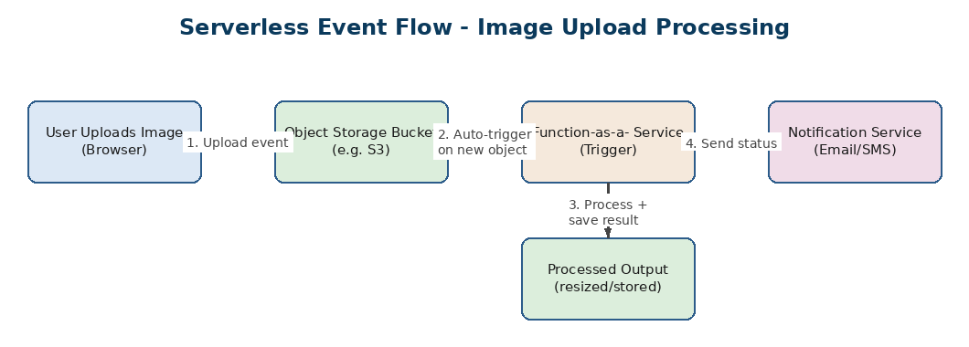
Figure 3.1 — Event-driven serverless flow for image processing
Procedure
- Step 1: The user uploads an image (for example, a profile photo or a delivery receipt) from the browser directly into an object storage bucket.
- Step 2: The storage bucket is configured with an event trigger, so the moment a new object appears, it automatically invokes a serverless function — no server needs to be running and waiting.
- Step 3: The function performs the processing task, such as resizing the image, compressing it, or scanning it for basic validation (correct format, not corrupted).
- Step 4: The processed output is written back into a separate 'processed' storage location, and a notification service sends a confirmation message (email, SMS, or push notification) once processing is complete.
- Step 5: If the function fails (say, the file was corrupted), it can be configured to retry a fixed number of times and then send a failure alert instead.
Expected Output
An uploaded image automatically gets resized/validated within a few seconds without any manual server management, and the user receives a notification once the process finishes.
Conclusion
Serverless computing removes the need to keep a server running all the time just to wait for occasional uploads. The system only runs (and only costs money) when an actual event happens, which makes this pattern very efficient for tasks like image processing that happen in short bursts.

Experiment 4: Edge Computing vs Fog Computing for Smart Traffic Management
Objective
To compare edge computing and fog computing for a smart traffic management system, and to decide where each type of processing should physically happen.
Architecture Sketch
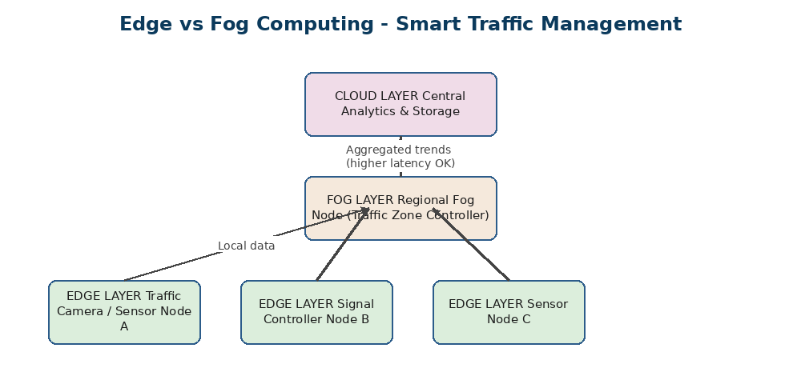
Figure 4.1 — Three-layer architecture: edge, fog, and cloud
Procedure
- Step 1: Placed traffic cameras and signal sensors at the road junctions themselves — this is the edge layer. Decisions that must happen instantly, like switching a signal to red when a pedestrian is detected, are handled right here so there is almost no delay.
- Step 2: Grouped several nearby junctions under one regional fog node — this is the fog layer. The fog node collects data from all the edge devices in its zone and makes slightly bigger decisions, such as adjusting green-light timing across a cluster of junctions to reduce a build-up of traffic.
- Step 3: Sent only summarised, aggregated data from the fog layer up to the cloud — this is the cloud layer. The cloud is used for city-wide analytics, historical trend reports, and long-term storage, where a small delay does not matter.
- Step 4: Compared the latency: edge processing reacts in milliseconds, fog processing reacts in around a second (zone-level), and cloud processing can take a few seconds since it depends on internet connectivity.
- Step 5: Noted the deployment location for each: edge devices sit inside or next to the sensor hardware, fog nodes sit in a local server room or roadside cabinet, and the cloud sits in a remote data centre.
Expected Output
A three-layer traffic system where instant decisions happen at the edge, zone-level coordination happens at the fog layer, and long-term insights happen in the cloud.
Conclusion
Edge computing is best when a decision cannot wait even a second, like emergency signal switching. Fog computing sits in between and is useful for coordinating a small area without waiting on the internet. Fog and edge computing together take pressure off the central cloud and make the whole traffic system faster and more reliable.

Experiment 5: Cloud Application Deployment Workflow
Objective
To demonstrate the complete deployment workflow of a cloud application, showing how the client, browser, web API, storage, and monitoring layer work together.
Architecture Sketch
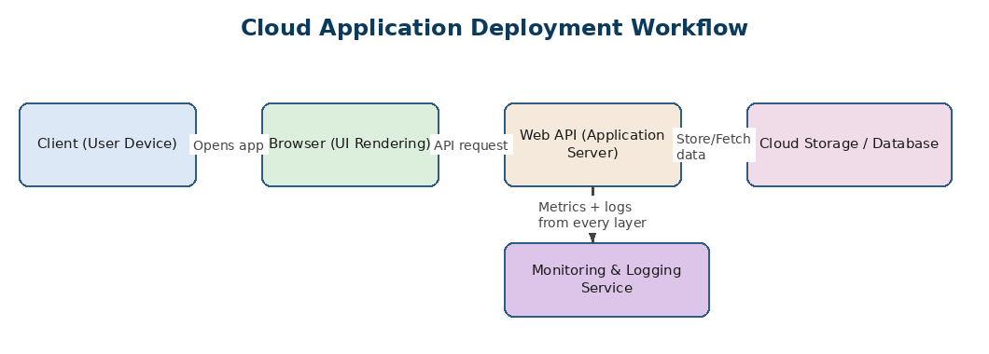
Figure 5.1 — End-to-end deployment and monitoring workflow
Procedure
- Step 1: The client opens the application on their device. The browser loads the front-end (HTML/CSS/JS) which was deployed on a cloud hosting service.
- Step 2: Whenever the user performs an action, the browser sends an API request to the Web API layer, hosted on the cloud platform.
- Step 3: The Web API processes the request and reads or writes data to the cloud storage/database as needed.
- Step 4: At the same time, a monitoring and logging service quietly collects metrics (response time, error rate, CPU usage) from every layer of the system.
- Step 5: If the monitoring service notices unusual behaviour (like a spike in errors or slow response time), it raises an alert so the issue can be fixed quickly, sometimes even triggering auto-scaling to add more resources automatically.
Expected Output
A running cloud application where a user's action in the browser is correctly handled by the Web API and storage layer, with the whole process being visible on a monitoring dashboard.
Conclusion
A cloud deployment is not just about writing code and putting it on a server. It needs the client, browser, API, storage, and monitoring layer to all work together smoothly. Monitoring is especially important because it lets the team catch problems early and scale the application before users are affected.

