SIMATS ENGINEERING
ASSESSMENT TOOL 2: Case Study
COURSE NAME: Cloud Computing and Big Data Analytics
COURSE CODE: CSA15
COURSE OUTCOME COVERED
CO3: Implement cloud-based solutions using cloud storage, web APIs, and platform services for real-world applications. (BL3)
Assessment Tool Weightage: 20%
Dave's Taxonomy: Precision (Level 3)
Question Count: 3
Total Marks: 30
Code of Conduct
I Kanishk C (Name / Reg No) 192511278 certify that this submission is my original work and that I have adhered to the guidelines specified for this assessment.
I understand that any violation of academic integrity rules will result in disciplinary action.
Signature of the student: Kanishk C

Assessment Tasks — Case Study
Below are my detailed answers to the three case studies, with the proposed architecture explained and a diagram included for each.

Case 1: Food Delivery Company — Cloud-Native Backend
Understanding the Case
A food delivery company needs a backend that can serve two types of users at once — customers placing orders and delivery partners updating status — while also handling payments, order tracking, and storing receipts and delivery photos. Because order volume changes a lot during lunch and dinner hours, the system needs to scale up and down on its own, which is exactly what a cloud-native design is good at.
Proposed Architecture
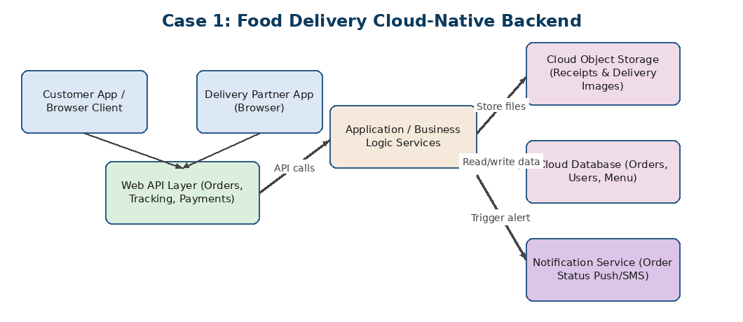
Figure 1.1 — Proposed cloud-native architecture for the food delivery backend
The system is split into clear layers so each part can scale and be updated independently:
- Browser/App Clients: The customer app and the delivery partner app are both browser-based (or a lightweight web view), so no separate backend logic is needed for each platform — they both talk to the same Web API layer.
- Web API Layer: A REST API layer handles orders, live tracking, and payments. It authenticates every request and routes it to the right backend service. Keeping this as its own layer means the company can add a new client (say a smartwatch app) later without changing the backend.
- Application/Business Logic Services: This is where order rules live — for example, assigning the nearest delivery partner, calculating delivery time, and applying discounts. Running this as small independent services (a microservices style) means one busy part, like live tracking, does not slow down the whole system.
- Cloud Object Storage: Receipts and delivery-proof images are unstructured files that are written once and rarely changed, so object storage is used here — it is cheap, scales endlessly, and is accessed directly through the Web API using simple upload/download URLs.
- Cloud Database: Structured data such as orders, user accounts, and the restaurant menu is stored in a managed cloud database, which supports fast lookups and keeps data consistent.
- Notification Service: Sends real-time order-status updates (like 'Out for delivery') to the customer through push notifications or SMS, triggered directly by the business logic layer.
Role of Each Component (Summary)
- Clients — collect user input, display live order status
- Web API — single entry point, authentication, routing
- Business logic services — the actual decision-making (assignment, pricing, ETA)
- Object storage — receipts and delivery images
- Database — orders, users, menu data
- Notification service — keeps users informed in real time
Conclusion
Splitting the backend into these layers means the company can scale just the parts that get busy (like the API layer during peak lunch hours) without over-paying for parts that stay steady (like storage). Using object storage for images/receipts and a proper database for structured data also keeps costs low while keeping the system fast.

Case 2: Media Startup — Storage and Processing for Video Uploads
Understanding the Case
A media startup receives video uploads from creators and needs to decide how to store the raw files and how to process them (for example, transcoding to different resolutions). The three options given are SAN-backed storage, object storage, and serverless processing, and the case asks us to analyse and recommend one deployment model.
Analysis of Options
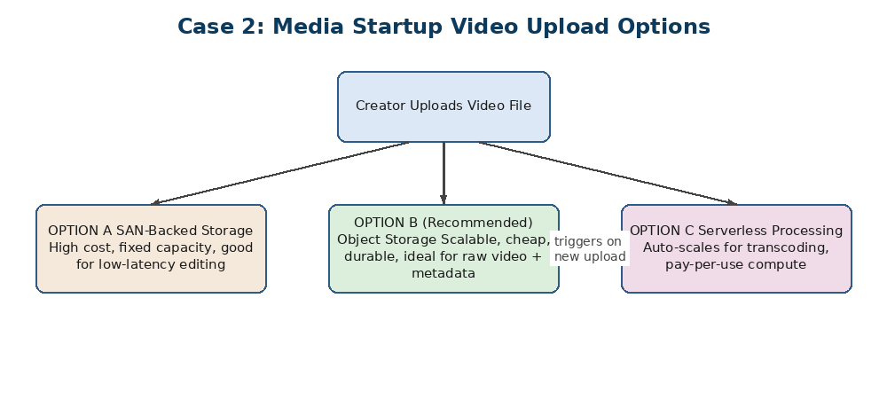
Figure 2.1 — Comparing storage and processing options for video uploads
- SAN-Backed Storage: A Storage Area Network gives very fast, low-latency block-level access, which is great for active video editing on dedicated hardware. But it is expensive, has a fixed capacity that must be planned in advance, and does not scale well if the startup suddenly gets many more creators uploading at once.
- Object Storage: Stores each uploaded video as an object with metadata (creator ID, upload time, format). It scales automatically, costs much less per GB than SAN, and is naturally suited to storing large raw video files that are uploaded once and read many times (for streaming or reprocessing).
- Serverless Processing: Instead of keeping transcoding servers running all day waiting for uploads, a serverless function can be triggered automatically the moment a new video lands in object storage. It only runs (and only costs money) while actually transcoding, which fits a startup's uneven upload pattern well.
Recommended Deployment Model
I recommend combining object storage with serverless processing. Raw and processed videos are kept in object storage because it is cheap and scales without any planning, and a serverless function is triggered on every new upload to handle transcoding, thumbnail generation, and format conversion. SAN storage is not recommended here because its high cost and fixed capacity do not match a startup's unpredictable and fast-growing upload volume.
Trade-offs
- Object storage has slightly higher latency than SAN for the very first read, but for a startup this is an acceptable trade-off against the huge savings in cost and the ability to scale without buying new hardware.
- Serverless functions have a short 'cold start' delay for the very first request after being idle, but for background video processing (which does not need to be instant) this delay does not affect the end-user experience.
Conclusion
For a fast-growing media startup with unpredictable upload volume, object storage plus serverless processing gives the best balance of cost, scalability, and low operational effort, compared with the fixed cost and fixed capacity of SAN-backed storage.

Case 3: Smart City Platform — Edge and Fog Computing
Understanding the Case
A smart city platform collects data from traffic sensors, air-quality sensors, and safety cameras spread across the city. Some decisions (like switching a traffic signal) must happen instantly, while others (like city-wide pollution trends) only matter over weeks or months. The case asks how edge and fog computing can be used alongside the cloud to meet both needs.
Analysis and Proposed Use
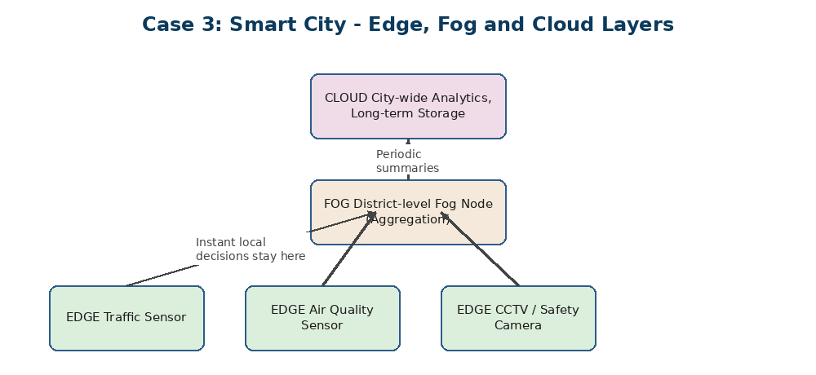
Figure 3.1 — Edge, fog, and cloud layers for the smart city platform
- Edge Layer: Small computing units are placed directly at or very close to each sensor (traffic sensor, air-quality sensor, CCTV camera). This layer handles decisions that cannot wait even a second, such as detecting a pedestrian and switching a signal, because sending that data all the way to the cloud and back would be too slow.
- Fog Layer: A regional fog node sits closer to a group of edge devices (for example, covering one district). It aggregates data from many edge devices, spots patterns across a wider area (like a traffic jam building up across three junctions), and makes zone-level decisions without needing to wait for the central cloud.
- Cloud Layer: The cloud receives only summarised data from the fog nodes at regular intervals. It is used for city-wide analytics, long-term storage, and generating reports for city planners — tasks where a delay of a few seconds or minutes is perfectly fine.
Why This Split Works
If everything were sent straight to the cloud, the round-trip delay would make instant actions (like emergency braking signals) impossible, and the network would be overloaded with constant raw sensor data from thousands of devices. By handling urgent, local decisions at the edge, mid-level coordination at the fog layer, and only long-term analytics in the cloud, the platform keeps critical response times low while still getting the benefit of centralised, city-wide insight.
Conclusion
For a smart city, edge computing should be used wherever a decision needs to happen in real time and locally, fog computing should be used to coordinate a nearby group of devices, and the cloud should be reserved for large-scale analytics and storage where speed is less critical than depth of insight.

