SIMATS ENGINEERING
ASSESSMENT TOOL 3: MCQ Test
COURSE NAME: Cloud Computing and Big Data Analytics
COURSE CODE: CSA15
COURSE OUTCOME COVERED
CO3: Implement cloud-based solutions using cloud storage, web APIs, and platform services for real-world applications. (BL3)
Assessment Tool Weightage: 10%
Dave's Taxonomy: Precision (Level 3)
Question Count: 15
Total Marks: 30
Code of Conduct
I Kanishk C (Name / Reg No) 192511278 certify that this submission is my original work and that I have adhered to the guidelines specified for this assessment.
I understand that any violation of academic integrity rules will result in disciplinary action.
Signature of the student: Kanishk C

Assessment Tasks — MCQ Test
I have gone through each question, marked the correct option, and added one line explaining why that option is correct, so that my understanding of the concept is clear.
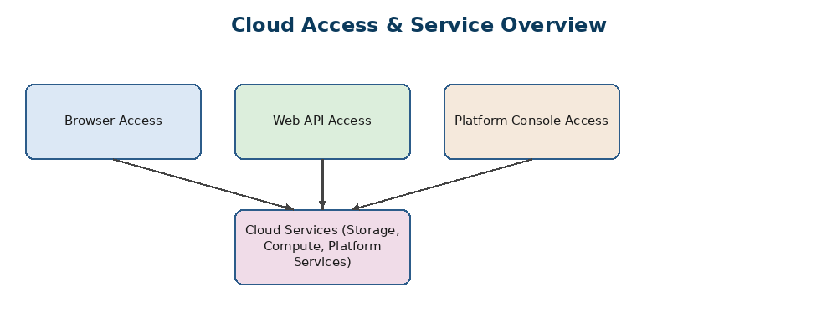
Overview of how cloud services are typically accessed
1. Which cloud storage model is best suited for storing virtual machine disks?
A. Object storage
B. Block storage ✓ (Correct Answer)
C. File storage
D. Archive storage
Why: VM disks need fast, low-latency, direct read/write access, which block storage provides by attaching like a raw disk.
2. Which protocol style is widely used for lightweight web APIs in cloud platforms?
A. SOAP only
B. REST ✓ (Correct Answer)
C. FTP
D. SMTP
Why: REST uses simple HTTP methods and is lightweight, which is why most modern cloud APIs are built as REST APIs.
3. Serverless computing is best described as:
A. Computing without networks
B. Running code without managing servers directly ✓ (Correct Answer)
C. Local execution only
D. Batch-only processing
Why: In serverless computing the cloud provider manages the servers; the developer only writes and runs functions.
4. Edge computing primarily helps by:
A. Increasing central storage only
B. Reducing latency near data sources ✓ (Correct Answer)
C. Eliminating internet access
D. Replacing cloud storage fully
Why: Edge computing processes data close to where it is generated, cutting down the delay of sending it to a distant server.
5. Fog computing differs from edge computing because it:
A. Always runs inside sensors
B. Introduces an intermediate distributed layer between edge and cloud ✓ (Correct Answer)
C. Works only in private clouds
D. Uses no network resources
Why: Fog computing sits between the edge devices and the cloud, aggregating data from a group of edge nodes.
6. Which storage model is commonly used for shared departmental files?
A. File storage ✓ (Correct Answer)
B. Register storage
C. Cache-only storage
D. Tape-only storage
Why: File storage organises data in folders and supports multi-user access, which fits shared departmental documents.
7. A browser calling a cloud web application typically communicates through:
A. BIOS interrupts
B. Web APIs ✓ (Correct Answer)
C. Only command-line tools
D. VPN tunnels only
Why: Browsers talk to cloud applications using Web APIs, usually over HTTPS.
8. SAN stands for:
A. Secure Access Node
B. Storage Area Network ✓ (Correct Answer)
C. Shared Application Namespace
D. Service Access Network
Why: SAN is short for Storage Area Network, a dedicated high-speed network for block-level storage.
9. Which of the following is a common benefit of serverless architecture?
A. Manual scaling of servers
B. Pay-per-use execution model ✓ (Correct Answer)
C. Dedicated physical hardware ownership
D. No monitoring required
Why: Serverless platforms charge only for the actual compute time used, which is the pay-per-use model.
10. Collaboration within the cloud usually improves:
A. Shared access to services and documents ✓ (Correct Answer)
B. Hardware disposal speed
C. Cable management
D. BIOS configuration
Why: Cloud platforms let multiple users access and work on the same documents/services from anywhere, improving collaboration.
11. Which one is an example of a platform service?
A. Managed application runtime ✓ (Correct Answer)
B. Keyboard driver
C. Physical rack switch only
D. Local USB storage
Why: A managed application runtime (PaaS) is a platform service that lets developers deploy apps without managing the OS.
12. Object storage is generally preferred for:
A. Mounting OS boot volumes
B. Large unstructured cloud data such as images and backups ✓ (Correct Answer)
C. CPU scheduling
D. Hypervisor installation
Why: Object storage is built to hold large amounts of unstructured data like images, videos, and backups at low cost.
13. Which component allows applications to communicate programmatically with cloud services?
A. Heat sink
B. Web API ✓ (Correct Answer)
C. Mouse driver
D. Compiler cache
Why: Web APIs expose cloud service functionality so applications can call them programmatically.
14. A low-latency smart factory use case is best supported by:
A. Edge computing ✓ (Correct Answer)
B. Cold archive only
C. Offline storage
D. Manual processing
Why: Smart factory decisions need to happen instantly on the shop floor, which is exactly what edge computing is for.
15. Which one is not a typical cloud access method?
A. Browser-based access
B. API access
C. Platform console access
D. Paper-based access ✓ (Correct Answer)
Why: Paper-based access is not a digital cloud access method; the cloud is accessed through browsers, APIs, or consoles.

